LEGEND:

| | - Node or part entrance. In this case it goes to first scene in part.

( ) – Exact scene

\ \ - Ending

// - Comment (COMMENTS MUSTN’T BE TRANSFERED IN GAME!)

IF „ “ – Condition

Big gap means what the text\choise must be showh on next slide inside scene

Big gap example:

Big gap ended.-^

\* \* - Battle node

. . – random event

All text not marked like „//“ must be shown in game

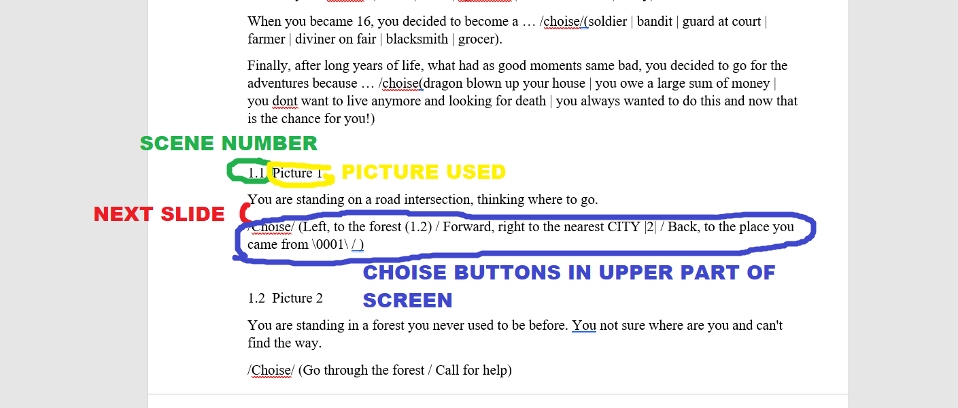

Parts:

|1| – Forest

|2| – City

|3| - Village

|4| - Holy order

|5| - Unlucky luck

|6| - Dragon location

|7| - Lich

|8| - Necromancer fight line

|9| - Regular bandit line

|10| - Not belonging to this world

|11| - Bandit leader line

EXAMPLE:  
  
(SCENE NUMBER) – (PICTURE NUMBER) – MUSIC GROUP

(TEXT)  
(MAYBE SOME INTERACTIONS)

(LINKS)