## 1. INTRODUCTION

“*Every day, we create 2.5 quintillion bytes of data — so much that 90% of the data in the world today has been created in the last two years alone.*”

- IBM Corporation, 2013

We are drowning in data. We like to talk about information society, but “[m]ost of the technology we call information technology is, in fact, data technology” (Shedroff, 2000, p. 272). The turn of 21st century is characterized by a severe information and data overload, on both an organizational and personal level (Jones, 2012; Shedroff, 2000). The industry leaders are quick to provide us with new buzzwords Big Data, Web 3.0, Semantic Web Deep Learning, and Internet of Things. Such terms may help familiarize the general public with the latest advances in technology, but they are often just new labels for problems that researchers, philosophers, and businesses were trying to address decades ago. These problems have grown in scale. They now also affect more people than ever before. However, the way we approach information and information design has not kept pace with the growing complexity of our information systems.

We may indeed be in the midst of a transition to a true information society. But for the time being, our approach to dealing with information problems is still rooted in the mechanistic, Tayloristic view of optimum organization. Our answer to the ever-increasing flow of unstructured data and information has been overstructuring (Cooley, 2000). System designers and engineers have a tendency to base their decisions on the system's capabilities rather than human needs which the system is supposed to cater for. This leads to bloated multi-purpose solutions that are out of proportion to what the human mind can process in a reasonable and useful manner. By framing people's problems as mere features in vast information systems, we fail to address the more fundamental {>>subtle nuances of everyday life<<} issues of how people perceive and interact with the information around them on day-to-day basis. We judge the quality of the system by the number of features it has, rather than how it enhances our lives. The field of human-computer interaction (HCI) has emerged to tackle this growing disconnect between the systems and people using those systems.

HCI gained prominence in the early 90’s and its popularity keeps rising to this day. The researchers in this field did succeed in shifting more attention to human actors, however, the concepts and ideas used are still much technocentric. {>>REWRITE!<<} Much of the research in HCI revolves around system capabilities and investigating how people manipulate data through visual interfaces, rather than how they perceive information and how it fits into the broader context of their everyday lives. It tries to extract and objectify universal truths and apply them to the design of interfaces which are usable, but not necessarily useful.

This paper examines the latest approaches to the design of human-centered information systems. These approaches are rooted in an ecological inquiry, investigating people in their natural surroundings, paying particular attention to the context of the information use. These emerging fields see people as an absolute focal point of the study. The underlying technology is of secondary interest. The utility of these post-modern perspectives on information management is illustrated on a design solution for a knowledge-sharing platform. The notion of design in this paper takes core principles from established fields of industrial design and design science. It then combines them with a more recent research from an emerging field of information design. Principles of information design are applied to conceptualize a possible solution for information problems posed by a specific context of traveling to a foreign country.

Traveling is an information-intense industry, and has been one of the most impacted by the massive proliferation of the Internet and social media in the last decade (Xiang, & Gretzel, 2010). Therefore, it was chosen as a suitable area of interest for this research. Moreover, the choice was motivated by author’s own personal experience with finding and sharing relevant travel information, and a long-term desire to design and develop a platform that would mediate a more authentic traveling experience. To guide the investigation, the following research question has been devised:

*How to provide travelers with location-based information through harnessing collective knowledge of local residents?*

The paper starts off by positioning itself in the multidisciplinary field of information management. Then it goes into examining the terminology and concepts used in the analysis by applying the latest perspectives for the design of human-centered information systems. After that, the methodology and the research design are presented, followed by the analysis itself. The paper concludes with proposing a possible solution to the information problem at hand, and finishes off by summarizing the findings.

## 2. RESEARCH DOMAIN

The purpose of this paper is to improve understanding of theoretical background for designing human-centered communication and information systems (IS). More specifically it looks at many-to-many online knowledge-sharing platforms, with a particular focus on information-seeking behavior within those platforms. On a more practical note, it aims to provide a set of guiding principles for designing such platforms in a specific context of travel and location-based information-seeking. The proposed platform design’s function is to harness locally embedded collective knowledge of residents and travelers, and disseminate this knowledge in the form of digitized information artifacts to a wider audience online.

The research is rooted in an inherently multi-disciplinary field of Information Management (IM), drawing on concepts and ideas from various disciplines, such as communication, information systems, information science, knowledge management, information architecture, social science, and design science (Fidel, 2012; Madsen, 2012). It is operating in both an information and knowledge domain without a clear distinction between the two, as they constantly intervene throughout the paper. This ambiguity in the terminology will be further examined in the paper’s conceptual framework section.

From a traditional IM perspective, the following research spans the entirety of the Information Management Cycle, as proposed by Choo (2002), with a particular focus on stages of information needs, acquisition, services, and distribution. The remaining stages are examined only peripherally, but nonetheless play an important role, as they are inherently encompassed in the overall design of an IS. Choo’s view on the management of the entire information value chain is more useful for examining IM from an organizational perspective, where much of the IM activity revolves around underlying technology and infrastructure. This technology-oriented IM views information primary as a resource to be objectified, collected, stored, managed, analyzed, and distributed (Schlögl, 2005). However, since the overarching goal is to design a knowledge-sharing IS, certain aspects of technology-oriented IM are still going to hold relevance in the analysis, particularly within the proposed design solution.

By focusing on information-seeking behavior, this paper takes a more human-centered, content-oriented approach to IM, which is rooted in library and personal perspectives of IM (Detlor, 2010; Schlögl, 2005). While library perspective is concerned with the information needs of people (patrons), the focus is still on storing, organizing, and distributing information. This perspective takes a rather top-down approach, where the library (librarian) serves as a broadcast medium to disseminate information in one-to-many manner with little regard for the immediate context of information use. On the other hand, personal perspective puts an individual human actor at the forefront. Here, IM is less about technical solutions and more about the human-side of IM. After all, it is humans who “add the context, meaning and value to information, and it is humans who benefit and use this information” (Detlor, 2010, p. 107). The field of study of personal information management (PIM) stems from this human-oriented perspective.

Much of the early study of PIM is grounded in the traditional techno-centric branch of IM. In this view, the actor’s interaction with information is seen through a simplistic perspective, where the interaction is often depicted by static input, output models (Jones & Teevan, 2007). The focus is on manipulation of information items and interfaces that mediate the interaction, rather than on the interaction itself and the context it occurs in. The study of PIM is an integral part of the human-computer interaction (HCI) field, but the growing realization that “our interactions with information are much more central to our lives than are out interaction with computers” (Jones & Teevan, 2007, p. 18) has lead to an emergence of a new branch of study called human-information interaction (HII).

This paper positions itself in this up-and-coming field of HII, which establishes the human actor as the study's prime focal point. The study takes a naturalistic approach to PIM, stressing the importance of various contexts and information spaces in which people interact with information and make sense of the world around them (Fidel, Pejtersen, Cleal, & Bruce, 2004; Naumer & Fisher, 2007). It is a holistic perspective that acknowledges the need to study people's interaction with information in the natural setting it occurs in. This ecological inquiry needs to be conducted in a cross-disciplinary manner considering “cognitive, physical, neurological, social, emotional, and economic aspects of interaction, among others” (Fidel, 2012, p. 1).

It is not technically feasible to study people across every single context they immerse themselves in on a daily basis. It is still reasonable to conduct research within a specific context(s). However, it is necessary to acknowledge the complex cross-contextual nature of human life and that “personal information and methods for managing it may move between these contextual boundaries” (Naumer & Fisher, 2007, p. 76).

By applying the latest approaches to HII, this paper examines problem-based information needs within a specific information space in a context of travel. This information space is set in a broader activity space where physical action and physical experiences occur. “In order to undertake activities in the activity space, people need access to information” (Benyon, 2001, p. 427). Therefore, principles of information design are applied to conceptualize a possible IS solution that would provide access to locally relevant information artifacts in a temporary information space of travel, while staying compatible with the flux of contexts of everyday human activity. {>>split last sentence!<<}

This paper’s author believes that due to the inherently broad, multi-disciplinary, and ambiguous nature of the conceptual framework, the findings are generalizable to a greater or lesser degree. With minor adjustments, the research design, methods, concepts, and models used throughout this paper can be repurposed for analyzing and designing online knowledge-sharing platforms that focus on contexts other than travel.

## 3. CONCEPTUAL FRAMEWORK

This section of the paper aims to improve understanding of the theoretical underpinnings of HII and information design—two young, emerging fields that have roots in more traditional fields of library and information science (LIS), PIM, HCI, IS design, and design science. Moreover, it serves as a theoretical framework for the analysis presented later on. First, the basic concepts and terminology are examined, as to clarify their meaning for paper’s purposes and to avoid confusion. Next sub-section aims to shed light on the evolving role of design in society. It examines the historical position of design as an all-encompassing human endeavor and its gradual transformation into a formalized field. The section concludes with conceptual models that have been chosen as relevant for the analysis.

According to Schrader, who studied 700 definitions of “information science” from 1900 to 1981, “the literature of information science is characterized by conceptual chaos” (as cited in Myburgh, 2005, p. 13). Rapid technological advances, widespread adoption of portable computing devices, and growing ubiquitous access to the Internet have characterized the turn of the 21st century (eMarketer, 2014a, 2014b; Internet Live Stats, n.d.). This has lead to a growing realization of the central role information plays in our everyday lives, and to a further conceptual and semantic confusion surrounding IM's core terms like data, information, and knowledge (Myburgh, 2005).

To accommodate for the ambiguity in terminology and interpretation of concepts, this paper takes a strong interpretivist view rooted in social construction, looking “for culturally derived and historically situated interpretations of the social life-world” (Crotty, 1998, p. 67). It strives to avoid a pitfall of false dichotomies that separate analytical concepts into neatly confined boxes with limited applicability to real world problems, if taken at face value. In this view, virtually any claim is valid to a greater or lesser degree. While this allows for a substantial freedom in the analysis, it also renders the outcomes of the analysis inconclusive. In other words, this paper claims to provide a “good enough” solution to a research problem at hand, but it does not (and by the definition it cannot) conclude with an all-encompassing answer with a single “correct” solution. The entire paper is based on this modus operandi.

The paper’s pragmatic nature stems from a phenomenological tradition in which the object and the subject are inherently interlinked—one cannot be adequately described without the other (Crotty, 1998). Rather than trying to objectify and isolate some sort of “reality out there,” the focus is on human experience of the world, not the world itself (Fidel, 2012). It studies the differences in the interpretations of the world and what aspects of our everyday life and environment affect these interpretations and how. In this view, the object of study is not information itself, but rather the role information plays in a wider context of work, study, and life in general (Bawden & Robinson, 2012; Wilson, 2006). The paper looks specifically for the role information plays in the context of travel.

The underlying goal of this paper is to go beyond HCI, which has traditionally been concerned with the study of PIM and information needs in IS design. In the world where people are drowning in data, HCI “has not really kept pace with the changes in technology” (Benyon, 2001, p. 426). This system-centric view sees the user as outside the computer and focuses primarily on how people manipulate data through interfaces. It investigates how people consume information, rather than how they comprehend it and integrate it in the broader context(s) of their everyday lives. What we call information systems, are in fact, often just data-manipulation systems. The design of these systems is usually driven by the capabilities of the given technology, rather than by the information needs of the end-user (Albers, 2008; Benyon, 2001; Wilson, 2000).

The growing realization of the inadequacy of HCI to cope with increasingly information-dense nature of everyday life has lead to an emergence of a new field of HII. This field has marked a “a philosophical shift of privileging the human’s interaction with the information, rather than the human’s interaction with the computer interface” (Albers, 2008, p. 117). This naturalistic view sees technology merely as an enabler, not the point of interest. It moves the human actor from outside to inside an information space in which “people must perceive and interpret the information artefacts so that they can achieve their goals in an activity space.” (Benyon, 2001, p. 429). The focus is on “on people interacting with information and solving problems” in an activity space, where their everyday experiences occur (Albers, 2008, p. 118). HII strives to uncover how people conceive information, rather than just perceive it (Benyon, 2001). At the end of the day, a “person does not want to use a web-based information system or a computer application; they want to accomplish a real-world goal” (Albers, 2008, p. 118). The term human information behavior (HIB) is sometimes used to describe essentially the same concept as HII. In this paper, the term HII is preferred, but both can be used interchangeably (Jones, 2012; Jones & Teevan, 2007). The Figure 1 illustrates the multidisciplinary nature of the field.

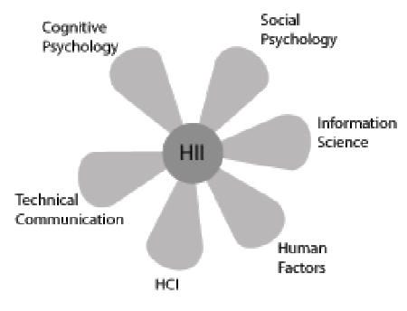

**Fields involved in successful communication of technical information. Adapted from Albers (2008)**

### 3.1 Terminology goulash

As mentioned earlier, there is quite a bit of conceptual confusion and a lack of consensus surrounding many of the terms central to the study of IM, and the various disciplines it encompasses. The word “information” is understood differently if one is an engineer developing a new enterprise intranet, than if one is a communications expert analyzing a political debate on television. One sees it as a resource existing independent of the human mind, while the other one sees it purely as product of human interaction. The following is a rough delineation of some of the key terms used throughout the paper and how they are understood for the purposes of this research.

#### Data

Data is a raw representation of something factual and quantifiable. It is created through measurement and direct observation. Moreover, it can be received, stored, processed, and transmitted by humans, computers, and other mediums (Myburgh, 2005). Data do not have an intrinsic discrete meaning and are therefore not an adequate product for communication (Myburgh, 2005; Shedroff, 2000). To obtain value from data, it must be transformed, organized, and given meaning. Once a human actor has made sense of data, it becomes information. Data can be subsumed under information in a sense that “data may or may not be information depending upon the state of understanding of the information user” (Wilson, 2000, p. 50).

#### Information

Information is a product of human interaction with data and that “part of an individual's knowledge which can be communicated, which has meaning and which can be understood by other individual” (Myburgh, 2005, p. 24). Information has meaning, as opposed to data. The term is often conflated with the terms data and knowledge, as it is typically used to describe different things in different contexts. In the early study of IM, information has been seen as something that can exist independent of the human mind and the medium that is used to carry it. In this system-centric view, the information is objectified and seen mainly as a resource to be managed and manipulated. However, the now more established notion sees information exclusively as a product of a communicative interaction process set in a certain context (Bawden, & Robinson, 2012). When we talk about information as an independent entity residing outside of the human mind, we are talking about an information item or an information artifact. That is the “packaging of information in a persistent form than can be acquired, created, viewed, stored, grouped (with other items), moved, given a name and other properties, copied, distributed, moved, deleted, and otherwise manipulated” (Jones & Teevan, 2007, p. 7). Another term used for an information item is a document, which refers to any recording of information (Myburgh, 2005).

#### Knowledge

In broad terms, knowledge can be described as “that which people know and is accumulated through understanding, interpreting, analysing and making meaning of what is experienced and observed, as well what others have communicated” (Myburgh, 2005, p. 22). It is derived from both data and information and depends on personality and intellect. Therefore, everyone possesses a highly personal unique body of knowledge that resides inside his or her head. Every knowledge management system is inherently trying to separate knowledge from the mind to a greater or lesser degree. Management studies in particular have grown fond of the notion of the tacit knowledge, popularized by Nonaka (1991). This view argues that an organization can tap into knowledge hidden in the heads of the organizational members by devising appropriate methods and processes to translate tacit knowledge into explicit knowledge that can be communicated to the rest of the organization. This again suggests a rather system-centric view, where knowledge is treated as a commodity to be captured, codified, and seen primarily as an organizational asset. In the tradition of Polanyi (Tsoukas, 2003), this paper treats knowledge as something highly situated and entirely ineffable. It cannot be transmitted, only information about the knowledge can, and “that information can only ever be an incomplete surrogate for the knowledge” (Wilson, 2000, p. 50). When a person interacts with information and uses it to solve a problem or achieve a specific goal, knowledge can also be seen as information in action (Hughes, 2002). The concept of wisdom is beyond the scope of this paper, and is regarded as a highest form of knowledge that has accumulated over a long period, and is impossible to communicate.

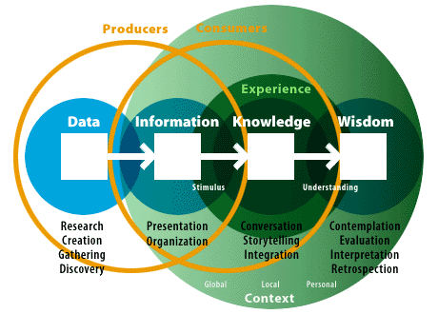

**The Understanding Spectrum. Illustration of the relationships between the key terms. Adapted from Shedroff (2000)**

#### Information behavior

Wilson described information behavior as “the totality of human behavior in relation to sources and channels of information, including both active and passive information seeking, and information use” (Wilson, 2000, p. 49). This broad term includes face-to-face communication, as well as a more passive reception of information with no intention to “act on the information given” (Wilson, 2000, p. 49). Research into information behavior has, for a long time, been dominated by an inquiry into the cognitive dimension of human life. Human-information interaction is a cognitive process after all—not a social or physical one. However, this perspective severely underplays, or completely ignores, the role of other dimensions like social or environmental (Fidel et al., 2004). It is therefore necessary to adopt a more multidimensional, ecological approach that also includes the social dimension which “views the human as a person who lives and acts in a certain context, rather than a user of information systems and services” (Fidel, 2012; Fidel et al., 2004). The ecological approach to HII starts with the study of environmental constraints before moving onto the investigation of cognitive constraints. In this view, “interacting with information is a way to overcome an obstacle in solving a problem” (Fidel, 2012, p. 7). The importance of the information itself is downplayed in favor of examining the problem-based and pragmatic nature of the interaction since “most of the time, people are trying to solve problems, to make sense of the world, and to do things, not find information for its own sake” (Bawden, & Robinson, 2012, p. 205).

Human processing of information is not seen as a static input-output process, but rather as a continuous act of sense-making which “focuses on how people understand information they receive within their life context, with factors such as the person’s expertise, social position, and situation affecting their understanding” (Fidel, 2012, p. 59). Information behavior as a research area is too broad for the purposes of this paper. A subset of information-seeking behaviour, which is concerned with the information needs, has been chosen as a primary area of research, and is illustrated in Figure 3. Information search behavior is “the ‘micro-level’ of behavior employed by the searcher in interacting with information systems of all kinds” (Wilson, 2000, p. 49). It focuses on the interaction with the system on both the interface, and the intellectual level. For the analysis’s purposes it is implicitly contained within the term information-seeking behaviour.

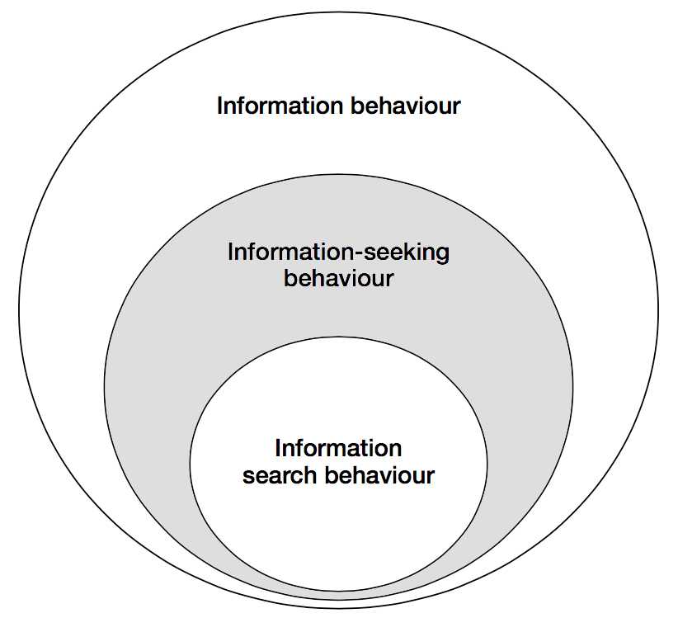

**A nested model of the information seeking and information searching research areas. Shading added by the author to highlight the area of interest. Adapted and modified from Wilson (1999)**

#### Information needs

Information need is a secondary human need that arises out of more basic, primal needs (Wilson, 1999). In the problem-based view, information is seen as a tool people use to cross a barrier they encounter when they try to achieve something, such as obtaining food, finding shelter, satisfying their curiosity. Here the information need is defined by uncertainty and an “actor’s realization that she misses something that is required to move from one situation to another” (Fidel, 2012, p. 176). Wilson (2006) suggests that the term information need implies a concrete entity residing in an actor’s mind, and the goal of a researcher is to simply figure out what these needs are. Assumingly, this simplistic conceptualization of the information needs is the reason behind a relatively low effectiveness of traditional consumer research in terms of figuring out the actual desires of people (Gócza, n.d.). Wilson goes on to suggest that we instead speak of “information seeking towards the satisfaction of needs” which sees the “full range of human, personal needs […] at the root of motivation towards information-seeking behavior” (Wilson, 2006, p. 665). This perspective suggests a more complex interplay of human mind, context, social setting, and environmental constraints (see Figure 4). Information needs are then seen as being an abstract concept in a constant state of flux, always changing depending on the current context, broader socio-psychological state, and the current role of the information user.

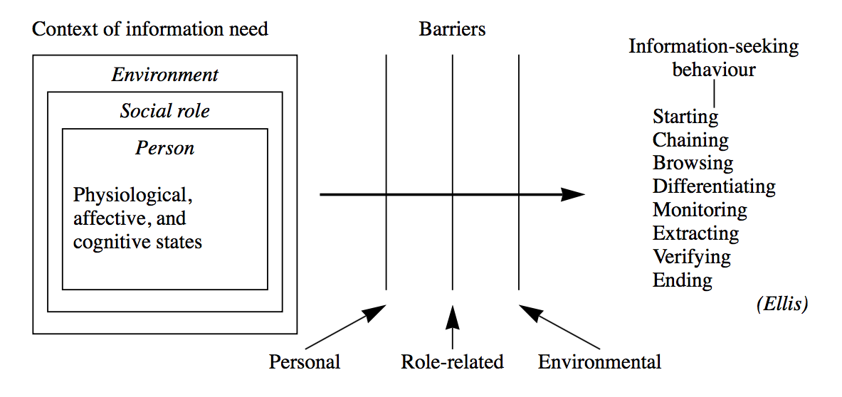

**Wilson’s model of information-seeking behaviour. Adapted from Wilson (1999)**

Much of the study of information-seeking behavior revolves around a single role in a person’s life. Most notably, organizational and management studies often consider only the work role of the people, ignoring their active roles as parents, students, politically engaged citizens, and countless other roles people take on over the course of a single day (Wilson, 2006). As mentioned in the previous section, investigation in a single context is not inherently an exercise in futility, but it is necessary to acknowledge that people might occupy several roles simultaneously and that there is always an array of contexts influencing a task-at-hand. Figure 5 serves as a good illustration of the complexity involved in a seemingly simple act of looking for information using only a single information system.

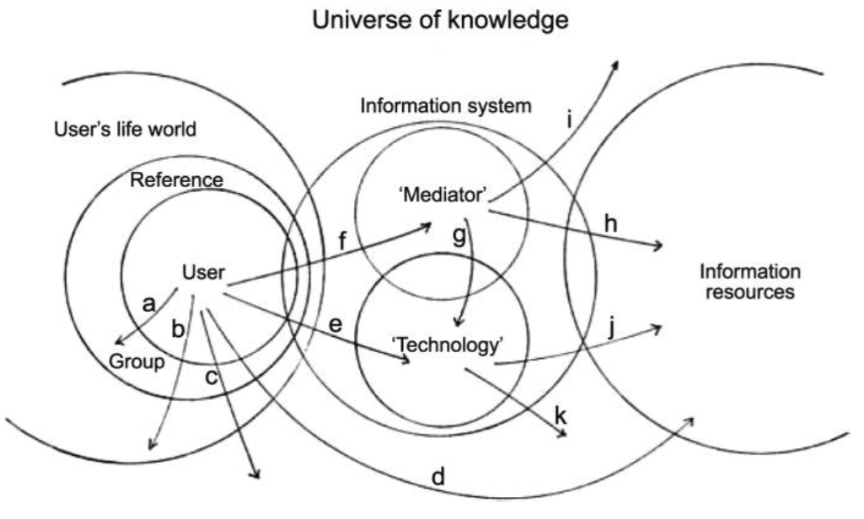

**The context of information seeking. Illustrates a variety of overlapping contexts when using a single information system, arrows show some of the possible search paths. Adapted from Wilson (2006)**

#### Actor

There are various terms used to describe a person interacting with an IS. Librarians call such people patrons. In the corporate context they are sometimes referred to as clients. Undoubtedly, the most widely used term is users. “All these terms include only those who actually use a system and ignore potential users who may also benefit from using it” (Fidel, 2012, p. 4). On the other hand, the term actor implies a sense of agency and shifts the focus from the system to the participant, who has an existence outside of the information system. It highlights the importance of HII taking place in a context(s) of activities. Furthermore, this conceptualization forces us to also consider the nonusers, who may be reluctant to use an IS because their information needs have not been satisfied (Fidel, 2012). The term user is occasionally used throughout the paper to avoid clumsy wording, but generally actor is the preferred term.

### 3.2 Design meets information

*“Overload, clutter, and confusion are not attributes of information, they are failures of design.”*

– Tufte, from an interview in Carmichael, 2011

With the rapid adoption of the World Wide Web in the last two decades, the term “designer” became strongly associated with a small subset of visual design. Today, when we say designer, most people think of a person that builds websites, creates screen-based interfaces, and is concerned primarily with the digital, or print medium. However, design as a craft is much older than the Internet culture would lead us to believe. If taken in its broadest sense, design has always been here, and is in one of the most fundamental human activities. In the words of one of the founding fathers of modern human-centered design:

*All men are designers. All that we do, almost all the time, is design, for design is basic to all human activity. The planning and patterning of any act toward a desired, foreseeable end constitutes the design process. Any attempt to separate design, to make it a thing-by-itself, works counter to the fact that design is the primary underlying matrix of life.*

– Papanek, 1979

{++ assuming? it can be said ++} Historically, there were three types of designers. The do-it-all master generalists, the likes of Leonardo Da Vinci, who have engaged in every conceivable act of creative endeavor. Coming up with innovative solutions to day-to-day problems, and designing new tools, methods, and entire cities for their patrons. Then a more specialized craftsmen, who have mastered the art of design through know-how passed on for generations of family-run businesses. And later through tapping into the collective knowledge of guilds. And lastly, there were everyday “laydesigners”.

Before advances in mass production majority of communities and families have directly participated in the process of designing/building their dwellings and everyday objects around them. “The connection between designer/builder and end-user was direct” (Papanek, 1995, p. 103). Vernacular architecture and design use locally sourced materials and methods to build structures that are designed directly around the needs of people using them. Such structures are more sensitive to a particular context of use and local environment, and are build on *human scale*. This idea is based on respecting natural proportions, stemming from principles of organic and biomorphic design and translating them into man-made system or objects (Papanek, 1983). It is directly opposed to gigantism, and admiration of bigness brought upon by industrial revolution. The concept of human scale was coined by Kohr (1957) in *The Breakdown of Nations* where he applied it to the size of political groupings. This concept was later popularized by Schumacher (1973) who put an economic twist to it in his *Small is Beautiful*. Papanek (1983) outlined a strategy for a sustainable, and honest design in his *Design for Human Scale*. The concept of human scale is revisited later in the paper.

Formalization of design combined with the evermore efficient means of mass production have certainly accelerated technological and cultural progress. But they have also made design inaccessible to a majority of people. Making it a matter of the so-called experts, concentrated in academia and business, not something concerning everyone. Perception and knowledge of design sensible to people’s lives is something that would benefit everyone from earliest stages of their life. Despite that, appreciation for good design is mostly self-taught, or acquired through higher education. This also creates a negative effect in a form of ethnocentrism from a perspective of designers. Artistic expression and newness-for-the-sake-of-newness take primer over utility of the objects they are designing. Design becomes less inclusive, a “game played by an increasingly small elite, with a complete disregard for people” (Papanek, 1983, p. 6). Designing primarily for the constructed needs of a small fraction of population in abundant societies. Often neglecting people with special needs, and those with limited access to conveniences of the modern life. Putting aside a moral issue with such approach, it also deprives us of truly inclusive designs, because “if we […] lump together all the seemingly little minorities […], if we combine all these ‘special’ needs, we find that we have designed for the majority after all” (Papanek, 1972 ,p. 68).

Papanek (1995) illustrates this disconnect between designers and people experiencing their designs on a constellation of people involved in building a house in which an architect/designer never comes in contact with the house occupant (for a diagram see Appendix 1). This can easily be translated to a modern example with design and development activities scattered around various organizational silos. Direct contact with customers happens mostly through customer support and marketing research departments. Solutions are designed for people, not with people.

A traditional design based on a waterfall model(s) begins with designers, is engineered, then marketed and given to the people in the end (see the first diagram in Figure 6). Subsequently, the end-user feedback is incorporated only peripherally after the design has already been completed. This approach neglects the fact that the design process should both begin, and end with people. Papanek (1983) suggests a more iterative design process flowchart (see the second diagram in Figure 6). In his conceptualization the flow starts with people, and is represented with a spiral, rather than a single arc, implying a more dynamic and continuous process with reoccurring feedback loops. Moreover, it acknowledges the changing nature of design by leaving empty spokes for including new design methods that may arise in the future.

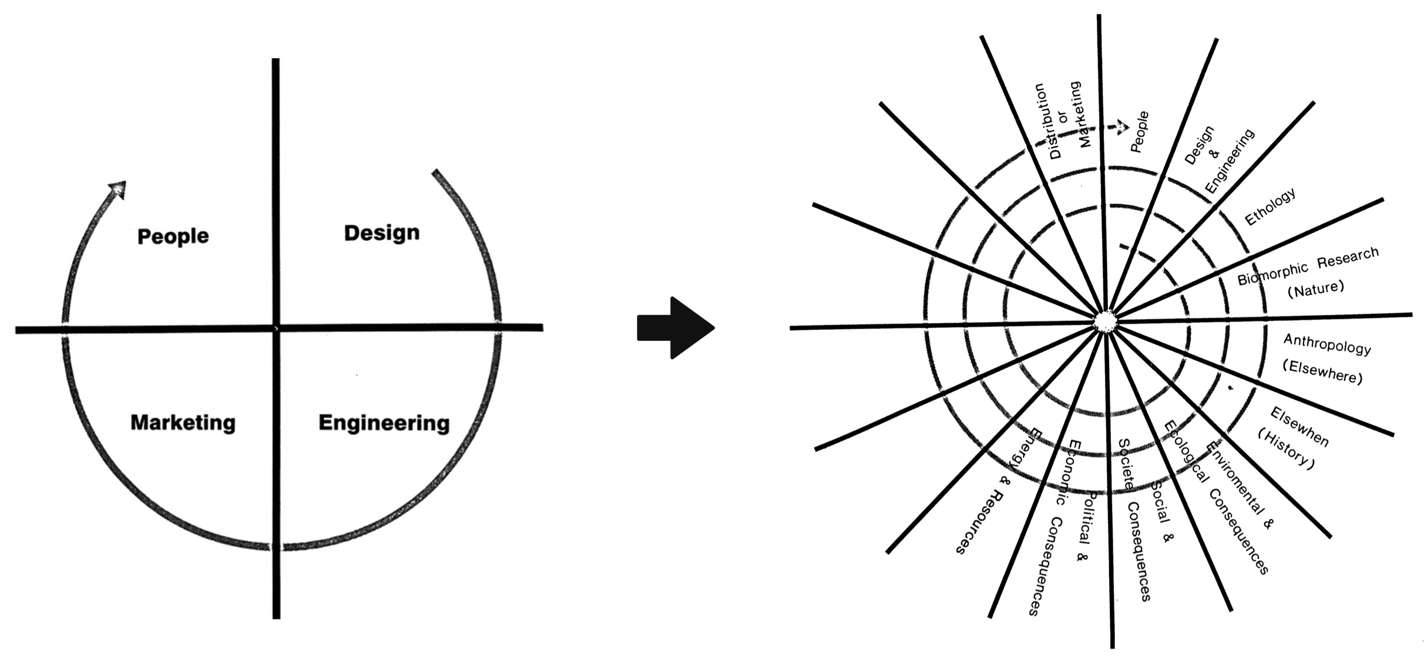

**From static to dynamic design process flowchart. Adapted from Papanek (1983)**

#### Rise of a designer

It was not until 20th century that design started emerging as a stand-alone field. In 1920s Bauhaus established itself as a leading school of thought in design, and continues to have an influence on the field to this day. Bauhaus brought fort a more critical inquiry into the relationship between people and their man-made environment. This school of art was sometimes criticized for prioritizing form over function, and was considered élitist and alienating by some. Nevertheless, it inspired many great designers, and paved the way for a design as a profession in and of itself.

The onset of the World War II has accelerated the technological progress. Countries and organizations pressed for resources have realized the importance of good design, and the benefits of building systems that provide a better human fit. To achieve this the field of industrial designer has emerged. The field gained popularity in part thanks to a celebrity industrial designer Henry Dreyfuss. His work on cars, airplanes, ships, telephones, typewriters, vacuum cleaners, and countless other everyday objects, still surrounds us to this day. Dreyfuss’s *Designing for People* (1955) is considered a classic among industrial designers, and has pushed entire industries to reconsider their approach to design. Dreyfuss was first and foremost a practitioner, primarily concerned with pragmatic aspects of design. Other famous design thinkers include Victor Papanek, R. Buckminster Fuller, and Donald Norman, whose work combines social commentary with foundations of human-centered design.

Industrial design has brought back human element into a world blinded by capabilities of the latest technology. It helped transform crude machinery into more enjoyable systems, that have a higher tolerance for human error, and are more sensitive to the context of use. The primary goal of industrial design is to aid the design of physical affordances of the systems we use. This is achieved through the study of human factors and ergonomics. It tries to answer a question of how to make things more comfortable to use. Because industrial design operates in a relatively well structured environment, the utility and purpose of the objects being designed is often defined in advance. Car is used to get from a point A to a point B. Designers do not have to ponder about the purpose of the car. They just need to make the driving experience as pleasant and hassle-free as possible. Information technology has fundamentally changed this relationship between designers and the purpose of the objects they are designing.

Up to this point, many designers would enter the field from an engineering background. An engineering mindset is well suited for structured, well-defined problems, but not as much in the ever-changing, ephemeral digital world. Wide adoption of personal computers and information technology shifted the focus from physical to cognitive aspects of design. The challenge of design stopped being how to sit a person comfortably in front of a machine. It became a matter of figuring out how to make the machine aid human mental processes. This shift required designers to move away from the compartmentalized physical world, and move into the uncertain realm of human mind, where semantics and pragmatics of information use are not known beforehand (Choo, 2002). Here, the role of a designer is not to simply create an object, but to give it purpose as well. To be able to do so effectively, designers need to build a sense of empathy for the end-user, and familiarize themselves more closely with the context(s) where their designs are being used. Design becomes a much more experimental process, in which designers try to uncover the hidden side of human behavior.

In 1990s, around the time Internet started gaining traction with the general public, a field of HCI emerged. The field was a direct answer to an increasingly ubiquitous access to personal computers. Increasingly complex information systems, required increasingly complex user interfaces. This new field has introduced a more robust methodology for doing ethnographic research in relation to design on information systems. However, it was still rooted in the engineering tradition. As a consequence, solutions were often based on the capabilities of any given system. Packing software with every conceivable feature, and stashing away the complexity behind dropdown menus (Cooley, 2000). It followed the mindset of “build it and they will come”, in which the majority of feedback was collected after the design was already completed. This era of design has produced systems that were usable, but bloated and vastly over proportionate to the everyday task they were supposed to aid. Assumingly, this was in part a consequence of designers focusing on the organizational information systems and office software. Such designs try to incorporate all of the existing organizational processes into the systems, instead of rethink those processes from the ground up.

It took another decade and the Dot-com bubble for designers to radically rethink the way they design information systems. It was the launch of the first Apple iPhone in 2007 that marked the beginning of a new era in design. While resistive touchscreen technology existed in the past, it was iPhone's capacitive touchscreen that brought this type of interaction with digital interfaces to a mainstream use. It represented a radical shift in the way we interact with the content on the screens around us. It removed the need for navigating with mouse and keyboard, which require a certain level of mental abstraction in order to grasp spatial relations, and causality on the screen. Modern touch screens let people interact directly with the content, representing an entirely “different tactile relationship to information” (Andreessen, 2015). This offered designers new possibilities for more immersive experiences, but it also posed a serious constrain, primarily due to much smaller screens, and shorter attention span of the Internet users (Weatherhead, 2014). Out of sudden, designers could not get away with simply hiding functionality in endless menus. As a result, services and tools became much more focused, and appear to be more problem-oriented. *Mobile first* design became a new way to conceptualize digital interfaces. This design mindset, proposed by Wroblewski (2011), suggests that every design should start with a bare minimum of the most important content (mobile screen), and gradually layer complexity for larger screens (desktop).

The new category of touch devices renewed interest of designers in information architecture, which has traditionally been a part of LIS. It has also created a whole new job market for user experience (UX), and user interface (UI) designers. These professions existed in the past, but they were considered exotic in a way, and only the largest organizations could afford to have such specialized personnel. Now, such designers are a necessity for a successful venture. UX design in particular has significantly improved people participation in the design process, and made ethnographic research a priority for many companies. Unfortunately, it often gets conflated with the UI design (Krishna, 2015), putting the focus again on the interface, and the underlying technology, rather than the person using the system. Also, there is now more tooling available to designers than ever before. According to Papanek (1972) designers can become victims of tyranny of absolute choice because “[w]hen everything becomes possible, when all the limitations are gone, design and art can easily become a never-ending search for novelty, until newness-for-the-sake-of-newness becomes the only measure” (p. 42). This pursuit for newness has been most apparent on the Web, with many designers blindly following the current trends, without ever revisiting the core underlying purpose of their designs.

Now, the field is slowly waking up to a new reality of a never-ending flow of data with no prospect of taming it. There are industry calls for more seamless designs, and building things that do not scale (Krishna, 2015; Graham, 2013). Solutions that do not involve screens for the sake of screens, but choose the medium most appropriate for a given context. The more advanced designs can even predict context(s) and adjust their functionality accordingly. Organizations are also trying to switch their focus from technologically-oriented solutions, to a more problem-based ones, by using Agile and Lean methodologies (Klein, 2013).

These newest approaches to design signify an industry-wide paradigm shift. A design independent of the technology, applied “to the media through which information flows” (Jacobson, 2000, p. 2). Focusing on “the continual development of rich interaction techniques and tools to support user’s ability to create and shape external representations of knowledge that ultimately support more effective situation awareness and understanding” (Pirolli, & Russell, 2011, p. 2). The author of this paper, subsumes these new approaches to design in the term *information design*; a young, ill-defined field with little consistency, and consensus across academia. Information design represents a “philosophical shift of privileging the human's interaction with the information, rather the human's interaction with the computer interface” (Albers, 2008, p. 117). It challenges menu-driven interactions (Cooley, 2000), and calls for a more context-specific information systems (Fidel, 2012). The focus is on edification, the process of personal enlightenment. It is a bottom-up approach in which “information designers seek to edify more than persuade, to exchange ideas rather than foist them on us” (Jacobson, 2000, p. 1). The proposed solution presented later on strives to adhere to these principles of information design.

### 3.3 Relevant models

Models in HII research can be divided into three main categories: descriptive, process, and complex. Descriptive models take a form of a simple diagram or a list, as their function is to merely list “the factors and activities involved in the aspects of information behaviour being considered” (Bawden, & Robinson, 2012, p. 193). Process models introduce a certain causality to the study of information behavior by showing an order of phenomena occurring. They are often represented as flow-charts or process diagrams, and are probably most widely used (Bawden, & Robinson, 2012). The most advanced models “introduce a greater degree of context and an increased number of perspectives, and are typically non-linear or multidirectional, rather than having a single sequence of steps” (Bawden, & Robinson, 2012, p. 197). These complex models capture more of the complexity of information behavior, but they are also much harder to apply in a reasonable manner. Due to the scope of the project and lack of sufficient longitudinal data, this paper utilizes the simpler process models, while acknowledging the lower explanatory power of applying these models.

The problem-based nature of the information-seeking behavior fits well with the notion of sense-making—a term commonly encountered in the literature on HCI and HII. It is “framed as the process of forming and working with meaningful representations in order to facilitate insight and subsequent intelligent action” (Pirolli, & Russell, 2011, p. 1). However, it cannot be seen simply as a model of information-seeking behavior, it is, rather, a set of assumptions, theoretical perspectives, and methodological approaches which serve as an overall framework for the study of how people interpret, and make sense of the world around them (Wilson, 1999). This paper utilizes the Dervin’s Sense-Making theory as conceptualized by Wilson (1999), and is illustrated in Figure 7. A situation is set in time and space, and defines the context in which information problem arises. A gap is defined by uncertainty, and represents the difference between the contextual situation and the desired situation. An outcome is the consequence of the Sense-Making process. A bridge is some means of closing the gap between situation and outcome (Wilson, 1999).

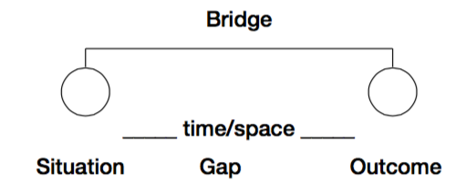

**Dervin’s Sense-Making framework modified. Adapted from Wilson (1999)**

The first model used in the analysis is the “information needs and seeking” conceptualization as proposed by Wilson (2006), and illustrated in Figure 8. This model will be used to investigate the environmental, socio-psychological, and role-based constraints, and will set the actor in a broader context of travel. Information seeking is seen as a way to satisfy more primal needs.

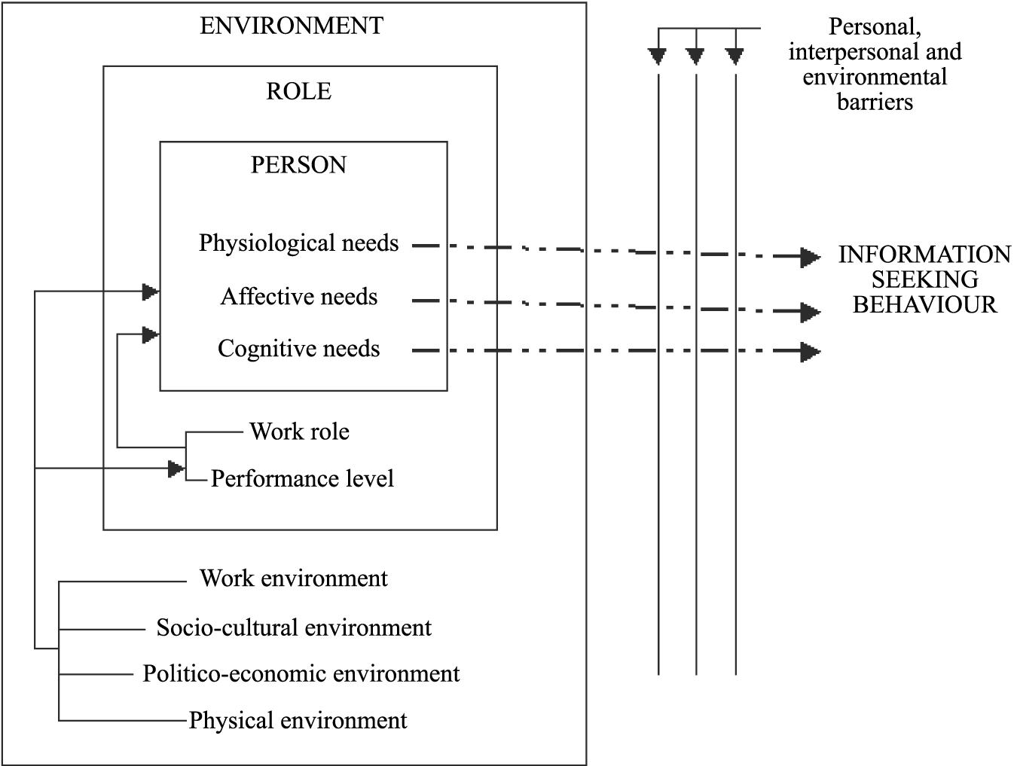

**Information needs and seeking. Adapted from Wilson (2006)**

Second is the “problem solving model of the information seeking and searching process” as proposed by Wilson (1999), and illustrated in Figure 9. This model moves closer to the human mind, and will be used to take a closer look at how an actor uses information to gradually lower uncertainty and reach a solution to a travel-related problem.

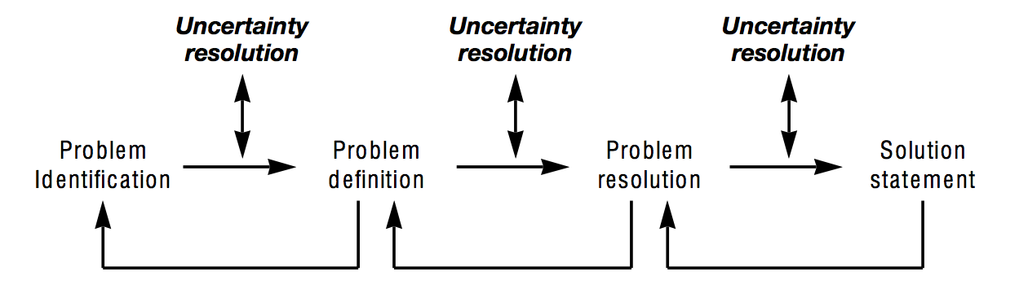

**A problem solving model of the information seeking and searching process. Adapted from Wilson (1999)**

## 4. Methodology

This paper takes a naturalistic, discovery-oriented approach to inquiry which puts “no prior constraints on what the outcomes of the research will be” (Naumer, & Fisher 2007, p. 77). Naturalistic inquiry is holistic and contextual, decoupling research from specific technology, or setting (Naumer, & Fisher 2007). That is not to say, that a specific technology will not be proposed for the design of the IS, or that an actor will not be examined in a specific context. It means that analysis, leading to the specific applications, is informed by a broad range of factors which are not concerned with particularities of travel, or a concrete choice of technology.

The pragmatic nature of the research does not lend itself to traditional research methodologies. Therefore, a Design Science Research Methodology (DSRM) as proposed by Peffers, Rothenberger, Tuunanen, & Chatterjee (2007) is applied. By applying DSRM, this paper does not try to understand reality, but in a tradition of design science it “attempts to create things that serve human purposes” (Peffers et al., 2007, p. 48). The core principle of this methodology is that it must produce an artefact created to address an observed problem. Production of the artefact is only a third step in the DSRM process. The subsequent demonstration, evaluation, and communication are an integral part of an iterative process to develop and design a satisfactory IS. However, given the scope of this research, the last three stages are omitted, and the focus is solely on the first three stages. These stages are (in the order they occur in):

Problem identification and motivation. Defining the research problem and justifying the value of designing a solution to that problem. Define the objectives for a solution. Infer objectives of the IS on which the appropriateness of the designed artifact will be judged. This stage requires knowledge of the state of the problem, and current solutions and their efficacy. Design and development. Creating an artefact which can take various forms. Conceptually, it can be any designed object in which a research contribution is embedded in the design.

The stages relevant for the purposes of this paper are highlighted in Figure 9, together with a problem-centered point of entry.

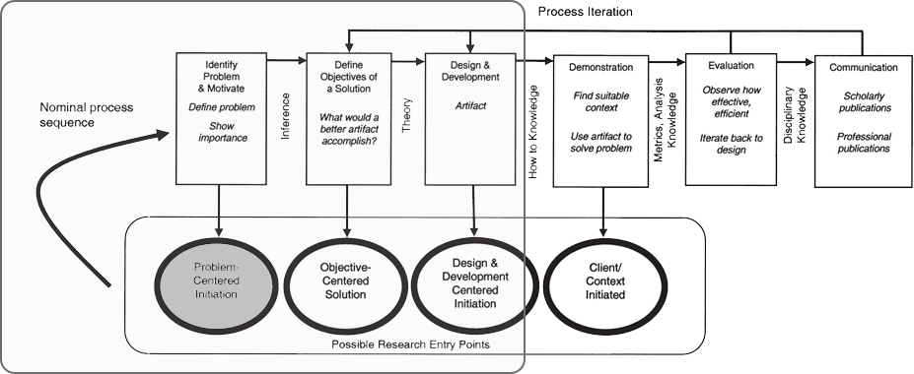

**DSRM Process Model. Model with a highlighted area of interest and point of entry. Adapted and modified from Peffers et al. (2007)**

### 4.1 Data collection

This paper represents the initial stage of a more long-term project to design a knowledge-sharing platform for travellers. The primary goal of the research presented here is to set a solid theoretical framework for future research. Therefore, primary data utilized in this paper is based on an existing research into human-centered approaches to IS design. This primary data is supplemented with secondary, empirical data based on exploratory interviews and an online questionnaire. The naturalistic and pragmatic approach to the inquiry naturally lends itself to qualitative data. Quantitative data is seen as way to objectify a complex reality and is deemed unsuitable for the purposes of this research.

The first set of empirical data was collected through an unstructured, exploratory interviews with students at the premises of Copenhagen Business School in Copenhagen, Denmark. A total of six people were interviewed, three individually, and three as a part of a group conversation. There were no assumptions or hypothesis prior to these interviews. The purpose was to get an overall idea of how people perceive their habits when it comes to finding information when travelling. Certain commonalities were identified, which served as foundation for creating an online questionnaire. Since the goal was to obtain qualitative data, the questionnaire was comprising of a very small number of open-ended questions. The questionnaire utilized a “logical jumps” feature, which determined the type of questions being asked based on the answer from the first question. By dividing the questionnaire into several logical branches, it was possible to have questions that asked the respondents to compare and contrast the different methods they use to look for travel-related information (the shortest path comprised of two questions, the longest of six). The design of the questionnaire relied heavily on people’s willingness to type out their answers, so there were instances where the respondents skipped all the open-ended questions and answered only the first one, used to determine which logical branch to present. However, the majority of respondents filled out all the questions, some with simple keywords, others with concise paragraphs of text. There was a total of 31 respondents, with an average of 6 minutes and 1 second spent on completing the questionnaire. To the author’s own surprise, the quality of the obtained data was relatively high. The commonalities identified in the initial interviews were further established and expanded on, and new ones were identified.