**No Persister for:**

If mapping file properties are set wrong following error occurs.

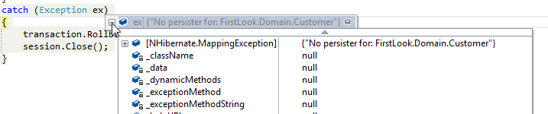

Mapping files should be selected as Embedded Resource

