**No Persister for:**

If hibernate.cfg.xml is configured wrong following error occurs.

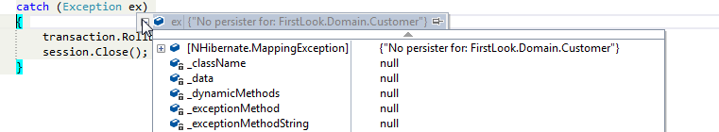

Mapping tag should be defined in the configuration file.

