Supplementary Materials
Comprehensive Pan-Cancer Analysis of Somatic Mutations in Core Circadian Clock Genes

Supplementary Figure S1
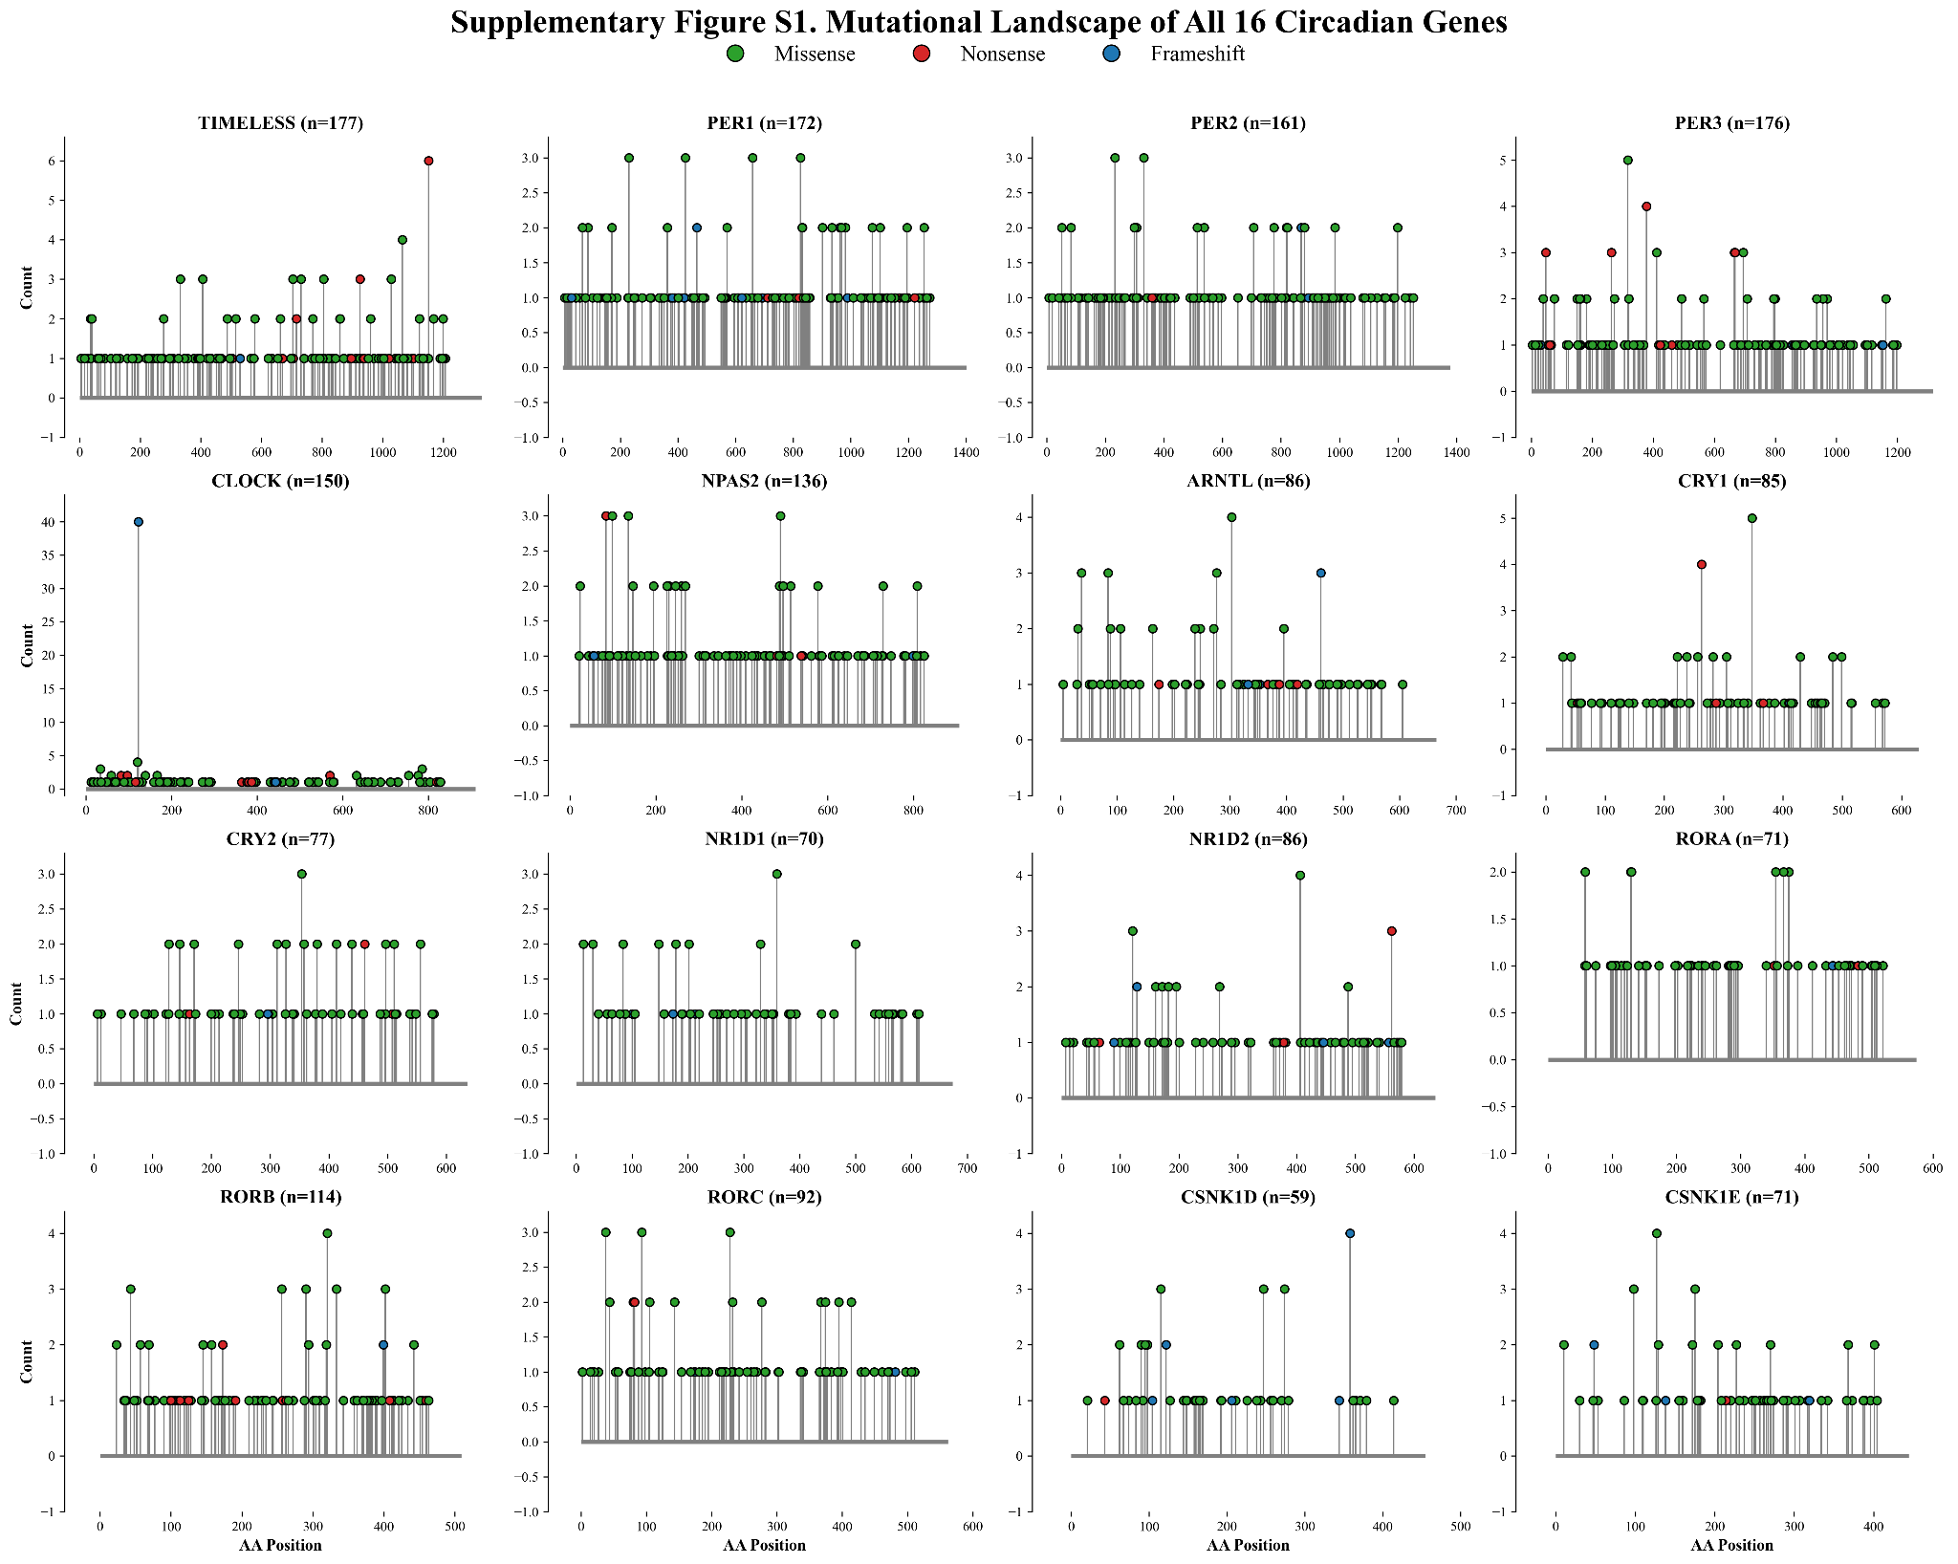
Figure S1. Comprehensive mutational landscapes across all 16 core circadian clock genes. High-resolution multi-panel lollipop representations depicting the positional distribution, protein domain localization, and variant classifications across the entire primaryTTFL network (ARNTL, CLOCK, NPAS2, CRY1, CRY2, PER1, PER2, PER3), accessory regulatory feedback loop (NR1D1, NR1D2, RORA, RORB, RORC), casein kinase regulators (CSNK1D, CSNK1E), and TIMELESS. Colored markers denote functional classes (green: missense mutations; black: nonsense/truncating; red: frameshift indels; purple: splice-site).

Supplementary Table S1
Table S1. Comprehensive catalog of 1,532 somatic missense variants and in silico pathogenicity predictions across 16 circadian clock genes. Due to large size (1,532 rows and 18 annotation columns), the complete catalog is provided in the accompanying master workbook: "Supplementary_Table_S1_1532_Missense_Variants.xlsx" (also in Sheet 1 of "Supplementary_Tables_S1_S2_S3_Complete.xlsx"). Below is an illustrative preview of the first 10 representative high-confidence variants.
Gene | Cohort | HGVSp | HGVSc | Transcript ID | SIFT | PolyPhen-2 | High-Conf.
CRY2 | STAD | p.V102M | c.304G>A | ENST00000616080 | deleterious | possibly_damaging | Yes
CRY1 | STAD | p.N312T | c.935A>C | ENST00000008527 | deleterious | probably_damaging | Yes
NPAS2 | GBM | p.F132V | c.394T>G | ENST00000335681 | deleterious | probably_damaging | Yes
RORB | GBM | p.A106V | c.317C>T | ENST00000396204 | deleterious | probably_damaging | Yes
CRY2 | GBM | p.L405M | c.1213C>A | ENST00000616080 | deleterious | probably_damaging | Yes
RORB | PAAD | p.A371T | c.1111G>A | ENST00000396204 | deleterious | probably_damaging | Yes
CRY1 | SKCM | p.R220C | c.658C>T | ENST00000008527 | deleterious | probably_damaging | Yes
TIMELESS | UCEC | p.L269P | c.806T>C | ENST00000553532 | deleterious | probably_damaging | Yes
TIMELESS | UCEC | p.R860C | c.2578C>T | ENST00000553532 | deleterious | probably_damaging | Yes
PER3 | OV | p.T566I | c.1697C>T | ENST00000361923 | deleterious | possibly_damaging | Yes

Supplementary Table S2
Table S2. Functional domain localization and pathogenicity scores of recurrent hotspot and critical regulatory site variants. Detailed in silico evaluations and structural domain mappings for recurrent variants (n >= 3), recurrent high-confidence mutations, and conserved functional site alterations (including CRY1 p.N312T and CRY2 p.V102M). Full tabular dataset available in "Supplementary_Table_S2_Functional_and_Recurrent_Variants.xlsx".
Gene | HGVSp | Count (n) | Protein Domain | SIFT | PolyPhen-2 | Cancer Cohorts
PER3 | p.R316C | 5 | PAS-B / Casein kinase binding region | deleterious | probably_damaging | SKCM
CLOCK | p.G120V | 4 | Basic Helix-Loop-Helix (bHLH) DNA-binding domain | deleterious | probably_damaging | BRCA, COAD, UCEC
CRY1 | p.R348C | 4 | DNA Photolyase / FAD-binding domain | deleterious | possibly_damaging | COAD, UCEC
CSNK1E | p.R127W | 4 | Protein Kinase Catalytic Domain (active site loop) | deleterious_low_confidence | probably_damaging | COAD, SKCM, UCEC
NR1D2 | p.S406L | 4 | Nuclear Hormone Receptor Ligand-Binding Domain (LBD) | deleterious | possibly_damaging | COAD, SKCM
ARNTL | p.E303K | 3 | PAS-B dimerization domain | tolerated | benign | COAD, UCEC
ARNTL | p.R37H | 3 | bHLH DNA-binding domain | deleterious | possibly_damaging | COAD, READ
CLOCK | p.A34V | 3 | N-terminal bHLH upstream regulatory segment | deleterious | benign | STAD, UCEC
CLOCK | p.F785L | 3 | C-terminal transactivation domain (TAD) | tolerated | benign | CESC, COAD
CRY2 | p.T354A | 3 | FAD-binding pocket | deleterious | probably_damaging | COAD, LUAD
CSNK1D | p.E247K | 3 | Kinase domain regulatory activation segment | deleterious_low_confidence | probably_damaging | READ, UCEC
CSNK1D | p.R115H | 3 | Kinase catalytic core domain | deleterious_low_confidence | probably_damaging | COAD, HNSC, UCEC
CSNK1D | p.R274Q | 3 | Kinase domain C-terminal lobe | deleterious_low_confidence | possibly_damaging | COAD, UCEC
CSNK1E | p.R98H | 3 | Kinase domain substrate-recognition interface | deleterious_low_confidence | probably_damaging | LUAD, OV, STAD
NPAS2 | p.A490T | 3 | PAC (PAS-associated C-terminal) motif | tolerated | benign | COAD, UCEC
NPAS2 | p.A99T | 3 | bHLH adjacent basic region | deleterious | possibly_damaging | CESC, COAD, READ
NPAS2 | p.Q136R | 3 | bHLH DNA-binding domain | tolerated | benign | OV
NR1D2 | p.E121K | 3 | CDD:cd07166 | deleterious | probably_damaging | COAD, UCEC
PER1 | p.T659I | 3 | Casein kinase phosphorylation cluster | deleterious | benign | LIHC
PER2 | p.R331I | 3 | PAS-B dimerization interface | deleterious | probably_damaging | UCEC, UCS
RORC | p.A93V | 3 | Zinc finger C4-type DNA-binding domain | deleterious | probably_damaging | COAD, PAAD, UCEC
TIMELESS | p.E805K | 3 | Central helical core domain | deleterious | possibly_damaging | CESC, HNSC, UCEC
TIMELESS | p.R1065C | 3 | C-terminal TIPIN-interaction domain | tolerated | possibly_damaging | COAD, UCEC
TIMELESS | p.R406C | 3 | TIMELESS PARP1-binding regulatory domain | deleterious | probably_damaging | SKCM, STAD, UCEC
TIMELESS | p.R731W | 3 | Central helical repeat domain | deleterious | probably_damaging | COAD
ARNTL | p.F247L | 2 | Gene3D:3.30.450.20 | deleterious | probably_damaging | COAD
ARNTL | p.K271N | 2 | Gene3D:3.30.450.20 | deleterious | probably_damaging | COAD
ARNTL | p.M88I | 2 | Gene3D:4.10.280.10 | deleterious | probably_damaging | COAD

Supplementary Table S3
Table S3. Pairwise statistical analysis of gene-gene co-occurrence and mutual exclusivity patterns across 16 circadian genes. Two-sided Fisher’s exact test evaluations and Benjamini-Hochberg false discovery rate (FDR) adjustments for all 120 pairwise combinations. Statistically significant co-occurring gene pairs (FDR q < 0.05) are highlighted. Full dataset available in "Supplementary_Table_S3_Gene_Interactions_CoOccurrence.xlsx".
Gene A | Gene B | Both (n) | Odds Ratio | Log2 OR | P-value | FDR q-value | Tendency
ARNTL | PER3 | 35 | 3.29 | 1.72 | 5.03e-07 | 6.03e-05 | Co-occurrence
CRY2 | PER3 | 30 | 2.82 | 1.49 | 4.01e-05 | 1.87e-03 | Co-occurrence
ARNTL | RORA | 24 | 3.06 | 1.61 | 4.67e-05 | 1.87e-03 | Co-occurrence
ARNTL | NR1D2 | 20 | 3.26 | 1.71 | 6.37e-05 | 1.91e-03 | Co-occurrence
ARNTL | RORB | 26 | 2.80 | 1.49 | 8.78e-05 | 2.11e-03 | Co-occurrence
ARNTL | CSNK1D | 16 | 3.44 | 1.78 | 1.73e-04 | 3.14e-03 | Co-occurrence
ARNTL | NPAS2 | 27 | 2.59 | 1.38 | 1.94e-04 | 3.14e-03 | Co-occurrence
ARNTL | CRY1 | 19 | 3.02 | 1.60 | 2.09e-04 | 3.14e-03 | Co-occurrence
CRY1 | CSNK1D | 15 | 3.33 | 1.74 | 3.44e-04 | 4.29e-03 | Co-occurrence
NR1D2 | PER3 | 28 | 2.44 | 1.29 | 3.58e-04 | 4.29e-03 | Co-occurrence
CLOCK | NR1D2 | 24 | 2.54 | 1.34 | 5.82e-04 | 5.91e-03 | Co-occurrence
CSNK1D | NR1D1 | 13 | 3.44 | 1.78 | 5.91e-04 | 5.91e-03 | Co-occurrence
PER1 | PER3 | 43 | 1.97 | 0.98 | 1.05e-03 | 9.72e-03 | Co-occurrence
CSNK1D | NR1D2 | 14 | 3.02 | 1.60 | 1.16e-03 | 9.90e-03 | Co-occurrence
CSNK1E | PER2 | 23 | 2.38 | 1.25 | 1.26e-03 | 1.00e-02 | Co-occurrence
NR1D2 | PER2 | 25 | 2.29 | 1.19 | 1.34e-03 | 1.00e-02 | Co-occurrence
ARNTL | CLOCK | 24 | 2.37 | 1.25 | 1.43e-03 | 1.01e-02 | Co-occurrence
NPAS2 | PER2 | 37 | 2.01 | 1.00 | 1.53e-03 | 1.02e-02 | Co-occurrence
CSNK1D | RORB | 18 | 2.58 | 1.37 | 2.30e-03 | 1.45e-02 | Co-occurrence
ARNTL | PER1 | 26 | 2.15 | 1.10 | 3.10e-03 | 1.83e-02 | Co-occurrence
PER3 | RORB | 35 | 1.90 | 0.92 | 3.35e-03 | 1.83e-02 | Co-occurrence
NPAS2 | PER3 | 38 | 1.86 | 0.90 | 3.35e-03 | 1.83e-02 | Co-occurrence
CRY1 | PER2 | 24 | 2.15 | 1.10 | 3.57e-03 | 1.86e-02 | Co-occurrence
PER3 | RORA | 31 | 1.97 | 0.98 | 3.74e-03 | 1.87e-02 | Co-occurrence
PER2 | RORA | 29 | 1.99 | 0.99 | 4.17e-03 | 2.00e-02 | Co-occurrence

