- First of all after the implementing codes(Driver.py,ShortestPath.py and Form1.py) in IDE. We can press Run button of IDE(Spyder, PyCharm etc..)

- In the First Figure, I tried to show how we add nodes. (we are adding node with add node button, then Graph will started to show up.

- After the put our map into program we can press RUN button. In default source will begin with ‘0’ node. Unfortunately, I could find Shortest Path algorithm with destination. So, Destination will not work in this project.
- After the press run button we can we answers.

  - First answer related with destination for each nodes form source
  - Second answer related with path or visited adress to go.

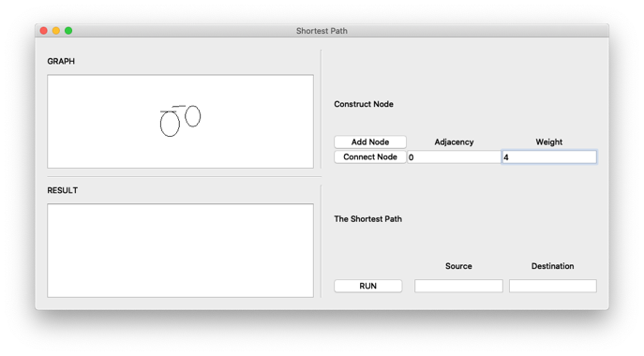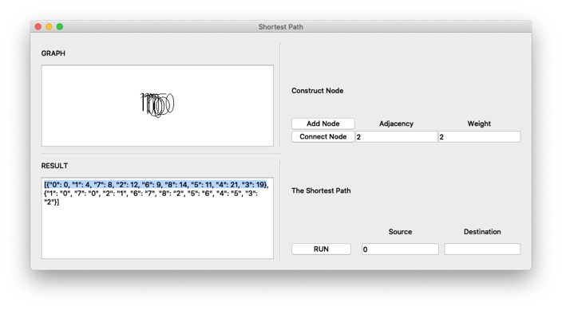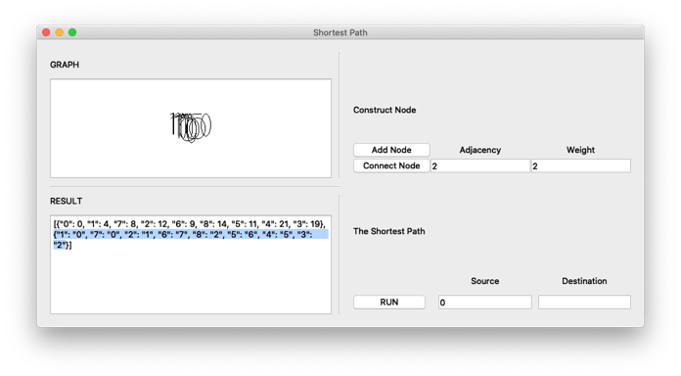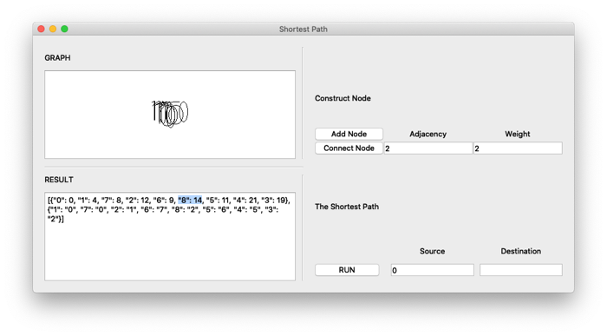

In the Last picture (Right Bottom) We can see the result. We can see the result works properly. However, I couldn’t arrange node position (visualizing) because of time.

Ps: I’m using MacOS X system because of this Doxygen do not work properly. So I want to share code in here.
