DATA ANALYSIS REPORT

Overview

This analysis is about a free to play mobile game refers to an experiment to determine according to some gaming industry performance indicators whether the in-game shop serves the purpose as is or new strategy needs to be placed to improve the revenue performance of the game.

Currently shop menu appears after the players play at least 2 matches which needs to be compare to other timings. Bear in mind showing the shop too early might distract to players and can make negative effect on players but also shop needs to be appear on best point in time during the players gaming experience in order to increase the in-game shopping performance.

Approach

In order to reach best decision on shop appearance timing, a test has been conducted on a new released game. During a 15-day period, all of the new players were divided into three fairly equally sized test groups:

* control_group had access to the shop after playing 2 matches.
* test_group_a had access to the shop after playing 4 matches.
* test_group_b always had access to the shop, regardless of the number of matches played.

Data

Data has been collected from approximately 108K players showing us mainly their first activity date, how many matches played when, how much they spend between 1st of May 2020 and 15th of May 2020 and which test group are they belong to.

If we look at the test results in fallowing figures.

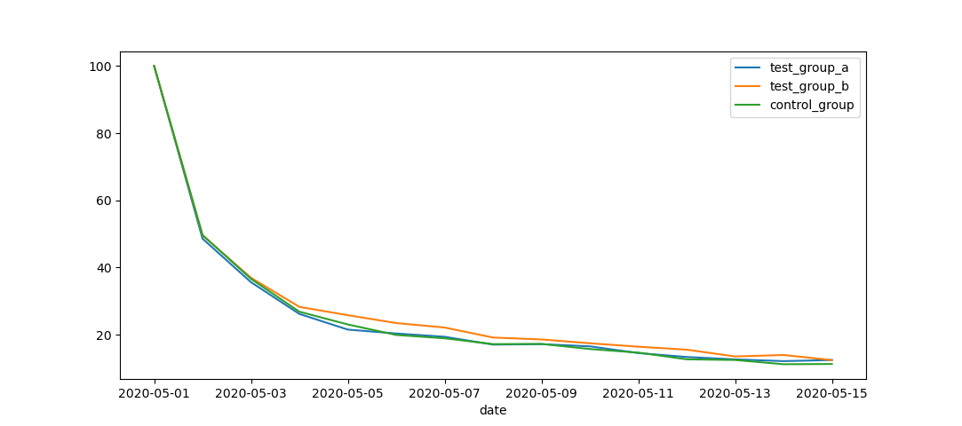

Figure 1-Retention Rate Measure

Figure 1 shows the players retention rate which means the percentage of users who played the game N days after their Acquisition. Test_group_b retention rate looks slightly better than other two for he period of 15 days but on the 15th exact Retention rates are Test_group_a=12.43 Test_group_b=12.42 and Control_group=11.25

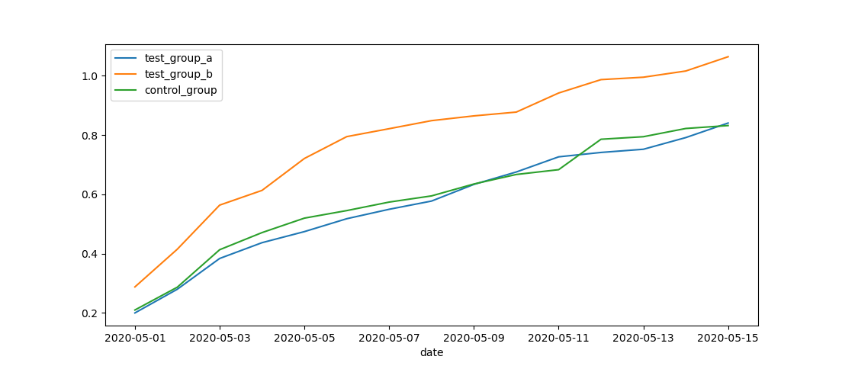

Figure 2-Cumulative ARPU Measure

Figure 2 shows the Cumulative ARPU metric measures how much revenue comes from each user N days after the players started playing the game. Test_group_b is the best performer at all time. Exact figures in GBP at the 15th are Test_group_a=0.84, Test_group_b=1.06 and Control_Group=0.83

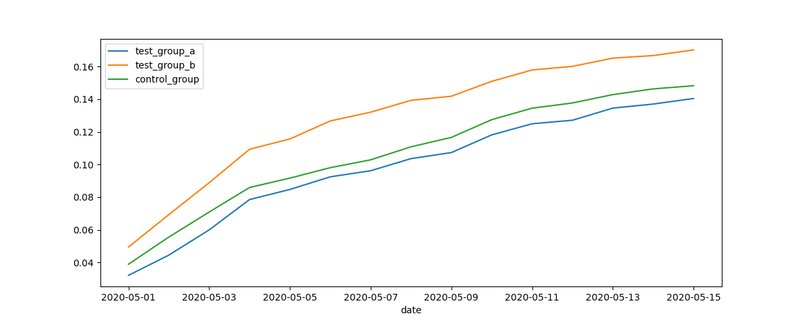

Figure 3-Cumulative Conversion Rate Measure

Figure 3 is the number of users who made a purchase in the game at some point between their Acquisition Date and N days after within 15 days testing period. Again, the winner is the orange team Test_group_b. On the 15th Test_group_a=0.14, Test_group_b=0.17 and Control_group=0.14

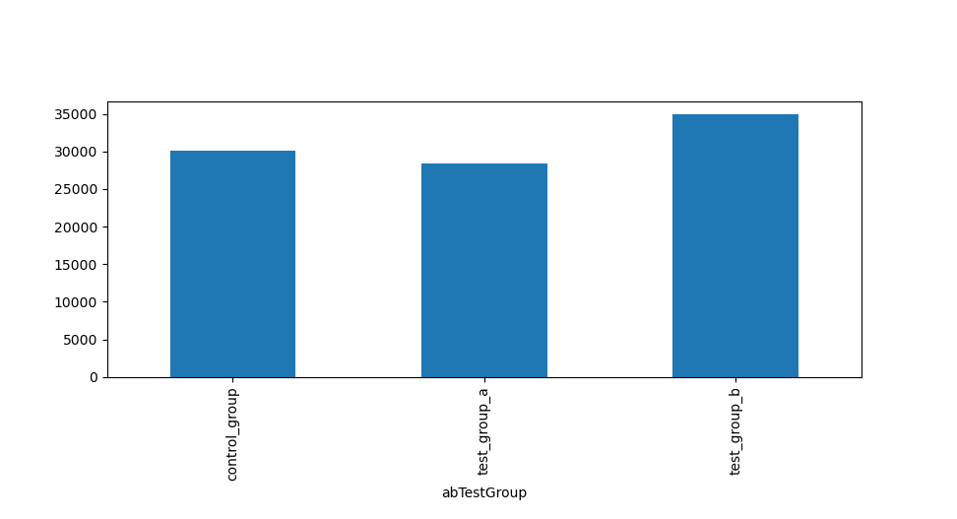

Figure 4 Total Revenue

Figure 4 is the total revenue per test group in GBP. Players in test_group_b looks like spent most in total.

Conclusion

According to above data findings with the visualized statistical evidences shows that “Test_group_b” where the in-game shop available at all time for the players is the best group in terms of keeping users playing the game, making the shop attractive with the end goal of improving the average revenue per user.

Current in game shop appearance timing strategy should be re-visited and this parameter should be tuned to improve chances of players to make purchase.