SMART BARBER BOOKING SYSTEM PROJECT REPORT

Prepared By:
Tolga Ertunç B2280.060052,
İlke Görkem Şahin B2180.060042.

1. Executive Summary
Smart Barber Booking System is a cloud-based, AI-assisted reservation and shop-management platform that digitizes barbershop appointment handling. It targets common operational inefficiencies such as heavy phone traffic, manual scheduling errors, double bookings, and customer no-shows by providing a self-service booking experience and automated communications.
During the analysis phase, three recurring pain points were identified: peak-hour phone traffic (up to ~60% missed calls), paper-based record confusion leading to double bookings (~15% conflict rate), and missed appointments due to lack of reminders (~30% no-show rate).
Key capabilities include:
• 24/7 online booking with conflict prevention to avoid double-booking.
• Automated SMS/email notifications and reminders to reduce no-shows.
• Admin dashboard for appointment oversight and basic revenue/expense tracking.
• AI-powered hairstyle preview module leveraging Python-based image processing.
Expected impact (projected) includes:
• Up to 60% fewer no-shows through automated reminders.
• Zero scheduling conflicts by enforcing a single source of truth for time slots.
• Operational efficiency gains of ~2 hours/day by reducing manual phone/admin workload.
• Approx. $15,000 additional annual revenue with an estimated break-even within ~6 months.
The solution follows an N-Tier architecture with a .NET Web API backend, a React 18 web client, and a PostgreSQL database, with containerized deployment planned via Docker. Development was organized using Agile/Scrum in iterative sprints to enable continuous feedback and incremental delivery.

2. Product Description and Vision
Smart Barber Booking System is an AI-powered reservation and management platform designed to digitize traditional barbershop appointment processes.
2.1. Current Challenges
Phone Traffic: Businesses struggle to manage appointments via phone during peak hours (60% missed call rate).
Manual Errors: Confusion with paper-based records leads to double bookings (15% conflict rate).
No-Shows: A lack of automated reminders results in customers missing appointments (30% rate).
2.2. Proposed Solution
A Cloud-based system that allows customers to book 24/7, preview hairstyles using AI, and enables business owners to track all revenue/expense flows via a dashboard.
2.3. Product Vision
The long-term vision is to provide a digital operating layer for small and mid-sized barbershops: a reliable booking engine, consistent customer communication, and actionable operational visibility in a single platform.
In the near term, the product prioritizes conflict-free scheduling, automated reminders, and a practical AI hairstyle preview to improve customer decision-making. Over time, the platform can evolve toward multi-branch support and modular integrations (e.g., payments, loyalty, analytics, and staffing) while maintaining a lightweight experience suitable for small businesses.
2.4. Delivery Approach (Agile/Scrum)
To ensure a structured and flexible development process, the Agile Software Development methodology, specifically the Scrum framework, was adopted. This approach allowed for iterative development, continuous feedback, and rapid adaptation to changes.
Iterative Development: The project was divided into 4 major sprints (2 weeks each), focusing on specific modules like Authentication, Booking Logic, and AI Integration sequentially.
Version Control: Git and GitHub were used for source code management, utilizing a feature-branch workflow to ensure code stability before merging into the main branch.
Project Management: Tools like Jira were employed to track tasks, bugs, and backlog items.
CI/CD: Docker were planned to ensure seamless integration of new features without disrupting the live environment.

3. Core Features and Capabilities
This section summarizes the system’s primary product capabilities (functional features) and supporting quality attributes (non-functional capabilities).
3.1. Core Features (Functional Capabilities)
ID | Requirements | Description
FR-01 | User Registration | Customers must be able to register using email and phone numbers.
FR-02 | Appointment Booking | Customers must be able to create an appointment by selecting staff, service, date, and time.
FR-03 | AI Style Preview | Customers must be able to upload photos and see hairstyle previews on their own faces using AI.
FR-04 | Payment Integration | Secure payments must be accepted through the system.
FR-05 | Notification System | Automated SMS/Email must be sent for appointment confirmations and reminders.
FR-06 | Admin Dashboard | Business owners must be able to manage staff, services, and daily revenue from the panel.

3.2. Non-Functional Capabilities (Quality Attributes)
ID | Requirements | Description
NFR-01 | Performance | API response time must be under 200ms under normal load.
NFR-02 | Security | All data transfer must occur over HTTPS; passwords must be hashed..
NFR-03 | Scalability | The system must run on Docker containers and be scalable as load increases.
NFR-04 | Compliance | Personal data and photos must be processed according to GDPR/KVKK standards and deleted after 24 hours.

4. Technical Architecture and Infrastructure
4.1. Architecture Overview
The solution follows an N-Tier architecture: a React client for customer and business workflows, a .NET Web API backend for business logic, and PostgreSQL as the primary system-of-record. Background work (notifications and AI preview processing) is handled asynchronously, with Redis supporting queueing/caching where needed. The platform is designed to be cloud-ready and containerized for repeatable deployment.
4.2. Database Schema
User: User identity information and contact details.
Appointment: Appointment time, status, and related services.
Ai Preview: Temporarily stored processed photos.
Employee & Service: Barber and service definitions.

4.3. System Data Flow
The following structure outlines the high-level data flow and interaction between the user, the core system, and the database layers:
2. User Interaction Layer (Client Side)
Initiates booking requests via the mobile/web interface.
Uploads source photos for the AI Hairstyle Preview feature.
Completes secure transactions for payments.
3. Smart Barber Core System (Application Layer)
Processes incoming appointment requests and checks for conflicts.
Executes the AI Engine to process uploaded images.
Triggers the Notification Service for status updates.
4. Data Storage Layer (PostgreSQL Database)
Stores user profiles and authentication data.
Persists appointment records and status history.
Manages barber schedules, service lists, and pricing configurations.
5. External Services (Notification Layer)
Receives triggers from the Core System to send confirmation emails and appointment reminders to users.
4.4. System Architecture and Flow
4.4.1. Use Case Diagram
The system is built on three main actors: Customer, Barber, and Admin. The Customer focuses on Booking and AI Preview, while the Admin focuses on Business Stats and Staff Management.
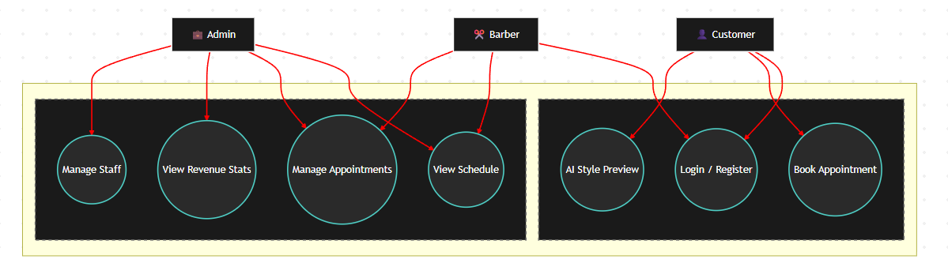
The Use Case Diagram above visualizes the functional requirements and the interaction between the system's primary actors and its modules.
The architecture is divided into two distinct subsystems: the Customer App for end-users and the Business Dashboard for internal management.
Customer: This actor interacts with the client-facing application to perform core tasks such as User Registration, Booking Appointments, and utilizing the AI Style Preview feature to visualize hairstyles before visiting the shop.
Barber: Staff members utilize the dashboard primarily for operational efficiency, specifically to View Schedules and Manage Appointments assigned to them.
Admin: The business owner has elevated privileges within the dashboard. In addition to standard appointment management, the Admin is responsible for Managing Staff profiles and monitoring business health through Revenue Stats.
This separation of concerns ensures that sensitive business data is accessible only to authorized personnel while providing a streamlined experience for customers.

4.4.2. Data Flow
- Client: Requests are sent via the React mobile/web app.
- API Gateway: Receives requests and handles security.
- Business Logic: .NET Core service executes business rules.
- Database: PostgreSQL persistently stores data.
- Async Jobs: Redis and Background Workers queue notifications and AI tasks.

4.4.3. Sequence Diagram
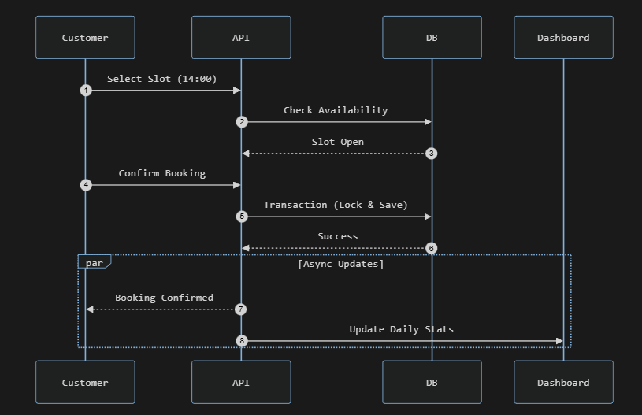

The sequence diagram above illustrates the real-time interaction required for a successful appointment booking:
When a user selects a time, the API queries the WorkingHours table to verify availability. The database performs a transaction lock on the selected row to prevent double-booking during the confirmation process. Once the booking is persisted in the database, the system triggers asynchronous events to send a confirmation email to the customer and update the Admin Dashboard stats via Socket.io.

5. Technology Stack
The platform uses a web-first stack with a dedicated API backend and supporting services for AI preview and asynchronous tasks:
Frontend: React 18, Tailwind CSS
Backend: .NET Web API (C#)
AI Service: Google Nano Banana API (Image Processing)
Database: PostgreSQL; Redis (caching / background jobs)
DevOps & Tooling: Docker (containerization), Git/GitHub, Jira

6. Security Architecture
Security is designed around HTTPS transport, JWT-based authentication, and separation between customer and business-facing access.
6.1. Authentication and Session Management
Users authenticate via the /api/auth/* endpoints. After login, the backend issues a JWT token which is required for protected requests.
6.2. Transport and Network Security
All data transfer is enforced over HTTPS.
6.3. Credential and Data Protection
Passwords are stored as hashed values. User profiles and appointment data are persisted in PostgreSQL, with backend-only access.
6.4. Privacy and Compliance
Personal data and photos are handled according to GDPR/KVKK requirements, and AI preview photos are deleted after 24 hours.
6.5. Authorization (High-Level)
Customer, Barber/Staff, Manager, and Admin capabilities are separated. Detailed RBAC and clearance rules are defined in Sections 7 and 8.

7. Role and Authorization Management Model
The system uses a Role-Based Access Control (RBAC) approach to ensure that each user can only access the features and data required for their responsibilities. Authorization is enforced at the API layer using JWT claims and server-side checks (least privilege by default).
7.1. Role Definitions
• Guest (unauthenticated): Can browse public pages and view available services/time slots.
• Customer: Can register/login, create and manage their own appointments, and use the AI style preview for their own uploads.
• Barber/Staff: Can view assigned schedules, see upcoming appointments, and update appointment status within their shop scope.
• Shop Owner/Manager: Can manage staff schedules, shop availability, pricing/services, and view shop-level statistics.
• System Admin: Can access administrative endpoints, perform configuration tasks, and view aggregated system metrics.
7.2. Permission Model (RBAC + Resource Scoping)
In addition to role checks, the backend applies resource scoping rules to prevent cross-user and cross-shop access. Requests are evaluated using (1) the role in the JWT and (2) ownership/scope fields such as userId and shopId.
• Self-scoped resources: Customers can only read/update their own profile and their own appointments.
• Shop-scoped resources: Staff and managers can only access appointments and schedules belonging to their shopId.
• Admin resources: System-wide endpoints (e.g., system configuration) are restricted to the System Admin role.
7.3. JWT Claims and Identity Context
After authentication, the backend issues a JWT used for protected requests. Authorization decisions are derived from token claims and validated server-side.
• sub / userId: Unique user identifier used for ownership checks.
• role: Customer, Staff, Manager, or Admin (drives RBAC checks).
• shopId (if applicable): Associates staff/manager accounts to a specific barbershop scope.
• exp / iat: Token lifetime and issuance time for session control.
7.4. Enforcement and Controls
• Controller-level protection: Protected endpoints require valid JWT and appropriate roles/policies.
• Server-side scope checks: Even if a user can call an endpoint, the backend verifies ownership/shop scope before returning data.
• Auditability: Security-relevant actions (login attempts, schedule updates, appointment cancellations) are logged for traceability.

8. Clearance Level System
Clearance levels classify operations and data by sensitivity. This provides an additional control layer, ensuring that higher-risk actions (e.g., access to PII or AI photo artifacts) are limited to appropriately trusted roles and scopes.
8.1. Clearance Levels
Level | Label | Typical roles | Allowed data/actions (examples)
0 | Public | Guest | View public info (services, shop location/hours), browse available time slots.
1 | Personal | Customer | Manage own profile and appointments, upload selfie and view own AI previews.
2 | Operational | Staff / Manager | View shop-scoped appointment queue, update appointment status, manage staff schedules (manager).
3 | Administrative | System Admin | System configuration, global monitoring and metrics, security review, and operational overrides (restricted).
8.2. Mapping Roles to Clearance
• Customer: Level 1 access for personal booking data and self-owned uploads.
• Barber/Staff: Level 2 access within shop scope for operational data (appointments, schedules).
• Shop Owner/Manager: Level 2–3 access within shop scope, including reporting and staff management features.
• System Admin: Level 3 access for system-wide configuration and aggregated metrics.
8.3. Handling of Sensitive Data
• AI photos: Stored temporarily for processing and deleted automatically within 24 hours.
• PII minimization: Only required customer fields are stored; access is restricted by role and scope.
• Secure transport: All requests are served over HTTPS; JWT tokens are required for protected endpoints.

9. User Experience and Interface
The following mockups demonstrate the user experience for both customers and business administrators.
9.1. Customer Booking Interface
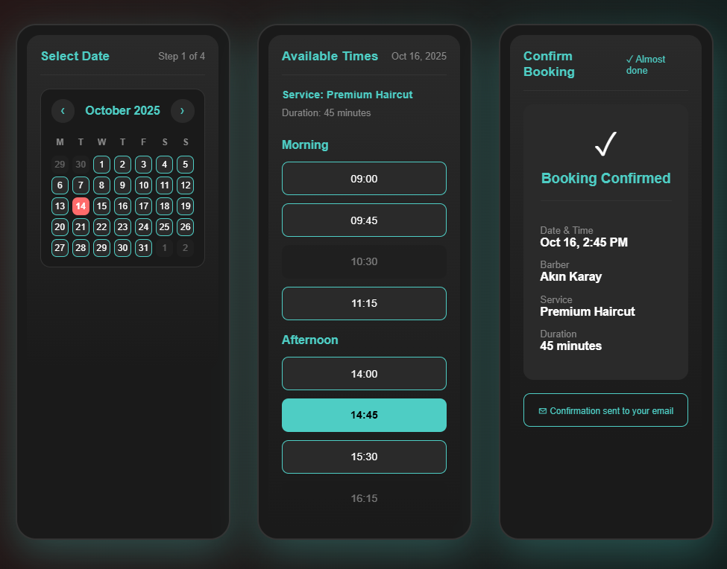
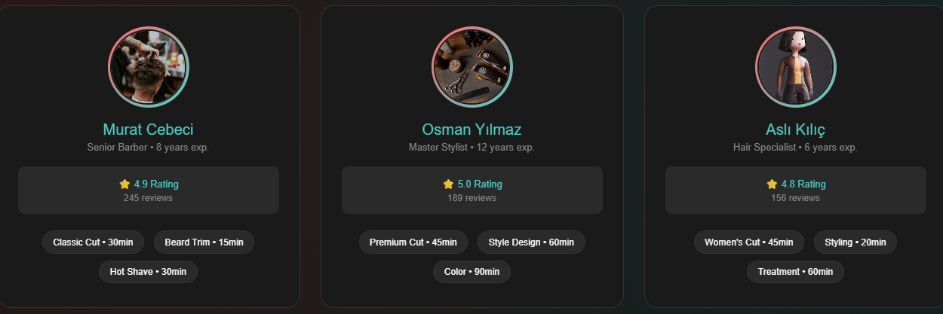

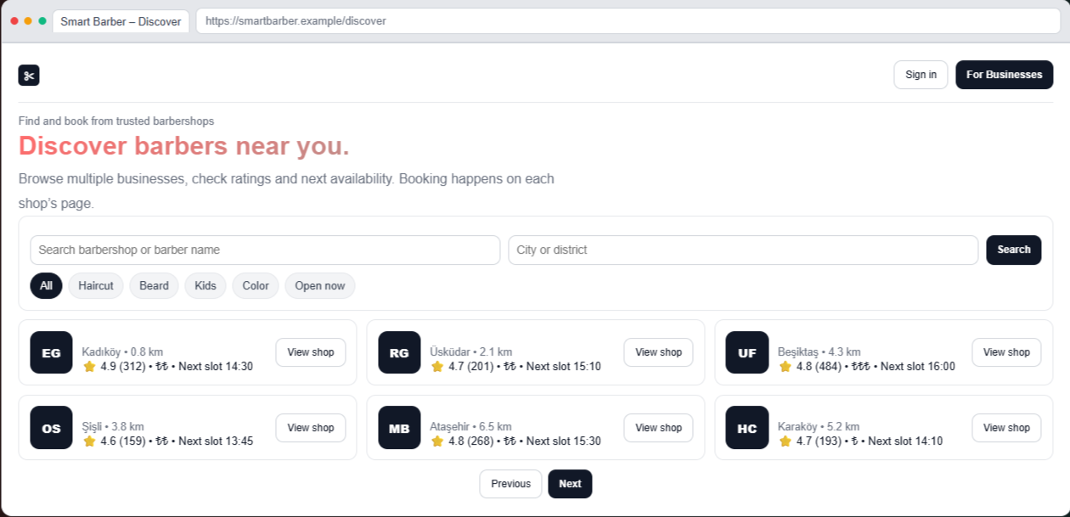

The mobile interface is designed for speed and simplicity, guiding the user through a 4 step booking process:
Users browse a calendar view to find available dates. The system filters and displays open time slots based on the specific barber's schedule and service duration. A summary screen presents the service details, price, and time for final user verification before booking.

9.2. AI Style Preview
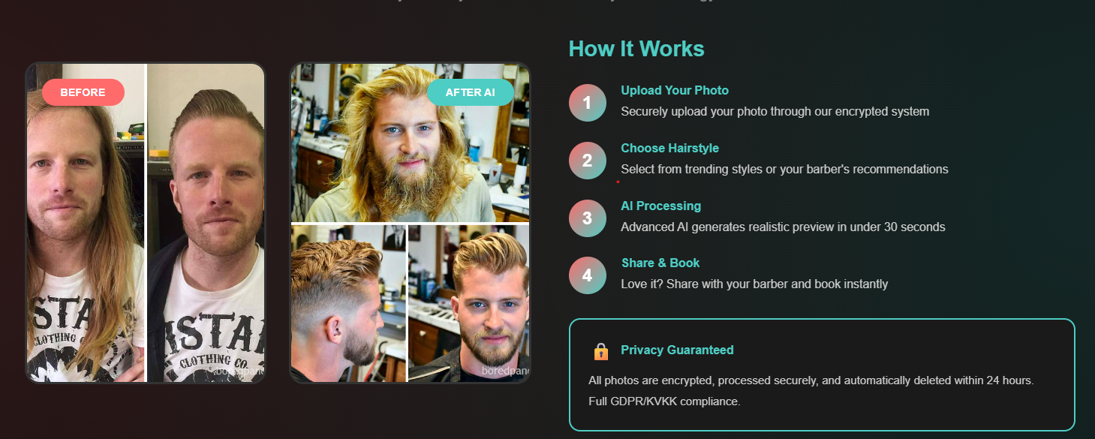

The interface features a side by side comparison tool where users can upload a selfie and visualize different haircuts generated by our Python AI service.
To ensure a seamless user experience, the process is broken down into 4 clear steps on the right panel: Upload, Choose Style, Process, and Book. Furthermore, considering the sensitivity of biometric data, a prominent Privacy Guaranteed section is included at the bottom.
This explicitly informs the user that their photos are encrypted and automatically deleted from the AWS S3 bucket within 24 hours, ensuring full compliance with GDPR and KVKK standards.

9.3. Admin Dashboard
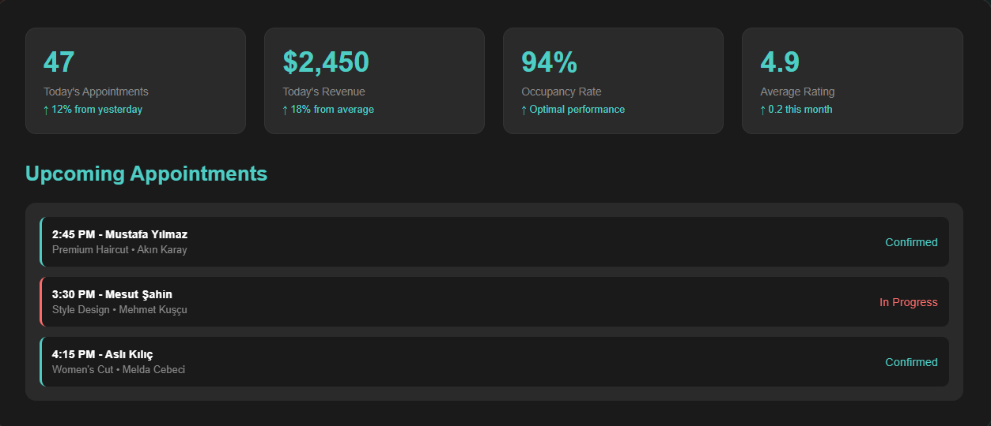
The Admin Dashboard serves as the central command center for shop owners, providing real-time insights:
Cards at the top display critical daily such as total appointments, revenue generated, and current occupancy rates. The Upcoming Appointments section lists bookings in chronological order, showing status indicators help staff manage the shop floor efficiently.

10. Installation and Deployment
10.1. Deployment Model
The solution is designed to run as a set of containerized services. This simplifies repeatable setup across development and production environments.
10.2. Prerequisites
• Docker engine (local or cloud host) to run the backend and supporting services.
• Access to persistent storage for PostgreSQL data and backups.
• An HTTPS setup (domain + TLS certificate) for secure client-to-API communication.
10.3. Configuration and Secrets
• Database connection settings (PostgreSQL).
• JWT signing secret and token lifetime policy.
• AWS S3 credentials/bucket configuration for temporary AI image storage.
• Redis connection settings (if caching is enabled).
10.4. Deployment Steps (High-Level)
• Build and publish container images for the .NET Web API and the Python AI service.
• Provide environment configuration and secrets to the runtime (do not hardcode in source).
• Start services in the correct order (database/cache first, then API and AI service).
• Verify health endpoints and run a smoke test for booking + AI preview flows.
10.5. Post-Deployment Operations
• Enable monitoring/logging and keep audit logs for security-relevant actions.
• Schedule database backups and define a restore procedure.
• Scale API/AI containers horizontally if demand increases.

The system adopts a containerized deployment strategy to ensure scalability and maintainability. The core application components, including the .NET Web API and Python AI Service, run within isolated Docker containers on a cloud server. Both the Mobile Client and Admin Dashboard communicate securely with the backend via HTTPS. The architecture utilizes PostgreSQL for persistent relational data, Redis for high-speed caching, and AWS S3 for secure storage of temporary AI-processed images.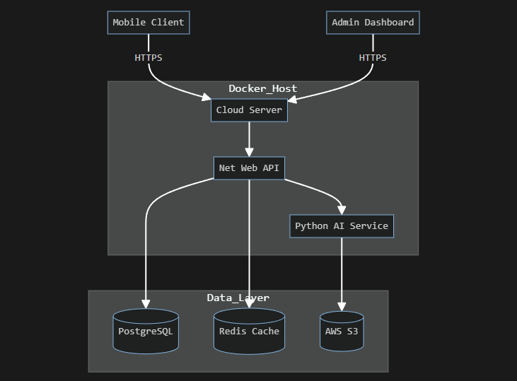

11. Integration and Scalability
11.1. Integration Interfaces
The system exposes a RESTful API consumed by the customer booking UI and the staff/admin interface. The API is designed to be stateless (JWT-based), allowing easy integration with web or mobile clients and enabling horizontal scaling.
Primary API surface (high-level):
• Authentication: register/login/me (JWT token lifecycle).
• Appointments: list available slots, create/cancel bookings, view appointment history.
• Staff/Admin: manage staff, services, working hours, and view schedules.
• AI preview: upload selfie and request hairstyle preview generation.
11.2. Internal Service Integration
The solution is structured as containerized services that communicate over private network boundaries:
• .NET Web API (core domain logic and orchestration).
• Python AI service (image processing and preview generation).
• PostgreSQL (system of record) and optional Redis (cache + rate limiting primitives).
• Object storage (e.g., S3-compatible) for temporary image storage with an automatic deletion policy.
11.3. Data Layer and Consistency
To prevent double bookings, appointment creation is guarded by server-side slot validation together with transactional consistency on the database side. This ensures correctness under concurrent requests.
Core data entities (summary):
• Users (customer identity and contact).
• Appointments (time range, customer, staff, service, status).
• Staff/Employees and Services (catalog and assignment).
• Working Hours / Availability rules (time windows and exceptions).
11.4. Scalability Approach
The architecture supports incremental scaling without redesign:
• Horizontal scaling: multiple API and AI service replicas behind a reverse proxy/load balancer.
• Caching: Redis can reduce repeated reads for slot listing and static reference data.
• Asynchronous processing: AI preview generation can run via background jobs/queues to keep the UI responsive.
• Database performance: indexing for time-based queries, connection pooling, and optional read replicas for reporting.
11.5. Extensibility
New integrations (payments, external calendars, CRM/marketing tools) can be added through dedicated adapters at the API boundary while keeping the core domain logic unchanged.

12. Competitive Analysis and Differentiation
12.1. Market Context
Typical barbershops rely on phone/WhatsApp bookings or generic scheduling tools. These approaches frequently lead to no-shows, double bookings, and limited personalization.
12.2. Differentiation Points
• Conflict-free booking: server-side slot calculation + consistency controls to eliminate double bookings.
• AI hairstyle preview: reduces uncertainty and improves customer decision-making before the visit.
• Privacy-first handling: temporary photo storage with a defined deletion policy and restricted access paths.
• Operational readiness: staff/admin flows are built-in, enabling real shop operations.
• Cloud-ready packaging: containerized design supports repeatable deployment and scaling.
12.3. Summary Comparison (Qualitative)
Dimension | Typical manual/generic tools | Smart Barber system
Booking consistency | Prone to conflicts; manual correction | Designed to prevent double bookings at source
Customer experience | Limited; no visual guidance | AI preview + structured booking flow
Security & privacy | Varies; informal sharing is common | HTTPS/JWT + defined data retention policy
Operational management | Basic or missing staff/admin controls | Role-based management and shop dashboards

13. Licensing and Commercial Model
13.1. Intended Use
This report presents an academic prototype. The commercial model below is a forward-looking proposal to enable real-world adoption.
13.2. Proposed Commercial Options
• SaaS subscription (per shop/month) with optional add-ons (AI previews, SMS reminders, advanced analytics).
• Per-seat pricing for staff accounts (for larger shops with multiple barbers).
• Enterprise/self-hosted license for organizations requiring on-prem deployment and custom integrations.
13.3. Cost Drivers and Assumptions
• Infrastructure: hosting, managed database, object storage, and bandwidth.
• AI compute: preview generation cost scales with usage and model complexity.
• Messaging: SMS/email gateway fees if reminders are enabled.

14. Technical Requirements
14.1. Runtime and Infrastructure Prerequisites
• Container runtime (Docker) and an orchestration option for production (Docker Compose or Kubernetes).
• PostgreSQL instance with persistent storage, backups, and access control.
• Optional Redis instance for caching and rate-limiting support.
• TLS termination (domain + certificate) to enforce HTTPS end-to-end.
14.2. Platform and Dependency Requirements (Reference)
• Backend API: .NET runtime compatible with the selected Web API version.
• AI service: Python runtime with required ML/image libraries.
• Object storage: S3-compatible service for temporary images (or equivalent).
• Client: modern evergreen browsers (Chrome/Edge/Firefox/Safari) for the booking UI.
14.3. Non-Functional Requirements
Non-functional expectations are aligned with the NFR set in Section 3 (performance, security, reliability). Key points include low-latency slot listing, secure transport, and auditability of sensitive actions.
14.4. Verification and Testing
To ensure reliability and prevent double bookings, a multi-layer testing approach is required:
• Unit testing: slot calculation and booking validation logic.
• Integration testing: API-to-database consistency (including concurrent booking attempts).
• User acceptance testing: end-to-end booking + AI preview flows with realistic scenarios.
14.5. Requirements Traceability (RTM)
The following matrix links functional requirements to implementation components to validate scope coverage.
Req ID | Requirement Name | Handling Module/Class | Related DB Table | Related API Endpoint
FR-01 | User Registration | AuthController, UserService | Users | POST /api/auth/register
FR-02 | Appointment Booking | AppointmentController, SlotCalculator | Appointments, WorkingHours | POST /api/appointments
FR-03 | AI Style Preview | AiService (Python), ImageProcessor | Ai Previews | POST /api/ai/preview
FR-04 | Payment Integration | PaymentService, StripeGateway | Payments | POST /api/payment/charge
FR-05 | Notification System | NotificationService, SmtpClient | -

15. Risk Analysis
15.1 Risk Identification & Assessment
API Downtime: The mobile and web clients becoming inoperable in the event of an API server crash. Impact: High, Likelihood: Low.
Server Overload: Traffic received during peak hours (especially with up to ~60% of missed call traffic shifting to digital) could strain the database. Impact: High, Likelihood: Medium.
Data Privacy Breach: Leakage of biometric data (facial photos) or personal information uploaded by users. Impact: Critical, Likelihood: Low.
AI Processing Latency: The Python AI service freezing the UI or creating a system bottleneck while processing photos. Impact: Medium, Likelihood: Medium.
Double Booking Constraints: Concurrent booking requests bypassing the Transaction Lock mechanism in the database to create an appointment for the same time slot. Impact: High, Likelihood: Low.
Appointment Overrun (Schedule Overlap): The risk of a specific service taking longer than anticipated, causing a domino effect of delays that overlap with subsequent customers' appointments. Impact: Medium, Likelihood: High.

15.2 Mitigation & Preventive Actions
The following preventive measures have been planned to minimize the effects of the identified risks:
For API Downtime: A "retry logic" and "circuit breaker" architecture will be implemented on the frontend.
For Server Overload: Redis caching will be used to reduce database queries. Docker containers will be able to scale horizontally as demand increases.
For Data Privacy Breach: An automatic deletion (auto-delete) policy within 24 hours will be strictly enforced for photos temporarily stored on the AWS S3 bucket, and data will be encrypted with AES-256.
For AI Processing Latency: Image processing tasks will be run as asynchronous background jobs to prevent the user interface from freezing.
For Appointment Overrun: A mandatory 15-minute buffer time will be automatically appended to the duration of every scheduled service within the system's booking engine to accommodate unexpected delays and ensure smooth transitions between customers.

Key operational risks and corresponding mitigations are summarized below.
Risk | Impact | Mitigation Strategy
API Downtime | High | Implement retry logic in the frontend and use circuit breaker patterns.
AI Processing Latency | Medium | Use asynchronous background jobs so the user UI doesn't freeze.
Data Privacy | Critical | Strictly enforce the 24-hour auto-delete policy for user photos and use AES-256 encryption.
Server Overload  Appointment Overrun | High  Medium | Utilize Redis caching to reduce database hits.  A mandatory 15-minute buffer time will be appended to the duration of every scheduled service.

15.3. Risk Matrix
Risk | Likelihood | Impact | Risk Level
Data Privacy Breach | Low | Critical | High
Server Overload | Medium | High | High
API Downtime | Low | High | Medium
Double Booking Conflicts | Low | High | Medium
AI Processing Latency | Medium | Medium | Medium
Appoinment Overrun | High | Medium | High

16. Code Security & Data Privacy

Code Security: The system architecture is based on the "Least Privilege" principle. The security layers are as follows:
Authentication and Authorization: All API requests are protected via /api/auth/* endpoints using JWT (JSON Web Token). Customer, Staff, and Admin privileges are strictly separated using Role-Based Access Control (RBAC).
Data Transmission and Cryptography: All data transfers will mandatorily be executed over HTTPS, and user passwords will be stored as hashed values in the database (PostgreSQL).
Resource Scoping: Users (e.g., customers) can only view and edit their own appointments and data via JWT claims.

Data Privacy:
The system is designed to be fully compliant with GDPR and KVKK.
PII (Personally Identifiable Information) minimization is applied in the processing of biometric data. Photos uploaded by users for the AI Style Preview are encrypted and automatically deleted permanently from AWS S3 within 24 hours after processing.

17. Implementation Roadmap
To ensure continuous feedback and incremental delivery, the development process is structured into 4 major sprints (2 weeks each) under the Scrum framework:
Sprint 1: Core Setup & Authentication (Weeks 1-2)
- Bootstrapping the Docker environment, PostgreSQL, and Redis setups.
- Creating the .NET Web API and React 18 skeleton.
- Completion of JWT-based user registration and login modules (RBAC).
Sprint 2: Booking Engine & Database Locks (Weeks 3-4)
  - Calculation of appointment slots (SlotCalculator) and API integration.
  - Coding the "Transaction Lock" mechanism at the PostgreSQL level to prevent double booking.
  - Completion of the 4-step booking screens on the customer mobile/web interface.
Sprint 3: AI Integration & Notifications (Weeks 5-6)
- Asynchronous integration of the Python AI service (Google Nano Banana API) with the .NET backend.
- Configuration of AWS S3 temporary file storage and the 24-hour deletion policy.
- Development of SmtpClient and SMS notification triggers.
Sprint 4: Admin Dashboard, Testing & Deployment (Weeks 7-8)
  - Building the real-time Admin Dashboard powered by Socket.io for business owners.
  - Conducting multi-layer testing of the system.
  - Building and publishing container images (Docker) and UAT (User Acceptance Testing) processes.

18. Validation and Testing Plan

To verify the zero-fault tolerance required for the appointment logic, the system will be subjected to a multi-layer testing strategy:
Automated End-to-End (E2E) Testing: The client side developed with React 18 will be subjected to automated UI tests using Java and Selenium (or similar modern frameworks). These scenarios will verify that a real user can log into the system and seamlessly complete the 4-step booking flow and the AI image upload process.
API Integration Testing: To prove the correctness of the .NET Core backend in the architecture, API tests (using tools like REST Assured/Postman) will be executed. Specifically, concurrent requests sent to the /api/appointments endpoint will be simulated to definitively confirm that database locks (transaction locks) prevent double bookings.
Unit Testing: The SlotCalculator and AppointmentController components, which are the heart of the business logic, will be tested in isolation.
Performance Testing: It will be measured whether the system can provide an API response time of under 200ms under normal load, and it will be verified that Redis caching effectively reduces the load on the database.

19. Succes Criteria

For the project to be considered successful, the system aims to quantitatively and qualitatively resolve the weak points identified during the analysis phase. The success criteria are as follows:
- Zero Conflicts: Completely reducing double booking errors to zero by enforcing a single source of truth for time slots.
- Decrease in No-Show Rates: Achieving up to a 60% reduction in missed appointments (no-shows) through automated SMS and Email reminders.
- Performance Target: Measuring base API response times under 200ms under normal system load.
- AI Processing Speed: Generating hairstyle previews via artificial intelligence from uploaded images in under 30 seconds, flawlessly and in accordance with privacy rules.
- Operational Efficiency: Reducing daily phone and record-keeping manual workload by approximately 2 hours through the admin panel and digital assistants.

