|  |  |
| --- | --- |
| **Topic** | Hazelcast |
| **Document Name** | HAZELCAST-EX-03 |
|  |  |

|  |  |  |  |
| --- | --- | --- | --- |
| **Document Difficulty Level** | | | |
| **Beginner** | **Junior** | **Senior** | **Expert** |
| □ | ■ | □ | □ |

# Document History

|  |  |  |  |
| --- | --- | --- | --- |
| Date | Author | Ver | Comments |
| 05.03.2025 | Mennan Tekbir | 1.0 | Initial Draft |
| 05.03.2025 | Mehmet Erdem Önal | 1.1 | Revisions |

# Hazelcast

## Exercise HAZELCAST-EX-03:

**Definiton:** Use the hazelcast server you set up in *HAZELCAST-EX-02* and create sample java program that puts a dummy Person object into the Hazelcast map 10,000 times ( in a for loop). Then, get these objects from the Hazelcast map.

**Helper Link:**  <https://github.com/hazelcast/hazelcast-code-samples/tree/master/serialization/kryo-serializer>

**Sample Person Class:**

public class Person {

private String name;

private Person() { }

...

Please provide screenshots to show your work.

## HAZELCAST -EX-03 Solution:

**Your Answer:**

**ekran görüntüsü, siyah, siyah beyaz, tasarım içeren bir resim

Yapay zeka tarafından oluşturulmuş içerik yanlış olabilir.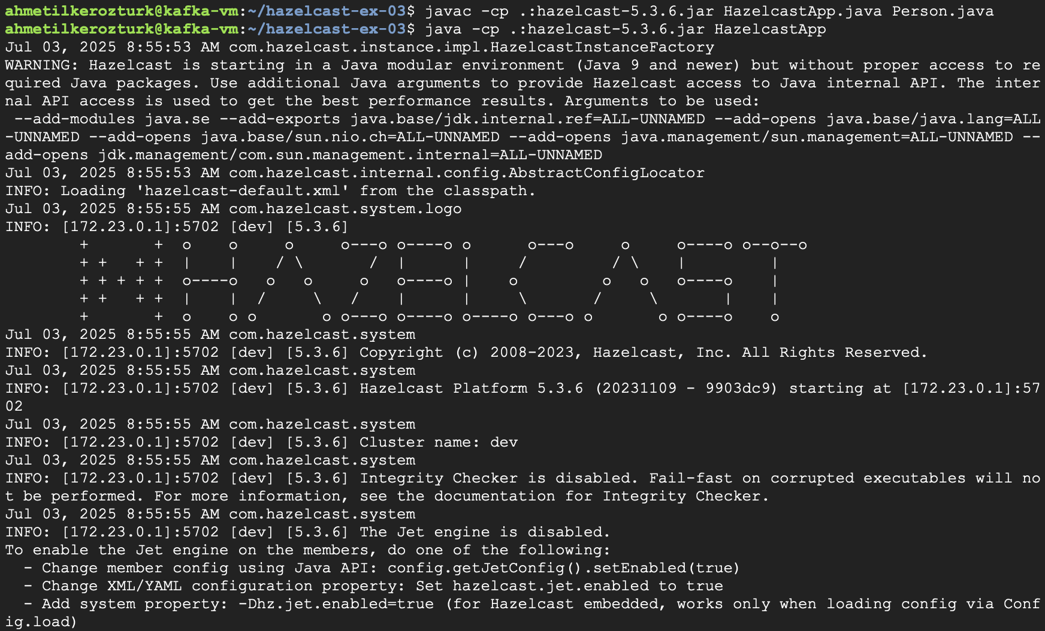metin, ekran görüntüsü, yazı tipi içeren bir resim

Yapay zeka tarafından oluşturulmuş içerik yanlış olabilir.**