DOKUZ EYLÜL UNIVERSITY
ENGINEERING FACULTY
DEPARTMENT OF COMPUTER ENGINEERING

CME 2210
Object Oriented Analysis and Design

FOOTBALL CLUB MANAGEMENT AND STATISTICS SYSTEM

by
İlker Soner
Durmuş Furkan Özkan

CHAPTER ONE
INTRODUCTION

  - Purpose
Purpose of this document is to present a detailed description of the program, Football Club Management and Statistics System. It will explain the purpose and features of the system, what system will do, classes and interfaces that were used.

  - Scope
This software system will be a Football Club Management and Statistics System. It will be useful for the statisticians and club managers. It also will be helpful to determine players’ skills and worth.

  - Definitions, Acronyms, and Abbreviations
MotM: Man of the match.
Goal: A pair of posts linked by a crossbar and typically with a net between, forming a space into or over which the ball has to be sent in order to score.
Assist: Help (someone), typically by doing a share of the work.
Pass success percentage (PS%): Statistic of successful and non-successful passes a player achieves.
Shots per game: Shots that player took per game. Including all hit and missed shots.
Red Card: A red card shown by the referee to a player who is being sent off the field.
Yellow Card: A yellow card shown by the referee to a player being cautioned.
Manager: A person responsible for controlling or administering an organization or group of staff.
Positions: a place where someone or something is located or has been put.
- Goalkeeper
- Defender (Centre-back, Sweeper, Full-back, Wing-back)
- Midfielder (Centre midfield, Defensive midfield, Attacking midfield, Wide midfield)
- Forward (Centre forward, Second striker, Winger)
  - References
WhoScored.com
IEEE. IEEE Std 830-1998 IEEE Recommended Practice for Software Requirements Specifications. IEEE Computer Society, 1998.

  - Overview
The next chapter, the Overall Description section, of this document gives an overview of the functionality of the product. It describes the informal requirements and is used to establish a context for the technical requirements specification in the next chapter.
The third chapter, Requirements Specification section, of this document is written primarily for the developers and describes in technical terms the details of the functionality of the product.

CHAPTER TWO
OVERALL DESCRIPTION
- Product Perspective
The product is open sourced. It doesn’t require internet connection. And the product has cross-platform support.
  - Product Functions
Product helps user to manage a team and keep analysis and statistics. Further detail in 3.2.
  - User Characteristics
The program is for managers who will be interested in player and team statistics. Also it is for curious people. The user is expected to be Windows literate and to be able to use button, pull-down menus, and similar tools.

  - Constraints
There were no constraints.

  - Assumptions and Dependencies
Project will be finished and ready to use at due date.

CHAPTER THREE
SPECIFIC REQUIREMENTS
- External Interfaces
Player Attributes which includes name,age,shirt number, position, height, weight, nationality.
Player Statistics which includes goals, assists, cards, minutes played, pass success percentage, MotM count, shots per game, cards received.
Team Info: name, goals, shots, cards received, possession percentage, pass percentage.

  - Functions
Add Player
Display Player Statistics
Display Player Attributes
Update Player Statistics
Update Player Attributes
Update First Eleven
Display First Eleven

  - Performance Requirements
Fastest performance with data structures and object oriented principles.

  - Design Constraints
There were no design complaints.

  - Object Oriented Models
This project includes classes, interfaces and data structures.
    - Analysis Class Model (Static Model)
Classes: Player class that extends Team class. Team class that extends league class.
Inheritence: Goalkeeper, defender, midfielder, forward classes that extends player class.
Player Class variables: name,age,shirt number, position, height, weight, nationality. Also, get set and display methods.
Team class: Player array,name, goals, shots, cards received, possession percentage, pass percentage. Also get set and display methods. Queue for first eleven players that will play the match. List for all players and substitutes.
League class: name and team list. Also get set and display methods.

    - Analysis Collaborations (Dynamic Model)
Player Attributes which includes name,age,shirt number, position, height, weight, nationality.
Player Statistics whick includes goals, assists, cards, minutes played, pass success percentage, MotM count, shots per game, cards received.
Team Info: name, goals, shots, cards received, possession percentage, pass percentage.
CHAPTER four
UML DIAGRAMS
Manager
Analyst
Add Player
Add Statistics
Display Player
Display Team
Display League
Display Statistics
Add Goals and Assists
Add Pass Percentage
Add Cards
<<includes>>
<<includes>>
<<includes>>
First Eleven
updates
Team Arrangement
updates

Use case dıagram
Analysts can add and update Player Statistics which includes goals, assists, cards, minutes played, pass success percentage, MotM count, shots per game, cards received. And they can add and update player which has variables name,age,shirt number, position, height, weight, nationality. Analysts can also display team, league, player and statistics.
Managers can only display team, league, player and statistics. But they can’t make changes on them.

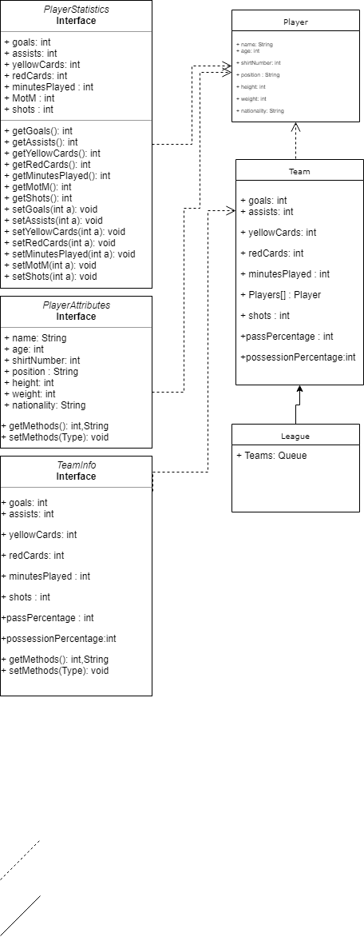
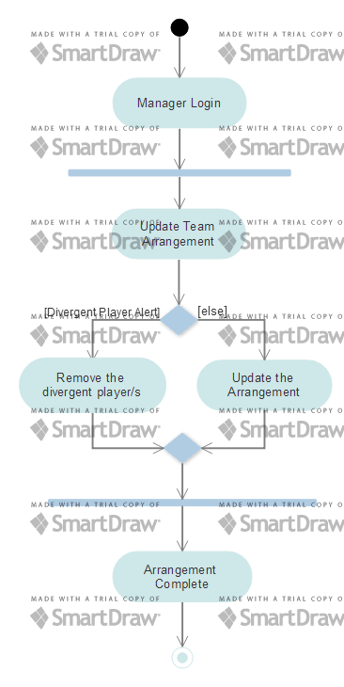
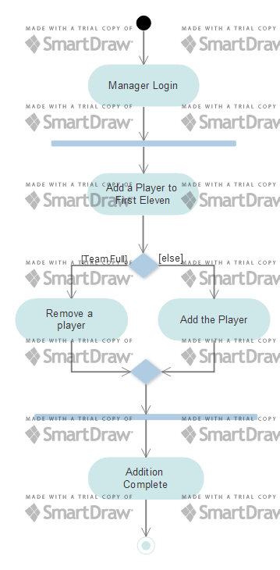
One of manager’s commands is updating the First Eleven. First Eleven represents which players will start the next match. Managers adds or removes players from the first eleven. If manager tries to add a player to the first eleven and if it is full, system returns an error message. Manager should remove a player from the first eleven in order to add the player he wants.

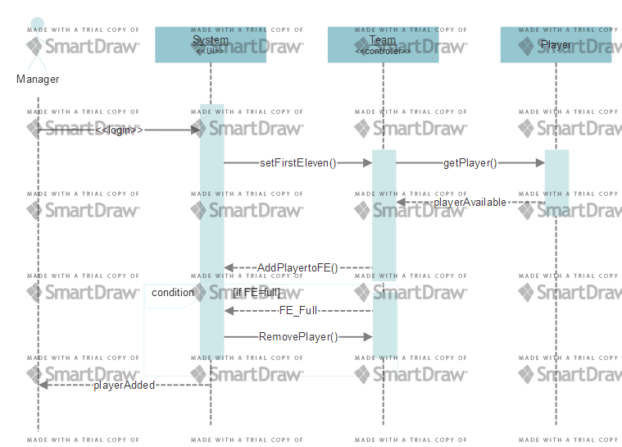

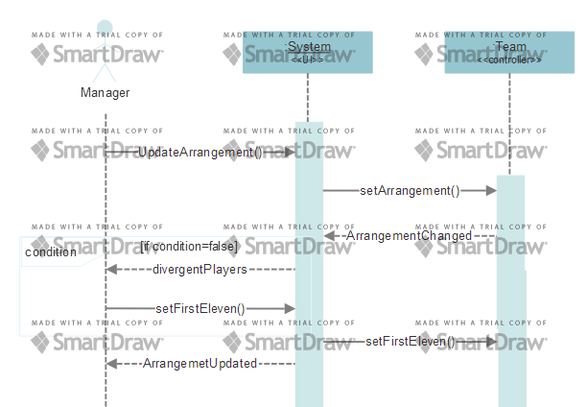

Manager can update the player arrangement that will be used in the match. Arrangements are like 4-4-2, 4-3-3 etc. When manager changes the arrangement and the players are divergent for this arrangement, system gives an error message to change the players which will suit the positions. For example if manager changes the arrangement to 4-4-2 to 4-3-3, one midfielder will be divergent and it needs to be changed.
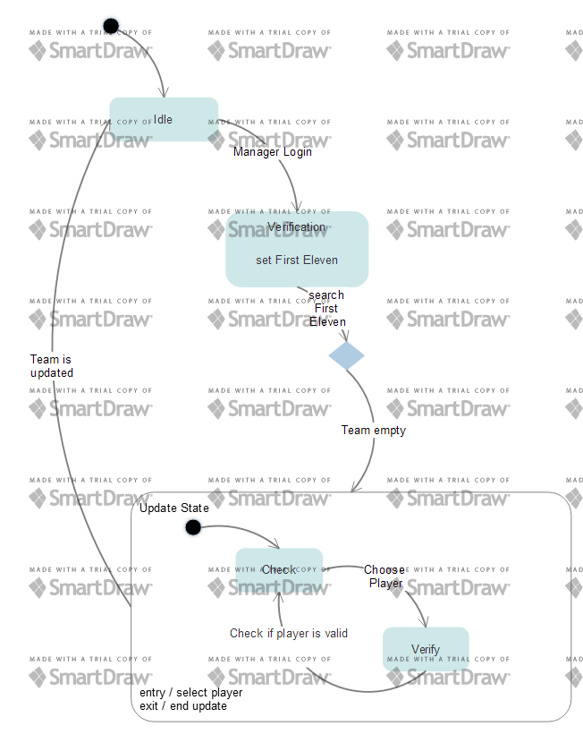

CHAPTER fıve
IMPLEMENTATION
In the main classes, we have team, player classes that fits encapsulation principle. Forward, midfielder, defender and goalkeeper classes extends the player class with inheritance. Team class includes all of the commands that manager will use. These commands are addPlayer, removePlayer, findPlayer, methods to set the first eleven and of course the get and set methods. In player class there is only variables and getters and setters.
In swing classes, firstly we have a login class that checks the username and password. If username and password are true, this page directs you to manager control page. In manager control page, we have five buttons which are: Add New Player, Remove Player, Set First Eleven, Display Player Attributes, Display First Eleven. When user clicks the Add New Player button, user will be directed to the AddPlayer page. In AddPlayer page, program will want the necessary variables to add a new player to the team. When all the text boxes are filled and when user clicks add, a new user will be added to the team. In RemovePlayer page a list of players will show up and user will select the player to be removed and user will successfully delete the player from the team. In Set First Eleven page, user will add a player from the team to the first eleven from choosing from the list on the page. In Display Players page user will see the list of the players’ names and if user wants to see more details about the players, user will click the details button and a new page will show up that displays player attributes in detail. And for last, Display First Eleven page helps user to see the team’s current first eleven.

CHAPTER sıx
CONCLUSION AND FUTURE WORKS
In conclusion, project finished with a few missing parts according to the project report. But with the done parts it works well. Planning for the classes and interfaces using diagrams in detail are important and necessary for the projects final position. In future works I should use the diagrams and do the planning more efficient.

