**USB Interface Information**

Can Communicate With A USB Module. USB Module sends Real Temperatures and Remote Commands to ACIT Software and gets

Compressor Frequency, Expansion Valve Position, Fan Rpm and etc. so that ACIT Cycle Algorithms can be able to run with Real Physical Values ! " ;

**Hardware Interface View :**

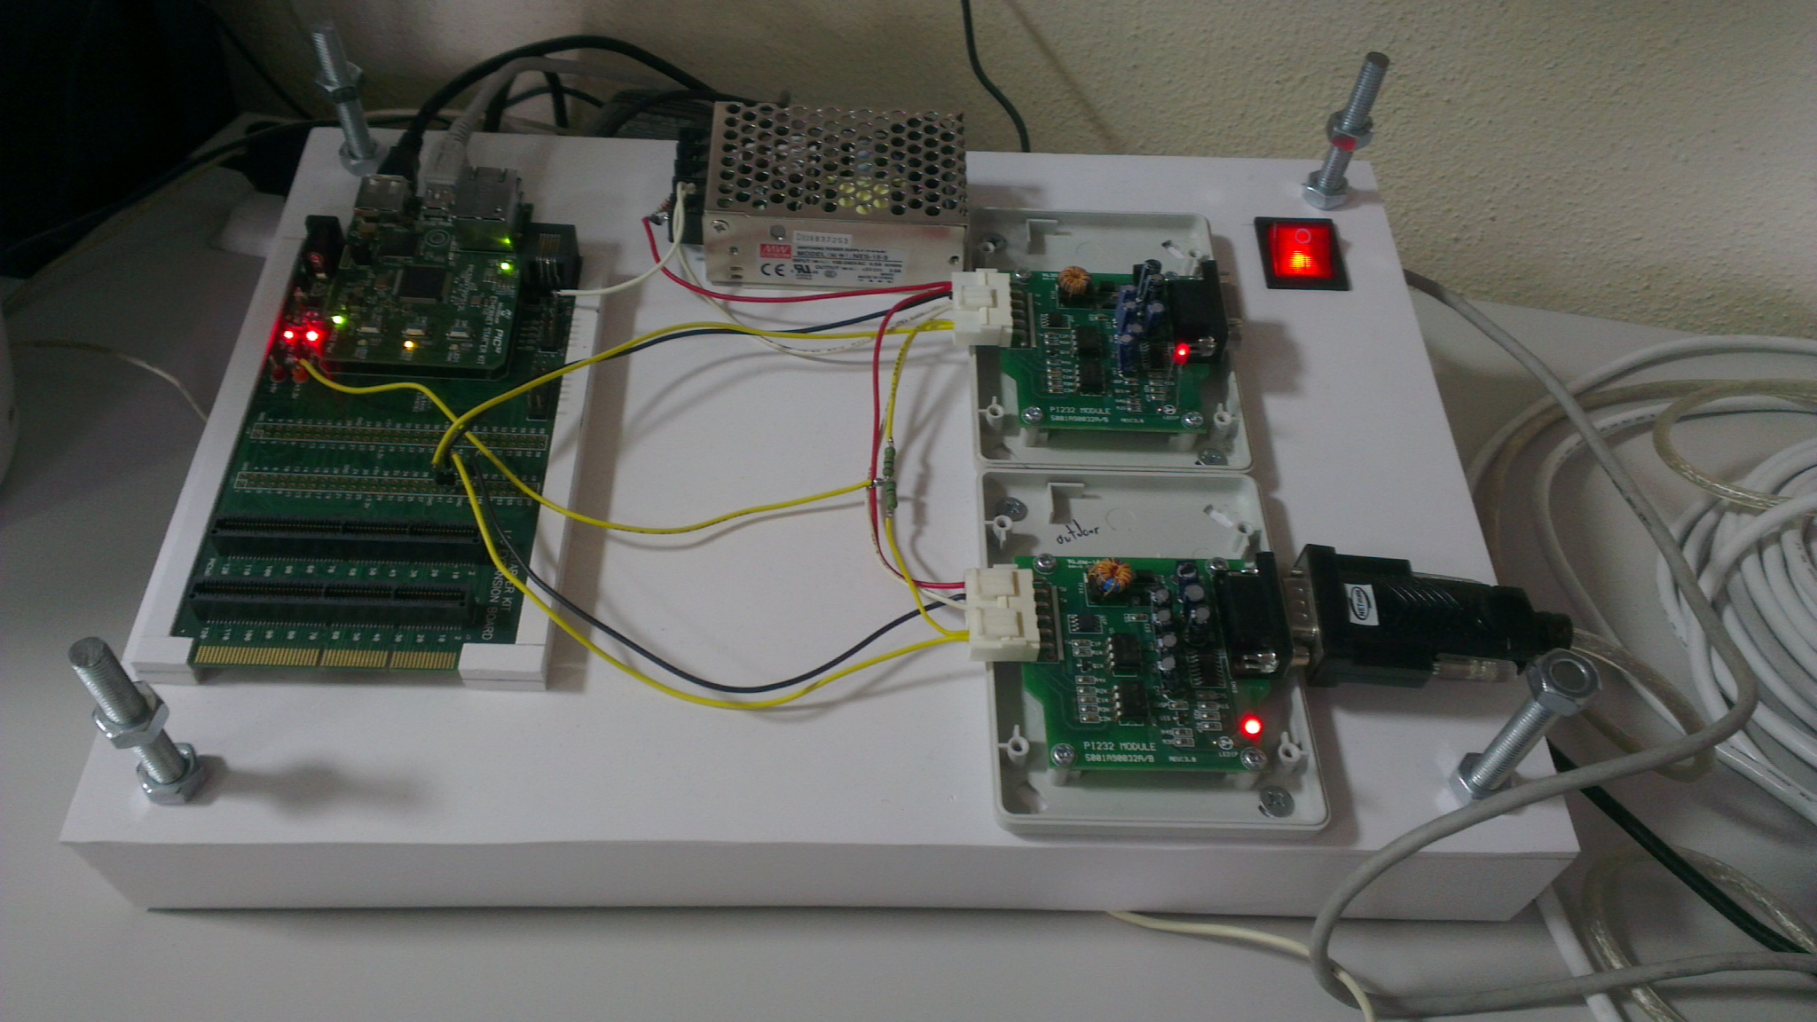

Indoor Unit Connection

Outdoor Unit Connection

PC Connection

**Basic PC – Driver Communication Principle :**

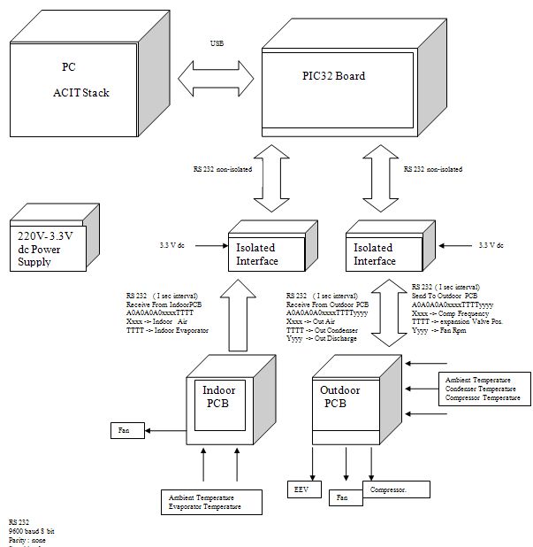

**Microchip USB Framework Location :**

<http://www.microchip.com/stellent/idcplg?IdcService=SS_GET_PAGE&nodeId=2680&dDocName=en547784>

**Current Microchip Framework that has been used: Microchip Solutions v2012-07-18**

<http://www.microchip.com/stellent/idcplg?IdcService=SS_GET_PAGE&nodeId=2896>

**Microchip USB Interface Project Location**

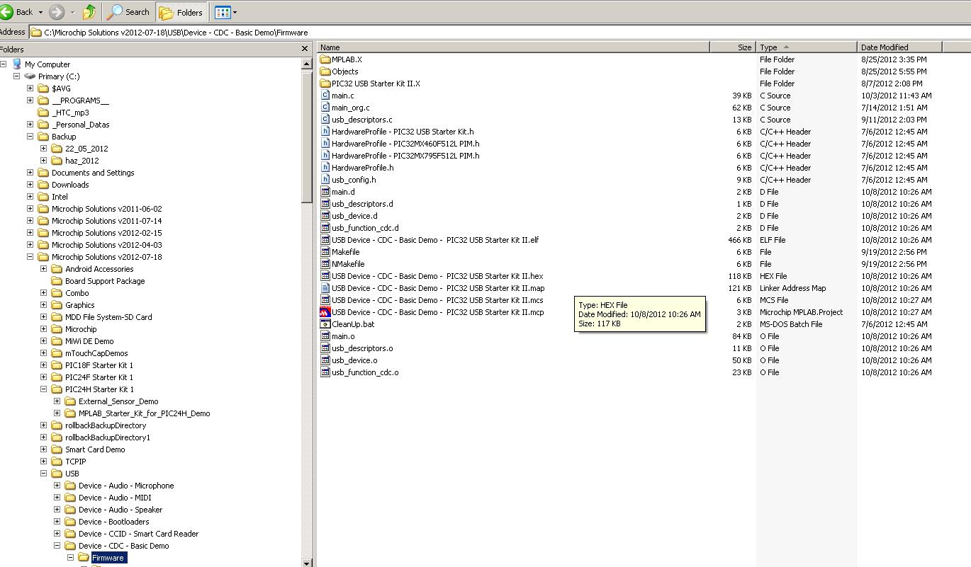

**Installing Drivers**

**Please refer to Microchip USB CDC Serial Emulator drivers**

<http://www.microchip.com/pagehandler/en-us/technology/usb/tools/home.html>

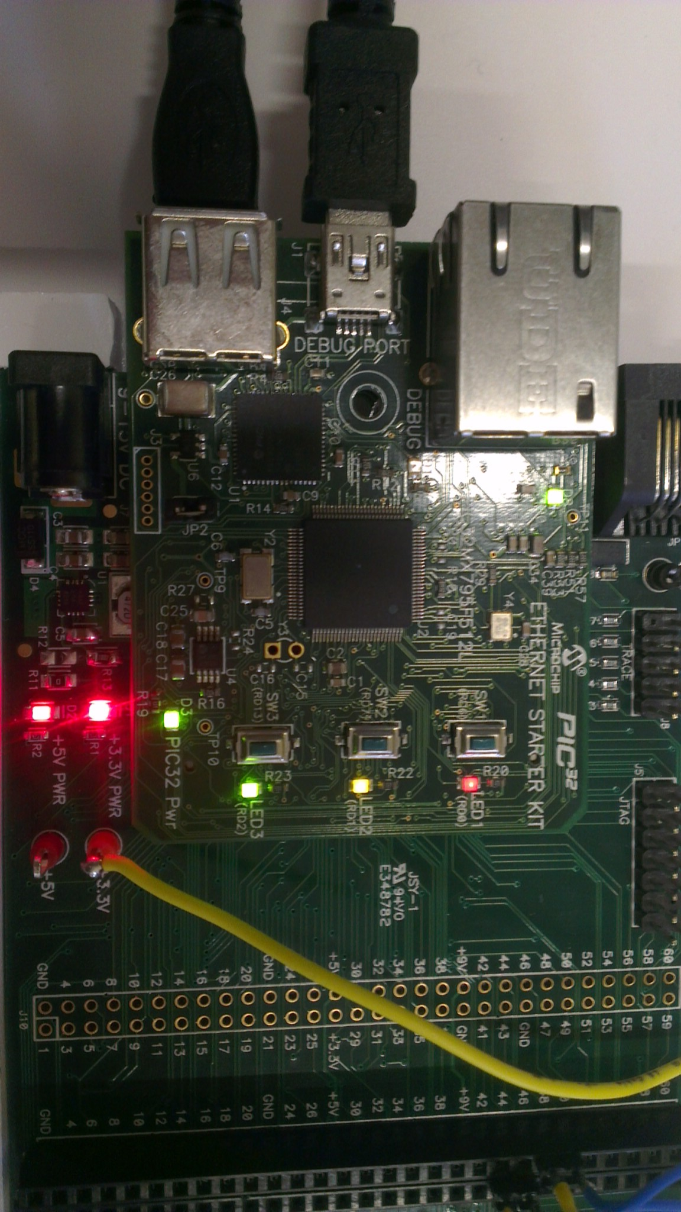

PC Driver Indication Leds

Whenever Driver is found Yellow and red led’s flashes simultaneously

USB – PC Interface

**Microchip Mplab Development Environment Version: Microchip Mplab C- Compiler Version :**

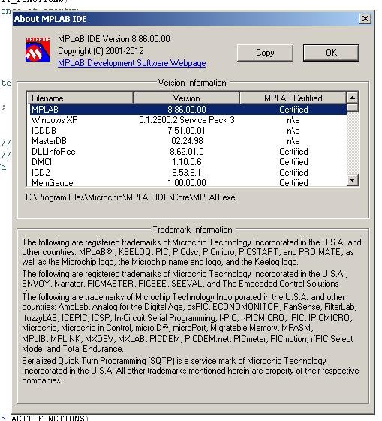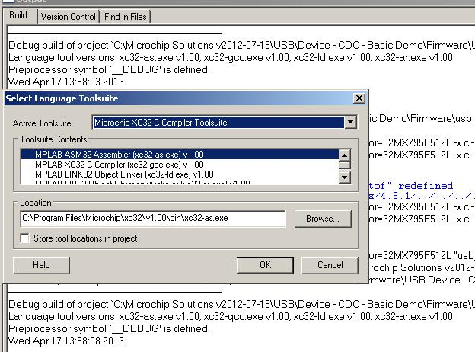

**GUI Interface & Shared data’s :**

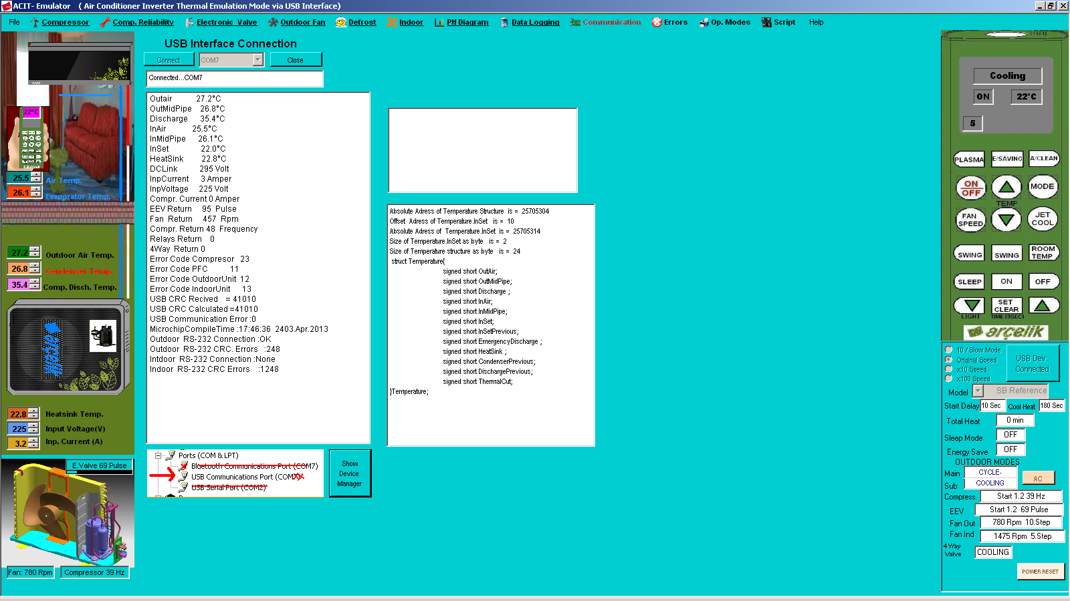

Below you can find the last phase of the ACIT stack embedded in an indoor unit

