**It is highly recommended that you read through all notes in this document before altering the template.** ilkinilkinilkinilkinilkinilkinilkinilkinilkinilkin

**Graduate School Note:** This template is for a **thesis**. See our web page for [templates for dissertations](http://www.mtu.edu/gradschool/policies-procedures/theses-dissertations/formatting/) and [reports](http://www.mtu.edu/gradschool/policies-procedures/timelines/report/formatting/). Template creation date: January 26, 2023. Created with Microsoft Word Professional Plus 2019.ilkinilkinilkinilkinilkinilkinilkinilkinilkinilkin

Replace the yellow highlighted text on this page with your information, remove the highlighting, and delete this note. If you are not enrolled in a Master of Science program, you may not have a degree program. The Graduate School will provide additional guidance during your review. Throughout this document, helpful notes are in blue highlighting. Note that this document is formatted to print single sided. Please see [the Guide](http://www.mtu.edu/gradschool/policies-procedures/theses-dissertations/pdfs/guide.pdf) for the required formatting changes for a double sided document and additional formatting guidance and description.ilkinilkinilkinilkinilkinilkinilkinilkinilkinilkin

# TITLE OF THESIS IN ALL CAPITAL LETTERSilkinilkinilkinilkinilkinilkinilkinilkinilkinilkin

Byilkinilkinilkinilkinilkinilkinilkinilkinilkinilkin

Blizzard T. Huskyilkinilkinilkinilkinilkinilkinilkinilkinilkinilkin

A THESISilkinilkinilkinilkinilkinilkinilkinilkinilkinilkin

Submitted in partial fulfillment of the requirements for the degree ofilkinilkinilkinilkinilkinilkinilkinilkinilkinilkin

MASTER OF SCIENCEilkinilkinilkinilkinilkinilkinilkinilkinilkinilkin

In Degree Programilkinilkinilkinilkinilkinilkinilkinilkinilkinilkin

MICHIGAN TECHNOLOGICAL UNIVERSITYilkinilkinilkinilkinilkinilkinilkinilkinilkinilkin

2023ilkinilkinilkinilkinilkinilkinilkinilkinilkinilkin

© 2023 Blizzard T. Huskyilkinilkinilkinilkinilkinilkinilkinilkinilkinilkin

ilkinilkinilkinilkinilkinilkinilkinilkinilkinilkin

**Graduate School Note:** Replace the highlighted text on this page with your information, remove the highlighting, and delete this note. Note that your degree program and department or college name may not be identical. Only use a college name here if your college does not have departments. If a dedication page is desired, insert it on the next page, taking care to have a section break after the dedication page. If you are not enrolled in a Master of Science program, you may not have a degree program. The Graduate School will provide additional guidance during your review.ilkinilkinilkinilkinilkinilkinilkinilkinilkinilkin

This thesis has been approved in partial fulfillment of the requirements for the Degree of MASTER OF SCIENCE in Degree Program.ilkinilkinilkinilkinilkinilkinilkinilkinilkinilkin

ilkinilkinilkinilkinilkinilkinilkinilkinilkinilkin

Department of Department Name OR College of School Nameilkinilkinilkinilkinilkinilkinilkinilkinilkinilkin

Thesis Advisor: Type the name of the advisor here in italics. If there are co-advisors, replace the word “Advisor” with “Co-advisor”.ilkinilkinilkinilkinilkinilkinilkinilkinilkinilkin

Thesis Co-Advisor: If there are co-advisors, type the name of the second co-advisor here in italics.ilkinilkinilkinilkinilkinilkinilkinilkinilkinilkin

Committee Member: Type the name of a Committee Member here in italics.ilkinilkinilkinilkinilkinilkinilkinilkinilkinilkin

Committee Member: Type the name of a Committee Member here in italics.ilkinilkinilkinilkinilkinilkinilkinilkinilkinilkin

Committee Member: Type the name of a Committee Member here in italics.ilkinilkinilkinilkinilkinilkinilkinilkinilkinilkin

Committee Member: Type the name of a Committee Member here in italics.ilkinilkinilkinilkinilkinilkinilkinilkinilkinilkin

Department Chair/College Dean: Type the name of the Department Chair or College Dean here in italics. Delete the title that doesn’t apply to the named individual.ilkinilkinilkinilkinilkinilkinilkinilkinilkinilkin

ilkinilkinilkinilkinilkinilkinilkinilkinilkinilkin

ilkinilkinilkinilkinilkinilkinilkinilkinilkinilkin

Table of Contents

List of Figures iv

List of Tables v

Author Contribution Statement vi

Acknowledgements vii

Definitions viii

List of Abbreviations ix

Abstract x

1 Main body (Heading 2) 1

1.1 Heading 3 Subsection 1

1.1.1 Accessibility Notes 2

2 Additional Chapter 4

2.1 Heading 2 Subsection 4

3 Final Chapter 5

4 Reference List 6

A Title of Appendix 7

A.1 Heading 8 subsection 7

A.1.1 Heading 9 subsection 7

B Copyright documentation 9

**Graduate School Note:** The Table of Contents above is automatically generated by applying paragraph styles to the headings in this sample document. Note that the Table of Contents is not included as an item in the Table of Contents. Please see the specific example sections that follow to use the styles created for this template. The table is updated by clicking on it and selecting “update”. ilkinilkinilkinilkinilkinilkinilkinilkinilkinilkin

Page numbering is set by using “section breaks”. Do not change the section breaks in this template. Delete this note.ilkinilkinilkinilkinilkinilkinilkinilkinilkinilkin

###### List of Figuresilkinilkinilkinilkinilkinilkinilkinilkinilkinilkin

Figure 1.1. Screenshot of how to assign levels to bookmarks in Acrobat using the headings present in this document. 3ilkinilkinilkinilkinilkinilkinilkinilkinilkinilkin

Figure 1.2. Native copper from Keweenaw County. 3ilkinilkinilkinilkinilkinilkinilkinilkinilkinilkin

ilkinilkinilkinilkinilkinilkinilkinilkinilkinilkin

Figure A.1. Map of the copper country region (light shading). 4ilkinilkinilkinilkinilkinilkinilkinilkinilkinilkin

Figure A.2. Miners with lunch pails at the Tamarack mineshaft. 5ilkinilkinilkinilkinilkinilkinilkinilkinilkinilkin

This section is optional.ilkinilkinilkinilkinilkinilkinilkinilkinilkinilkin

If a list of figures is included, it should consist of a table that lists the figure number, the first line of the figure caption, and the page number on which the figure occurs. The formatting of the list of figures is similar to that of a table of contents, except that there are no subheadings.ilkinilkinilkinilkinilkinilkinilkinilkinilkinilkin

To utilize the automatic numbering features of Word which will automatically build the list (see below), insert captions using the “Insert Caption” tool on the “References” tab.  
Screenshot of the "Insert Caption" command in Microsoft Word. This command can be found on the References tab.ilkinilkinilkinilkinilkinilkinilkinilkinilkinilkin

You are not required to label your appendices as A, B, C, etc. You may choose to continue them as additional chapters in your document. ilkinilkinilkinilkinilkinilkinilkinilkinilkinilkin

If appendices A, B, C, are used, a separate label must be used for these figures. Use Find/Replace to replace the filler label with the label “Figure.” See [this tutorial](http://shaunakelly.com/word/numbering/numberingappendixes.html) for assistance:ilkinilkinilkinilkinilkinilkinilkinilkinilkinilkin

As a result, this list of figures is composed of two lists – one for the main body, and one for the appendices. Manually delete the carriage return between the lists prior to preparing your final PDF.ilkinilkinilkinilkinilkinilkinilkinilkinilkinilkin

If you only want part of the caption in your list, you have two options:ilkinilkinilkinilkinilkinilkinilkinilkinilkinilkin

1. Manually delete extra information in the caption that isn’t needed in the list. After manually editing the list, only update the page numbers in the table to maintain your text changes.ilkinilkinilkinilkinilkinilkinilkinilkinilkinilkin
2. Use a [style separator](https://smawins.com/news/microsoft-word-run-on-headings-and-more-using-the-style-separator/) to delineate where you want to end the caption description. See Figure 1.2 for an example in this document.ilkinilkinilkinilkinilkinilkinilkinilkinilkinilkin

Delete this note.ilkinilkinilkinilkinilkinilkinilkinilkinilkinilkin

###### List of Tablesilkinilkinilkinilkinilkinilkinilkinilkinilkinilkin

Table 1.1. Sample table. Distance from Houghton to various cities. 1ilkinilkinilkinilkinilkinilkinilkinilkinilkinilkin

ilkinilkinilkinilkinilkinilkinilkinilkinilkinilkin

Table A.1. Important dates in the history of the Graduate School at Michigan Tech. 5ilkinilkinilkinilkinilkinilkinilkinilkinilkinilkin

ilkinilkinilkinilkinilkinilkinilkinilkinilkinilkin

ilkinilkinilkinilkinilkinilkinilkinilkinilkinilkin

This section is optional.ilkinilkinilkinilkinilkinilkinilkinilkinilkinilkin

If a list of tables is included, it should consist of a table that lists the table number, the first line of the table caption, and the page number on which the table occurs. The formatting of the list of tables is similar to that of a list of figures.ilkinilkinilkinilkinilkinilkinilkinilkinilkinilkin

To utilize the automatic numbering features of Word which will automatically build the list (see below), insert captions using the “Insert Caption” tool on the “References” tab.  
Screenshot of the "Insert Caption" command in Microsoft Word. This command can be found on the References tab.ilkinilkinilkinilkinilkinilkinilkinilkinilkinilkin

You are not required to label your appendices as A, B, C, etc. You may choose to continue them as additional chapters in your document. ilkinilkinilkinilkinilkinilkinilkinilkinilkinilkin

If appendices A, B, C, are used, a separate label must be used for these figures. Use Find/Replace to replace the filler label with the label “Table.” See [this tutorial](http://shaunakelly.com/word/numbering/numberingappendixes.html) for assistance:ilkinilkinilkinilkinilkinilkinilkinilkinilkinilkin

As a result, this list of tables is composed of two lists – one for the main body, and one for the appendices. Manually delete the carriage return between the lists prior to preparing your final PDF.ilkinilkinilkinilkinilkinilkinilkinilkinilkinilkin

If you only want part of the caption in your list, you have two options:ilkinilkinilkinilkinilkinilkinilkinilkinilkinilkin

1. Manually delete extra information in the caption that isn’t needed in the list. After manually editing the list, only update the page numbers in the table to maintain your text changes.ilkinilkinilkinilkinilkinilkinilkinilkinilkinilkin
2. Use a [style separator](https://smawins.com/news/microsoft-word-run-on-headings-and-more-using-the-style-separator/) to delineate where you want to end the caption description. See Figure 1.2 for an example in this document.ilkinilkinilkinilkinilkinilkinilkinilkinilkinilkin

Delete this note.ilkinilkinilkinilkinilkinilkinilkinilkinilkinilkin

###### Author Contribution Statementilkinilkinilkinilkinilkinilkinilkinilkinilkinilkin

This section was previously named the preface.ilkinilkinilkinilkinilkinilkinilkinilkinilkinilkin

An author contribution statement is required in two situations: ilkinilkinilkinilkinilkinilkinilkinilkinilkinilkin

* A document includes previously published materials, or ilkinilkinilkinilkinilkinilkinilkinilkinilkinilkin
* A document includes materials developed collaboratively. ilkinilkinilkinilkinilkinilkinilkinilkinilkinilkin

A single author contribution statement at the beginning of the thesis is required if published material, such as a journal article, is republished in its entirety as a chapter in the document. Published materials include those already in print, accepted for publication, in review, or planned for submission in the near future. ilkinilkinilkinilkinilkinilkinilkinilkinilkinilkin

An author contribution statement is also required if part of the thesis was prepared collaboratively. For example, if a chapter of a thesis was prepared jointly by the author of the thesis and another student (who worked together on the research project and in the writing of the text of the chapter), the author contribution statement must clearly describe the contributions made by each individual. ilkinilkinilkinilkinilkinilkinilkinilkinilkinilkin

###### Acknowledgementsilkinilkinilkinilkinilkinilkinilkinilkinilkinilkin

This section is optional.ilkinilkinilkinilkinilkinilkinilkinilkinilkinilkin

This page is used to thank individuals, groups, or organizations for their support. If you are required to acknowledge the support of a sponsor, this is generally an appropriate place to do so.ilkinilkinilkinilkinilkinilkinilkinilkinilkinilkin

###### Definitionsilkinilkinilkinilkinilkinilkinilkinilkinilkinilkin

This section is optional.ilkinilkinilkinilkinilkinilkinilkinilkinilkinilkin

Include a list of definitions here, if desired.ilkinilkinilkinilkinilkinilkinilkinilkinilkinilkin

###### List of Abbreviationsilkinilkinilkinilkinilkinilkinilkinilkinilkinilkin

This section is optional.ilkinilkinilkinilkinilkinilkinilkinilkinilkinilkin

Include a list of abbreviations here, if desired.ilkinilkinilkinilkinilkinilkinilkinilkinilkinilkin

###### Abstractilkinilkinilkinilkinilkinilkinilkinilkinilkinilkin

This section is required. Do not delete the section break on this page. It follows this blue text on a separate line.ilkinilkinilkinilkinilkinilkinilkinilkinilkinilkin

An abstract is a concise summary of the document. It is not an introduction. It should clearly identify the topic and major findings of the research. The abstract in the document will be used for the ProQuest index and your Digital Commons record. Publication with ProQuest is required for theses. Thesis abstracts should be less than 150 words in order to ensure that they are not truncated by automated search engines. Under no circumstances may an abstract be longer than two pages (double-spaced) or one page (single-spaced).ilkinilkinilkinilkinilkinilkinilkinilkinilkinilkin

**Graduate School Note:** to add additional sections to the preliminary pages of the document, consult a style guide for appropriate location. Headings in this section must use the style “Heading 6” to be properly included in the table of contents. Note that the abstract must be the last section in the preliminary materials, and the table of contents must follow the approval page (or dedication page, if present). This section is required. Do not delete the section break on this page.ilkinilkinilkinilkinilkinilkinilkinilkinilkinilkin

ilkinilkinilkinilkinilkinilkinilkinilkinilkinilkin

ilkinilkinilkinilkinilkinilkinilkinilkinilkinilkin

## Main body (Heading 2)ilkinilkinilkinilkinilkinilkinilkinilkinilkinilkin

The main body of the document is included here. The organization of this section is at the discretion of the committee.ilkinilkinilkinilkinilkinilkinilkinilkinilkinilkin

Use Heading 2 for chapter headings. A page break will automatically be inserted before each new chapter. Use Headings 3-5 for sections within each chapter. Use “Normal” text for paragraphs in the document. To [edit the appearance of styles](http://blogs.mtu.edu/gradschool/2010/11/23/edit-a-style/) in this document, see our blog for a tutorial.ilkinilkinilkinilkinilkinilkinilkinilkinilkinilkin

To insert landscape pages into your document and properly format the page numbers, please see this [tutorial on landscape page numbers](http://guides.lib.umich.edu/c.php?g=283073&p=1886009), and check to ensure that the numbers are not in the margins.ilkinilkinilkinilkinilkinilkinilkinilkinilkinilkin

### Heading 3 Subsectionilkinilkinilkinilkinilkinilkinilkinilkinilkinilkin

Apply the style “GS Table Caption” to each table caption and center tables. Centering tables and captions will help with your margins. Word puts padding around the text in each cell so that borders don’t touch the text. Tables that are flush left will have table borders in the margin space and will require revision.ilkinilkinilkinilkinilkinilkinilkinilkinilkinilkin

Table .. Sample table. Description of styles used in this document.ilkinilkinilkinilkinilkinilkinilkinilkinilkinilkin

| Heading Label | Function of Heading | Present in Table of Contents? |
| --- | --- | --- |
| Heading 1 | Title of document. Only used once | No |
| Heading 2 | Main chapter heading | Yes |
| Heading 3-5 | Sub-sections of chapters | Yes |
| Heading 6 | Main sections in preliminary pages (List of Figures, Acknowledgements, etc.) | Yes |
| Heading 7 | Main appendix heading (Appendix A) | Yes |
| Headings 8-9 | Sub-sections of appendices (A.1, etc.) | Yes |
| GS Administrative Home | Used on approval page to right align administrative home | No |
| GS Approval Line | Used to properly align names listed on approval page | No |
| GS Table Caption | Used for table captions – centers the caption on page | No |
| GS Table Cell | Plain text for table | No |
| GS Tale Header | Bold text for table header | No |
| Title Page Text | Centers text on title page | No |
| Title Page Text – section | Centers text on title page and places large space after to separate sections | No |
| Normal | Used for body text; 12 pt spacing after each paragraph | No |

[Randomly generated typographic filler text] Lorem ipsum dolor sit amet, consectetur adipiscing elit. Curabitur aliquet tincidunt orci, sit amet vestibulum mauris egestas in. Maecenas mattis sollicitudin purus. Quisque scelerisque feugiat ante, eget pretium massa tempus at. Praesent facilisis nibh quis nulla feugiat bibendum. Vivamus blandit ullamcorper velit sit amet vulputate. Ut at pretium enim. Vivamus nec mi eget dui iaculis consequat.ilkinilkinilkinilkinilkinilkinilkinilkinilkinilkin

#### Accessibility Notesilkinilkinilkinilkinilkinilkinilkinilkinilkinilkin

Please read this entire section to learn about accessibility. For readability, only the opening paragraph is highlighted.ilkinilkinilkinilkinilkinilkinilkinilkinilkinilkin

This Word document is formatted so that it will create an accessible PDF with minimal corrections. It is very important to consistently use the Headings as described in Table 1.1. Michigan Tech has a good website describing many of the [accessibility requirements for documents](https://www.mtu.edu/accessibility/training/documents/). Alt text, descriptive hyperlinks, and table formatting can help all people equally access your work. A dissertation, thesis, or report differs from a traditional document in that sections like the list of tables, main content chapters, and appendices all appear at the same outline level in a table of contents, but have unique formatting as in this document. ilkinilkinilkinilkinilkinilkinilkinilkinilkinilkin

When you convert your document from Word to PDF, these differences will require special mapping of the headings to bookmark levels if you create bookmarks. See Table 1.2 for a description. If you are using Word on a PC, you can access the bookmarks preferences from the Acrobat tab. See our [blog tutorial on bookmarks](https://blogs.mtu.edu/gradschool/2012/06/04/create-bookmarks-using-word-and-adobe-acrobat/) for more information. If you do not have access to the full version of Acrobat, you will need to alter the bookmarks manually using your software’s procedure.ilkinilkinilkinilkinilkinilkinilkinilkinilkinilkin

Table .. Mapping of headings to bookmarks for PDF conversion.ilkinilkinilkinilkinilkinilkinilkinilkinilkinilkin

| Heading Label | Bookmark Level |
| --- | --- |
| Heading 1 | 1 |
| Heading 2 | 2 |
| Heading 3 | 3 |
| Heading 4 | 4 |
| Heading 5 | 5 |
| Heading 6 | 2 |
| Heading 7 | 2 |
| Heading 8 | 3 |
| Heading 9 | 4 |

See Figure 1.1 on page 3 for a screenshot of how the bookmarks preferences should look when the proper levels and bookmarks are set. Note that in this document, the table of contents styles have already been defined to appear correctly.ilkinilkinilkinilkinilkinilkinilkinilkinilkinilkin

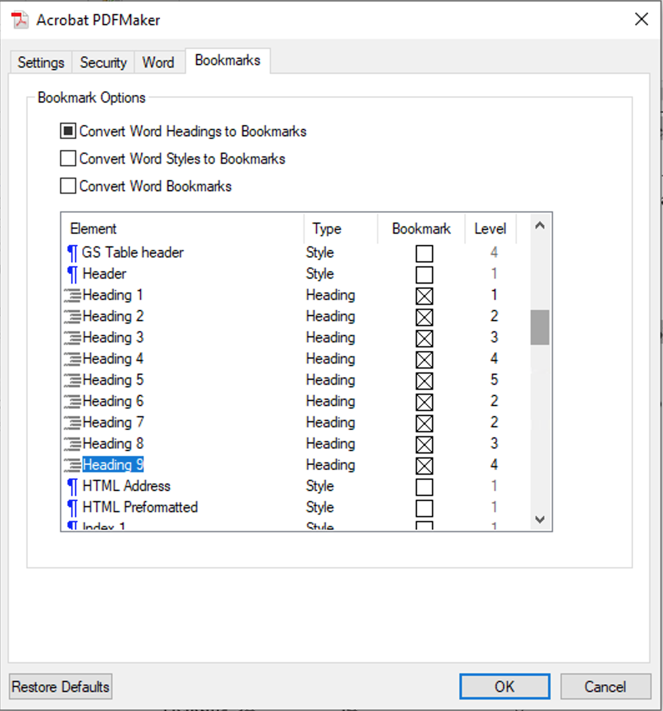ilkinilkinilkinilkinilkinilkinilkinilkinilkinilkin

Figure .. Screenshot of how to assign levels to bookmarks in Acrobat using the headings present in this document.ilkinilkinilkinilkinilkinilkinilkinilkinilkinilkin

Lorem ipsum dolor sit amet, consectetur adipiscing elit. Vestibulum commodo mi non eros imperdiet rhoncus. Donec dignissim vehicula ipsum, at imperdiet libero feugiat at. Nunc purus nulla, suscipit vestibulum faucibus vitae, pharetra non tellus. Cras eu arcu at sapien posuere eleifend. Etiam vitae ligula tempor, blandit neque quis, tincidunt ligula.ilkinilkinilkinilkinilkinilkinilkinilkinilkinilkin

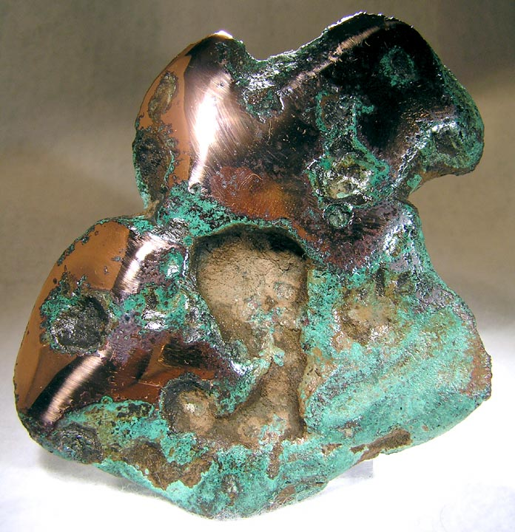ilkinilkinilkinilkinilkinilkinilkinilkinilkinilkin

Figure .. Native copper from Keweenaw County.ilkinilkinilkinilkinilkinilkinilkinilkinilkinilkin

Image source: https://en.wikipedia.org/wiki/Copper_Country. See Appendix B for full attribution and copyright licensing information. Note that when you use Word’s automatic cross-reference command to an Appendix, select “Heading Number (no context)” for best results.ilkinilkinilkinilkinilkinilkinilkinilkinilkinilkin

## Additional Chapterilkinilkinilkinilkinilkinilkinilkinilkinilkinilkin

[Randomly generated typographic filler text] Lorem ipsum dolor sit amet, consectetur adipiscing elit. Curabitur aliquet tincidunt orci, sit amet vestibulum mauris egestas in. Maecenas mattis sollicitudin purus. Quisque scelerisque feugiat ante, eget pretium massa tempus at. Praesent facilisis nibh quis nulla feugiat bibendum. Vivamus blandit ullamcorper velit sit amet vulputate. Ut at pretium enim. Vivamus nec mi eget dui iaculis consequat.ilkinilkinilkinilkinilkinilkinilkinilkinilkinilkin

### Heading 2 Subsectionilkinilkinilkinilkinilkinilkinilkinilkinilkinilkin

[Randomly generated typographic filler text] Lorem ipsum dolor sit amet, consectetur adipiscing elit. Curabitur aliquet tincidunt orci, sit amet vestibulum mauris egestas in. Maecenas mattis sollicitudin purus. Quisque scelerisque feugiat ante, eget pretium massa tempus at. Praesent facilisis nibh quis nulla feugiat bibendum. Vivamus blandit ullamcorper velit sit amet vulputate. Ut at pretium enim. Vivamus nec mi eget dui iaculis consequat.ilkinilkinilkinilkinilkinilkinilkinilkinilkinilkin

## Final Chapterilkinilkinilkinilkinilkinilkinilkinilkinilkinilkin

[Randomly generated typographic filler text] Lorem ipsum dolor sit amet, consectetur adipiscing elit. Curabitur aliquet tincidunt orci, sit amet vestibulum mauris egestas in. Maecenas mattis sollicitudin purus. Quisque scelerisque feugiat ante, eget pretium massa tempus at. Praesent facilisis nibh quis nulla feugiat bibendum. Vivamus blandit ullamcorper velit sit amet vulputate. Ut at pretium enim. Vivamus nec mi eget dui iaculis consequat.ilkinilkinilkinilkinilkinilkinilkinilkinilkinilkin

## Reference Listilkinilkinilkinilkinilkinilkinilkinilkinilkinilkin

This section is required. Use a style appropriate for your field. You may also choose to place references at the end of each chapter. You may use an alternative name for this section such as Works Cited or Bibliography.ilkinilkinilkinilkinilkinilkinilkinilkinilkinilkin

Title of Appendixilkinilkinilkinilkinilkinilkinilkinilkinilkinilkin

Appendices are optional. It is optional to use letters to number your appendices (for example: Appendix A). Use the Heading 7 style to define each new appendix as needed if using A, B, C, etc... Headings 8 and 9 can be used for subsections within an appendix. A page break will automatically be inserted before each new appendix.ilkinilkinilkinilkinilkinilkinilkinilkinilkinilkin

Alternatively, you could choose to continue with the numbering of chapters in your document by continuing to use the Heading 1 style for new chapters. Using Heading 1 is simpler for new appendices. If you use Heading 1, you should not also name the appendices A, B, C. For example, it is not recommended to name an appendix: “6. Appendix A. Thermochemical Data.” Instead, give the chapter a descriptive name: “6. Thermochemical Data.”ilkinilkinilkinilkinilkinilkinilkinilkinilkinilkin

Heading 8 subsectionilkinilkinilkinilkinilkinilkinilkinilkinilkinilkin

[Randomly generated filler text] Lorem ipsum dolor sit amet, consectetur adipiscing elit. Nunc iaculis metus eget orci eleifend, sit.ilkinilkinilkinilkinilkinilkinilkinilkinilkinilkin

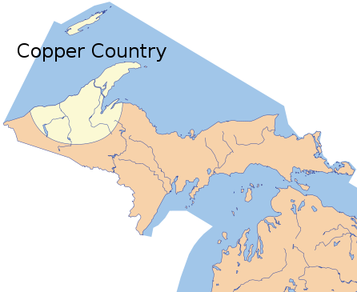ilkinilkinilkinilkinilkinilkinilkinilkinilkinilkin

Figure A.1. Map of the copper country region (light shading). Image source: https://en.wikipedia.org/wiki/Copper_Country. See Appendix B for full attribution and copyright licensing information.ilkinilkinilkinilkinilkinilkinilkinilkinilkinilkin

Heading 9 subsectionilkinilkinilkinilkinilkinilkinilkinilkinilkinilkin

Lorem ipsum dolor sit amet, consectetur adipiscing elit. Ut efficitur urna convallis ante sagittis commodo. Donec orci purus, lobortis a. ilkinilkinilkinilkinilkinilkinilkinilkinilkinilkin

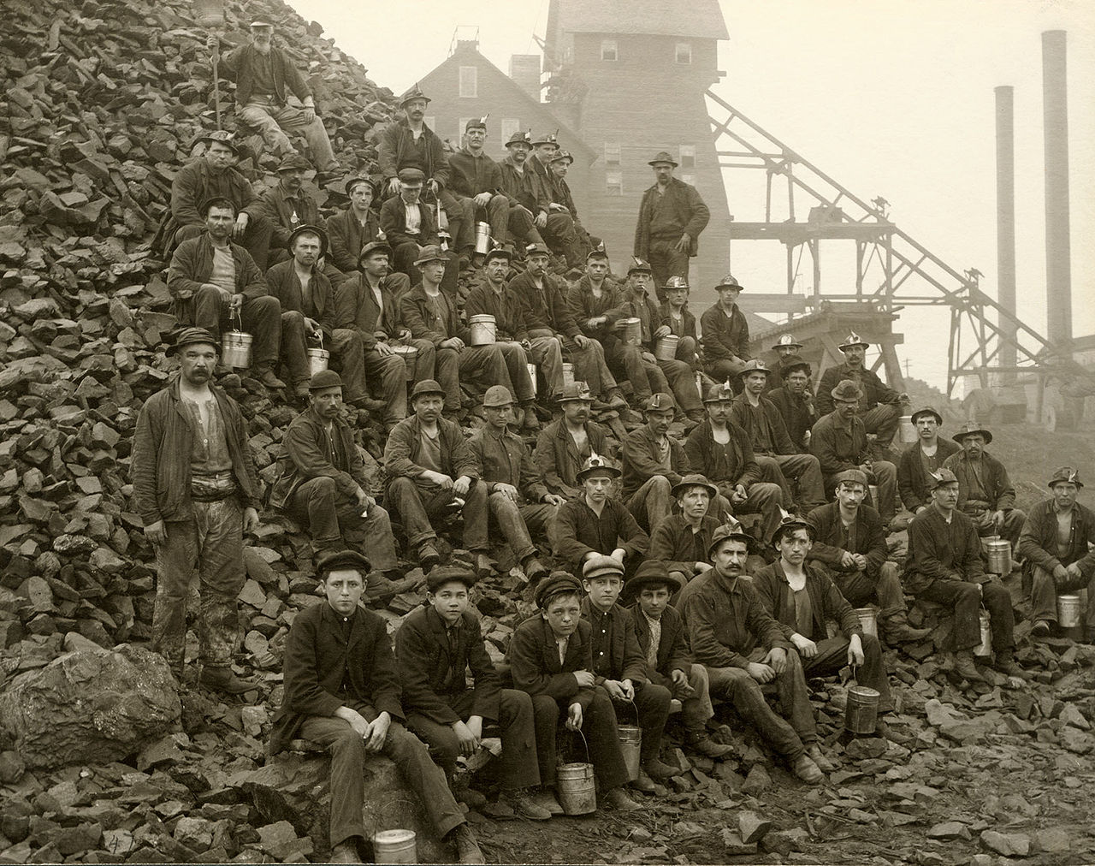ilkinilkinilkinilkinilkinilkinilkinilkinilkinilkin

Figure A.2. Miners with lunch pails at the Tamarack mineshaft. Image source: <https://en.wikipedia.org/wiki/Copper_Country>. See Appendix B for full attribution and copyright licensing information.ilkinilkinilkinilkinilkinilkinilkinilkinilkinilkin

Lorem ipsum dolor sit amet, consectetur adipiscing elit. Ut efficitur urna convallis ante sagittis commodo. Donec orci purus, lobortis a.ilkinilkinilkinilkinilkinilkinilkinilkinilkinilkin

Table A.1. Important dates in the history of the Graduate School at Michigan Tech.ilkinilkinilkinilkinilkinilkinilkinilkinilkinilkin

|  |  |
| --- | --- |
| Date | Event |
| 1885 | Michigan Mining School is established |
| 1927 | First masters’ degree are awarded |
| 1934 | First PhDs are earned |
| 1950 | The Board of Control approved the creation of the Graduate School |
| 1960 | First dean of the Graduate School was appointed |
| 2005 | First female dean of the Graduate School, Jacqueline Huntoon, was appointed |
| 2009 | Graduate enrollment exceeds 1000 students for the first time |

Lorem ipsum dolor sit amet, consectetur adipiscing elit. Ut efficitur urna convallis ante sagittis commodo. Donec orci purus, lobortis a.ilkinilkinilkinilkinilkinilkinilkinilkinilkinilkin

Copyright documentationilkinilkinilkinilkinilkinilkinilkinilkinilkinilkin

You must provide documentation for all copyrighted material that you include in your document. Below is an example of how this can be accomplished. See Section 5.3 of the *Guide* for more information.ilkinilkinilkinilkinilkinilkinilkinilkinilkinilkin

All images in this document are from Wikipedia. They are all public domain, or licensed for reuse under Creative Commons license 3.0. Please see below for full citation and attribution information.ilkinilkinilkinilkinilkinilkinilkinilkinilkinilkin

Figure 1.1: “Michigan Copper Country” by Phizzy at the English language Wikipedia. Licensed under CC BY-SA 3.0 via Wikimedia Commons - <https://commons.wikimedia.org/wiki/File:MichiganCopperCountry.svg#/media/File:MichiganCopperCountry.svg>. Accessed July 2015.ilkinilkinilkinilkinilkinilkinilkinilkinilkinilkin

Figure A.1: “Tamarack Miners Copper Country MI sepia” by Adolph F. Isler (1848-1912); dust cleaned up by Howcheng. - Keweenaw National Historical Park archives, Jack Foster Collection. Downloaded from http://www.fhwa.dot.gov/byways/photos/61352. Licensed under Public Domain via Wikimedia Commons - <https://commons.wikimedia.org/wiki/File:TamarackMiners_CopperCountryMI_sepia.jpg#/media/File:TamarackMiners_CopperCountryMI_sepia.jpg>. Accessed July 2015.ilkinilkinilkinilkinilkinilkinilkinilkinilkinilkin

Figure A.2: “Copper-24459” by Rob Lavinsky, iRocks.com – CC-BY-SA-3.0. Licensed under CC BY-SA 3.0 via Wikimedia Commons - <https://commons.wikimedia.org/wiki/File:Copper-24459.jpg#/media/File:Copper-24459.jpg>. Accessed July 2015.ilkinilkinilkinilkinilkinilkinilkinilkinilkinilkin