**PLANNED MASTER THESIS PROJECT DESCRIPTION**

**Renewable energy efficiency and ICT**

Application of Satellite imagery and satellite data on ICT to calculate an efficiency rate of renewable energy resources

Author:

Ilkin Mammadov

April 2019

**Renewable energy efficiency and ICT**

Application of Satellite imagery and satellite data on ICT to calculate an efficiency rate of renewable energy resources

1.1 Problem area

Renewable energy is a type of energy which can be produced or generated from natural resources. These resources may be solar, wind, geothermal, hydraulic, biomass and so on. In some cases, solar or wind energy can be stored in batteries in order to use later. Renewable energy sources also play the most important role in maintaining continuity and meeting needs.

Furthermore:

* The most important substance for the development of a country is energy. Therefore, renewable energy resources are important,
* It is environmentally important because it reduces the use of fossil fuel,
* Provides new employment and reduces unemployment;
* It is important because it enables the use of electricity to geographical areas where it is difficult to obtain electricity.

People, especially in urban areas can’t get data of alternative energy potential of his/her home, yard or any land.

Application of satellite imagery and ICT together provides its users with necessary information of solar, wind, wave and geothermal energy potential and other services related to that. After realization of this project customers and users who uses that service can get the data of how much green energy can be generated in his/her home or land by analyzing particular area.

Beside that project will also provide services in areas such as installation of solar panels and wind turbines, cost structure, statistics and consulting.

**1.2 Project Overview**

These project is intended to Improve quality of life in urban areas with Earth Observation satellite data:

* Innovative Business models with direct or indirect revenue streams
* Various regularly updated data provide information on cities
* Mobile applications or web-based services permit to reach multiple users
* Interaction with other services or data already existing is key

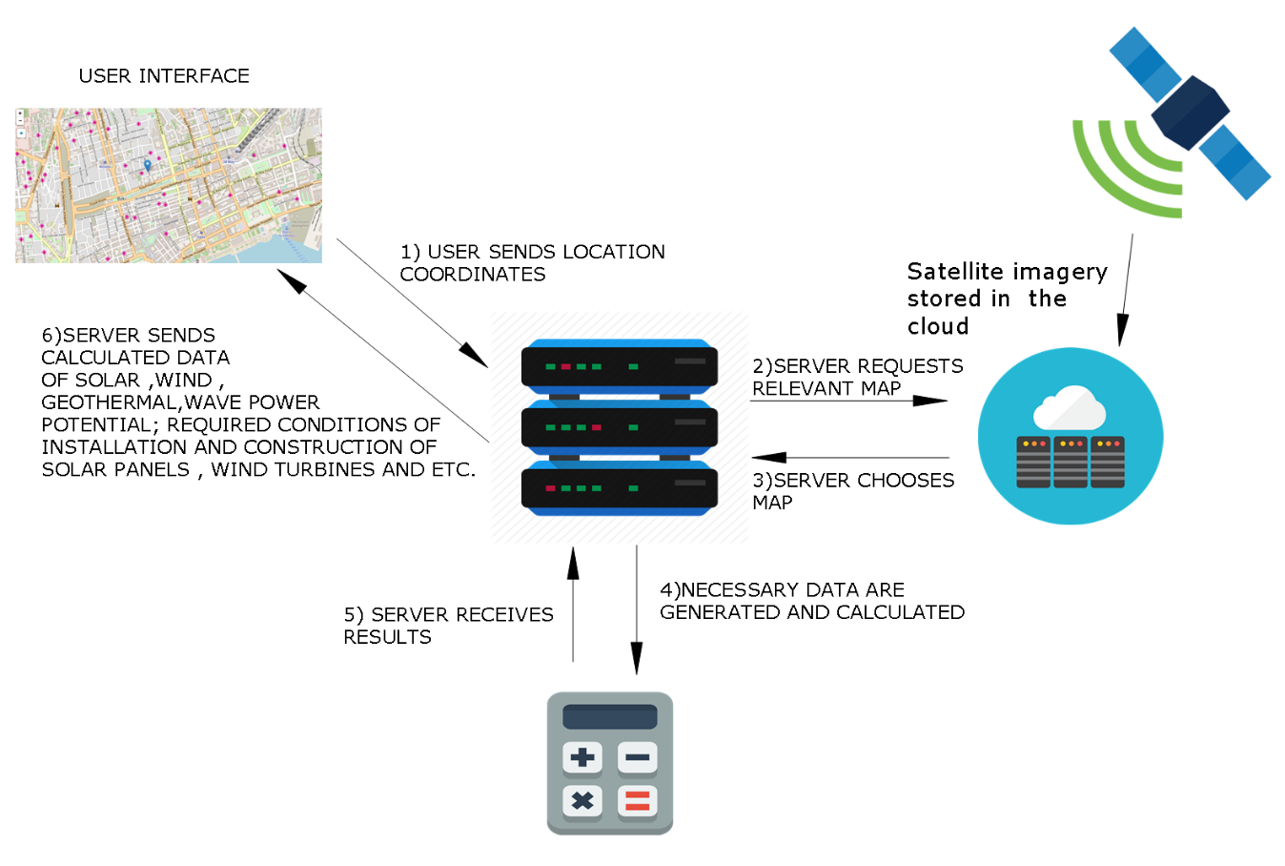**Technical Background of Product**

First , Maps will be retrieved by satellites to cloud server as little parts of map by area.

Satellite sends optical imagery and 3D maps (1)

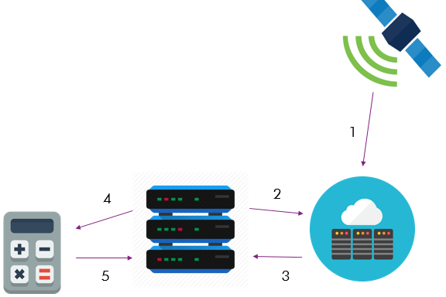

Server selects the relevant part of the map according to the user selected location. (2 and 3)

After selecting map, program generates necessary data which will be sent to user later. (4)

Our system calculates solar resources, wind resources, geothermal energy and water wave energy according to structure values of selected area

Customers and Income  
Potential customers include governments and companies operating in the energy market that use or will use alternative energy, have access to affordable energy resources.  
Initially, the project must complete the pilot phase and go in search of the next potential customer.For successful results, sales can be made through government support and future intergovernmental agreements.  
Key revenue channels and sources of sales revenue are:  
- Service sales  
- Technical service  
- Sale of spare parts  
- Consulting