**PROBLEM STATEMENT:** Traffic Management

**FLOWCHART :**

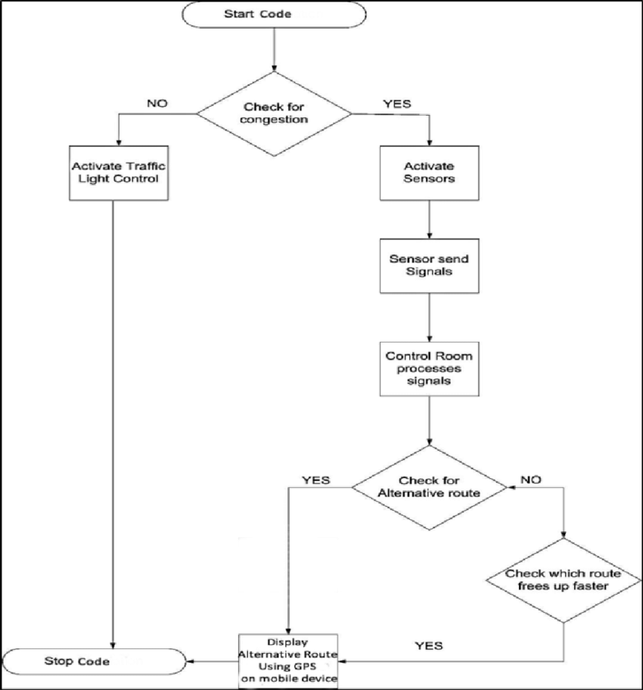

**INNOVATION:**

1. **Real-time Traffic Insights:** The project innovates by providing real-time traffic insights to commuters and traffic authorities. It offers up-to-the-minute information on traffic conditions, allowing commuters to make informed decisions about their routes and helping authorities respond promptly to incidents or congestion.
2. **IoT Data Integration:** The integration of IoT devices, including traffic cameras, sensors, and GPS-equipped vehicles, is an innovative aspect. These devices work together to collect a wide range of data, enabling a comprehensive understanding of traffic patterns.
3. **Advanced Analytics:** The use of advanced data analytics techniques, such as machine learning and predictive analytics, is a significant innovation. These techniques allow the system to not only detect current congestion but also predict future traffic conditions, helping commuters plan ahead.
4. **Geospatial Analysis:** Incorporating geospatial data and analysis into the system is innovative. It allows for location-specific insights and helps commuters and authorities understand traffic conditions in particular areas or on specific routes.
5. **User-Friendly Interfaces:** The project innovates by providing user-friendly web and mobile applications that make traffic information accessible to a wide audience. These interfaces offer interactive maps, real-time updates, and personalized route recommendations.
6. **Alerting and Notifications:** The implementation of an alerting system that notifies users about traffic incidents, congestion, or alternative routes in real-time is innovative. It enhances the user experience and safety.
7. **Data-Driven Decision Making:** Enabling data-driven decision-making for both commuters and traffic authorities is a significant innovation. Commuters can optimize their travel plans, while authorities can use data insights for more effective traffic management.
8. **Scalability and Flexibility:** The project's design for scalability and flexibility is innovative. It allows the system to accommodate increased data volumes and adapt to changing traffic patterns and user needs over time.
9. **Privacy and Security:** The project takes privacy and security seriously, ensuring that user data is protected and compliant with data protection regulations. This approach to data security is an essential innovation.
10. **Public Access:** Making the traffic information accessible to the public through websites and mobile apps is an innovative step. It empowers commuters with valuable information, contributing to a more efficient and stress-free travel experience.

**ROAD MAP :**

**STEP 1 : To detect and analyse the location of the vehicles.**

**STEP 2 : By using cameras we can capture the vehicles location to know congestion place and also by another way using sensor also we can detect the congestion location by users mobile .**

**STEP 3 : Then using these IOT devices we can detect and avoid traffic congestion and to maintain traffic management easily.**

**STEP 4 : Then by this way we know and avoid the congestion occurs.**