**Review of the Basics of Circuit Design, Test, and Measurement**

**Spring 2021**

**Introduction**

The purpose of this lab is to reacquaint you with basic lab equipment such as a digital multi-meter and the Analog Discovery 2 (the AD2 is a very powerful tool that includes an oscilloscope, a function generator, a power supply, etc.), as well as SPICE circuit simulation software like LTspice. Both LTspice and the AD2 are powerful tools for circuit designs and debugging, and it is important for you to know how to use them well.

This lab will first review what you have learned from previous classes about circuit measurements using a digital multi-meter (DMM). Then, it will move on to some simple amplifier and filter designs using the standard engineering design process: circuit design, simulation, implementation and testing.



Please note that you can complete this whole lab with your lab-in-a-box parts and equipment.

Total Points: 120

**Lab Procedure**

**Part 1. DMM Basics**

1. What are the color-code bands of a 47k Ω resistor? What is the tolerance of the one in your lab box? (2 pts)

The bands are as follows: yellow, purple, orange, gold

The gold band signifies the tolerance, which is ±5%

2. Use your DMM to measure the actual resistance of this resistor. What is its actual resistance? (2 pts)

Surprisingly, it is exactly 47.0 kΩ

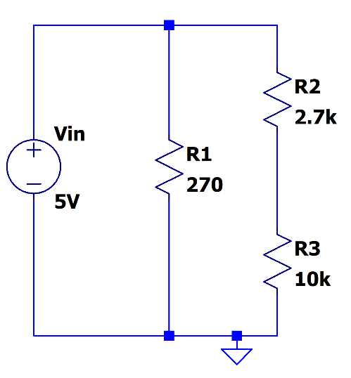Based on the picture below, answer questions 3-8. Round your numbers to two decimal places.

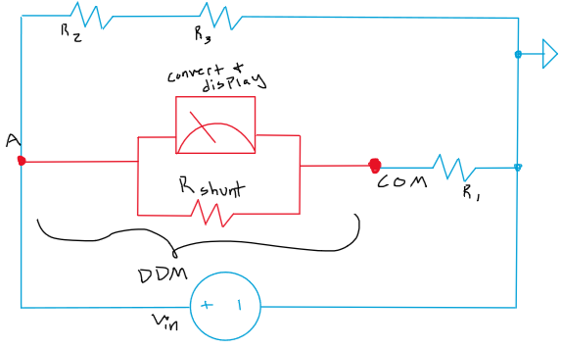3. Show, by drawing, how you would connect your DMM to measure current through R1. Include the circuit inside the DMM. (4 pts)



Current could also be obtained without breaking the circuit by measuring the voltage across R1 and dividing it by the resistance of R1.

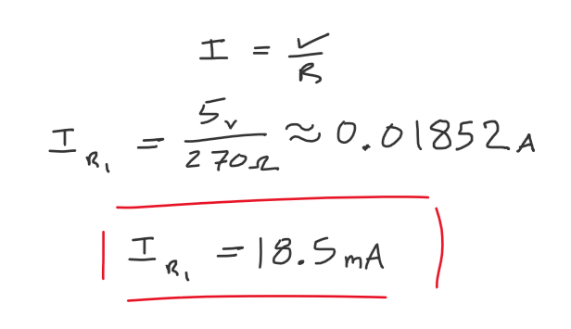4. Calculate the current through resistor R1. (2 pts)

5. Use your DMM to measure the current though resistor R1. You can use your power supply as the input voltage source. Report your measurement below. (2 pts)

The measured value is 19.02mA

6. How much power is dissipated in R1? Use your actual measurement results to calculate this power. (2 pts)

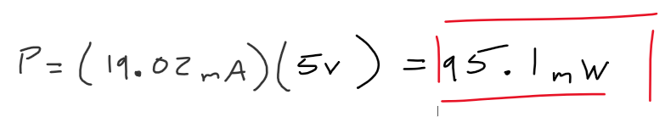

7. Calculate the voltage across resistor R3. (2 pts)

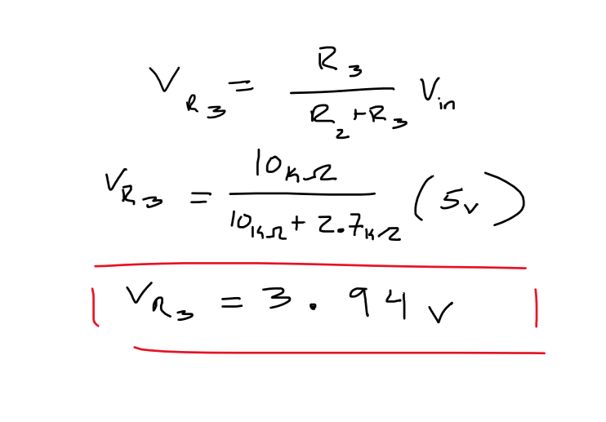

8. Use your DMM to measure the voltage across resistor R3. Report your measurement below. (2 pts)

The measured value is 3.92 V

**Part 2. Amplifier Design**

9. What are the four ideal characteristics of an operational amplifier? (4 pts)

* Infinite input resistance
* Zero output resistance
* Infinite Open-Loop Gain
* Gain independent of Frequency (not certain check this)

10. What is a non-inverting amplifier? Draw the schematic of an op-amp implementation of a non-inverting amplifier and derive its gain equation. (4 pts)

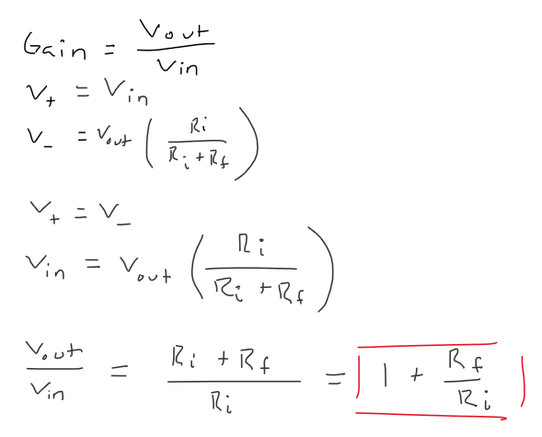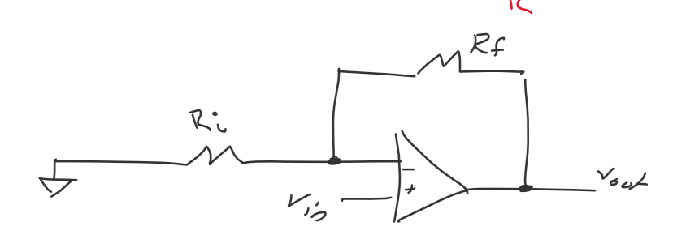

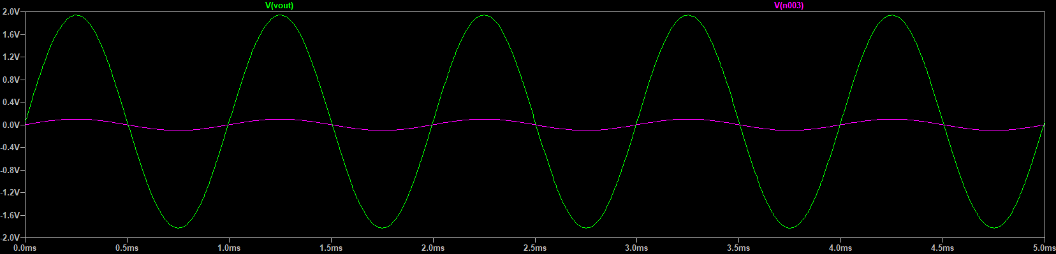11. Design a non-inverting amplifier with a gain of approximately 20. You will need to build this circuit; thus please choose components that are available to you in your parts kit. Run a transient simulation on LTspice with an input AC test voltage (100mV amplitude and 1 kHz frequency); measure the output voltage. Paste your LTspice schematic and simulation result (show both input voltage waveform and output voltage waveform) below. (10 pts)



12. Build this non-inverting amplifier on your protoboard. Use the function generator on your AD2 to generate a 100mV amplitude and 1 kHz frequency AC input signal. Use your AD2 oscilloscope to measure both input voltage waveform and output voltage waveform. Use cursors to show the gain of 20. Paste your measurement result below. Compare the measurement result with your simulation results. (10 pts)

For our circuit, to utilize only components available within the kit, a gain of approximately 19 was utilized. In the physical circuit, as seen in the waveform below, the output voltage at one peak was approximately 1.58 volts when the input voltage was approximately 0.098 volts.

Thus, the gain of the physical circuit would be as calculated below:

$$\frac{Vout}{Vin}=\frac{1.58V}{0.098V}=16.1$$

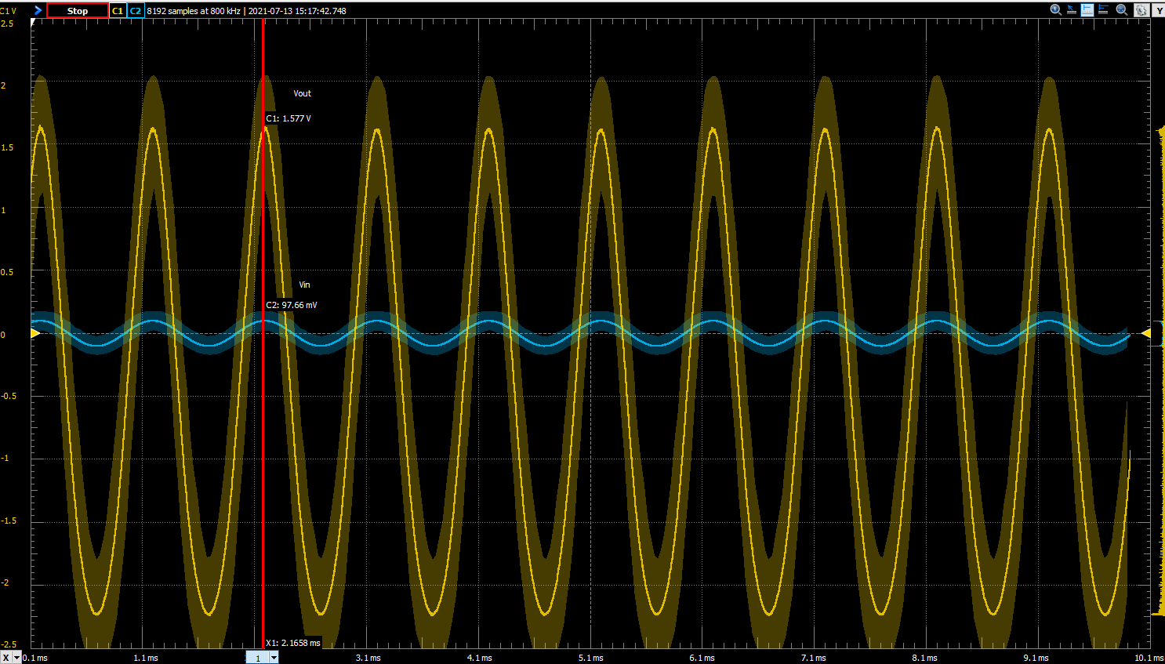The value varies significantly from the predicted value of the simulation. This variance is most likely due to the tolerance of the resistors used as well as the accuracy of the physical Op-Amp in comparison to its simulation. The measurement of the signal does also note that there is variance in the waveforms themselves via the light yellow and blue highlighted areas around each trace.

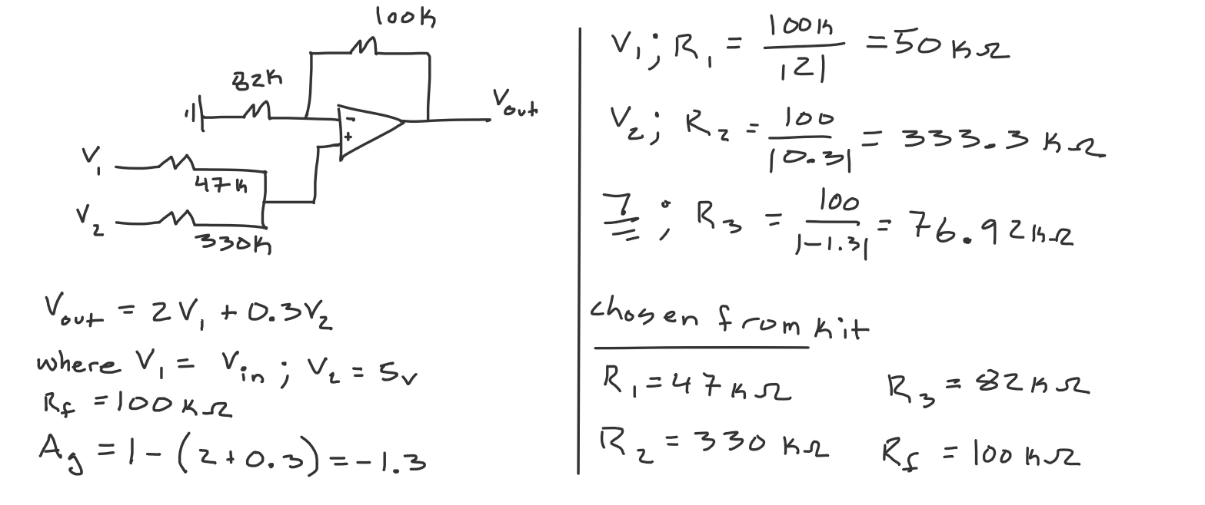13. You have an input signal that ranges from -0.5V to 0.5V. In order to present this signal to an analog to digital converter you want to amplify it by a factor of 2, and shift it so that it occupies the range +0.5 to +2.5V. Design a circuit with op-amps that accomplishes this task, validate it in simulation, build it, and validate that the hardware works as expected. You may use a sine wave of 0.5V amplitude as your test signal. Place all necessary calculations, schematics and validation plots below. (20 pts)

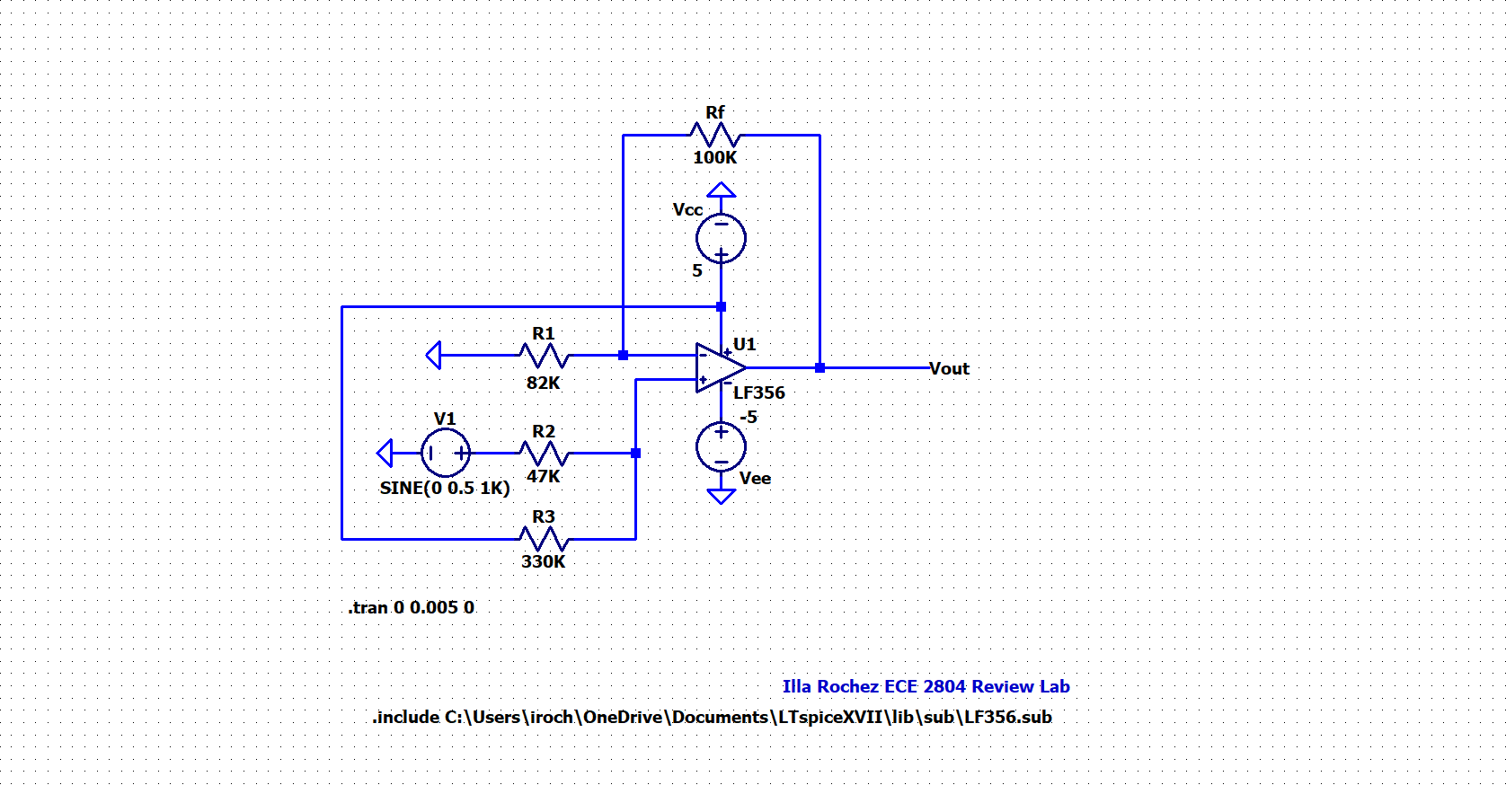

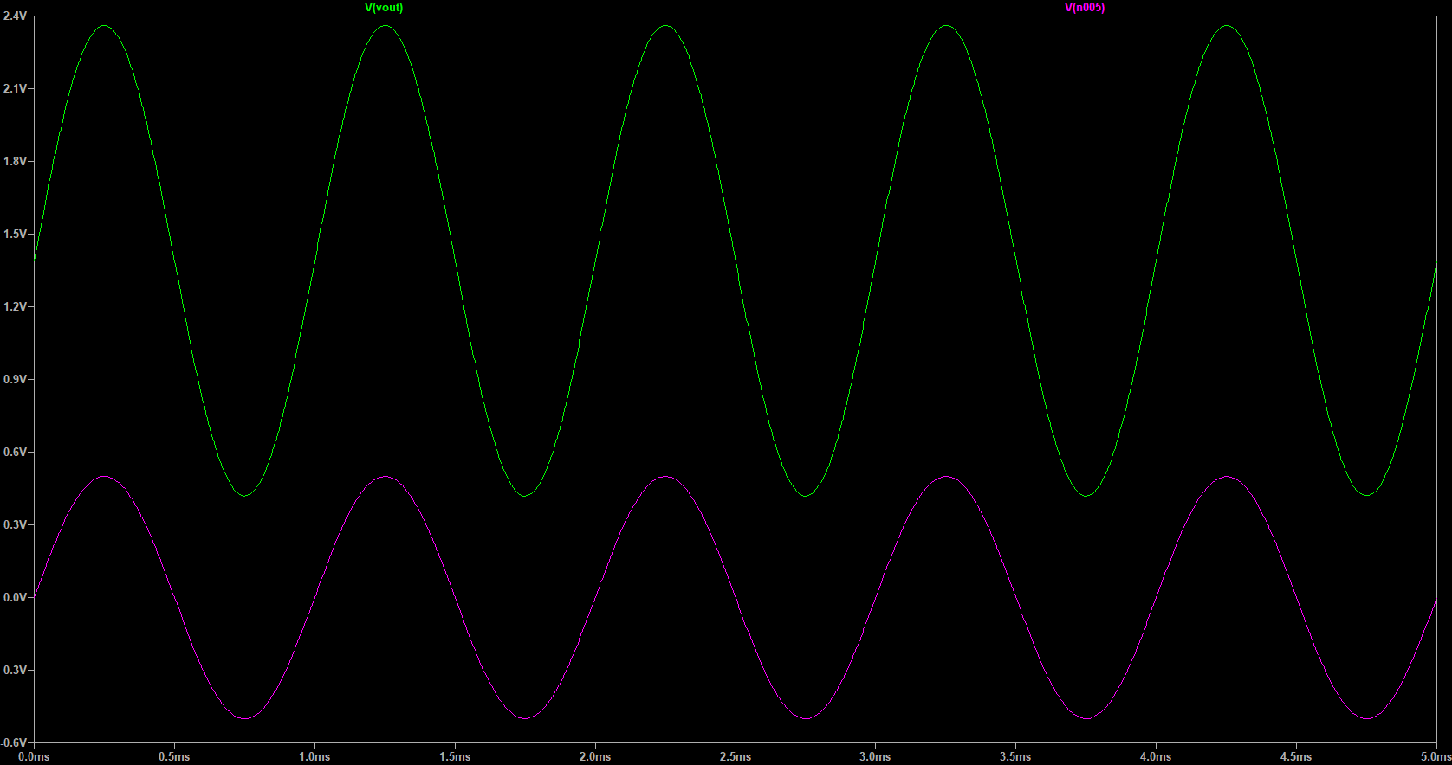

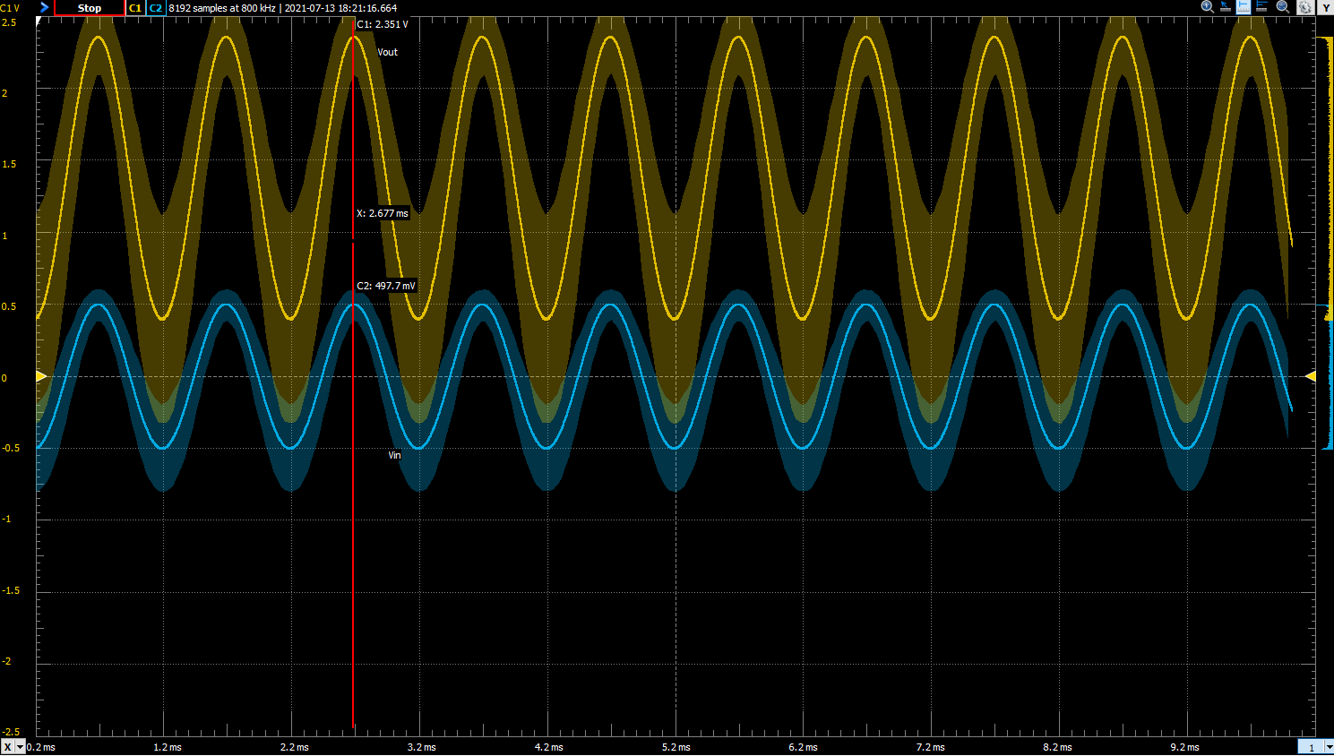

**Part 3. Filter Design**

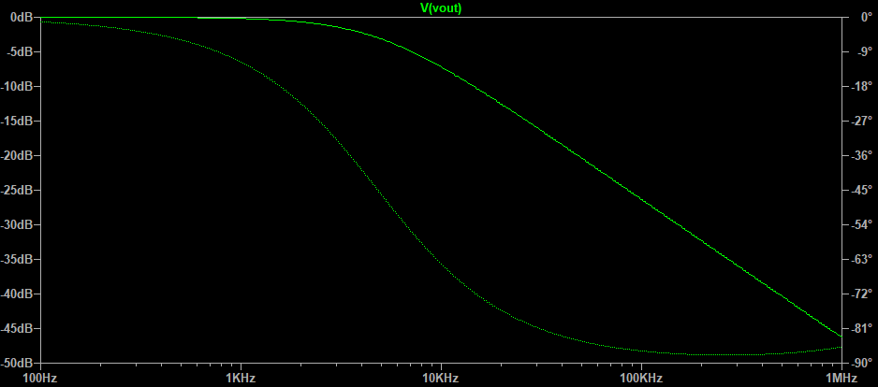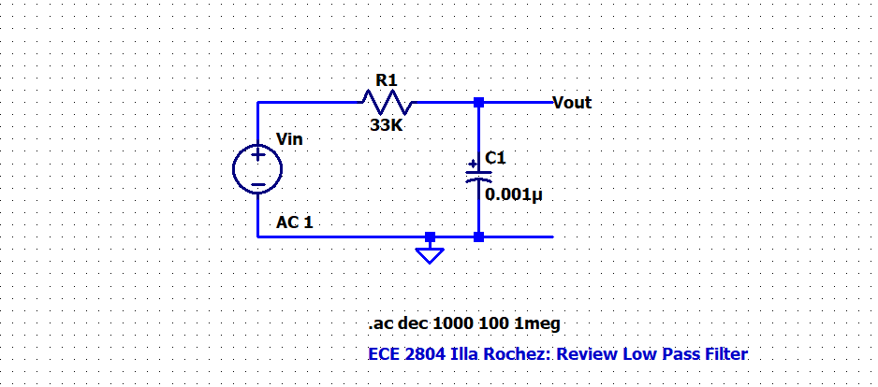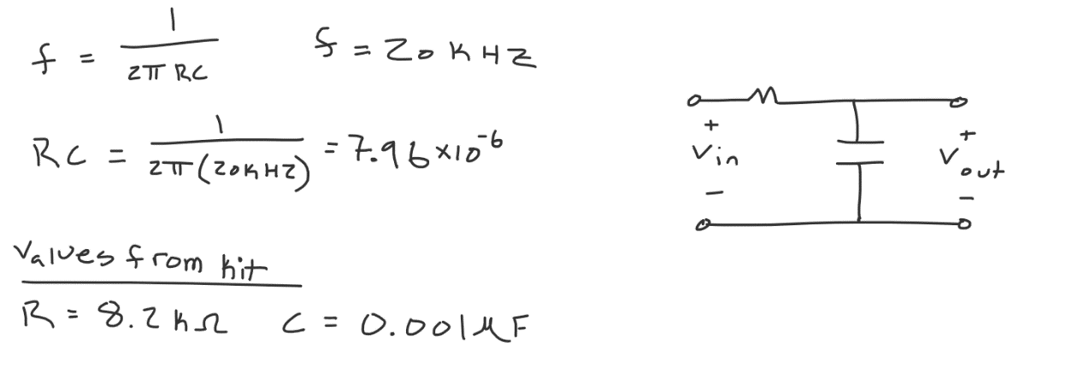14. Design a first order low-pass RC filter that has a break frequency of 20 kHz. Show your calculations. Run an AC sweep from 100 Hz to 1 MHz on LTspice for your circuit and paste your schematic and simulation result below. (10pts)

15. Build the circuit on your protoboard and use the network analyzer on your AD2 to measure the frequency response for the RC low pass filter you designed. Make sure to label the 3dB below passband point (break frequency). Compare the measurement result with your simulation results. (10 pts)

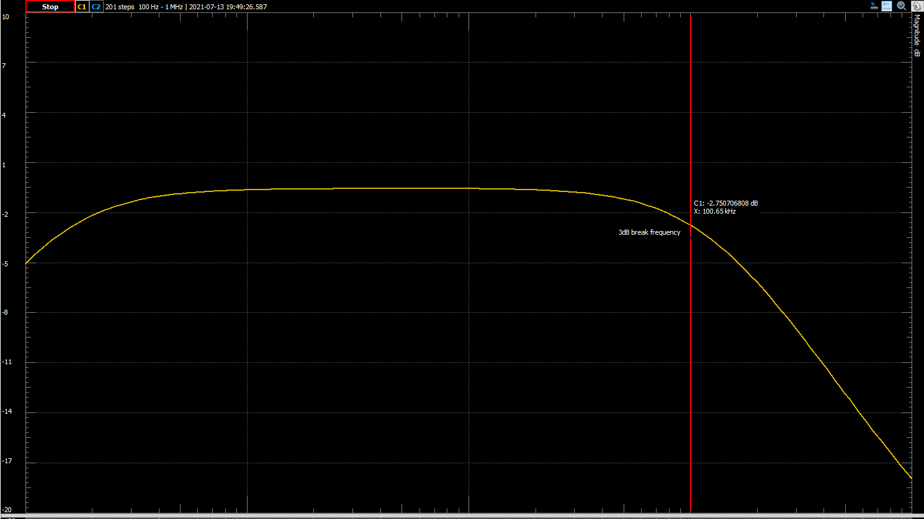

Compared to the simulation, there is a unaccounted for curve at the beginning. This is most likely due to the capacitor’s charging traits. And so a small period of time needed to pass before it was fully primed. The other imperfections may be related to the tolerance of the capacitor and resistor that were used in addition to human error.

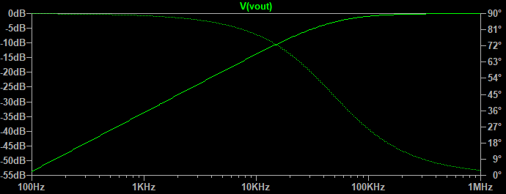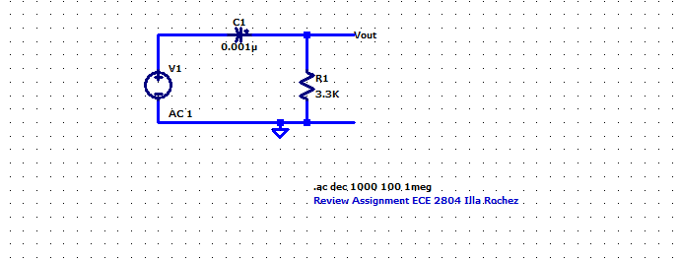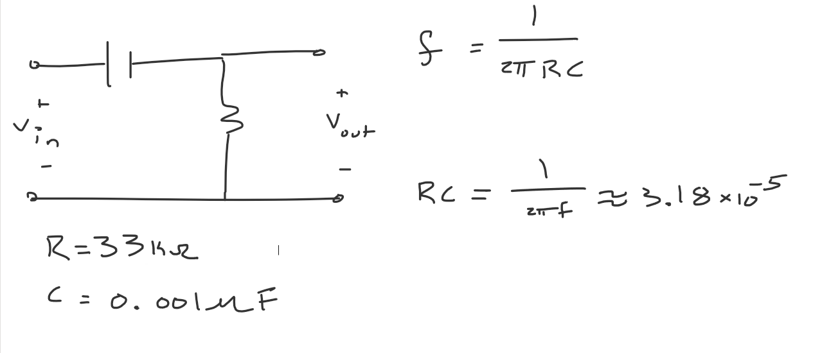16. Design a first order high-pass RC filter that has a break frequency of 5 kHz. Show your calculations. Run an AC sweep from 100 Hz to 1 MHz on LTspice for your circuit and paste your schematic and simulation result below. (10pts)

17. Use the network analyzer on your AD2 to measure the frequency response for the RC high pass filter you designed. Make sure to label the 3dB below passband point (break frequency). Compare the measurement result with your simulation results. (10 pts)

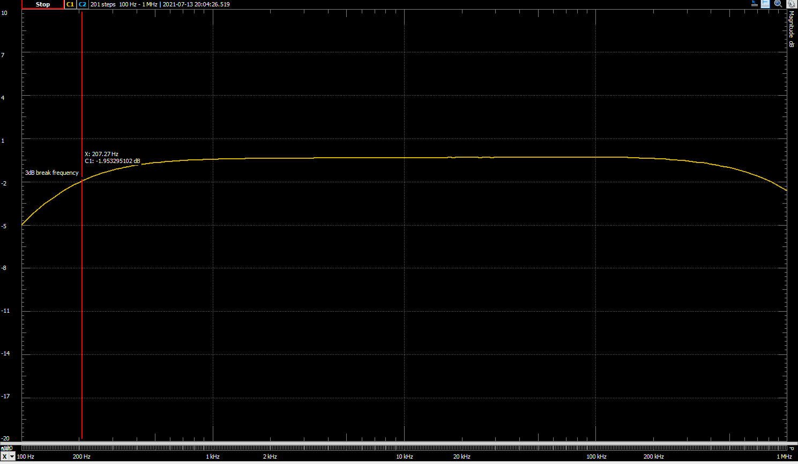This is not anywhere near as accurate as the simulation results, most likely for similar reasons as to why the low pass simulation was more accurate. There could also be error from the usage of values that aren’t exactly equal to the mathematically calculated results for the filter. This may have also altered the placement of the 3dB point.

18. What is the significance of the 3dB below passband cutoff point? (4 pts)

The significance of this point lies in what happens before or after the point (depending on if the circuit is a low pass or a high pass filter.). On a low pass filter for example, after the 3dB point, the graph begins to slope downward until it eventually hits the stop frequency, completely terminating the signal. Similar results occur on a high pass filter where all of the values before the 3dB point are “filtered” out. This point determines at what frequency the filter starts or stops.

19. Find a way to combine the previous circuits to produce a bandpass filter that has a lower 3dB point at 5 kHz and an upper 3dB point at 20 kHz. Validate your new circuit with LTspice, implement it, and validate the hardware by measuring its frequency response. In both simulation and measurement, show that the 3dB points are in the correct locations. Paste any necessary calculations, schematics or plots below. (10 points)

