- Follow this link and download the Cloud SDK Installer according to the instructions on the page: https://cloud.google.com/sdk/docs/install.
  - Make sure that someone has added you to the cloud project before using the command line
- Go to the GitHub/Libraries folder
- Download the cloud_sql_proxy.exe, a mssql.jar file, and a .dll file corresponding to your OS (x64 or x86)
  - Ignore the mysql.jar file for now. That’s for mysql and at the moment we are using SQL Server
  - You’ll want to install the .jar file that is the same as your java version version. I was only able to get jre8 version to work even though I have a higher version installed on my PC, so I don’t know exactly how it works.
    - You can check your java version by typing: java -version into a command line
- Place the cloud_sql_proxy.exe in a place you can easily find it (I put mine where I have all my code for the class)
- Place the .dll file inside of Program Files/Java/JDK_Version/bin folder, or wherever your JDK is installed. Default is Program Files.
- Place the .jar file somewhere you can easily find. I placed mine in the JDK folder, outside of the bin folder
- Type “Environment Variables” into the windows search bar to open this window:
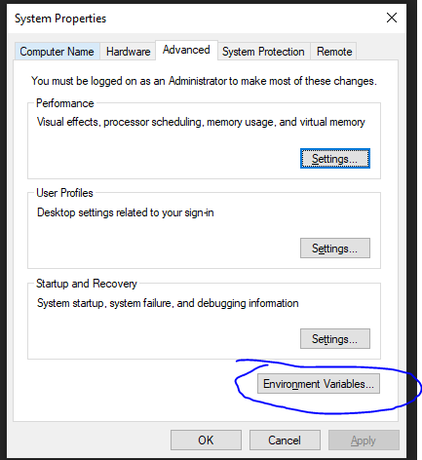
- Click on “Environment Variables” in the new window that opened.
- In the new window that opened, find or create the CLASSPATH variable under “User Variables”
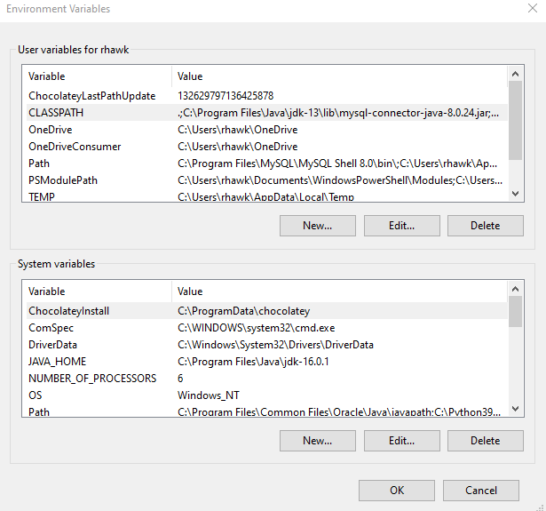
  - If creating, click “New…”, type CLASSPATH as the variable name, and the variable value is the full path to the jar file you installed.
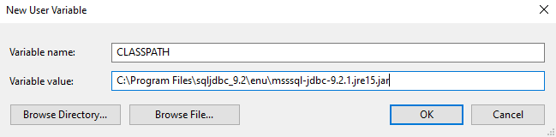
  - If editing, click “Edit…” once you’ve selected CLASSPATH. In the new window click “New” and enter the full path to the jar file you installed.
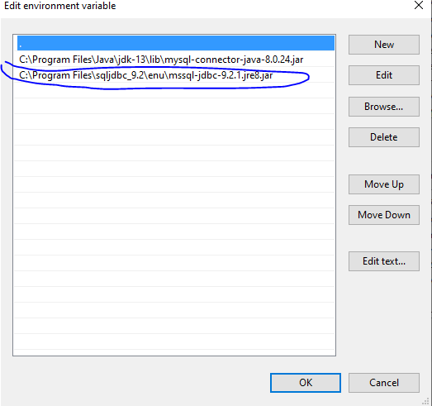
- Close out of the Environment Variables
- Go into your IDE and add the .jar file you installed as a referenced library to the project you are working in
  - Google is your friend if you don’t know how to do this on your IDE (I didn’t at first).
- Now download the most recent JavaToSQL files from the GitHub
- Save them to your project and open them.
- Before running them, open your Google Cloud SDK (If not open)
  - Run the command gcloud -init, unless the console already has
    - Ignore setting up a default region and timezone
  - Follow the prompts for signing in and connecting to the recipe-finder-database
  - Once the sign in has been complete, run this command: "C:\Users\rhawk\Documents\College\CS 380\cloud_sql_proxy.exe" -instances=recipe-app-server:us-west1:custom-recipe-380=tcp:1433
    - Replace my file path with your file path to the cloud_sql_proxy.exe, making sure to include the quotes
- Once that is done, the console should be listening and ready for new connections.
- Create a new Java file with a main method, and create a “CreateDatabase” object and run the createDatabase method.
  - Don’t worry about deleting anything when running this method. I have it to not create a database and tables if they exist

