# Iteration 1

## Planning

Reads data from 2 files and displays the contents of each file in a table

## Design

**PSEUDO CODE**

/* $scope.getData() */

// when the ‘Read File’ button is pressed..

// check that no files have been loaded previously..

// if so, set ‘status’ to indicate this is the first file

// call ‘readFile()’ function to read input ‘file’ as first file

// otherwise, check ‘status’ to see if the first file has been read

// if so, set ‘status’ to indicate this is the second file

// call ‘readfile()’ function to read input ‘file’ as second file

// otherwise, check ‘status’ to see if the second file has been read

// if so, set ‘status’ to indicate no more files are to be read

/* $scope.readFile() */

// new instance of ‘FileReader()’ using input ‘file’, and store in a variable

// read contents of variable as text

// onload..

// store result of reading-as-text in new variable

// call ‘convertStringToNumbers()’ function to convert result to numbers

// send array of numbers to global array

// check if both files have been read

// if so, call ‘calculate()’ function with both files as inputs

## Time Log

**ITEM ESTIMATED TIME ACTUAL TIME**

Pseudo Code 20 mins 1 hour, 20 mins

Construction 1 hour 2 hours, 30 mins

Testing 30 mins 1 hour. 15 mins

**Total 1 hour, 50 mins 5 hours, 5 mins**

## Testing

**JSHint**

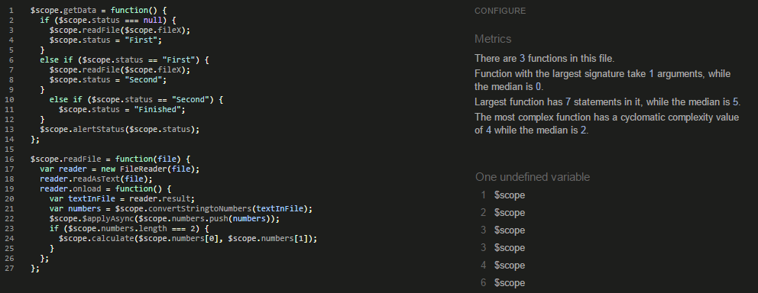

# Iteration 2

## Planning

Display means and standard deviations for each file.

## Design

**CLASS DIAGRAM**

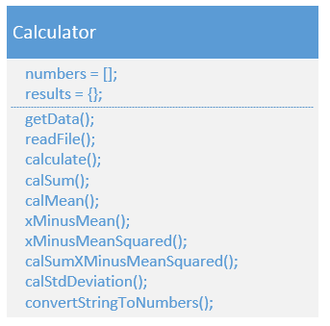

## Time Log

**ITEM ESTIMATED TIME ACTUAL TIME**

Design 30 mins 20 mins

Construction 1 hour 1 hour, 45 mins

Testing 20 mins 40 mins

**Total 1 hour, 50 mins 2 hours, 45 mins**

## Testing

**JSHint**

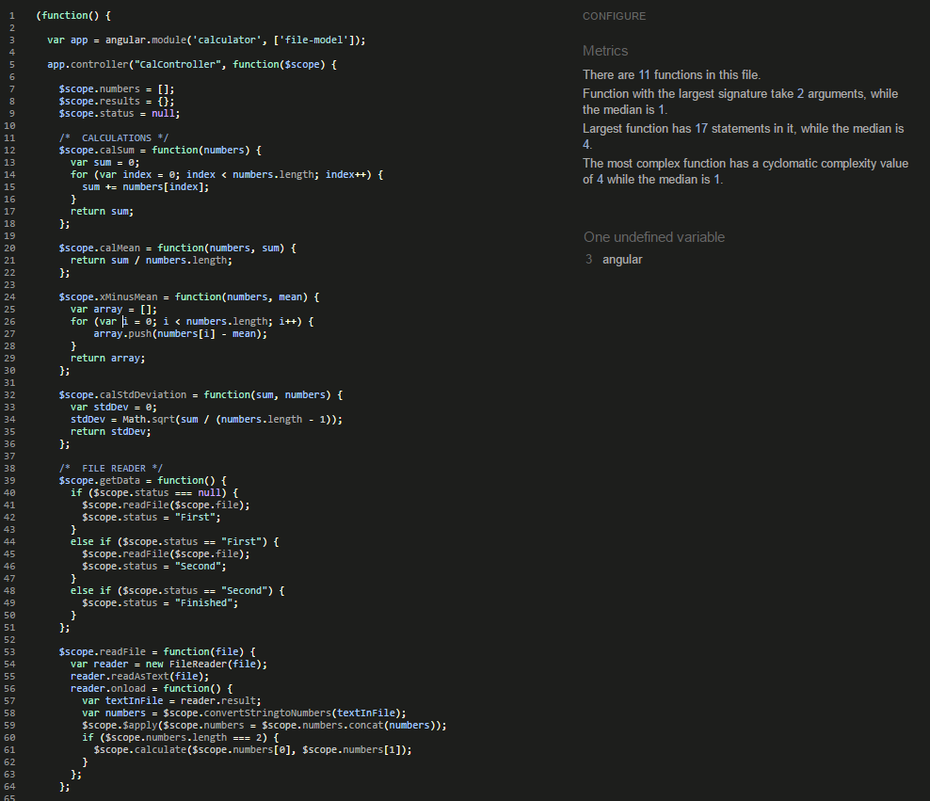

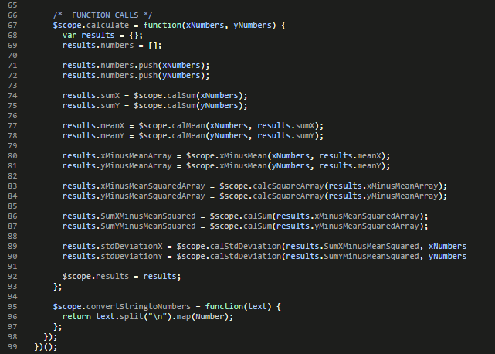

# Iteration 3

## Planning

Calculates and displays the linear regression parameters beta0 and beta1.

## Design

**CLASS DIGRAM**

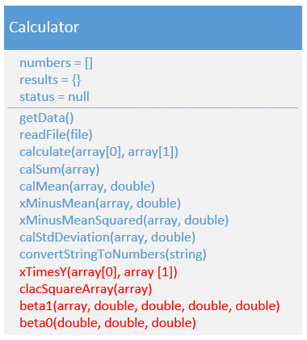

## Time Log

**ITEM ESTIMATED TIME ACTUAL TIME**

Design 10 mins 5 mins

Construction 40 mins 20 mins

Testing 10 mins 10 mins

**Total 1 hour 35 mins**

## Testing

**JSHint**

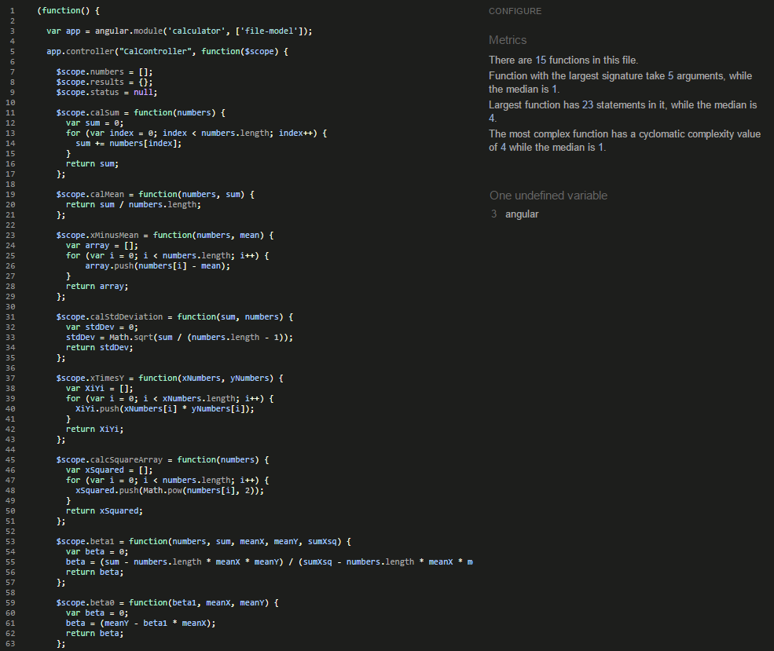

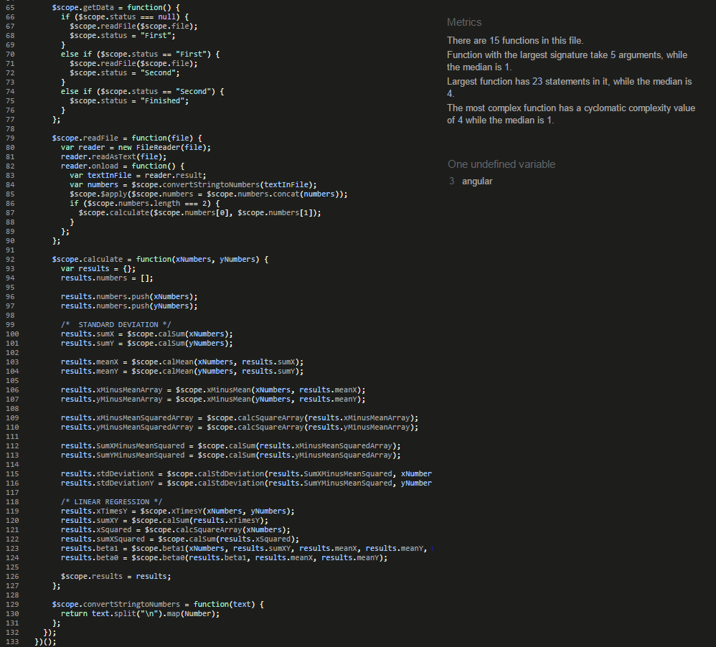

# Iteration 4

## Planning

Calculates and displays the correlation coefficients r and r^2

## Design

**CLASS DIAGRAM**

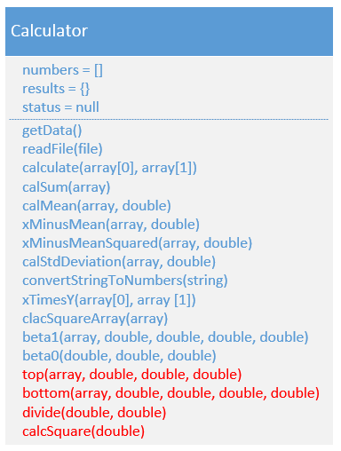

## Time Log

**ITEM ESTIMATED TIME ACTUAL TIME**

Design 10 mins 5 mins

Construction 30 mins 15 mins

Testing 10 mins 10 mins

**Total 50 mins 30 mins**

## Testing

**JSHint**

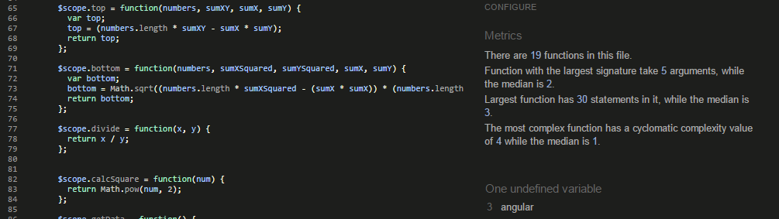

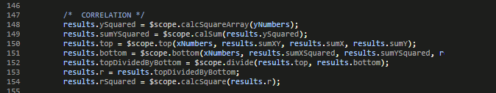

# Iteration 5

## Planning

Given and estimate, Xky calculates and displays a predicted Yk.

**NOTE:** With this iteration, I was unsure whether we were to assume Xk = 386, or whether Xk would need to be defined by the user, so constructing the code assuming Xk = 386 was rather easy, as it was just defining another function, function call, and storing it again within the results object. But I also constructed an input field that allowed the user to define Xk, and then perform the Yk calculation. I commented out the assumption code in case it was needed.

## Design

**CLASS DIAGRAM**

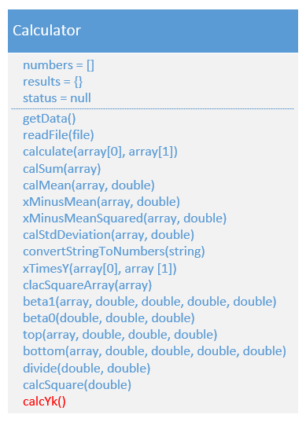

## Time Log

**ITEM ESTIMATED TIME ACTUAL TIME**

Design 10 mins 10 mins

Construction 1 hour 1 hour, 20 mins

Testing 15 mins 20 mins

**Total 1 hour, 25 mins 1 hour, 50 mins**

## Testing

**JSHint**

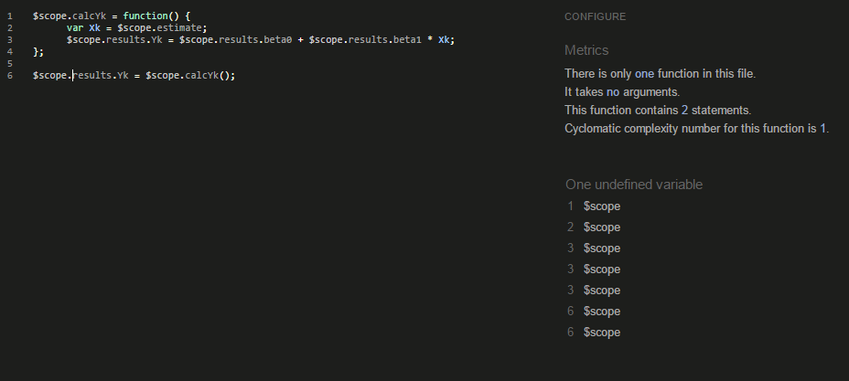

# Iteration 6

## Planning

STRETCH GOAL: Program is enhanced to store data and results in LocalStorage.

## Design

**PSEUDO CODE**

// When both files are loaded, calculations are performed, and the data & results are passed to a function called ‘sendToStorage()’.

// sendToStorage()..

// convert object containing data & results to a string

// store string object in LocalStorage

// when the ‘Read Storage’ button is pressed, call function ‘loadStorage()’.

// loadStorage()..

// retrieve string object from LocalStorage and store in a variable

// parse string object to original form and store in a variable

// return stored contents to original object to be displayed

## Time Log

**ITEM ESTIMATED TIME ACTUAL TIME**

Pseudo Code 10 mins 5 mins

Research 20 mins 10 mins

Construction 1 hour 20 mins

Testing 20 mins 5 mins

## Testing

**JSHint**

