Proposed application:
Design and build a program for generating briefly weekly reports with details of cars for sale into a separate text file for a sales department of a used car dealership using given in CSV file data. //add all conditions. Highlight: the cheapest car available, average price of cars, average mileage of all cars, and total cars for sale including total value of the stock.

Stakeholders
- Sales department;
- Data administrator;
- Management;
- Owners.

Requirements:

Functional Requirements:
FR-001: Data should be read from a file DealershipStockList.csv provided by data administrator;
FR-002: Data should be processed;
FR-003: Report should be generated and saved to text file.

Non-Functional Requirements
NFR-001: Salespeople should have an access to the report;
NFR-002: Report should include:
- the cheapest car available,
- average price of cars,
- average mileage of all cars,
- and total cars for sale including total value of the stock.
NFR-003: The program should be easy to use for non-technical people;
NFR-004: Should generate a report within an adequate timeframe;
NFR-005: Compatible with computer system which is used;
NFR-006: Reusable every week.

Use case diagram
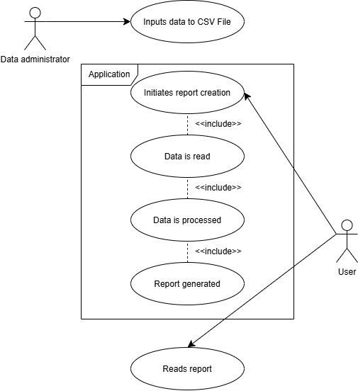

Use case descriptor
Use Case​ | FR-001: Data should be read from a file DealershipStockList.csv provided by data administrator
Objective​ | Application sourced the data needed for report generation from .csv file
Pre-Condition​ | - .csv file exists at the expected path;  - Method created for file reading;  - .csv file is formatted as expected (has all the columns needed and in right order).
Main Flow​ | - Access .csv file;  - Read contents line by line to an array of strings;
Alternative Flow​ | - File does not exist at the expected path;  - Program throws an error “Error: File not found. Please place the CSV file with data to /bin/debug and try again”;  - Program ends;  - Method is not created for file reading;  - Program ends;
Post Condition​ | An array of strings is ready to be processed

Use Case​ | FR-002: Data should be processed
Objective​ | Application sourced the data needed for report generation from .csv file
Pre-Condition​ | - Program has an array of strings;  - Substrings are of correct data types
Main Flow​ | - Program defines a Car class;  - Program creates a list of Car objects;  - Each string of an array splits by ‘,’;  - Program tries to parse each substring into appropriate data type;  - Program writes data as a Car object and adds it to the list.
Alternative Flow​ | - Substring parsing fails  - Program throws an error “Error: failed to parse the data. Please check the data is valid and try again”;  - Program ends.
Post Condition​ | The data is parsed into the List of Cars, has correct data types and is ready to be used for report generation

Flow chart
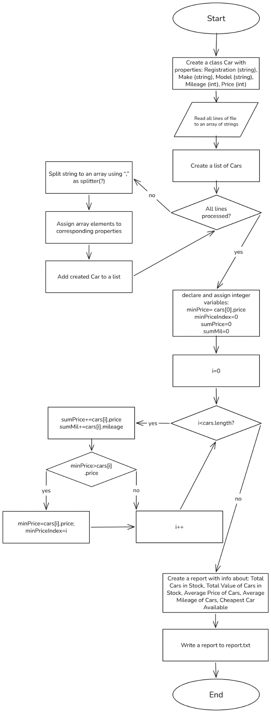

Program Design Language (PDL)
Create a class Car with properties: Registration (string), Make (string), Model (string), Mileage (int), Price (int)
Read all lines of file to an array of strings
Declare a list of Cars
For each line in lines:
Split string to an array using “,” as splitter(?)
Assign array elements to corresponding properties
Add created Car to a list
declare and assign integer variables:
minPrice= cars[0].price
minPriceIndex=0
sumPrice=0
sumMil=0
Loop through 0 to last elements of a list of cars, find minimal price, index of cheapest car, calculate a total value and total mileage
For i=0 to cars.length, i++:
if(minPrice>cars[i].price){minPrice=cars[i].price; minPriceIndex=i} sumPrice+=cars[i].price
sumMil+=cars[i].mileage
Create a report with info about: Total Cars in Stock, Total Value of Cars in Stock, Average Price of Cars, Average Mileage of Cars, Cheapest Car Available
Write a report to report.txt
Conclusion
The proposed application is to provide a way of generating weekly reports about the used car dealership’s stock. During the execution of Task 1, I defined the stakeholders and requirements (3 functional and 6 non-functional). Also, use case diagram was created and use case descriptors for FR-001 and FR-002 were made.
Then, during design stage, I created a flow chart and PDL for proposed application.
These steps helped me to better understand the task given and made a development stage much simple, while also providing an important documentation to the project.

