# Creation of an IAM user on AWS

Use the AWS Console and browse to Users, create a new user Comprehend.

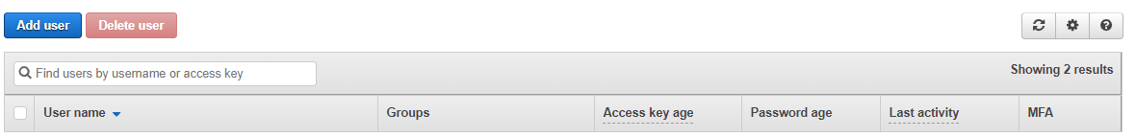

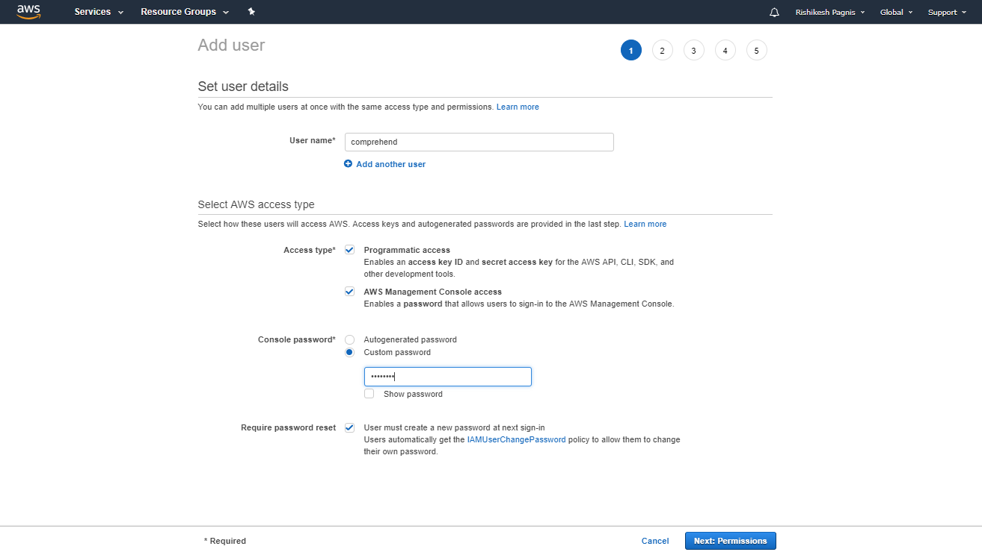

Make sure you have checked the Programmatic Access, Console access may be required if you are planning to provision services such as S3 to store your documents(collection)

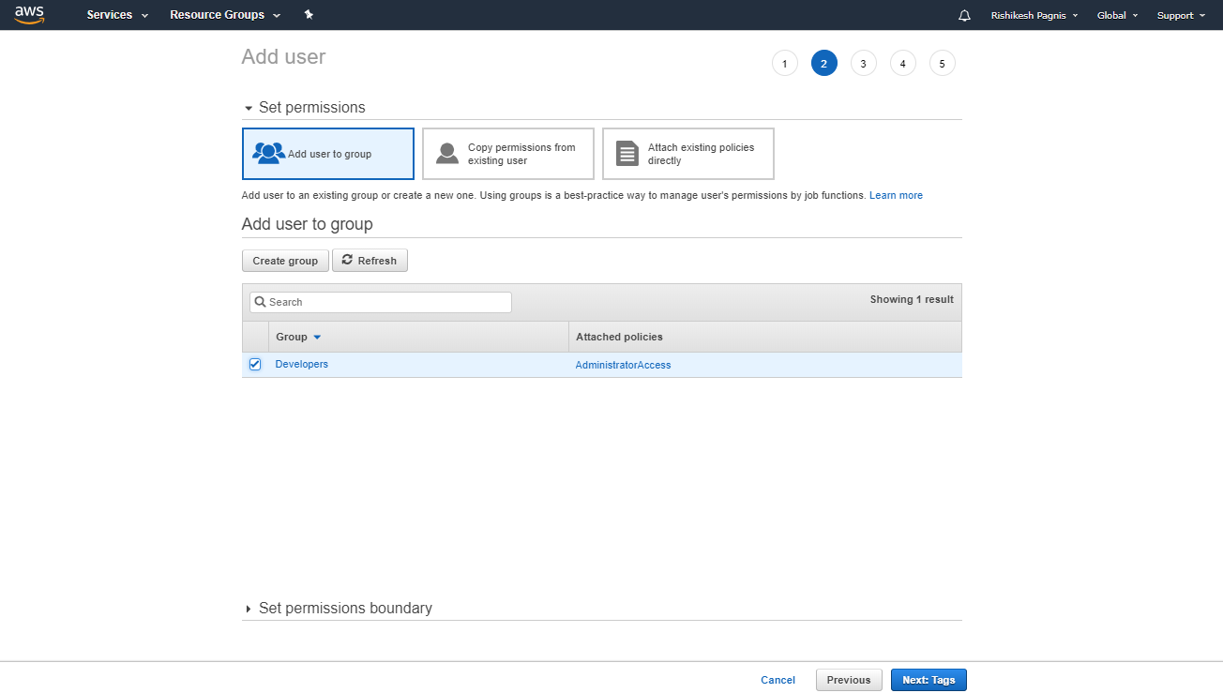

Add User – Comprehend to the group Developers by selecting the group.

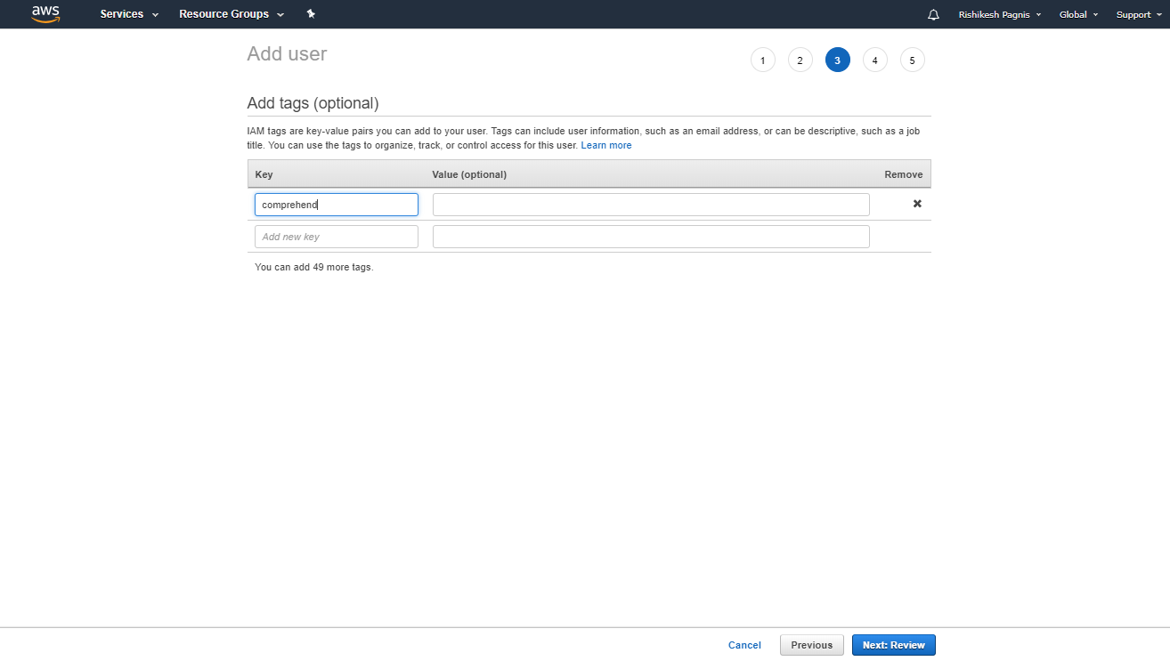

Add tags which are a key value pair to the user, Value is optional. We have used comprehend as the tag.

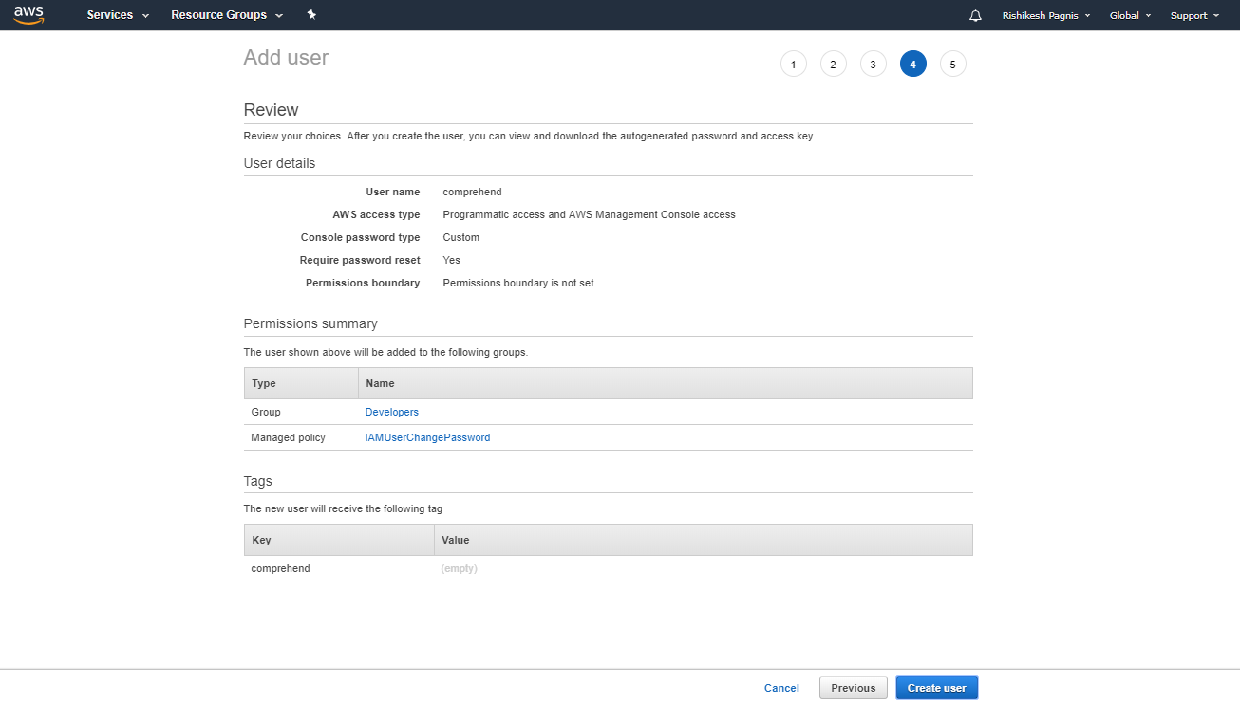

Review the IAM user setup before creating the user.

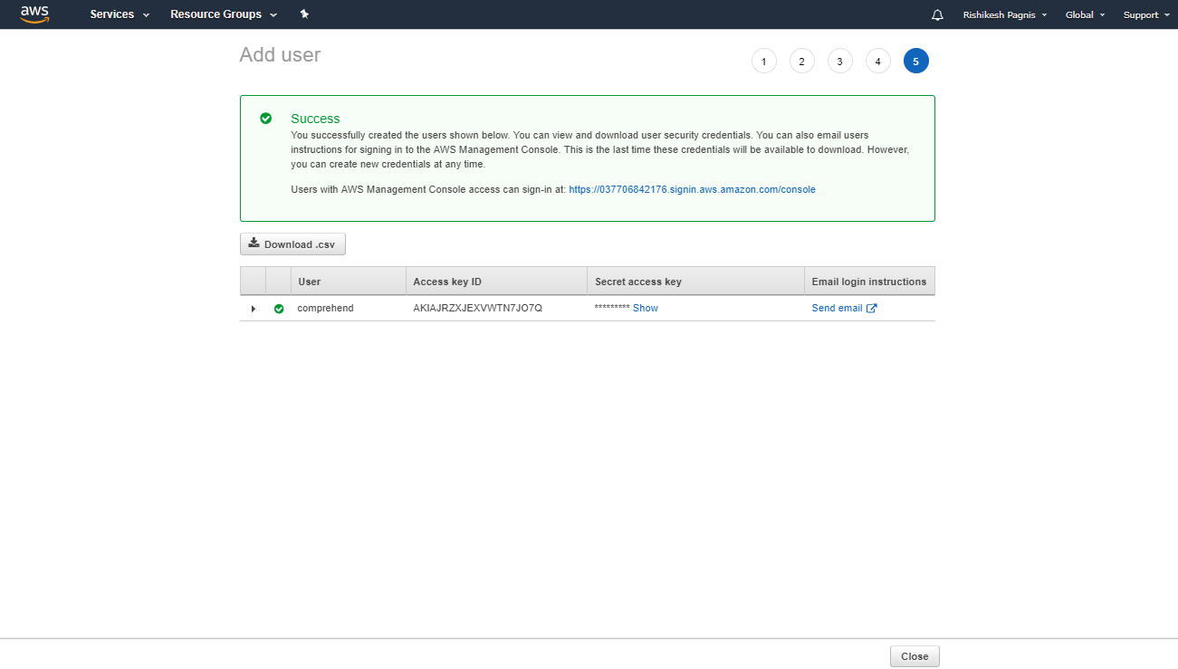

Click Close, you should now be able to see the user that you have created in the user list as below:

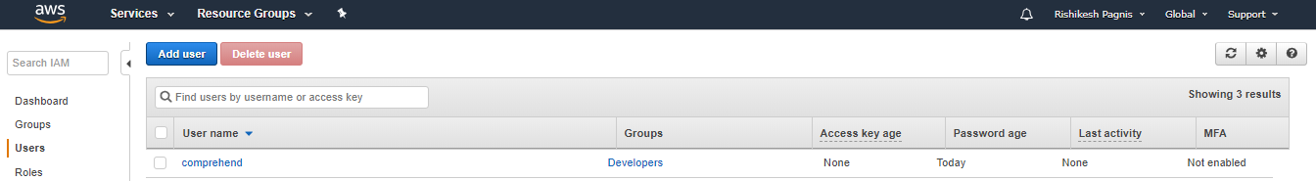

Creation of S3 Bucket

The next step is to create a S3 bucket to store your documents which can be done using the following steps:

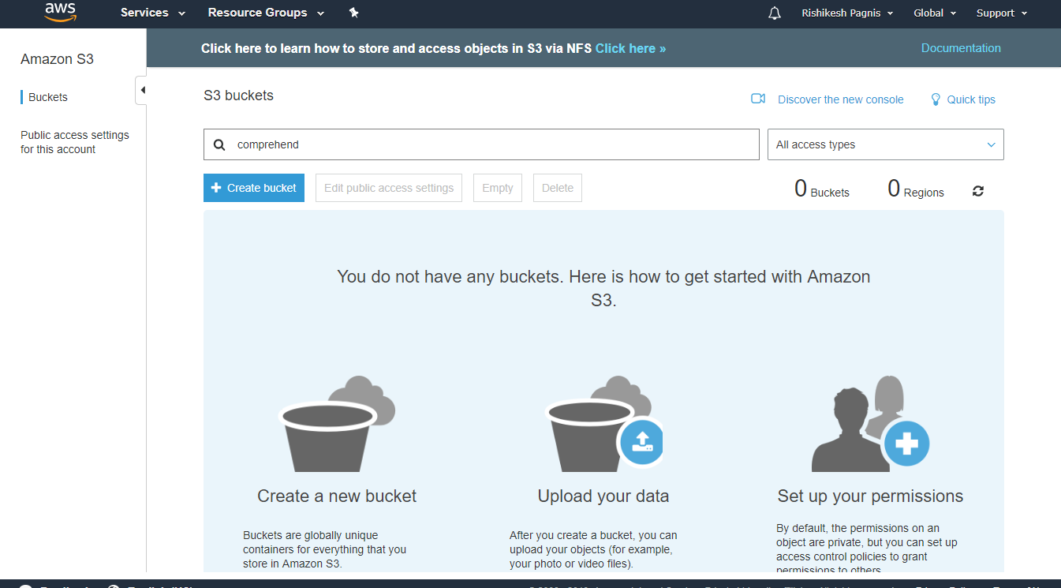

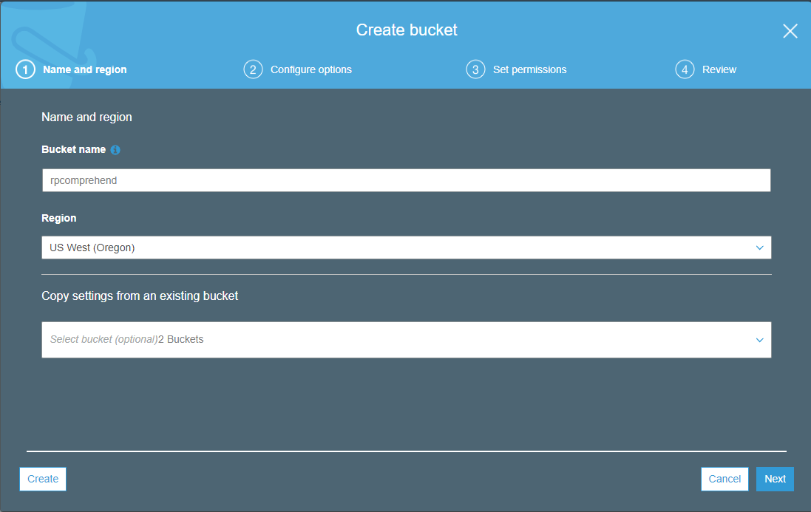

You can then configure options

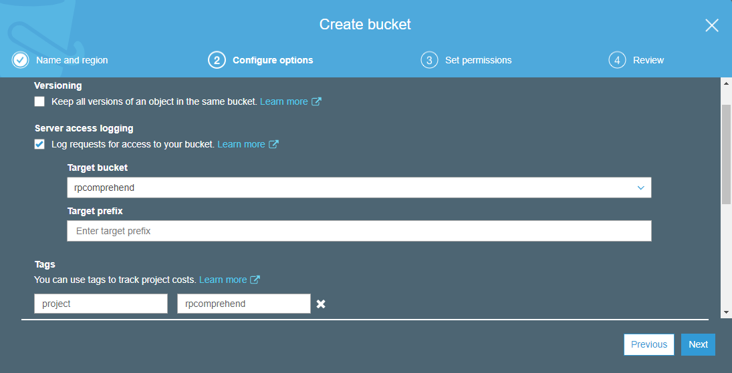

You need not change anything on the next screen, other granting access to Amazon S3 Log Delivery Group for creation of Access logs:

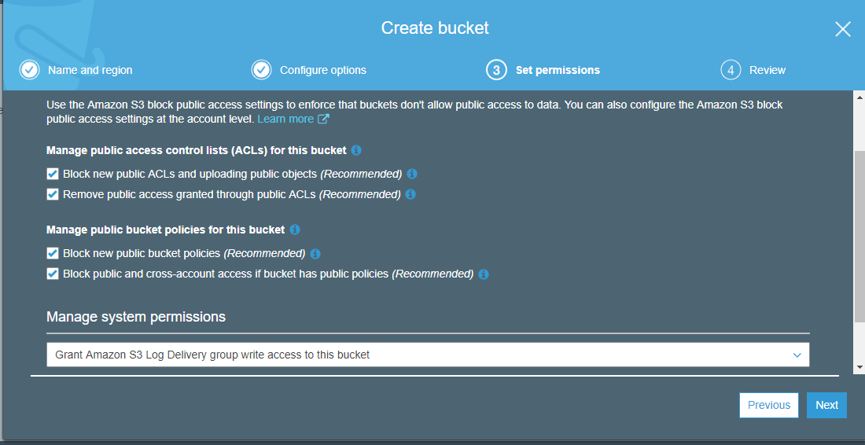

Review your S3 Bucket Settings:

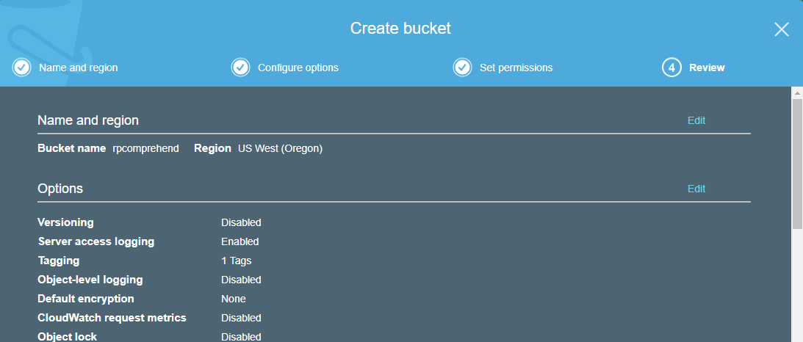  
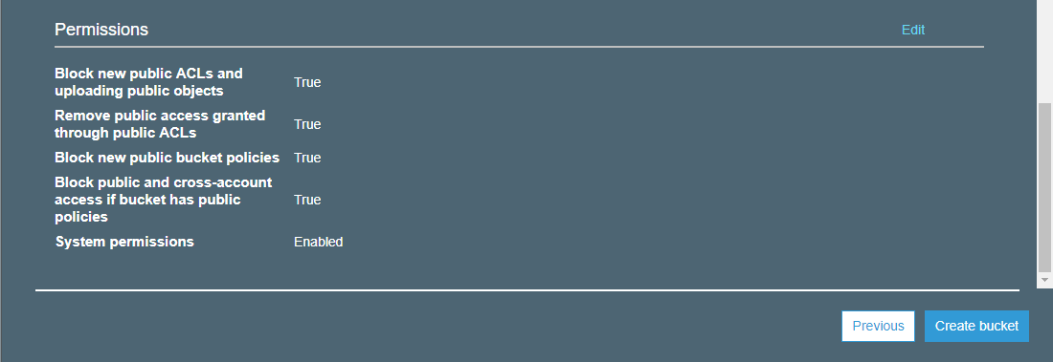

You should now be able to see the newly created bucket.

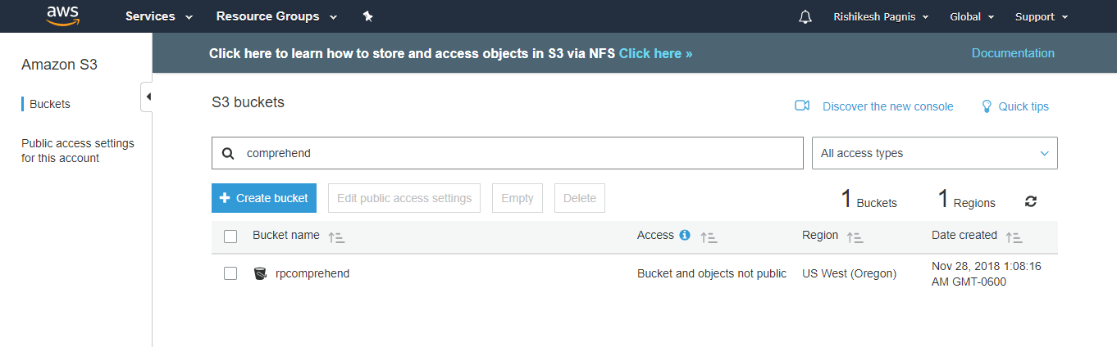

To have a public access to the bucket,

Click on the bucket and open permissions, edit permissions if you need public access.

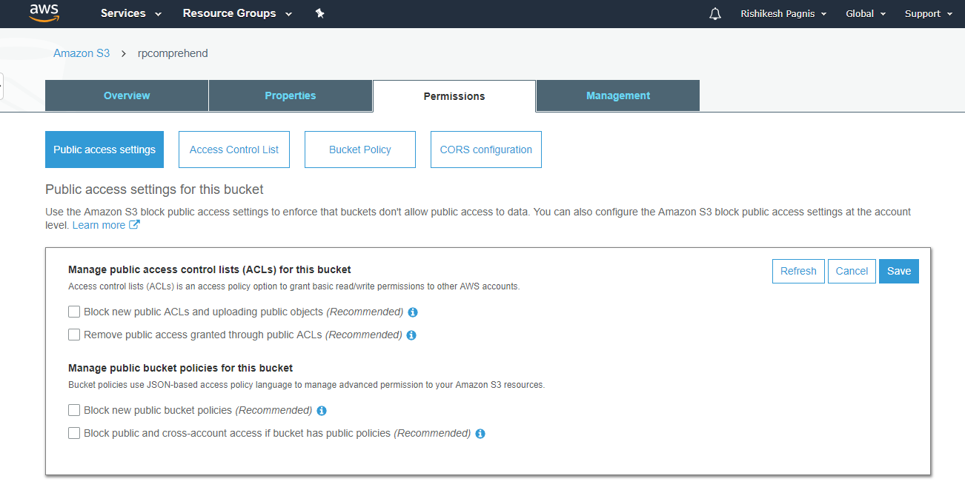

Create a folder CSProjectMain

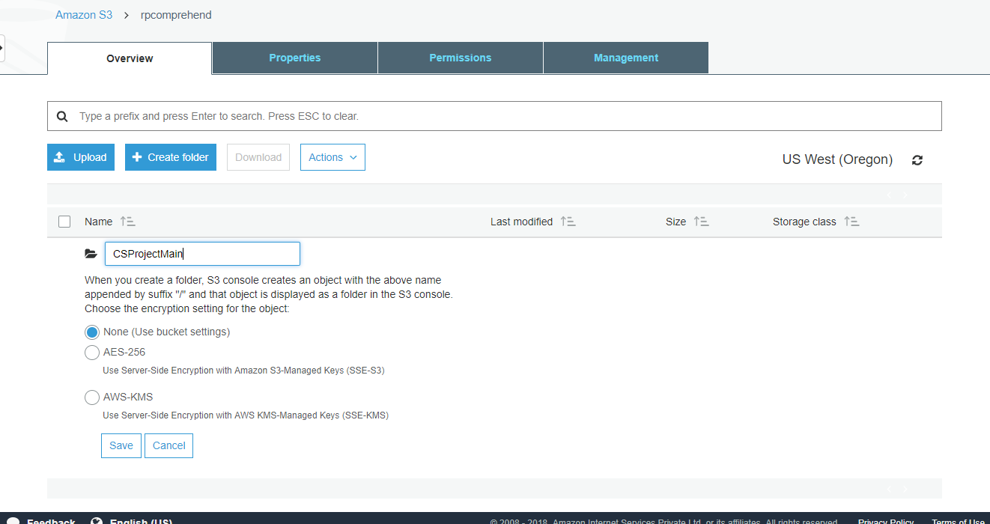

Upload your collection that you want to analyze to this folder: Folder permissions may need to be changed to access the folder from outside the environment. Use the make public setting for folder to do the same.

