**Image Processing**

<http://uiuc-cse.github.io/matlab-sp15/>

**Types of Images**

1. Binary: M x N logical matrix of 1s or 0s

(white or black)

1. Indexed: M x N array (one element for each pixel) whose value is the number corresponding to the row in the color-map (MNx3 array, with cols r-g-b values)

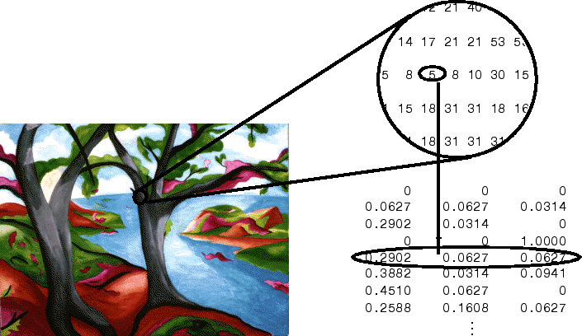

1. Intensity (Grayscale): M x N array of type double (decimal values) with intensity values for each pixel

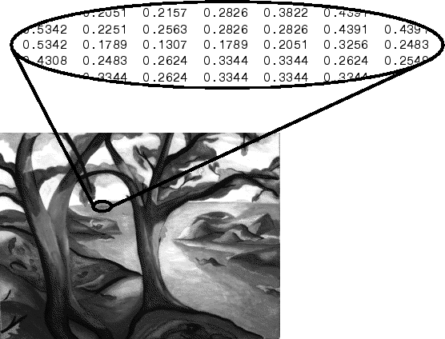

1. RGB: M x N x 3 array with each “layer” of each pixel defining the r, g, b components, respectively

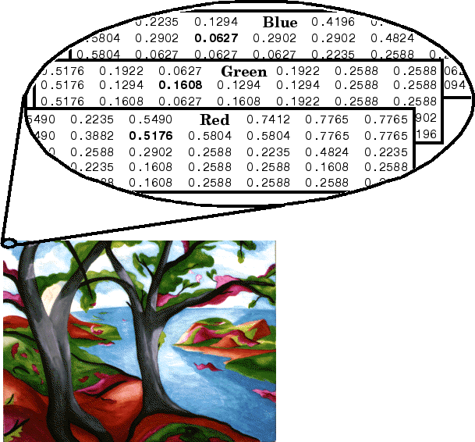

$$\vec{u}∙ \vec{v}=\left|\vec{u}\right|\left|\vec{v}\right|*cos⁡θ$$