**Overview of Abaqus Elements**

**1.Introduction**

Abaqus provides a wide range of elements for different geometries and analysis types. An element is characterized by the following:

* Family: Continuum, Shell, Membrane, Rigid, Beam, Truss, etc.
* Number of Nodes: Depends on element shape and its order of interpolation
* Degrees of Freedom per Node: Depends on the solution field of the analysis (Displacement, Rotation, Temperature, etc.) and the order of modeling space (1D, 2D and 3D).
* Formulation: Applicable to some of the element families (eg small- and finite-strain shells) otherwise most elements provide both automatically
* Integration: Reduced and full integration

Fig 1- Commonly used element families.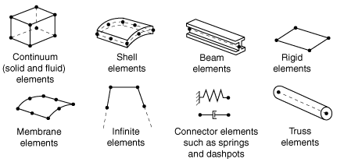

**2.Naming**

Each element comes with a unique name in Abaqus which identifies primary characteristics of the element such as S4R which stands for **S**hell, **4**-node, **R**educed integration elements, and C3D4 which stands for **C**ontinuum, **3**-**D**, **4**-node elements. An exhaustive list of element types is available in Abaqus documentation [1].

|  |  |
| --- | --- |
|  |  |

Fig 2- Example of Abaqus elements and naming convention for elements in Abaqus.

**3. Element Selection**

Element selection generally requires some knowledge on the theory and application of finite element analysis (FEA). For different problems and analysis types there are some general (rule-of-thumb) guidelines on the element selection. User should generally know that in Abaqus:

* All elements include a variety of element-based loads, for example body forces (eg gravity) and surface pressure loads on solid and shell elements, and forces distributed on a line for beam and shell elements.
* All elements are suitable for geometrically non-linear analysis (except small-strain shell).
* There is generally no restriction on the type of material used for an element.
* Most elements can be used for both Standard and Explicit solvers.

**3.1.Solid Elements**

The solid (or continuum) elements in Abaqus can be used for linear analysis and for complex nonlinear analyses involving contact, plasticity, and large deformations. They are available for stress, heat transfer, acoustic, coupled thermal-stress, coupled pore fluid-stress, piezoelectric, magnetostatic, electromagnetic, and coupled thermal-electrical analyses. An Abaqus user should know that

* Triangular and quadrilateral elements are commonly used for 2D modeling of solids.
* For 3D modeling tetrahedral and hexahedral elements can be used.
* Generally the use of quadrilateral and hexahedral elements is recommended for modeling of continuum solids.
* Solid element in Abaqus can provide first-order (linear) and second-order (quadratic) interpolation.

**3.1.1 Quadrilateral and Hexahedra Elements**

Two-dimensional quadrilateral elements include CPE4R (plane strain), CPS4R (plane stress) and CAX4R (axisymmetric) and three-dimensional hexahedral element include C3D8R (8-node trilinear brick) and C3D20R (20-node quadratic brick). Application of quads and hex elements are generally recommended whenever possible however these elements are geometrically less versatile and difficult to be used for complicated geometries. It should be noted that by effective use of different domain decompositions techniques (eg partitioning) it is possible use these elements even in complex geometries.

**3.1.2 Triangular and Tetrahedral elements**

Tetrahedral elements provide geometrically versatility and most of automatic meshing algorithms utilize these types of elements. User of Abaqus should generally know that

* First-order (linear) tetrahedral elements (CPE3R, CPS3R, CAX3R and C3D4) are stiff and they should not be used for structural analysis (except if an extremely fine mesh is used).
* Modified second-order tetrahedral and triangles (CPE6M, CPS6M, CAX6M, and C3D10M) are effective alternatives to linear types when the application requires use of these elements (like in complex geometries). These elements can be used with automatic mesh generation and are robust for large deformations and contact problems.
* A good mesh of hexahedral elements (C3D8R) usually provides a solution of equivalent accuracy at less cost.

**3.2. Shell and Membrane Elements**

Shell elements are developed based on the shell theory that approximates a thin 3D continuum (small thickness compared to lateral dimensions) using a 2D formulation. Depending on the ration between thickness and lateral directions dimensions different theories have been developed. The use of shell and membrane elements requires a good level of understanding about the theories of shells and membranes and proper selection of these elements should be consulted with experiences users. Abaqus offers conventional shell elements (2D geometry and thickness is defined by section property) and continuum shell elements (3D geometry).

Fig 3- Conventional and continuum shell elements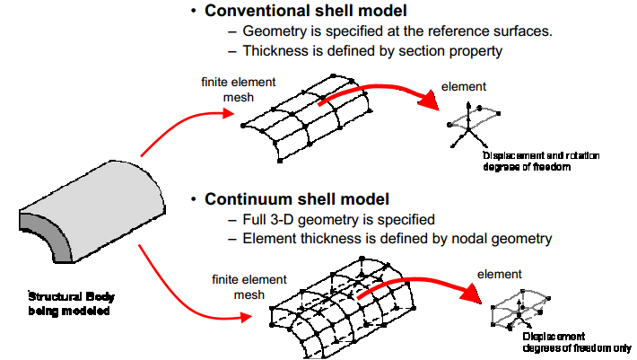

**3.2.1 Conventional Shell Elements**

Abaqus provides both triangular and quadrilateral shell elements with linear interpolation and user-choice of larger- and small-strains formulations. For most of applications large-strain shell elements (S4R, S3R, and SAX1) are appropriate with these considerations

* S4R: A robust quadrilateral element for general-purpose applications.
* S3R: A triangular element that may suffer from shear-locking. The application of this elements is not recommended for curved surfaces.

Small-strain shell elements (S4RS, S4RSW, S3RS) are more efficient for problems that involve small membranes strains with arbitrary large rotations subject to following considerations:

* S4RS: An efficient quadrilateral shell element that performs poorly when it is warped (eq in twisting problems)
* S4RSW: Less efficient quadrilateral shell element that can account for warped configurations.
* S3RS: A triangular shell element with properties similar to S4RS

**3.2.2 Continuum Shell Elements**

These elements allow for capturing through-thickness deformations (eq thickness tapering). For problems that involve contact modeling, these elements are more accurate since they can account for two-sided contact and thickness changes.

Fig 4- Application of continuum shell elements in modeling lib/seam forming.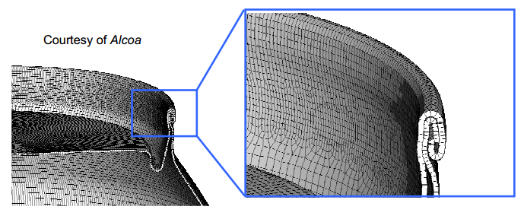

They use of these elements is also recommended for composite laminate structures because they capture through-thickness response. These elements have both wedge-shaped (SC6R) and hexahedral (SC8R) geometries. The choice of thickness direction for hexahedral shell elements can be ambiguous since any of the six faces can be the bottom face. By default Abaqus uses standard nodal connectivity convention to define thickness direction, however non-default direction can be specifined using the “stack direction” parameter on the shell section definition.

Fig 5- Abaqus convention for thickness definition in continuum shell elements.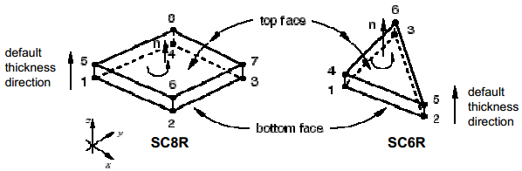

**3.2.3 Membrane Elements**

Memebrane elements are generally used to represent thin surfaces in space that have in-plane strength and no out-of-plane bending stiffness (eg a ballon or an airbag). Abaqus offers different membrane elements (M3D4R, M3D4, M3D3) with following properties:

* M3D4R: Reduced integration quadrilateral elements with hourglass control.
* M3D4: Full integration quadrilateral elements without hourglassing.
* M3D3: Reduced integration triangular elements

more advanced 6-, 8- and 9-node membrane elements are also available for use in Abaqus.

**3.3 Beam and Truss Elements**

Beam is an approximation of 3D continuum to 1D and it is only applicable when the dimensions of the cross section are small compared to axial direction. The main advantage of beams are their geometrical simplicity and efficiency (require a few degrees of freedom). Elementary beam theory (Also known as Euler-Bernoulli beam) allows for three modes of deformation for beams including axial stretching, curvature change (bending), and torsion (in 3D space). More advanced beam theories also account for transverse shear deformations (also calle Timoshenko beams). Abaqus offers a vriety of beam elements, including “Euler-Bernoulli”-type beams and “Timoshenko”-type beams with solid, thin-walled open/closed sections with linear, quadratic and cubic interpolation. Most commonly used beam elements in Abaqus are B31 (shear flexible linear) and B32 (shear flexible quadratic).

Trusses are rods that only carry tensile and compressive loads. Abaqus also provide truss elements (T3D2).

**3.4 Rigid Bodies/Elements**

A rigid body is a collection of points that their motion is governed by the motion of a single reference point. This means a part of body that can not deform can be considered as a rigid body. Rigid bodies are very commonly used in finite element analysis because they are computational very efficient (only require 6 degrees of freedom). Abaqus allows for definition of analytical rigid bodies and rigid elements. Analytical rigid bodies are more commonly used because of their several advantages including having potential to reduce noise in the solution, computational efficiency, and ease of definition. Analytical rigid bodies have some disadvantages for example they can not be used to define a general 3D rigid geometry. Three types of analytical rigid surfaces are available in Abaqus (Segments, Cylinder, and Revolution).

|  |  |
| --- | --- |
|  |  |

Fig 6- Example application of rigid elements in crush modeling.

**3.5 Special-Purpose Elements**

Abaqus also has a number of special-purpose elements. A non-exhustive list of these elements are following:

* Mass and rotary inertia elements: used to define inertial properties at discrete points
* Non-structural mass: used to for features of the model that only contribute to mass matrices and without stiffness.
* Surface elements: versatile elements that model surfaces in space.
* Connector elements: used to model connections between regions of the model.

**4. Advanced Topics**

**4.1 Reduced Integration/Full integration**

Except very simple geometries, in finite element analysis the stiffness and mass of elements are calculated by numerical integration. Abaqus uses Gaussian quadrature method for most of the elements. Reduced-order integration (primarily used by Abaqus Explicit) allow for fast and cheap calculation of the element matrices but may have significant effect on the accuracy of the element for a given problem. Abaqus uses letter R at the end of element name to label reduced-integration elements. For example CAX4R is the 4-node, reduced-integration, axisymmetric, solid element. Reduced integration uses a lower order integration (only one Gauss-point or more dependent on the geometry of element and order of interpolation) to calculate the element matrices for example C3D20R only uses 8 integration points compared to C3D20 which uses 27 integration points therefore its computation is almost 3.5 less costly.

Fig 7- Integration points used in reduced- (left) and full (right) integration in quadrilateral elements.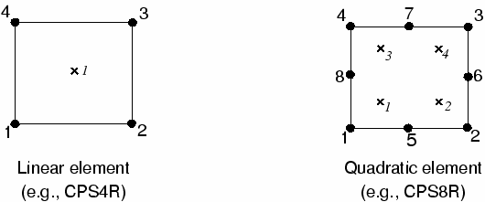

**4.2 Hourglassing**

The numerical algorithms used for the calculations and integration of the element matrices during assembly step may influence how element behaves. Reduced-order integration (primarily used by Abaqus Explicit) allow for fast and cheap calculation of the element matrices but the used of this integration algorithm comes with some drawbacks. Hourglassing can be a problem with first-order, reduced-integration elements (CPS4R, CAX4R, C3D8R, etc.) in stress/displacement analyses. Since the elements have only one integration point, it is possible for them to distort in such a way that the strains calculated at the integration point are all zero, which, in turn, leads to uncontrolled distortion of the mesh. First-order, reduced-integration elements in Abaqus include hourglass control, but they should be used with reasonably fine meshes. Hourglassing can also be minimized by distributing point loads and boundary conditions over a number of adjacent nodes.

In Abaqus/Standard the second-order reduced-integration elements, with the exception of the 27-node C3D27R and C3D27RH elements, do not have the same difficulty and are recommended in all cases when the solution is expected to be smooth. The C3D27R and C3D27RH elements have three unconstrained, propagating hourglass modes when all 27 nodes are present. These elements should not be used with all 27 nodes, unless they are sufficiently constrained through boundary conditions. First-order elements are recommended when large strains or very high strain gradients are expected.

**4.3 Shear and Volumetric Locking**

Fully integrated elements in Abaqus/Standard and Abaqus/Explicit do not hourglass but may suffer from “locking” behavior: both shear and volumetric locking. Shear locking occurs in first-order, fully integrated elements (CPS4, CPE4, C3D8, etc.) that are subjected to bending. The numerical formulation of the elements gives rise to shear strains that do not really exist—the so-called parasitic shear. Therefore, these elements are too stiff in bending, in particular if the element length is of the same order of magnitude as or greater than the wall thickness**.**

Volumetric locking occurs in fully integrated elements when the material behavior is (almost) incompressible. Spurious pressure stresses develop at the integration points, causing an element to behave too stiffly for deformations that should cause no volume changes. If materials are almost incompressible (elastic-plastic materials for which the plastic strains are incompressible), second-order, fully integrated elements start to develop volumetric locking when the plastic strains are on the order of the elastic strains. However, the first-order, fully integrated quadrilaterals and hexahedra use selectively reduced integration (reduced integration on the volumetric terms). Therefore, these elements do not lock with almost incompressible materials. Reduced-integration, second-order elements develop volumetric locking for almost incompressible materials only after significant straining occurs. In this case, volumetric locking is often accompanied by a mode that looks like hourglassing. Frequently, this problem can be avoided by refining the mesh in regions of large plastic strain.

If volumetric locking is suspected, check the pressure stress at the integration points (printed output). If the pressure values show a checkerboard pattern, changing significantly from one integration point to the next, volumetric locking is occurring. Choosing a quilt-style contour plot in the Visualization module of Abaqus/CAE will show the effect.

|  |  |
| --- | --- |
|  |  |

Fig 8- Hourglassing and shear locking for quadrilateral elements.

**4.4. Modified Elements**

A family of modified 6-node triangular and 10-node tetrahedral elements is available that provides improved performance over the first-order triangular and tetrahedral elements and that occasionally provides improved behavior to regular second-order triangular and tetrahedral elements. In Abaqus/Explicit these modified triangular and tetrahedral elements are the only 6-node triangular and 10-node tetrahedral elements available. Regular second-order triangular and tetrahedral elements are typically preferable in Abaqus/Standard; however, regular second-order triangular and tetrahedral elements may exhibit “volumetric locking” when incompressibility is approached, such as in problems with a large amount of plastic deformation. Modified triangular and tetrahedral elements work well in contact, exhibit minimal shear and volumetric locking, and are robust during finite deformation

**4.5 Hybrid Elements**

Hybrid elements are intended primarily for use with incompressible and almost incompressible material behavior; these elements are available only in Abaqus/Standard. When the material response is incompressible, the solution to a problem cannot be obtained in terms of the displacement history only, since a purely hydrostatic pressure can be added without changing the displacements.

Near-incompressible behavior occurs when the bulk modulus is very much larger than the shear modulus (for example, in linear elastic materials where the Poisson's ratio is greater than .48) and exhibits behavior approaching the incompressible limit: a very small change in displacement produces extremely large changes in pressure. Therefore, a purely displacement-based solution is too sensitive to be useful numerically (for example, computer round-off may cause the method to fail).

This singular behavior is removed from the system by treating the pressure stress as an independently interpolated basic solution variable, coupled to the displacement solution through the constitutive theory and the compatibility condition. This independent interpolation of pressure stress is the basis of the hybrid elements. Hybrid elements have more internal variables than their nonhybrid counterparts and are slightly more expensive.

**4.6 Cylindrical Elements**

Cylindrical elements (CCL9, CCL9H, CCL12, CCL12H, CCL18, CCL18H, CCL24, CCL24H, and CCL24RH) are available only in Abaqus/Standard for precise modeling of regions in a structure with circular geometry, such as a tire. The elements make use of trigonometric functions to interpolate displacements along the circumferential direction and use regular isoparametric interpolation in the radial or cross-sectional plane of the element. All the elements use three nodes along the circumferential direction and can span angles between 0 and 180°. Elements with both first-order and second-order interpolation in the cross-sectional plane are available.

**5. Summary of Recommendations for Element Usage**

The following recommendations apply to both Abaqus/Standard and Abaqus/Explicit:

* Make all elements as “well shaped” as possible to improve convergence and accuracy.
* If an automatic tetrahedral mesh generator is used, use the second-order elements C3D10 (in Abaqus/Standard) or C3D10M (in Abaqus/Explicit).
* Use the modified tetrahedral element C3D10M in Abaqus/Standard in analyses with large amounts of plastic deformation.
* If possible, use hexahedral elements in three-dimensional analyses since they give the best results for the minimum cost.

Abaqus/Standard users should also consider the following recommendations:

* For linear and “smooth” nonlinear problems use reduced-integration, second-order elements if possible.
* Use second-order, fully integrated elements close to stress concentrations to capture the severe gradients in these regions. However, avoid these elements in regions of finite strain if the material response is nearly incompressible.
* Use first-order quadrilateral or hexahedral elements or the modified triangular and tetrahedral elements for problems involving large distortions. If the mesh distortion is severe, use reduced-integration, first-order elements.
* If the problem involves bending and large distortions, use a fine mesh of first-order, reduced-integration elements.
* Hybrid elements must be used if the material is fully incompressible (except when using plane stress elements). Hybrid elements should also be used in some cases with nearly incompressible materials.

**6. References**

[1] Abaqus 6.13 Documentation