**Overview of Abaqus Meshing**

**1. Mesh Generation Techniques**

Abaqus CAE mainly provides four different mesh generation techniques:

* Free meshing
* Swept meshing
* Structured meshing
* Mapped meshing
* Virtual topology

**1.1 Free Meshing**

Free meshing technique is the most easily accessable meshing mechanism in Abaqus that requires no pre-established mesh pattering (eg partitioning). For 2D models Abaqus CAE produce free meshes with following element types:

* Quadrilateral (default): Can be applied to any planar or curved surface
* Quadrilateral-dominated: Allows some triangular elements for transition.
* Triangular: can be applied to any planar or curved surface.

For 3D models Abaqus CAE can mesh any geometry with tetrahedral elements unless the mesh seeds are too coarse.

|  |  |
| --- | --- |
|  |  |

Fig 1- Different meshes created by free meshing in Abaqus CAE.

**1.2 Swept Meshing**

Abaqus/CAE uses swept meshing to mesh complex solid and surface regions. The swept meshing technique involves two phases:

* Abaqus/CAE creates a mesh on one side of the region, known as the source side.
* Abaqus/CAE copies the nodes of that mesh, one element layer at a time, until the final side, known as the target side, is reached. Abaqus/CAE copies the nodes along an edge, and this edge is called the sweep path. The sweep path can be any type of edge—a straight edge, a circular edge, or a spline. If the sweep path is a straight edge or a spline, the resulting mesh is called an extruded swept mesh. If the sweep path is a circular edge, the resulting mesh is called a revolved swept mesh.

Swept meshing can use all-quad elements for planar and curved surfaces and quad-dominated meshes for degenerate revolved regions for 2D cases. Similarly hex, hex-dominated and wedge meshes can be created for 3D cases.

|  |  |
| --- | --- |
|  |  |
|  |  |

Fig 2- Swept meshing technique in Abaqus CAE.

To determine if a region is swept meshable, Abaqus/CAE tests if the region can be replicated by sweeping a source side along a sweep path to a target side. In general, Abaqus/CAE selects the most complex side (for example, the side that has an isolated edge or vertex) to be the source side. In some cases you can use the mesh controls to select the sweep path. If some regions of a model are too complex to be swept meshed, Abaqus/CAE asks if you want to remove these regions from your selection before it generates a swept mesh on the remaining regions. You can use the free meshing technique to mesh the complex regions, or you can partition the regions into simplified geometry that can be structured or swept meshed.

General requirements for sweep meshable regions as following:

* Topological: The source side may contain multiple faces but the target face and each connecting side must have only one face.
* Geometric: Adjacent faces will be combined to form the source side only if the edge dihedral angles are not too far from 180 degrees.

|  |  |
| --- | --- |
|  |  |

Fig 3- Examples of sweep meshable/unmeshable regions.

**1.3 Structured Meshing**

The structured meshing technique generates structured meshes using simple predefined mesh topologies. Abaqus/CAE transforms the mesh of a regularly shaped region, such as a square or a cube, onto the geometry of the region you want to mesh. You can apply the structured meshing technique to simple two-dimensional regions (planar or curved) or to simple three-dimensional regions that have been assigned the Hex or Hex-dominated element shape option.

|  |  |
| --- | --- |
|  |  |

Fig 4- Application of structured meshing to simple and more complex shapes (left). Regions that structured mesh can be used for (right).

A two-dimensional region can be meshed using the structured meshing technique if it has the following characteristics:

* The region has no holes, isolated edges, or isolated vertices.
* The region is bounded by three to five logical sides, where each side is a connected set of edges.

In general, structured meshing gives you the most control over the mesh that Abaqus/CAE generates. If you are meshing a four-sided region with all quadrilateral elements, the total number of element edges around the boundary must be even. For three- and five-sided regions, the constraint equations are more complex. Abaqus/CAE respects seed distribution wherever possible when generating a structured mesh. (Seed distribution describes the spacing of the seeds, not necessarily the number of seeds. For example, are the seeds evenly spaced along an edge or more concentrated at one end?) However, meshes must be compatible across regions, and Abaqus/CAE may adjust the nodes of a mesh region that is adjacent to a region that was meshed using the free meshing technique. As a result, the element nodes may not match the seeds exactly.

For 3D models, meshing more complex regions with this technique may require manual partitioning. If you do not partition a complex region, your only meshing option may be the free meshing technique with tetrahedral elements. Meshes constructed using the structured meshing technique consist of hexahedral elements, which are preferred over tetrahedral elements. You can eliminate holes (whether they pass all the way through the part instance or just part way through) by partitioning their circumferences into halves, quarters, etc.

|  |  |
| --- | --- |
|  |  |

Fig 5- Effective partitioning used for structured meshing of more complex 3D geometries.

**1.4 Mapped Meshing**

The terms structured meshing and mapped meshing are used interchangeably in the finite element analysis literature. However, Abaqus/CAE makes a subtle distinction between the two terms. Mapped meshing is a subset (special case) of structured meshing that allows for improved mesh quality. Mapped meshing refers only to structured meshing of four-sided, two-dimensional regions—the square mesh pattern in Fig 4.

Some models that appear very complex actually contain faces with relatively simple geometry. When you mesh such a model with free or swept meshing, the resulting element quality can be poor on these faces. However, if you allow Abaqus/CAE to use the mapped meshing technique where the geometry is appropriate, it often generates elements of good quality, especially if the region is a long, thin rectangular face.

You cannot apply mapped meshing directly to a region. However, you can apply it indirectly by meshing a region and allowing Abaqus/CAE to apply mapped meshing where appropriate. For example, Fig 6 shows the effect of free meshing a part and allowing Abaqus/CAE to use mapped meshing where appropriate.

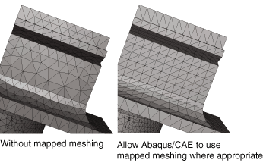

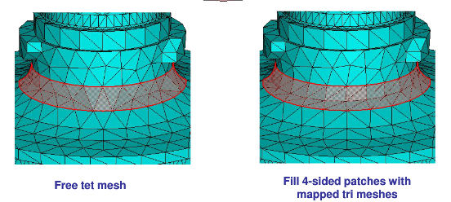

Fig 6- The effect of allowing mapped meshing.

By default, Abaqus/CAE uses mapped meshing where appropriate when you are doing the following:

* Using the advancing front algorithm to sweep mesh a solid region with hexahedral or hexahedral-dominated elements.
* Using the advancing front algorithm to free mesh a shell region with quadrilateral or quadrilateral-dominated elements.
* Free meshing a solid region with tetrahedral elements.
* Free meshing a shell region with triangular elements.

**1.5 Virtual Topology**

In some cases part instances in the assembly contain small details such as faces and edges. Virtual topology allows you to ignore unimportant details. Part instances that contain virtual topology can be meshed when using one of the following mesh techniques:

* Free meshing: Triangular and tetrahedral elements. Quadrilateral and quadrilateral-dominated elements using advancing front algorithm.
* Swept meshing: Hex or wedge elements.
* Mapped meshing: Quadrilateral, triangular, or hex elements.

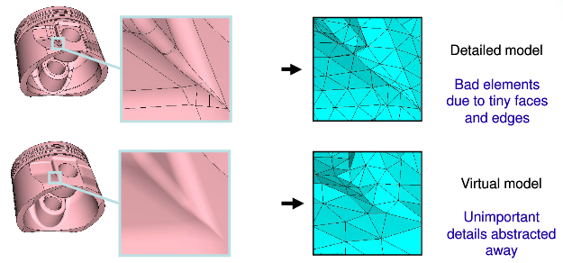

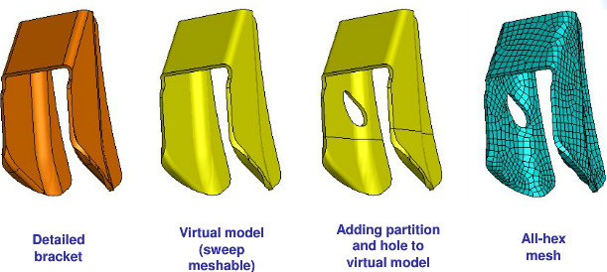

Fig 7- Example of detail removal using virtual topology (top), and application of virtual topology in swept mesh (bottom).

**2. References:**

[1] Abaqus 6.13 Documentation