**Overview of Material, Damage and Failure Modeling in Abaqus**

**1. Introduction**

Abaqus has an extensive material library which can be used to model many engineering materials, including metals, rubbers, concrete, damage and failure, fabrics, and hydrodynamics. Abaqus also provides the facilities to create and use a user-defined material model for the purpose of finite element simulation.

|  |  |
| --- | --- |
|  |  |
|  |  |

**Fig. 1-** Examplesof different material models used in the Abaqus simulations.

**2. Material Models**

**2.1. Elasticity**

Under small enough strains, the linear relationship between stress and strains can be considered for most of the materials, usually called elastic response and described by linear elasticity theory. The elastic response of metals is usually modeled with linear elasticity. It is also possible to define it with an equation-of-state model. In Abaqus, for linear elasticity:

* Elastic properties can be specified as isotropic or anisotropic
* Elastic properties may be dependent on temperature and/or predefined field variables

**2.2. Plasticity**

Plastic deformations are non-recoverable deformations. Plasticity theories are developed to model the material's response under ductile nonrecoverable deformation. A typical uniaxial stress-strain curve for a metal is characterized by a linear section with a slope equivalent to its elastic modulus (Young's modulus) and a yield point beyond, where the stress-strain curve deviates from linearity. Any strain beyond the yield point can be decomposed to an elastic recoverable component and a plastic non-recoverable component. For most metals, yield stress is a small fraction (0.1% to 1%) of the elastic modulus.

**Fig. 2- 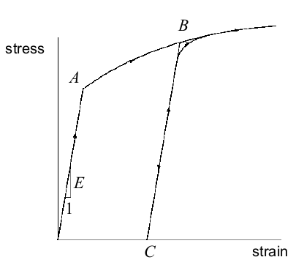**Typical stress-strain response for uniaxial tension test of a metal characterized by liear section (before A) with slope E (modulus of elasticity), and non-linear section (beyond A) where A is the yield point. Strains in AB section are composed of elastic and plastic components. Upon unloading from point B and reloading from C, material shows a linear elastic-plastic response with the same slope E.

**2.2.1. Isotropic Metal Plasticity**

In Abaqus, Mises yield surface is used to model isotropic metal plasticity. The plasticity data are defined as true stress vs. logarithmic strain. Abaqus assumes that no work hardening continues beyond the last entry point. In Abaqus Explicit given yield stress data point should be specified using equal intervals on the plastic strains otherwise it will be regularized to this form.

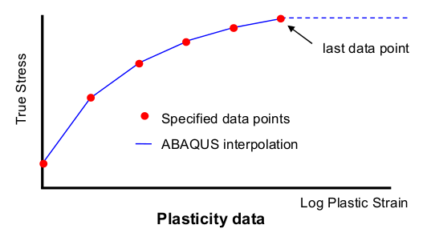

**Fig. 3-** Abaqus interpolates data points given and considers no work hardening beyond the last data point.

**2.2.2. Anisotropic Metal Plasticity**

Abaqus uses Hill's yield potential (an extension of the Mises yield function) to model anisotropic metal plasticity. In this material model:

* A reference yield stress (σ0) is need to be defined
* 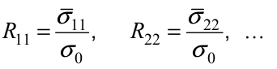Aniotropy is introduced through the definition of stress ratios where Rij are determined from uniaxial and pure shear tests.

This model should be used when anisotropy is already induced in the material but not for the cases where anisotropy develops with the plastic deformation.

|  |
| --- |
|  |

**Fig. 4-** Using different plasticity models for the simulation of sheet metal forming can result in different values for predicted (anisotropic) blank thickness.

**2.2.3. Hardening**

Abaqus offers the following options for the modeling of hardening:

* Isotropic hardening: uniform stress-plastic strain response in all directions
* Linear kinematic hardening: used in the cases where simulation of Bauschinger effect is relevant. Applicaitons include low cycle fatigue studies involving small amounts of plastic flow and stress reversal.
* Combined nonlinear isotropic/kinematic hardening: more general than linear model
* Johnson-Cook hardening: suitable for high-strain-rate deformation of many materials including most metals. This mode in only available in Abaqus Explicit.

**2.2.4. Progressive Damage and Failure**

This material model allows for the prediction of damage initiation and propagation in Mises, Johnson-Cook, Hill and Drucker-Prager plasticity models. These models are suitable for both quasi-staitc and dynamic situations.

|  |  |
| --- | --- |
|  |  |

**Fig. 5-** Progressive damage in material response (left) and simulation of projectile penetrating a plate using damage models.

**2.2.5. Porous Metal Plasticity**

This is another model to simulate plasticity in metals with dilute concentration of voids. This model is based on Gurson's porous plasticity model with void nucleation and failure. This model is best used in the simulation of tensile failure in ductile material which is happening based on the nucleation and coalescence of voids, therefore not applicable to compressive failure.

**2.3. Rubber Elasticity**

Constitutive behavior of rubbers (hyperelastic or hyperfoam) is usually expressed in by a strain energy potential U= U(F) such that:

where S is a suitable measure of stress and F is the deformation gradient tensor. 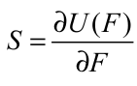The strain energy potential is usually written in terms of the strain invariants I1, I2 and Jel as



where I1, I2 are measures of deviatoric strain, and Jel is a measure of volumetric strain.

**2.3.1. Rubber Elasticity Models**

Abaqus supports following rubber elasticity models:

* Physics-based models
* Arruda-Boyce
* Van der Waals
* Phenomenological models:
* Polynomial
* Mooney-Rivlin (1st order)
* Reduced Polynomial (independent of I2): Neo-Hookean (1st order) and Yeoh (3rd order)
* Ogden
* Marlow (independent of I2 )

Abaqus/CAE has the capability to fit these models to the experimental data provided by user to calculate model parameters. In case of the presence of noise in data, user can employ Abaqus/CAE capabilities for data-smoothing during fitting process. The selection of proper rubber elasticity model (in other words strain energy function) depends on availability of sufficient and accurate experimental data, type of material under consideration and user experience. Different experimental data that can assist proper selection of the material include:

* Uni-axial tension/compression
* Bi-axial tension/compression
* Planar tension/compression
* Volumetric test data (e.g. for highly confined materials)

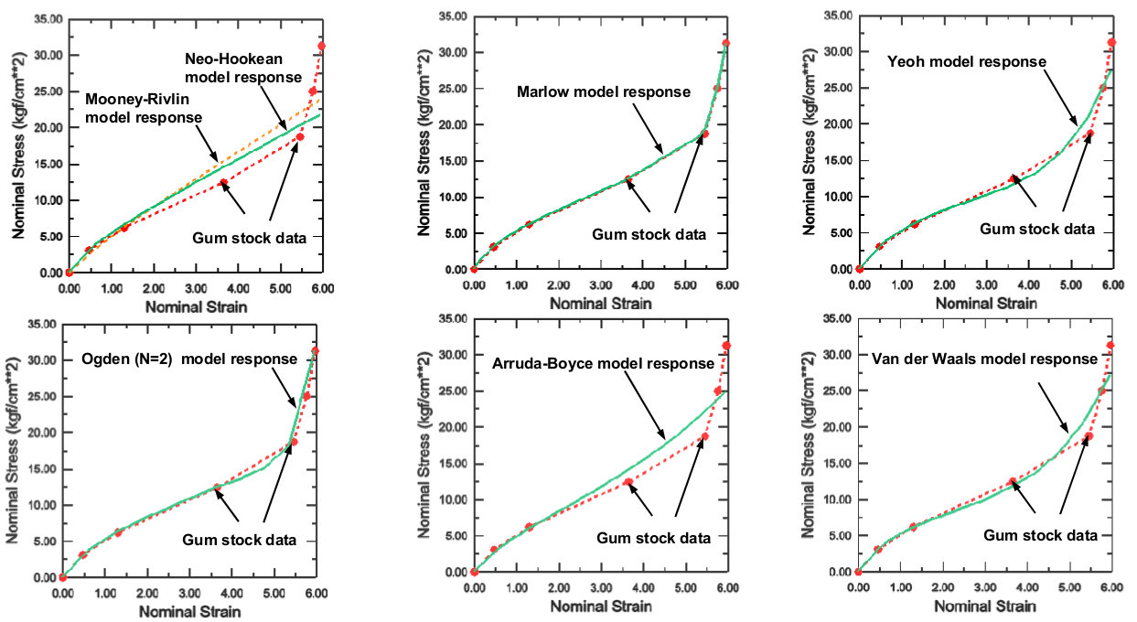

**Fig. 6-** Automatic evaluation of material parameters by Abaqus/CAE for Gum stock uniaxial data (Gerke)

**2.4. Concrete**

**2.4.1. Brittle Cracking Model**

This material model for concrete is mainly applicable in situation that tensile cracking is dominant and compressive failure can be neglected (the compressive behavior is assumed to be linear elastic). The model uses a brittle failure criterion to remove elements (failed ones) from the mesh. The model also accounts for anisotropy induced by cracking.

**2.4.2. Damaged Plasticity Model**

This model can be used for the analysis of concrete structures under monotonic, cyclic, and/or dynamic loading. The model uses an internal state variable (scalar, isotropic) damage model to account for tensile cracking and compressive crushing observed in concrete. For this purpose, model uses two failure criteria (one for each mode) and the evolution of failure is controlled by two hardening variables.

In this material model, the tensile damage variable (DAMAGET) is a monotonically increasing quantity associated with tensile (cracking) failure of the material. The stiffness degradation variable (SDEG) can increase or decrease to capture the stiffness recovery effects associated with the opening/closing of cracks.

**2.5. Additional Materials**

**2.5.1. Hydrodynamic Materials**

This material model is mostly useful for materials in which the material's volumetric strength is determined by an equation of state, e.g. for fluids, ideal gasses, explosives, compaction of granular materials.

**Fig. 7-**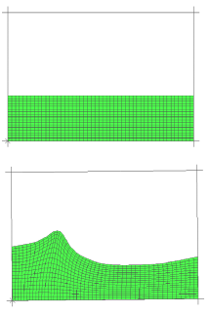 Simulation of water sloshing in a tank using hydrodynamic material models.

**2.5.2. User-defined Material**

Abaqus provides a wide range of important material models for the simulation of the different engineering materials. There are cases in which a new material response needed to be modeled. For these situations, Abaqus provides to user the capabilities to defined a user-defiend material model (UMAT subroutine for Abaqus/Standard and VUMAT subroutine for Abaqus/Explicit). Application of user-defined material models requires extensive knowledge about the constitutive modeling of material response, finite element analysis and coding and therefore it is not recommended for amateur users.

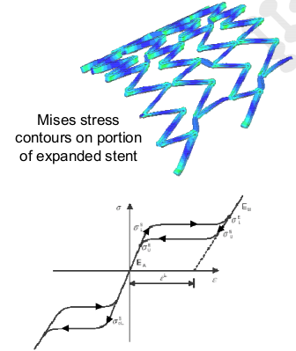

**Fig. 8-** Mises stress contours on a portion of expanded stent simulated using user-defined material (VUMAT)

**3. References**

1 – Abaqus 6.13 Documentation.