# EquatIO

Download EquatIO from the webstore. <https://webstore.illinois.edu/home/>

EquatIO is free for anyone with an @illinois.edu account

**MATHTYPE MUST BE INSTALLED ON THE COMPUTER.** MathType is available through the Webstore for free for all College of Engineering faculty, staff, and students. $49.95/yearly license for all other users.

After EquatIO has been downloaded and installed:

1. Open the original PDF file AND Go to Program List and Open EquatIO
   1. Choose **Microsoft**
   2. Enter **your university email** and select **Work or School Account**
   3. Enter your university **email address and password**
   4. Verify using Two-Factor Authentication.
2. If this is the first time using EquatIO, you should see the following pop-up:

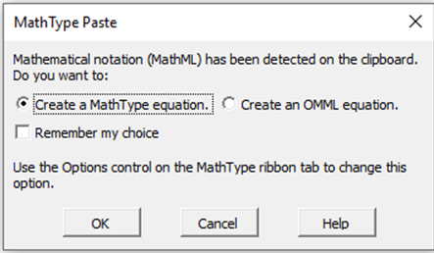

Select **Create a MathType equation** and **Remember my choice**.   
 Select **OK**.

1. Your screen will have the EquatIO overlay that will look like this

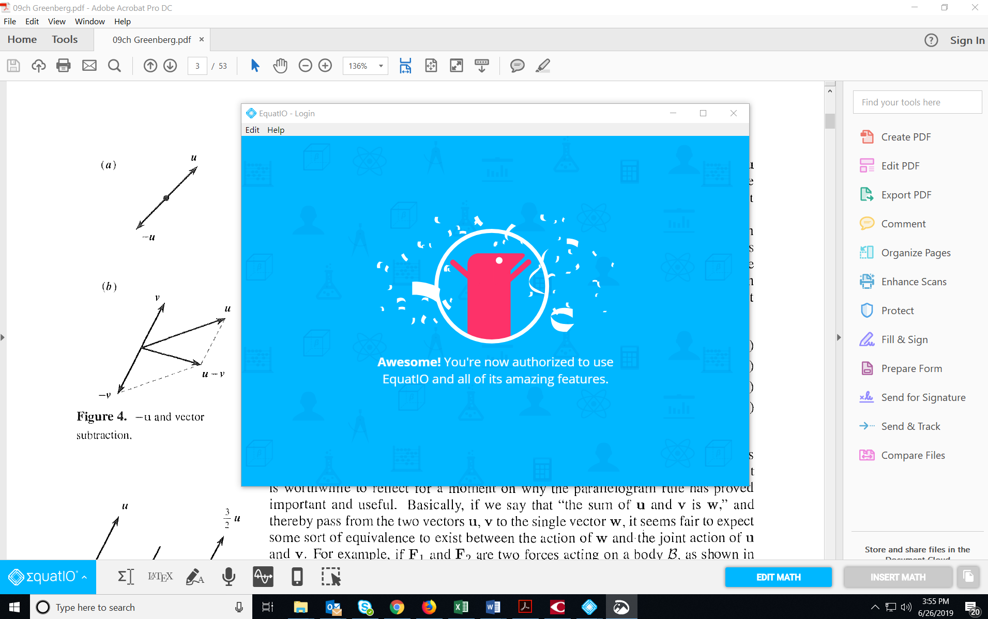

1. At the bottom of the screen there is a Tool Bar (the numbers were added to explain the menu more easily)



Menu 1 2 3 4 5 6 7 8 9 10

(This list does not appear on your screen – this is a description of the icons)

1 – Equation Editor

2 – LaTex Editor

3 – Handwriting Recognition

4 – Speech Input

5 – Graph Editor

6 – EquatIO Mobile

7 – Screenshot Reader

8 – Edit Math

9 – Insert Math

10 –

Open the **Blue EquatIO Menu** at the bottom left.



Select **OPTIONS – MATH OPTIONS**.  
(PDF file and Word file must be on same monitor)

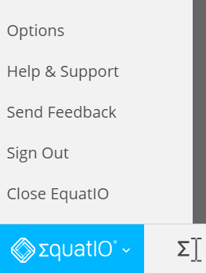

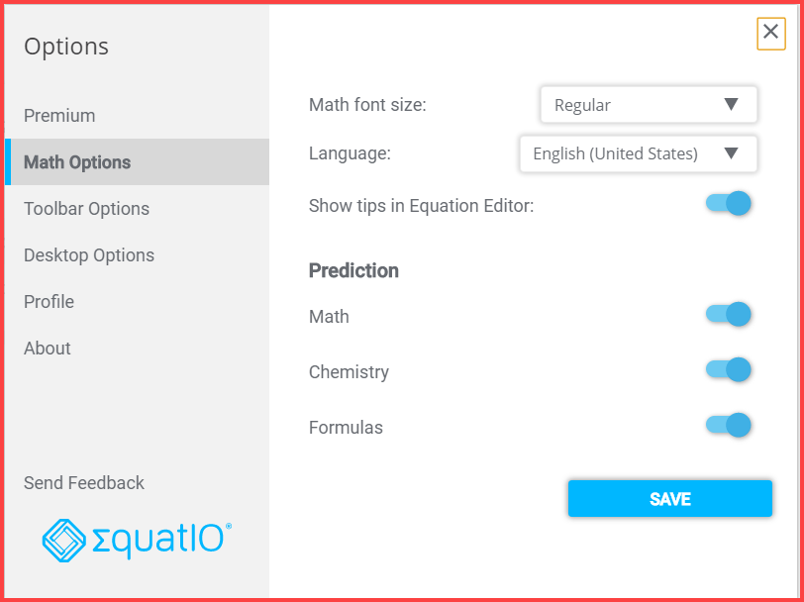

* Prediction: Select **Math, Chemistry, and Formulas**.
* SAVE
* Locate equation to be copied/converted
* Select **Screenshot Reader**



* Draw a box around the **equation**.

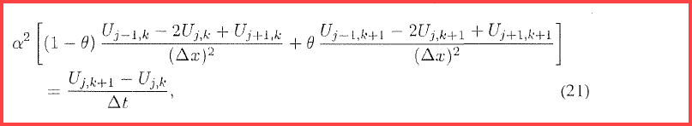

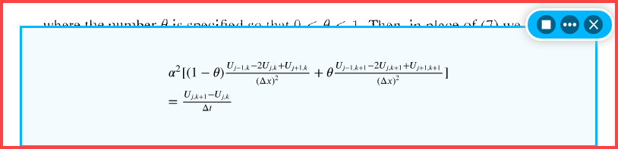

- Three dots will open output menu  
- Arrow/Box will start/stop spoken math.  
- X will close options.

* Select the **format** that the equation should be saved in.

**MathMl Output**

$$\begin{aligned}α^{2}[(1-θ)\frac{U_{j-1,k}-2U_{j,k}+U_{j+1,k}}{(Δx)^{2}}+θ\frac{U_{j-1,k+1}-2U_{j,k+1}+U_{j+1,k+1}}{(Δx)^{2}}] \\ =\frac{U_{j,k+1}-U_{j,k}}{Δt}\end{aligned}$$

**LaTex Output**

\left. \begin{array}{l}{ \alpha ^ { 2 } [ ( 1 - \theta ) \frac { U _ { j - 1 , k } - 2 U _ { j , k } + U _ { j + 1 , k } } { ( \Delta x ) ^ { 2 } } + \theta \frac { U _ { j - 1 , k + 1 } - 2 U _ { j , k + 1 } + U _ { j + 1 , k + 1 } } { ( \Delta x ) ^ { 2 } } ] }\\{ = \frac { U _ { j , k + 1 } - U _ { j , k } } { \Delta t } }\end{array} \right.

* Paste into the document where the equation should appear. (Ctrl-V)
* Select “x” to close the window and move to the next equation.

Save the Word file when complete.

EquatIO Help pages can be found at <https://www.texthelp.com/en-us/products/equatio/>