**REAL ESTATE**

**MARKET SEGMENTATION**

Analyzing the Real Estate Market in India for Housing App Tech Startup

GitHub Link:

Team

Mohamed Illiyas

Susnata Biswas

Vijayaragavan

**Abstract:**

Real estate sector is one of the most globally recognized sectors. It comprises of 4 sub sectors. Housing, Retail, Hospitality, & Commercial. The construction industry ranks third among the 14 major sectors in terms of direct, indirect and induced effects in all sectors of the economy.

In India, the real estate sector is the second-highest employment generator, after the agriculture sector. It is also expected that this sector will incur more non-resident Indian (NRI) investment, both in short term and the long term.

By 2040, the real estate market in India will grow to a peak. That is, it will reach to Rs. 65000 Crore from Rs. 12000 Crore. It will contribute to the 13% to the country’s GDP. The sub sectors like Retail, Hospitality and commercial real estate are also growing significantly to provide high infrastructure.

The market segmentation is the process of dividing a broad group of consumer or target market into sub groups based on demographics, needs, common interests, geographic locations, psychographic behavior, etc. Market segmentation is one of the key building blocks of strategic marketing. Market segmentation is essential for marketing success

Now, we analyze the real estate market in India using Segmentation analysis and come up with a feasible strategy to enter the market in India. So that we offer this market demand information to the Housing App which provides online property rental service and Real Estate Listing Service.

**Overview of Real Estate Market in India:**

Indian firms are expected to raise more than thirty-five trillion rupees INR through infrastructure and real estate investment in 2022. As the demand for cloud resources is increasing, the space required for the cloud setup became unavoidable. Tech giants like Google, Amazon, Facebook are in search of land for configuring their data centers. According to the recent report, real estate demand for data centers is expected to increase by 15-18 Million sq. ft by 2025. Manufacturing industry accounted for 24% increase in their office space. This is due to the enlargement of the E-commerce industry. People are more likely to buy electronic gadgets and so the electronic manufacturing industry have grown to multifold environment. Bengaluru is expected to be the most favoured property investment destination for NRIs, followed by Ahmedabad, Pune, Chennai, Goa, Delhi and Dehradun.

Indian real estate sector has witnessed high growth in recent times with rise in demand for office as well as residential spaces. Top three cities in India recorded a huge investment in total real-estate sector in 2021.

Mumbai – 39%

NCR Delhi – 19%

Bengaluru – 19%

* To increase this market in India, Government of India along with the governments of respective states has taken several initiatives to encourage development. The Smart City Project, with a plan to build 100 smart cities, is a prime opportunity for real estate companies. If they establish and succeed in this project, then the growth will be exponential. Government has created an Affordable Housing Fund (AHF) in the National Housing Bank (NHB) with an initial corpus of Rs. 10,000 crores. The low home loan interest rates regime is expected to drive the housing demand and increase sales by 35-40% in the festive season in 2022.

**Data Sources:**

We have gathered some datasets which are somehow related to the case. Multiple datasets are combined together to gain good insights.

<https://prsindia.org/policy/analytical-reports/land-records-and-titles-india>

Property Rates Data:

<https://www.magicbricks.com/Property-Rates-Trends/ALL-COMMERCIAL-rates-in-New-Delhi>

<https://rbidocs.rbi.org.in/rdocs/Publications/PDFs/RAPMSA07052015FL6A5F839BAB9B4D0190CE127D04DEF74C.PDF>

Real Estate Industry Growth – Infographic:

<https://www.ibef.org/industry/real-estate-india/infographic>

Packages and Tools used:

● Numpy

● Pandas

● Matplotlib

● Seaborn

● Plotly

● Sklearn

● Scipy

Importing Packages and tools:

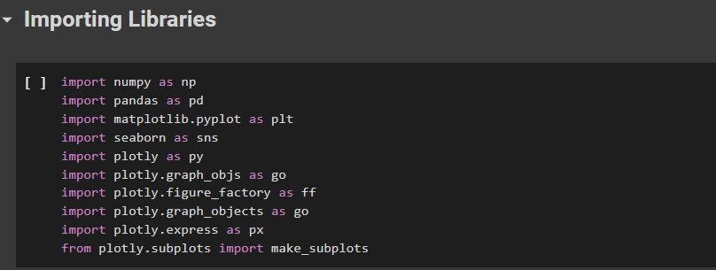

Uploading Dataset:

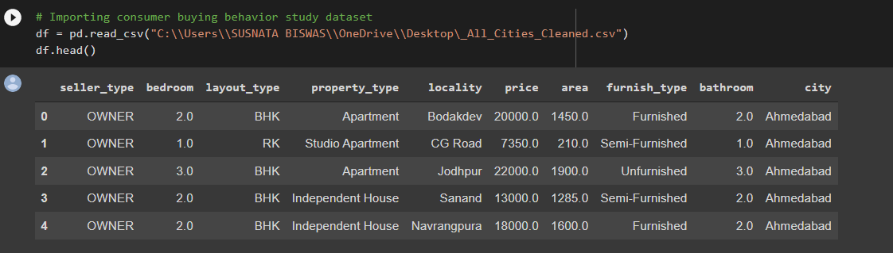

**Data Pre-processing** :

● Checking is there any null values in the data set

There is no null values in the data.

We have 193000+ rows of data with 10 features.

By applying df.info (), we can see that we have no null values.

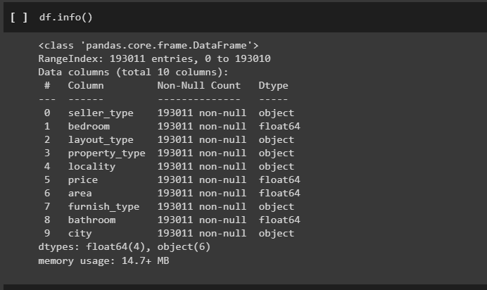

Observing Unique values in each features:

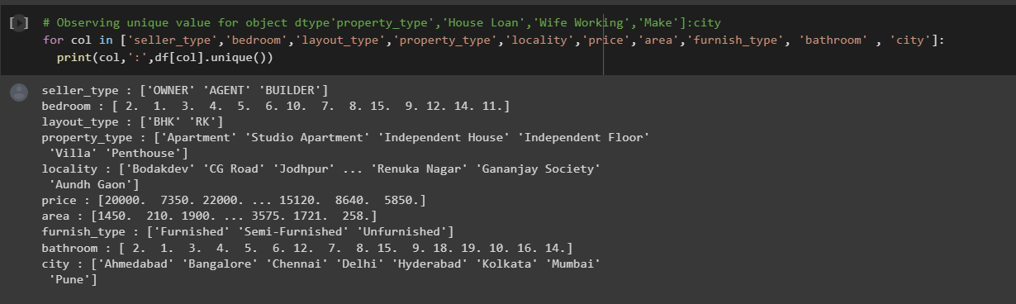

**Analysis:**

**Behavioral and psychographic analysis:**

**Behavioral:**

Behavior segment extraction the similarities in behavior or reported behavior. A wide range of possible behaviors can be used for this purpose, including prior experience with the product, frequency of purchase, amount spent on purchasing the product on each occasion (or across multiple purchase occasions), and information search behavior.

This type of Survey data is cheap and easy to collect. But survey data can be contaminated by a wide range of biases. Such biases can, in turn, negatively affect the quality of solutions derived from market segmentation analysis.

Carefully selecting the variables that are included as segmentation variable in common sense segmentation, or as segmentation variables in data-driven segmentation, is critical to the quality of the market segmentation solution. Developing a good questionnaire typically requires conducting exploratory or qualitative research. Answer options provided to respondents in surveys determine the scale of the data available for subsequent analyses.

Survey data is prone to capturing biases. A response bias is a systematic tendency to respond to a range of questionnaire items on some basis other than the specific item content.

**Psychographic Analysis:**

When people are grouped according to psychological criteria, such as their beliefs, interests, preferences, aspirations, or benefits sought when purchasing a product, the term psychographic segmentation is used. Psychographic criteria are, by nature, more complex than geographic or socio-demographic criteria because it is difficult to find a single characteristic of a person that will provide insight into the psychographic dimension of interest.

Seller type and its count:

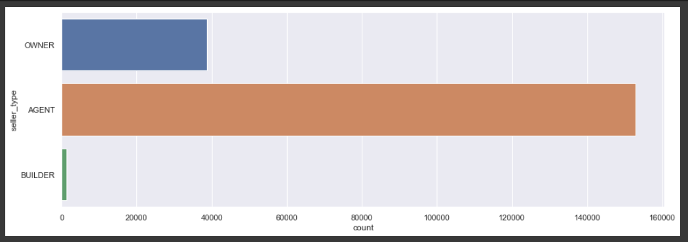

Number of Bathrooms in Houses:

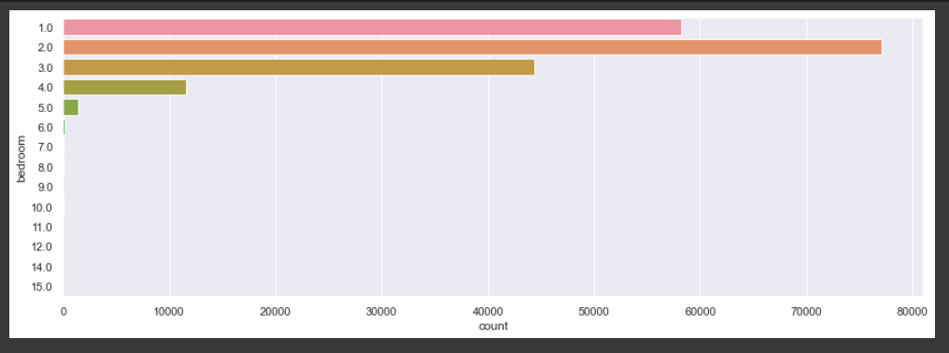

Property Type in India:

This denotes the behavioral attributes usually followed by the people. From this type of analysis, we could be able to find the most preferred type of property by the people.

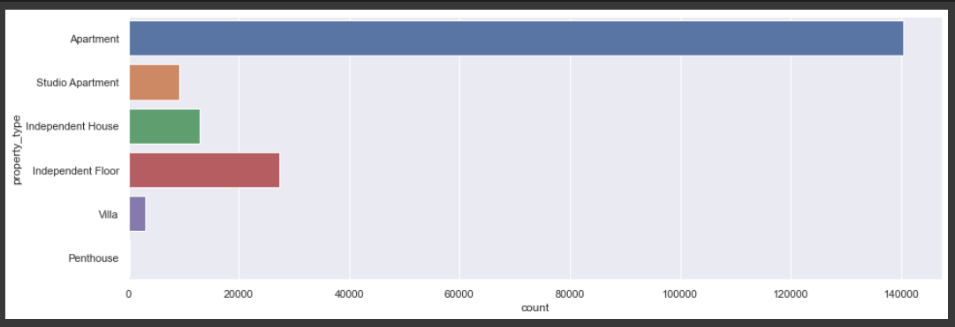

Furnish Type:

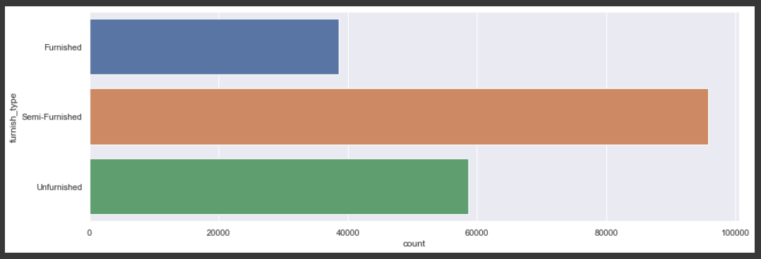

Layout Type Preference:

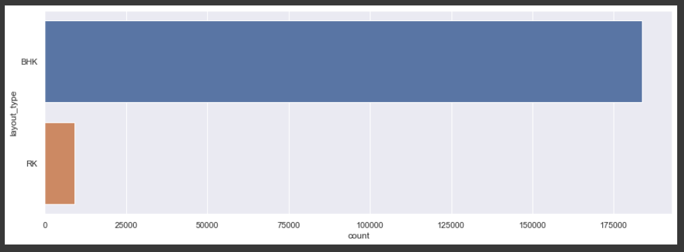

Observations from the Analysis:

Seller type: Agents sell the greater number of flats.

Bedrooms: Attachment with 2 attached bedrooms is preferred mostly.

Layout type: BHK is preferred by most of the sellers.

Property type: Apartment is the most selling property.

Furnished type: Semi-furnished is the most furnished property.

Bathrooms: Attachment with 2 bathrooms is preferred mostly.

**Demographic Analysis:**

It describes the composition of a population, such as age, race, gender, income, migration patterns, and population growth.

Data like age, income, spending score, family size, ethnicity, job type, Marital size and the likes help in facilitating this segment.

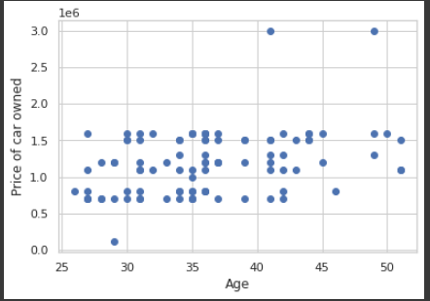

**Geographic analysis**

Geographic information is segmentation criterion used for the purpose of market segmentation. when geographic segmentation is used – the consumer’s location is considered.

The price of houses in Delhi seems to be high compared to other places.

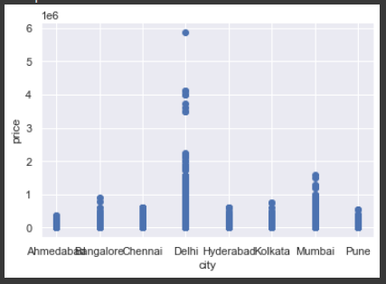

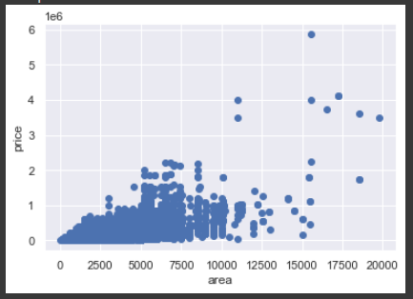

Number of bedrooms impacting price of houses:

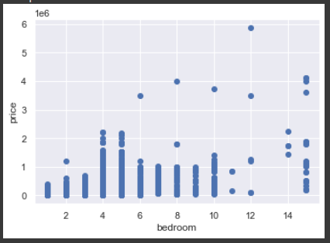

Layout type impacting Price:

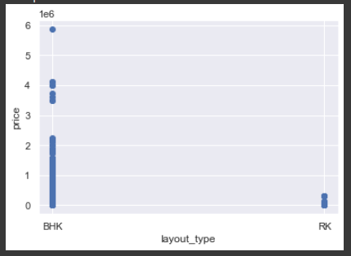

Property Type and its Price range:

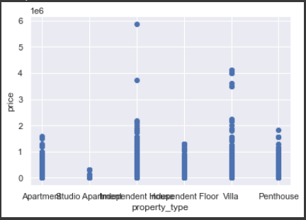

Furnishment Impacting price:

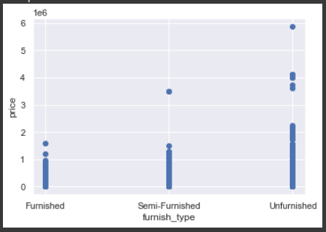

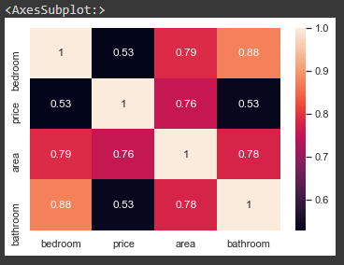

**Pair Plot describing multiple correlation between variables:**

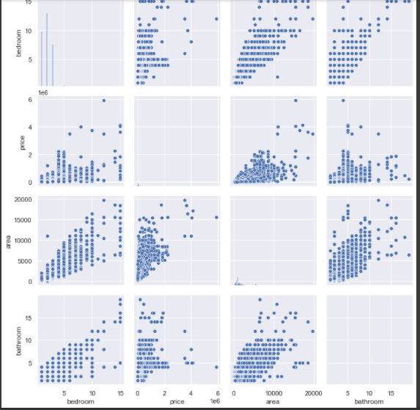

**Segmentation:**

We use clustering for the segmentation.

**Clustering** is the task of grouping observations in such a way that members of the same cluster are more similar to each other and members of different clusters are very different from each other. Clustering is the task of grouping observations in such a way that members of the same cluster are more similar to each other and members of different clusters are very different from each other.

We use K Means clustering for the segmentation.

**k-means clustering** algorithm is an iterative process of moving the centers of clusters or centroids to the mean position of their constituent points, and reassigning instances to their closest clusters iteratively until there is no significant change in the number of cluster centers possible or a number of iterations reached.

**Using K means clustering**

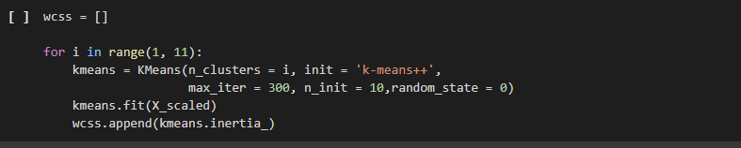

**Elbow method for optimal K**

Elbow method is one of the most popular ways to find the optimal number of clusters. This method uses the concept of WCSS value. WCSS stands for Within Cluster Sum of Squares, which defines the total variations within a cluster.

It is the sum of the squares of the distances between each data point and its centroid within a cluster1 and the same for the other two terms. To measure the distance between data points and centroid, we can use any method such as Euclidean distance or Manhattan distance.

**Number of cluster vs WCSS:**

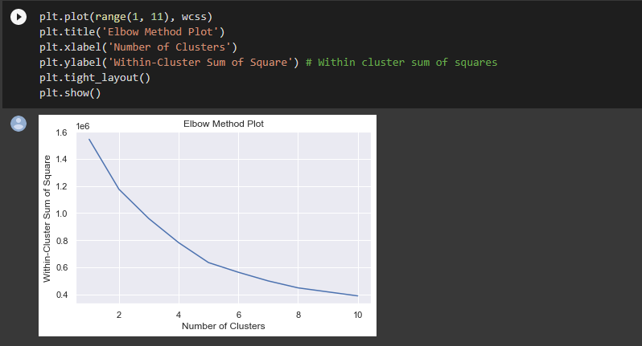

**Fit KMeans into data**

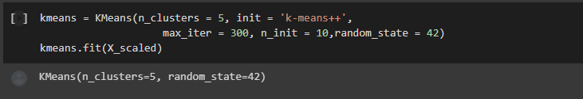

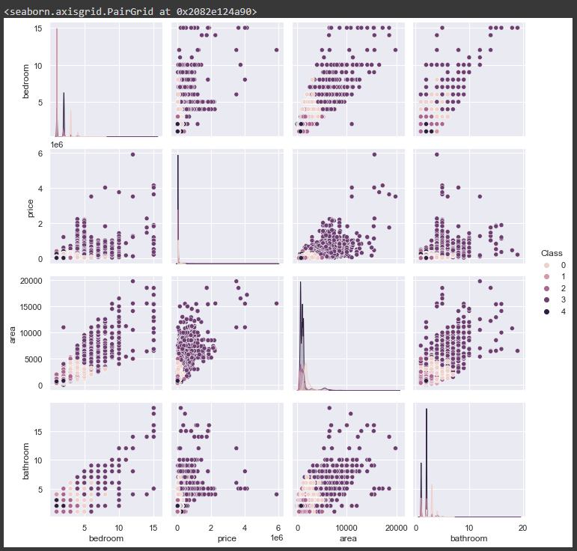

Here we can see 5 clusters based on bedroom, price, area and bathroom.

**Target Segment:**

We are going to target only few of the segments which will impact the market. Those segments are behavioral, demographic, geographic segments. Behavioral and psychographic segment helps in understanding the behavior and characteristics of the consumer/customer, so that we can suggest them according to their interests. Demographic segment helps to identify the age group of people, income of the different levels of people. So, it will definitely help us to target the specific range of people and improve the business. Geographic segments mainly focus on the location. Targeting customers where the demand is high will be a useful strategy to increase the business. Now we will target the above said segments and develop a strategy to launch our Housing services App.

**Market Strategy:**

Marketing mix is key to success in any business. The marketing mix is a combination of factors(strategies) that can be combined by a company to influence consumers to purchase a product. There are 4 Ps of marketing.

Product, Price, Promotions, Place

1. **Product**

A product is a commodity produced or built to satisfy the need of an individual or a group. Here the property is the product. It is important to do extensive research before buying/selling a property as it has a fluctuating life cycle. So, our system will recommend and list out the property based on the behavioral and psychographic segmentation.

1. **Price**

Price is a very important component of the marketing mix. The price of the product is basically the amount that a customer pays for it to enjoy the product. It is the most essential and crucial element of a marketing plan because it paves way for the profit and loss. Adjusting the price of the product, even a little bit has a big impact on the entire marketing strategy as well as greatly affecting the sales and demand of the product in the market. Things to keep on mind while determining the cost of the product are, the competitor’s price, list price, customer location, discount, terms of sale, etc.,

The price of the property can be determined by the geographic segmentation.

1. **Place**

Place is a very important part of marketing mix strategy. We should position and distribute our product in a place that is easily accessible. Our application can be accessible throughout India. So customers from all over the places can interact with the application and know the pricing.

1. **Promotion**

Promotion is a marketing communication process that helps to publicize the product and its feature to the public. It is the most expensive and essential components of the marketing mix, that helps to grab the attention of the customers and influence them to buy the product. Promotions can be done using segmentation results. Specific type of properties can be suggested to the specific set of people based on their behavioral, demographic segments.

**Potential customer base:**

In India, there are 600 million smart phone users in 2021. So, we can obviously say that this Tech Startup for Housing App is a good initiative and we can achieve a good profit margin from this business. Normal mobile users are also switching to the smart phone. So, there will be further increase in the income and share for the upcoming years. Recent Reports said that there will be investment of around 35 Trillion rupees in Real estate sector. So as our app acts as a bridge between buyer and seller, it will definitely produce a huge profit. Even if 1% of the mobile users visit our app, then the count will be around 60000. If 1% of that 60K people show some interest to buy/sell property, then 600 people will get benefited from our application.

**Target Price**

Advertisers pay a wholesome of money for the sales of their products. Some private advertisements can be displayed on the applications. Also google provides AdSence service. From these services we can gain some amount. Google pays $1 for 1000 views and private advertisers can be charged $2 for 1000 views.

So totally we gain $3 for 1000 views.

**Potential Profit**

Potential Profit = Potential Customer Base * Target Price Range

= (60000/1000) * $3

= $180

$180 is the potential profit generated every day.

References:

<https://prsindia.org/policy/analytical-reports/land-records-and-titles-india>

<https://www.magicbricks.com/Property-Rates-Trends/ALL-COMMERCIAL-rates-in-New-Delhi>

<https://rbidocs.rbi.org.in/rdocs/Publications/PDFs/RAPMSA07052015FL6A5F839BAB9B4D0190CE127D04DEF74C.PDF>

<https://www.ibef.org/industry/real-estate-india/infographic>

<https://byjus.com/commerce/marketing-mix/>