TO: Visiting Families, Friends, and Loved Ones; Attention all who have incarcerated loved ones in WNY
FROM: The Connect Travel Network
SUBJECT: Affordable Transportation to Visitation Facilities

Having a loved one in a correctional facility is difficult enough without the
added stress and high cost of transportation.
Connect Travel was built to solve this problem. We are a secure, peer-to-
peer ride-sharing platform that pairs local, background-verified community
drivers with families traveling to New York State DOCCS facilities. By
pooling passengers together into larger vehicles, we are able to reduce the
cost of travel to approximately $50 per rider.
How the Program Works: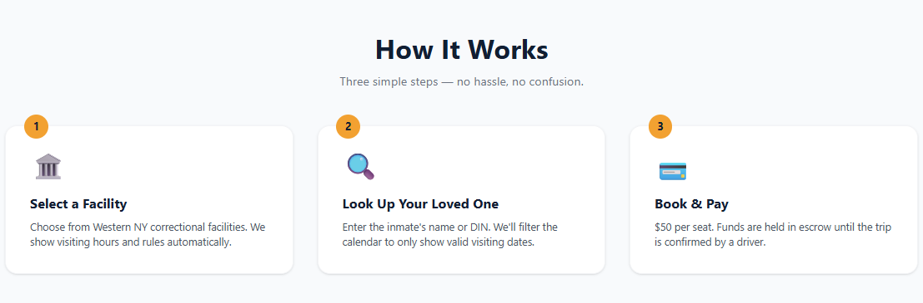

Join/Follow The Connect Travel FB Community Download/Book Connect Travel Homepage 

