**Migration of Labview into the Test**

**of magnetic Properties  
Marc Schnaitmann, Till Schwaderer, Smiljan Mahkovec, Jan Philipp Grünewald, Christian Meier**

**Prof. Dr. Helmut Förschner, Uwe Weidlich, Markus Salamon – SS 2017**

**Summary**

This project deals with the migration of a measuring-system for magnetic properties in a new environment. Main task of this project was the mapping of Pascal-Code into the graphical coding language of LabVIEW. Further work was done regarding enhancing the program by code optimizations as well as the implementation of some new features (e.g.: overcurrent protection, graphical user interface, …).  
The result is a more user-friendly and reasonable code for the latest hardware that can be used to identify the main characteristics of transformer sheets.

**The Project**

Building SubVIs for:

* hardware communication
* mathematical operations
* plotting

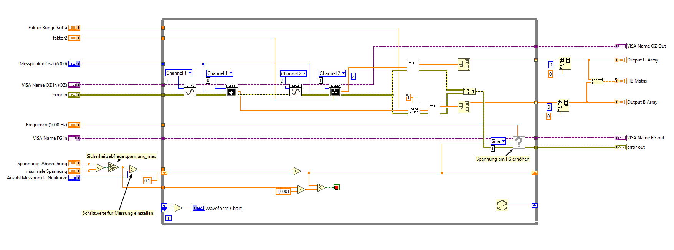

The simple state machine:

Following states are included:

**“Hier das Zustandsdiagram-horizontal…”**



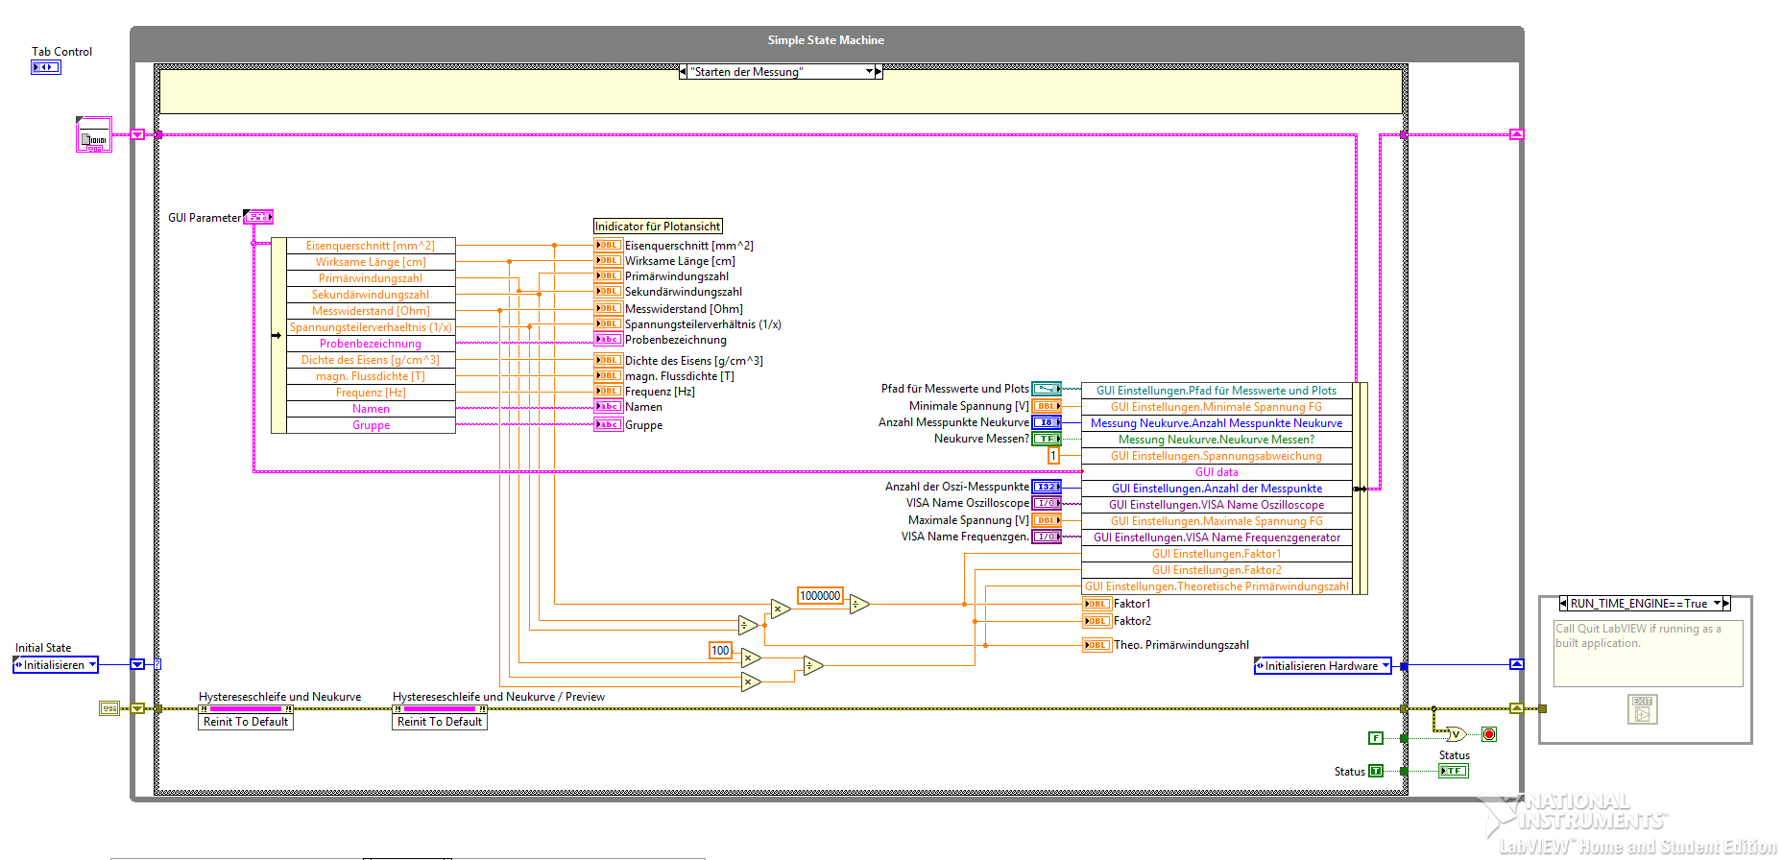

Plot View:

* overview about all properties
* can be saved in different ways

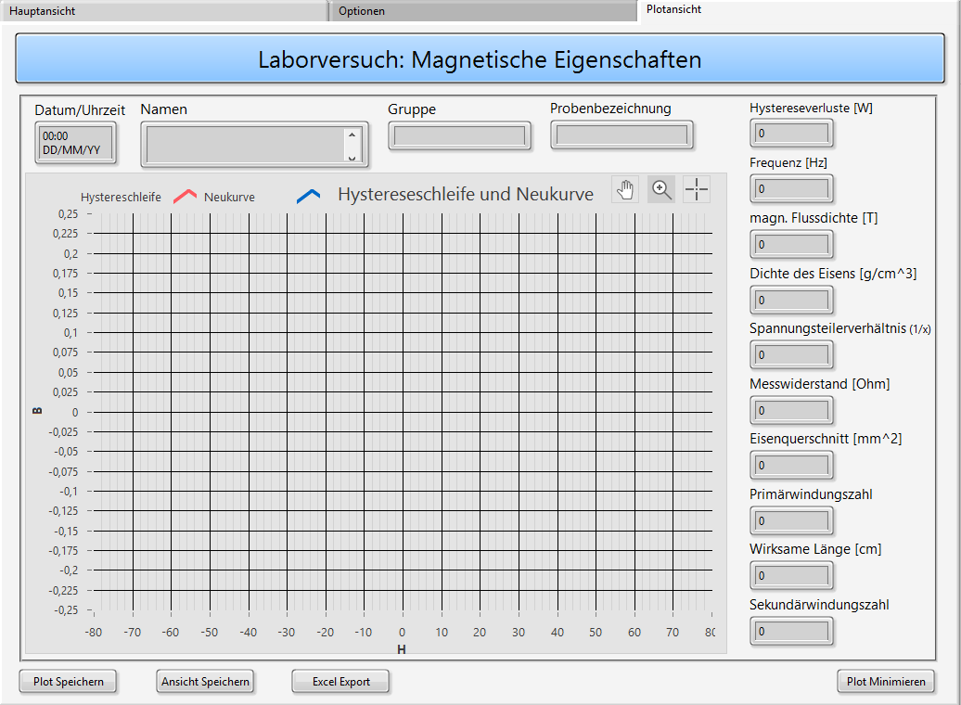

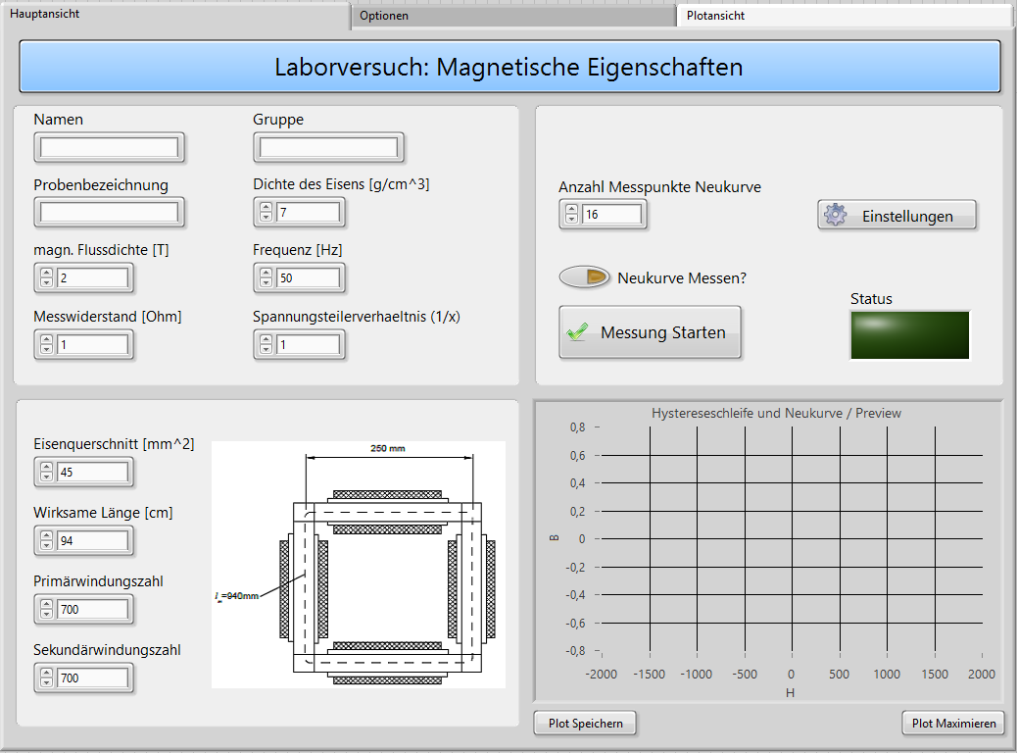

GUI (Graphical User Interface):

* has 3 tabs (main, options, plotting)
* fully functional without the labview software