Vedant COBB033

Step1-Search on Google the METAMASK.

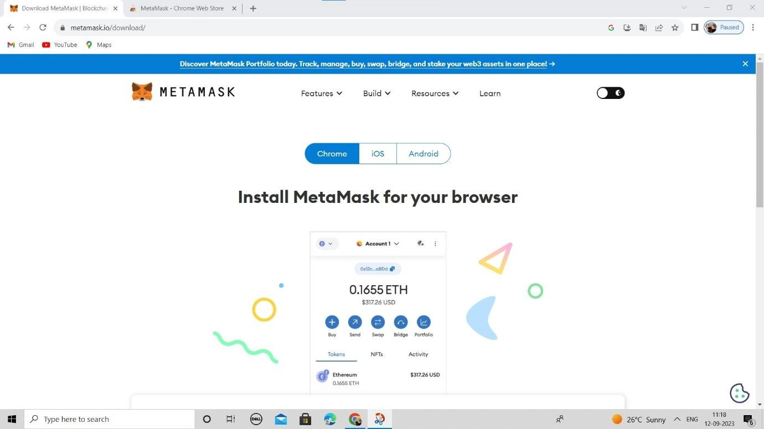

Step2-Download the METAMASK .Click on the Button “Add to Chrome”.

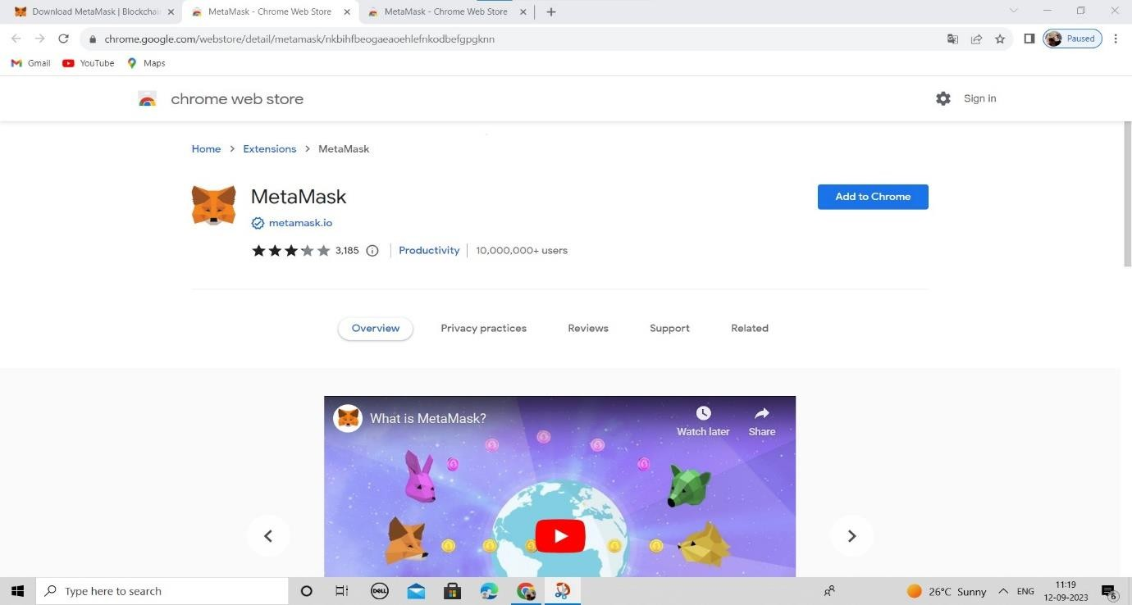

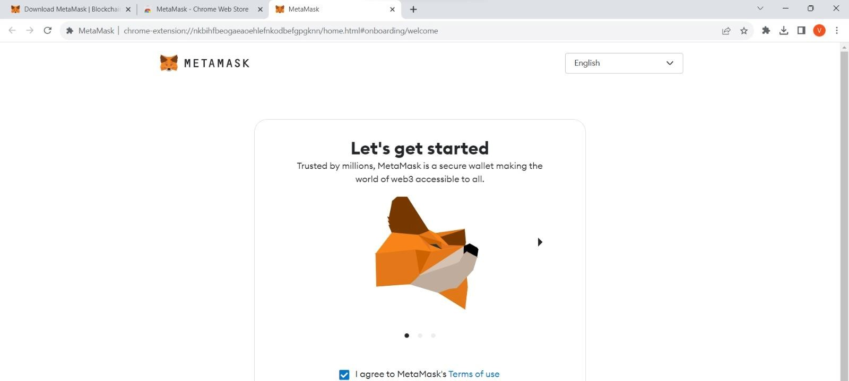

Step4-Click on the “Create a Wallet”.

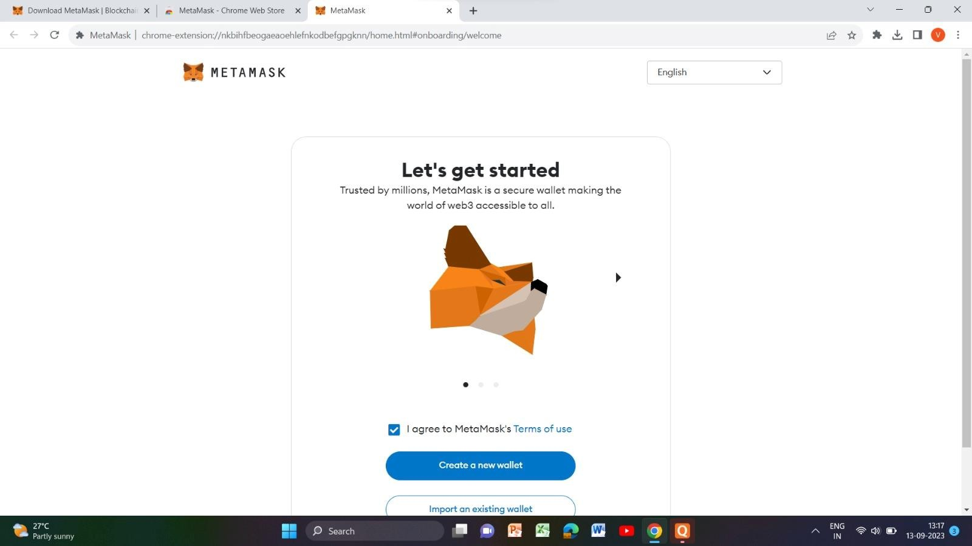

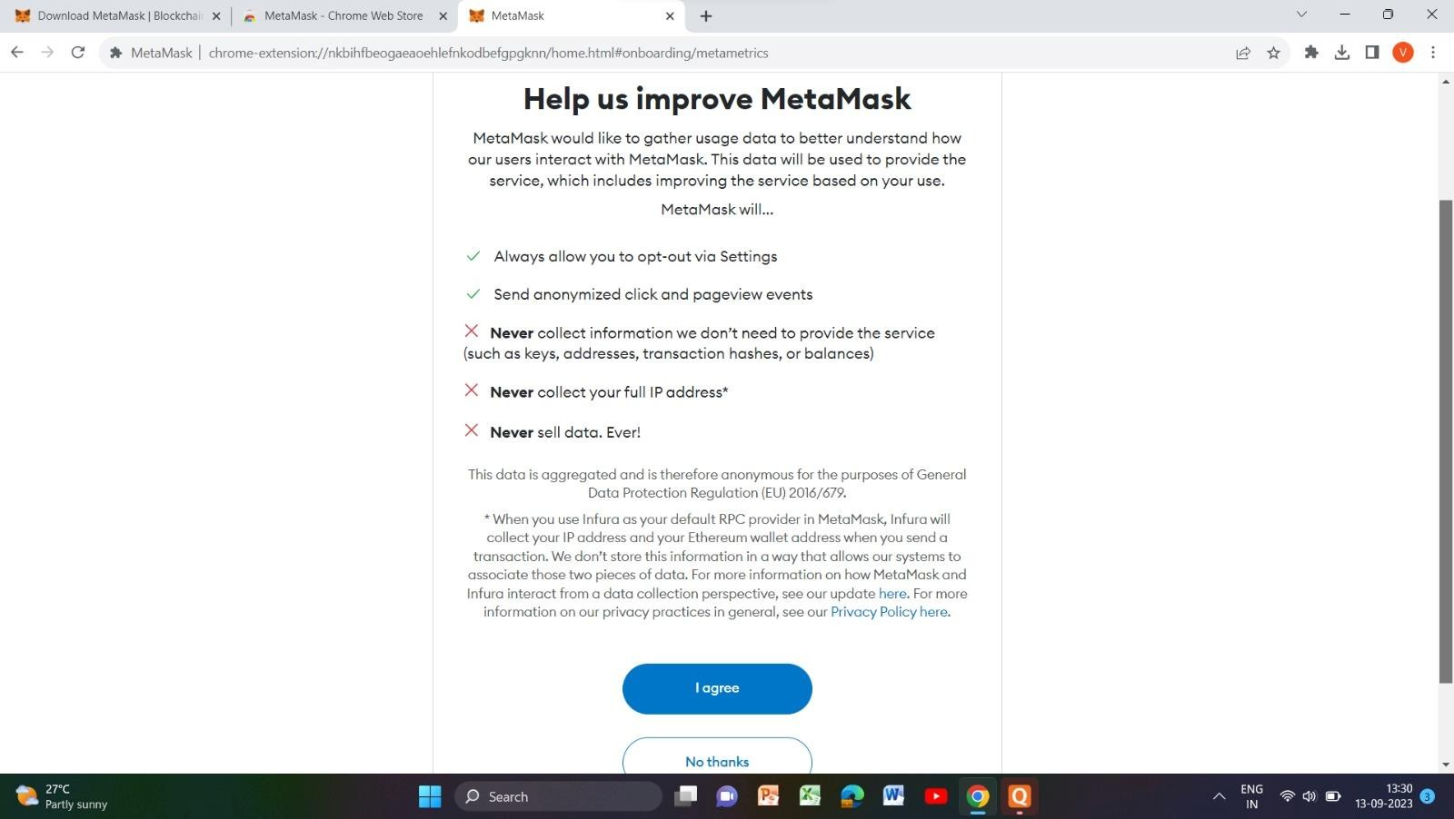

Step6-Enter the new Password “\*\*\*\*\*\*\*\*”and confirm Password “\*\*\*\*\*\*\*\*”Tick on I agree. Click on Create.

