Clean Architecture Kata
Course Registration Exercise

Description

Required Functionality
Student accesses the system and views the courses currently available for her to register. Then she selects a course and registers for it.

Business rules
- Student must be logged in and with a valid session.
- Student cannot register to a course if she is already registered to it.
- Student cannot register within 5 days of course start date.

Primary Actor
Student

Preconditions
- Student is already logged into system, but it’s session might have expired.

Postconditions
- Student is registered into a course.

Main Success Scenario
- Student opens the application.
- System displays a list of courses available for registering.
- Student selects one Course from the menu.
- Student submits the request.
- System registers student for the selected courses and displays a confirmation message.

Extensions
- (5a) User could not be registered into the course, one of the business rules was not satisfied: system displays a message explaining the problem.

Clean Architecture Diagram
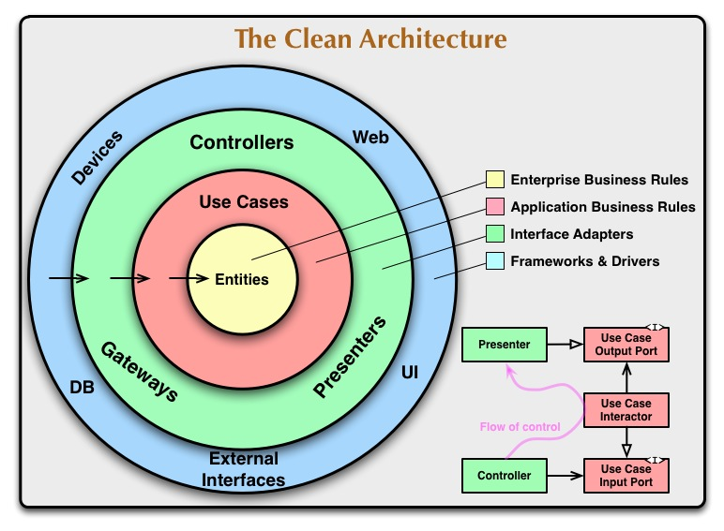

Steps for the exercise

Identification Phase
First of all, let’s start by identifying the different layers on the system:
- Identify required Domain Entities (Enterprise business rules)
- Identify required Use Case(s) (Application business rules)
- Identify required Gateways, Controllers, Presenters... (Interface Adapters)
- Identify required storage systems & UI (Frameworks & Drivers)

Implementation Phase
Once this is (almost) clear in your mind, let’s start writing code! Here you are free to do it as you like, but here are some recommendations:
- Remember the Dependency Rule: internal layers know nothing about external ones.
- Do you remember TDD? Sure! Write at least one test per layer (that’s enough, it’s not the goal of this Kata).
- Try to implement the functionality in the same order defined in the Identification Phase.

