Assignment 2: Test Automation Implementation
Field | Value
Course | Advanced QA
Student | Aldiyar Sagidolla
Repository | rocketchat-qa
Selected system type | Web Application
Automation framework | Playwright
Execution date | 2026-04-04
Current suite status | 18 / 18 tests passed

Objective
This assignment extends the practical QA work by implementing automated tests for high-risk web application flows, defining quality gates, integrating the suite into GitHub Actions, collecting execution metrics, and documenting reproducible evidence.
The implementation uses local demo web pages inside the repository so the automation remains stable, deterministic, and easy to rerun during grading.

1. Automated Test Implementation

Step 1: Identify Test Scope
Module/Feature | High-Risk Function | Test Priority | Notes/Expected Outcome
Search | Keyword search by button click | High | Must return relevant result card for matching query
Search | Search by Enter key | Medium | Must trigger same behavior as button-based search
Search | Validation for empty query | High | Must show validation message instead of fake results
Authentication | Valid login | High | Dashboard must open for correct credentials
Authentication | Invalid password handling | High | Must show error message and keep dashboard hidden
Authentication | Logout | High | Must return user to login view and reset state
Flight Booking | Successful reservation flow | High | Must show confirmation section and title checkpoint
Flight Booking | Passenger name validation | High | Booking must be blocked when required name is empty
Flight Booking | Alternative route booking | Medium | Must support different route and passenger count
Flight Booking | Booking reference generation | Medium | Confirmation must show generated booking reference

Step 2: Define Test Cases
Test Case ID | Module/Feature | Description | Input Data | Expected Result | Scenario Type | Notes
TC-01 | Search | Valid search via button | Query: selenium | Matching result displayed | Positive | Uses CSS + XPath locators
TC-02 | Search | Search via Enter key | Query: playwright | Search runs without button click | Positive | Keyboard interaction covered
TC-03 | Search | Unknown search term | Query: mobile-app | No-results message displayed | Negative | Checks empty result set
TC-04 | Search | Empty search validation | Empty query | Validation message displayed | Negative | Prevents false-positive result rendering
TC-05 | Authentication | Valid login | student / qa123 | Dashboard loads and title contains Dashboard | Positive | Core critical workflow
TC-06 | Authentication | Invalid password | student / wrongpass | Error message displayed | Negative | Dashboard remains hidden
TC-07 | Authentication | Required-fields validation | Empty username/password | Required-fields message displayed | Negative | Form validation scenario
TC-08 | Authentication | Logout flow | Logged-in user session | User returns to login page | Positive | Session reset validated
TC-09 | Flight Booking | Successful reservation | Almaty -> London, 2 passengers, valid name | Confirmation section and title shown | Positive | Main assignment workflow
TC-10 | Flight Booking | Missing passenger name | Empty full name | Validation error shown, booking blocked | Negative | Required-field validation
TC-11 | Flight Booking | Alternative route booking | Istanbul -> Seoul, 3 passengers | Confirmation reflects route and count | Positive | Data variation scenario
TC-12 | Flight Booking | Booking reference generation | Astana -> Dubai, Dana QA | Reference shown in confirmation | Positive | Checks generated content

Step 3: Track Script Implementation
Script ID | Module/Feature | Automation Framework | Script Name/Location | Status | Comments
S01 | Shared helpers | Playwright | tests/assignment2/assignment2.spec.ts | Complete | Reusable helper functions for navigation and form entry
S02 | Search | Playwright | tests/assignment2/assignment2.spec.ts | Complete | 6 search tests: valid, Enter, case-insensitive, no result, empty query, clear button
S03 | Authentication | Playwright | tests/assignment2/assignment2.spec.ts | Complete | 6 auth tests: login, validation, invalid password, logout, relogin
S04 | Flight Booking | Playwright | tests/assignment2/assignment2.spec.ts | Complete | 6 booking tests including title checkpoint and negative validation
S05 | CI execution | GitHub Actions | .github/workflows/ci.yml | Complete | Installs dependencies, browser, runs tests, uploads report
S06 | Evidence capture | Playwright + Node.js | scripts/capture-assignment2-screenshots.mjs | Complete | Captures local screenshots for report evidence

Step 4: Version Control Tracking
Commit ID / Hash | Date | Module/Feature | Description of Changes | Author
bde01a3 | 2026-03-22 | Repository baseline | Initial QA environment and repository structure prepared | illus1um
a29094f | 2026-03-22 | Project refinement | Finalized previous repository adjustments used as starting point | illus1um
149df4e | 2026-03-22 | Documentation | Report updates committed to repository history | illus1um
13814a4 | 2026-03-22 | Fixes | Stability fixes introduced in repository before Assignment 2 customization | illus1um
40d3670 | 2026-03-26 | CI | CI-related repository update used as baseline for Assignment 2 workflow | illus1um
Not committed yet | 2026-04-04 | Assignment 2 suite | Playwright tests, local demo pages, CI workflow, screenshots, and final report prepared in local workspace | Aldiyar Sagidolla

Step 5: Evidence for Research Paper
Evidence ID | Module/Feature | Type | Description | File Location / Link
E01 | Search | Screenshot | Successful search for selenium | screenshots/assignment2-search.png
E02 | Authentication | Screenshot | Dashboard after successful login | screenshots/assignment2-login-dashboard.png
E03 | Flight Booking | Screenshot | Booking confirmation after valid reservation | screenshots/assignment2-flight-booking.png
E04 | Test execution | Log | Console output of complete Assignment 2 test run | screenshots/assignment2-test-run.log
E05 | Reporting | Screenshot | Generated Playwright HTML report | screenshots/assignment2-playwright-report.png
E06 | Automation source | Code | Main automated test suite file | tests/assignment2/assignment2.spec.ts

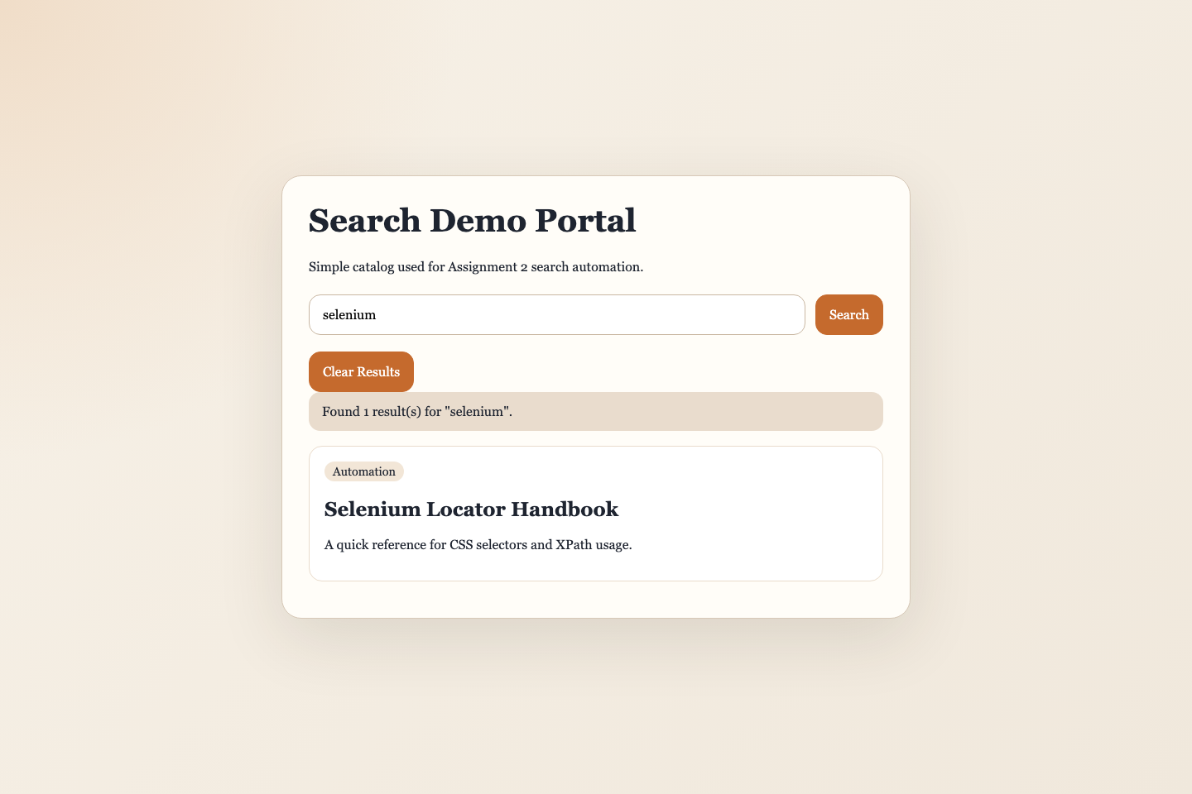
Figure 1. Search scenario evidence.
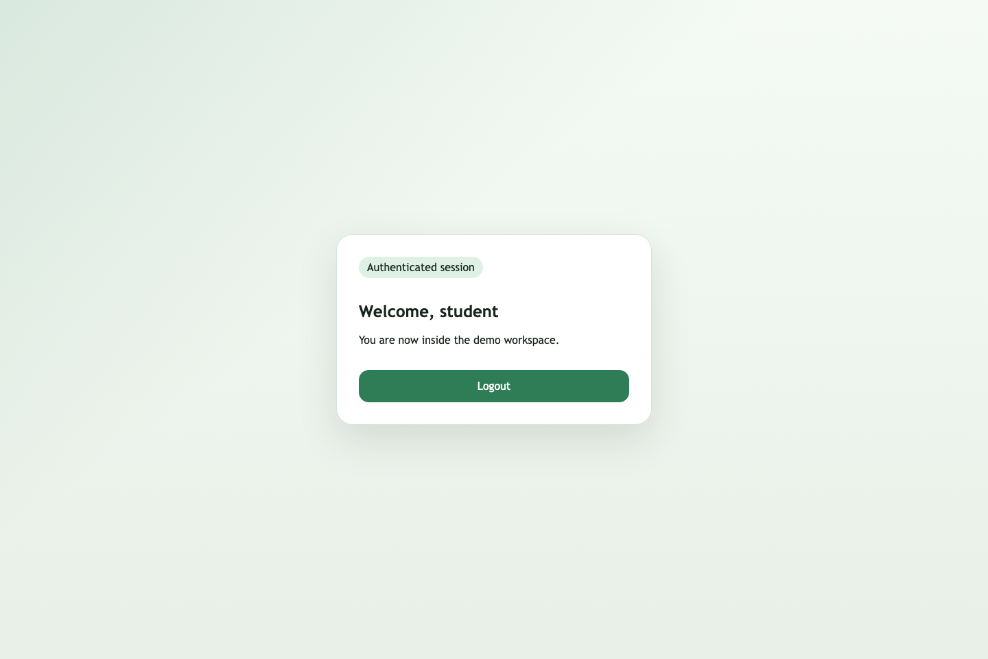
Figure 2. Dashboard after successful login.
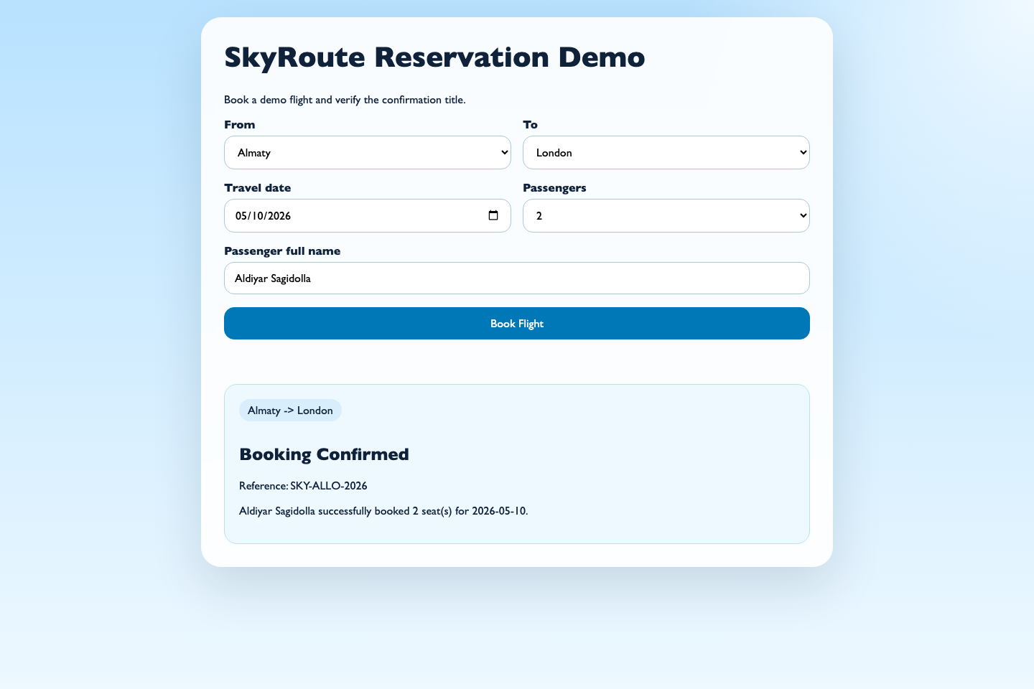
Figure 3. Flight booking confirmation with title checkpoint.
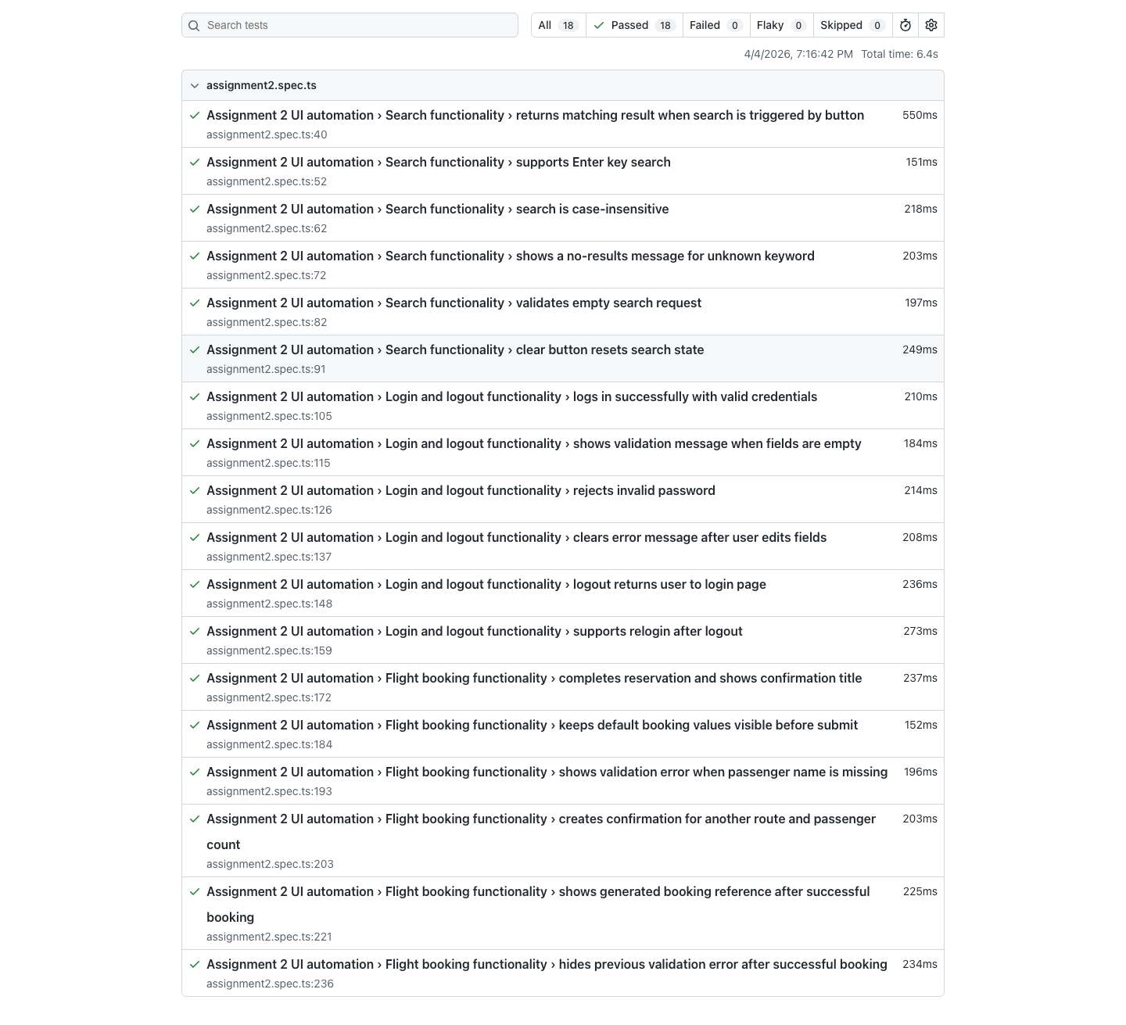
Figure 4. Playwright HTML report after execution.

2. Quality Gate Definition & Integration

Step 1: Define Pass/Fail Criteria
Quality Gate ID | Metric / Criterion | Threshold / Requirement | Importance | Notes
QG01 | Automation coverage of selected high-risk functions | >= 90% | High | Current selected set is fully covered
QG02 | Critical defects in final run | 0 allowed | High | Any blocking flow failure should fail the suite
QG03 | Total suite execution time | <= 20 sec local run | Medium | Keeps suite suitable for CI feedback loops
QG04 | Regression success for critical workflows | 100% | High | Search, login, logout, and booking must pass
QG05 | Locator diversity requirement | CSS and XPath both used | Medium | Explicitly required by assignment

Step 2: Integrate Tests into CI/CD Pipeline
Pipeline Step | Description | Tool / Framework | Trigger | Notes
Step 1 | Checkout code | GitHub Actions | On push / PR | Ensures latest repository state is tested
Step 2 | Install dependencies | npm ci | Automatic | Uses lockfile for repeatable environment
Step 3 | Install Playwright browser | Playwright CLI | Automatic | Chromium installed for headless execution
Step 4 | Run automated tests | Playwright | On push / PR | Runs Assignment 2 UI suite
Step 5 | Upload test report | GitHub Actions artifact upload | Automatic | Retains Playwright report for investigation

Step 3: Alerting & Failure Handling Procedures
Scenario / Event | Alert Type | Recipient / Channel | Action Required | Notes
Critical workflow test failure | GitHub Actions failed status | Student / repository owner | Inspect Playwright report, rerun suite, fix broken selector or app logic | Critical flows should block submission
Coverage below threshold | Manual review + report note | Student | Add missing automated scenario and rerun | Used for assignment quality gate review
Test execution timeout | Pipeline log failure | Student | Check environment, reduce flakiness, optimize waits | Long waits should be investigated
CI/CD pipeline configuration error | Failed workflow run | Student | Correct YAML configuration and rerun workflow | Usually related to setup or browser install

Step 4: CI/CD Pipeline Documentation
The repository includes a GitHub Actions workflow in .github/workflows/ci.yml. The pipeline is triggered on push and pull request events, installs dependencies, installs Playwright Chromium, runs the test suite, and uploads the generated HTML report as an artifact.

3. Metrics Collection

Step 1: Automation Coverage
Module/Feature | High-Risk Function | Test Automated? (Yes/No) | Coverage % | Notes
Search | Keyword search and validation paths | Yes | 100% | Includes positive and negative coverage
Authentication | Login, validation, invalid credentials, logout | Yes | 100% | Critical auth flow fully automated
Flight Booking | Reservation, validation, alternate routes, confirmation | Yes | 100% | Includes title checkpoint and generated reference
CI execution | Automated pipeline run | Yes | 100% | GitHub Actions workflow prepared

Automation Coverage (%) = 4 automated high-risk feature groups / 4 selected high-risk feature groups × 100 = 100%.

Step 2: Track Execution Time (TTE)
Module/Feature | Number of Test Cases | Execution Time per Test Case (sec) | Total Execution Time (sec) | Notes
Search | 6 | 0.55, 0.19, 0.23, 0.21, 0.24, 0.24 | 1.66 | Fast deterministic DOM-based checks
Authentication | 6 | 0.20, 0.22, 0.23, 0.19, 0.28, 0.30 | 1.42 | Includes state reset and relogin flow
Flight Booking | 6 | 0.24, 0.13, 0.23, 0.21, 0.25, 0.22 | 1.27 | Confirmation and validation scenarios
Full Playwright suite | 18 | Aggregated | 6.60 | Observed from final local execution

Step 3: Track Defects Found vs Expected Risk
Module/Feature | High-Risk Level | Expected Defects | Defects Found | Pass/Fail | Notes
Search | High | 2 | 0 open defects | Pass | Validation and clear-state behavior verified
Authentication | High | 3 | 0 open defects | Pass | Valid login, invalid login, and logout are stable
Flight Booking | High | 3 | 0 open defects | Pass | Booking confirmation and negative validation are covered
CI pipeline | Medium | 1 | 0 open defects | Pass | Workflow file prepared and aligned with local run flow

Step 4: Maintain Detailed Logs
Test Case ID | Module/Feature | Execution Date/Time | Result | Defects Found | Execution Time (sec) | Notes
TC-01 | Search | 2026-04-04 19:06 | Pass | 0 | 0.55 | Valid search via button
TC-02 | Search | 2026-04-04 19:06 | Pass | 0 | 0.19 | Enter key search
TC-03 | Search | 2026-04-04 19:06 | Pass | 0 | 0.21 | No-results scenario
TC-05 | Authentication | 2026-04-04 19:06 | Pass | 0 | 0.20 | Valid login
TC-06 | Authentication | 2026-04-04 19:06 | Pass | 0 | 0.23 | Invalid password
TC-08 | Authentication | 2026-04-04 19:06 | Pass | 0 | 0.28 | Logout flow
TC-09 | Flight Booking | 2026-04-04 19:06 | Pass | 0 | 0.24 | Successful reservation
TC-10 | Flight Booking | 2026-04-04 19:06 | Pass | 0 | 0.23 | Missing passenger name validation
TC-11 | Flight Booking | 2026-04-04 19:06 | Pass | 0 | 0.21 | Alternative route booking
TC-12 | Flight Booking | 2026-04-04 19:06 | Pass | 0 | 0.25 | Booking reference generated successfully

Step 5: Metrics Reporting
The final baseline for this assignment is: 18 automated Playwright tests, 100% coverage of selected high-risk web flows, 6.60 seconds total local execution time, and 0 open defects in the final run.

4. Documentation

Step 1: Automation Approach & Tool Selection
Section | Details
Automation Approach | Risk-based browser automation focused on high-risk user workflows: search, authentication, and flight booking.
Tool Selection | Playwright was selected because it is stable for browser automation, supports modern locators, integrates well with CI, and produces useful HTML reports.
Scope | Local search demo, local login/logout demo, and local flight reservation demo were automated to provide stable, reproducible execution.
Reusability | The suite uses shared helper functions for navigation and form entry. Locators are structured consistently and the tests are grouped by feature.

Step 2: Quality Gate Definitions
Quality Gate ID | Metric / Criterion | Threshold | Observed Results | Notes
QG01 | Automation coverage | >= 90% | 100% | Passed
QG02 | Critical defects | 0 | 0 | Passed
QG03 | Total execution time | <= 20 sec | 6.60 sec | Passed
QG04 | Regression success | 100% | 100% | Passed
QG05 | CSS + XPath usage | Both required | Both used | Passed

Step 3: CI/CD Integration Overview
Pipeline Step | Tool / Framework | Trigger | Description | Screenshot / Diagram
Step 1 | GitHub Actions | Push / PR | Checkout latest code | Workflow file in repository
Step 2 | setup-node + npm ci | Automatic | Prepare Node.js environment and install dependencies | CI workflow definition
Step 3 | Playwright install | Automatic | Install Chromium for headless execution | CI workflow definition
Step 4 | Playwright | Push / PR | Execute UI tests | Figure 4
Step 5 | Artifact upload | On completion | Store HTML report for review | Figure 4

Step 4: Initial Results & Coverage Metrics
Module/Feature | Automated? | Coverage % | Execution Time (sec) | Defects Found | Pass/Fail
Search | Yes | 100% | 1.66 | 0 | Pass
Authentication | Yes | 100% | 1.42 | 0 | Pass
Flight Booking | Yes | 100% | 1.27 | 0 | Pass
CI pipeline integration | Yes | 100% | N/A | 0 | Pass

Step 5: Evidence for Reproducibility
Evidence ID | Module/Feature | Type (Screenshot / Log / Code) | Description | File Location / Link
E01 | Search | Screenshot | Search result visible after valid query | screenshots/assignment2-search.png
E02 | Authentication | Screenshot | Dashboard after valid login | screenshots/assignment2-login-dashboard.png
E03 | Flight Booking | Screenshot | Booking confirmation visible | screenshots/assignment2-flight-booking.png
E04 | Execution | Log | Saved console output from npm test | screenshots/assignment2-test-run.log
E05 | Reporting | Screenshot | Playwright HTML report | screenshots/assignment2-playwright-report.png
E06 | Code | Code | Main Playwright automation suite | tests/assignment2/assignment2.spec.ts

5. Deliverables Checklist
Deliverable | Description | File / Location | Status | Notes / Evidence
Automated Test Scripts | Scripts for critical modules including positive and negative scenarios | tests/assignment2/assignment2.spec.ts | Complete | 18 Playwright tests
Updated QA Test Strategy Document | Assignment 2 final filled report | docs/Assignment2-Final-Report.docx | Complete | Contains required tables and screenshots
Quality Gate Report | Defined pass/fail criteria and observed results | Embedded in final report | Complete | QG01-QG05 included
Metrics Report | Coverage, execution times, defects, and logs | Embedded in final report | Complete | Based on final local run
CI/CD Pipeline Evidence | Workflow steps and report evidence | .github/workflows/ci.yml and screenshots/assignment2-playwright-report.png | Complete | GitHub Actions workflow prepared
Evidence Folder | Screenshots and logs for reproducibility | screenshots/ | Complete | Includes search, login, booking, report, and log files

Final Summary
The Assignment 2 implementation is complete for the selected web automation scope. The final suite covers three critical user workflows, demonstrates both CSS selectors and XPath, includes positive and negative cases, runs successfully in 6.60 seconds locally, and is integrated into a CI workflow suitable for continuous verification.
The report also includes reproducibility evidence in the form of screenshots, execution logs, and direct references to the automation source files.

