Total Points: / 30 Name: Jeremiah Webb

1. **(1 pts)** What is the range of signed 10-bit integers?

-512 to 511

1. **(4 pts)** Convert the following **signed decimal numbers** to their binary equivalents (use 9 bits):
2. -64 = 111000000
3. 100 = 001100100
4. 145 = 010010001

v. 255 = 011111111

Can we write the binary equivalent of ALL above four numbers using ONLY 8 bits? Yes or No. Give reasoning. **( 1 pt)**

We cannot just use 8 bit signed numbers, because the range of 8 signed bits are from -128 to 127, the range for 9 bits is -256 to 255

1. **(4 pts)** Represent the following decimal number in both **binary sign/magnitude and Two’s complement** using 16 bits:

i. +512

Binary Sign = 0000001000000000

Two’s Complement = 0000001000000000

ii. -29

Binary Sign = 1000000000011101

Two’s Complement = 1111111111100011

1. **(2 pts)** Find the following differences using twos complement arithmetic:

i. 7-4

ii. 12-7

i. ii.

4 = 0100 7 = 0111 7 = 00111 12 = 01100

flip 1011 -4 = 1100 flip 11000 -7 = 11001

+ 1 + + 1 +

----------- ----------------- ------------- -------------------

-4 = 1100 3 = 0011 -7 = 11001 5 = 00101

1. **(3 pts)** Covert the following binary (already in 2s complement) to decimal:

i. 1 0 1 1 0 1 0 0

ii. 0 1 1 1 1 1 1 1

iii. 1 1 1 1 1 1 1 1

I. Negative leading 1

10110100 = -76

ii. Positive leading 0

01111111 = 127

iii. Negative leading 1

11111111 = -1

1. **(5 points)** Using Logisim implement a 1-bit full adder.

* Name the circuit fulladder_yourfirstName_yourlastName.
* Your fulladder should take 3 inputs (x,y,CarryIn) and yield two ouputs (sum, CarryOut).
* Once built, be sure to test out your circuit for all possible input values to ensure that its implemented correctly!

Submit the following:

* 1. .circ file
  2. Screenshot of the circuit

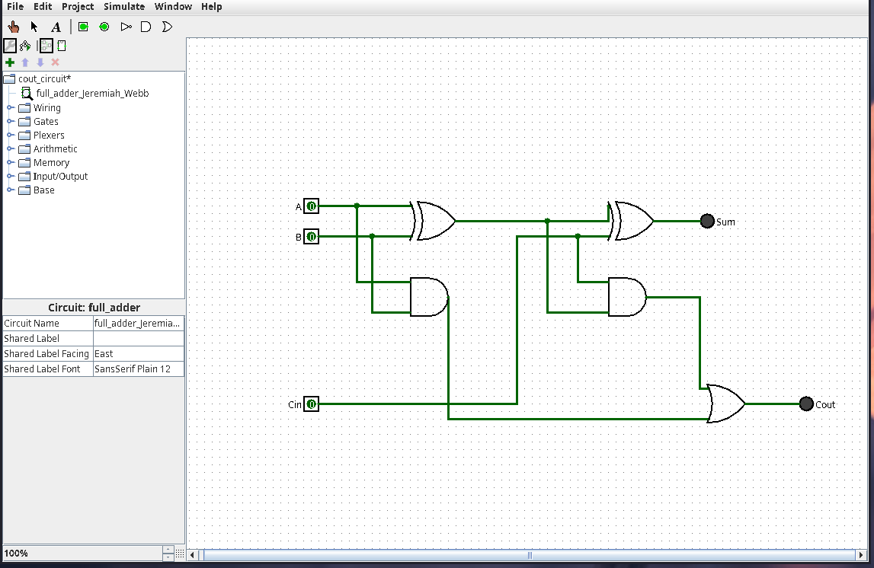

* 1. Screenshot of truth table

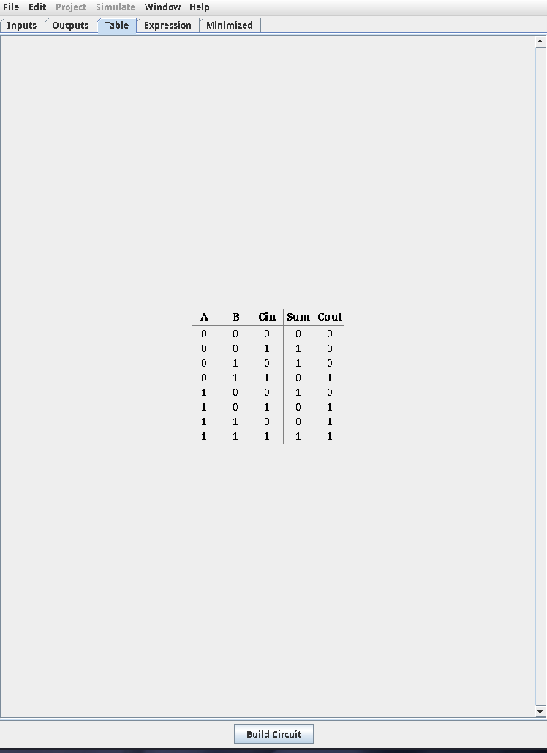

1. **(10 points)** Implement a 6-bit ripple carry adder using the 1-bit full adder created in question 5.

* Name your circuit rippleCarryAdder_yourfirstName_yourlastName.
* Your rippleCarryAdder takes two 6-bit inputs X and Y and 1-bit input value CarryIn and produces a 6-bit Sum and a 1-bit CarryOut.
* To build this circuit you should use 6 copies of 1-bit fulladder circuit designed in question 5.
* Once built, be sure to test out your circuit for all possible input values to ensure that its implemented correctly!

Submit the following:

* 1. .circ file
  2. Screenshot of the circuit showing addition of **101111 + 011100**

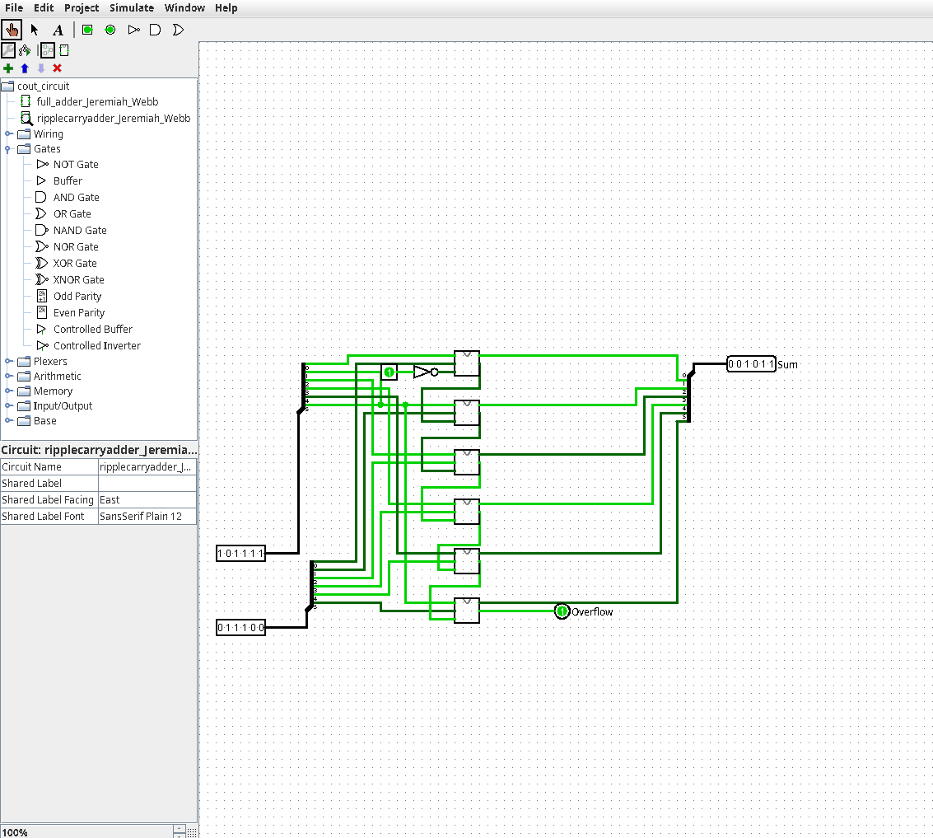

* 1. Screenshot of the circuit showing addition of **111111 + 000100**

