Name: Jeremiah Webb

ID: 2545328

**HW 4: Floating Point Numbers**

**[6 points] Task 1:**

Write the binary IEEE 32 bit representation for the following numbers:

1. +0

0 00000000 00000000000000000000000

1. -0

1 00000000 00000000000000000000000

1. Inf

0 11111111 00000000000000000000000

1. -inf

1 11111111 00000000000000000000000

1. Denormal

0 00000000 11000000000000000000000

1. NaN

0 11111111 00000000000000000000000

**[10 points] Task 2:**

1. Convert 0x7237176E from hexadecimal to IEEE 32-bit Format. (0x means the number is given in hex)

Convert to binary

0111 0010 0011 0111 0001 0111 0110 1110

7 2 3 7 1 7 6 E

Normalize:

1.110010001101110001011101101110 * 2^ 30

Exponent: 30+127 = 157 = 10011101

Final Answer: 0 10011101 11001000110111000101111

1. Convert 8.625 from Decimal to IEEE 754 32- bit Floating Point format

Convert to binary:

1000.101

Normalize: 1.000101 * 2^3

Find exponent: 3+127 = 130 = 10000010

Final Answer: 0 10000010 00010100000000000000000

**[5 points] Task 3**: Precision

As you should know, floating points are approximation of real numbers. Not every real number can be represented. Define three numbers in double precision in python:

A =  55555555555555555555552523523523525555.1305197613051976;

B = -55555555555555555555252352523525555555.1305197613051976;

C=0.1;

And now print them on the screen. Are the numbers you have printed the one you have defined? If not why? Submit the screenshot aswell. Refer the supplemental materials below.

The numbers are not the same, and this is due to floating point error. Python actually uses the dtoa algorithm to accurately calculate and mitigate floating point error. Additionally Python’s print statement does not accurately present a float number without specific formatting, as demonstrated below. Since the floating point “Double” type number has to be converted to an ASCII string for stdout, there is some data lost.

Link for CPython code showing dtoa algorithm: [link](https://github.com/python/cpython/blob/9776b0636ae39668d3ce1c006d4be01dad01bf9f/Python/dtoa.c" \l "L2204-L2845)

(Python is dynamically typed, didn’t need to define data types).

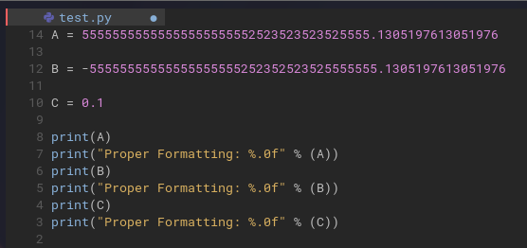

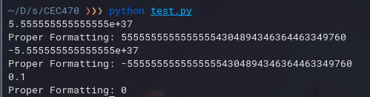

**[5 points] Task 4**: Associative property

It should be pretty clear now that floating point numbers and real numbers are two different sets of numbers. You have studied that addition is associative for real numbers. This means that if A,B and C are real number, than (A+B)+C = A+(B+C). Well, this is NOT true for floating point.

Write a short python program to prove that addition is not associative for floating point.

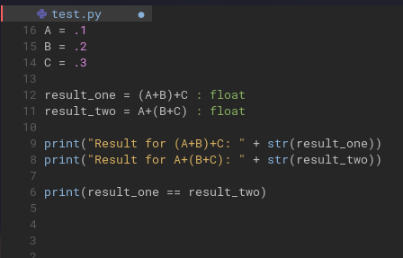

This is neovim btw, I highly suggest you check it out.

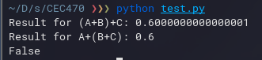

**[Bonus 2 points] Task 5:** Watch the video <https://www.youtube.com/watch?v=PZRI1IfStY0> and summarize the main points covered.

**Notes:**

* Please put all code into one file along with all the screenshots

Supplemental materials:

1. <https://www.h-schmidt.net/FloatConverter/IEEE754.html>
2. <https://dwayneneed.github.io/.net/2010/05/06/fun-with-floating-point.html>
3. <https://www.youtube.com/watch?v=PZRI1IfStY0>
4. <https://docs.oracle.com/cd/E19957-01/806-3568/ncg_goldberg.html>