Student: Jeremiah Webb

Date: 11/15/2022

Code Snippet & Image:

#include <stdint.h>

#include <stdio.h>

#include <stdlib.h>

int main(int argc, char **argv) {

if (argc < 2) {

printf("Integer Argument expected!\n");

return 1;

}

char *addr_string = argv[1];

uint32_t address = strtol(addr_string, NULL, 10);

printf("The address %u contains:\n", address);

uint32_t page_size = 4096;

uint32_t page = address / page_size;

printf("page number = %u\n", page);

uint32_t offset = address % page_size;

printf("offset = %u\n", offset);

}

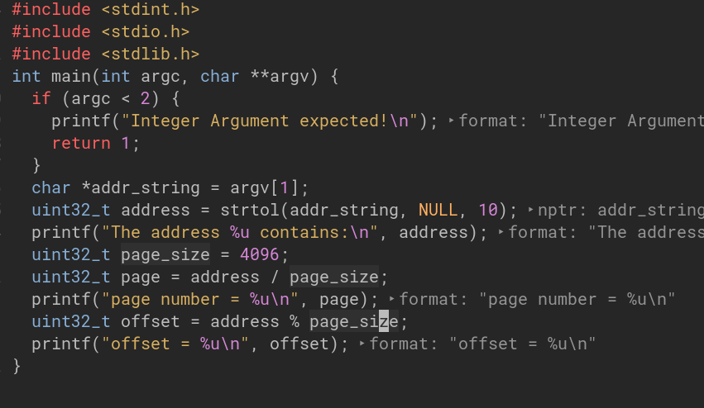

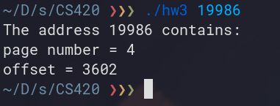Code Output