- Define the following terms using 1-3 sentences or a formula.
  - Moore’s Law
Moore’s law says that the number of transistors that can be packed into a given unit of space ( chip)
would double every two years.
  - Stored program computer
In a stored program computer, programs or instructions are represented in a manner suitable
for electronically storing in memory alongside the data. The computer gets its instructions by
reading them from memory, and a program can be set or modified by setting the values of a
portion of memory.
  - Amdahl’s law
A program with parallel processing , a relatively few instruction s that have to be performed in sequence will have a limiting factor on program speedup such that adding more processor s may not make the program run faster.
  - Instruction Set Architecture (ISA)
ISA, or simply architecture: the abstract interface between hardware
and the lowest level of software that encompasses all the information
necessary to write a machine language program, including instructions,
registers, memory access, IO,
  - Computer architecture
In computer engineering, computer architecture is a set of rules and methods that describe the functionality, organization, and implementation of computer systems

- Write the range using 8 bits for:
- Unsigned integers 0 - ((2^8) -1) 0-255
- Signed integers (2^7) – ((2^7)-1) -128-127
Unsigned 0 - 2^n -1 n = given bits
Signed -(2^n-1) - ((2^n-1)-1)

- Describe the steps that transform a program written in a high-level language such as C into a representation that is directly executed by a computer processor.
The use of compiler to reads the high-level source code and translates it into a program in assembly language. The use of assembler to transforms the program in assembly language into a program in machine language as it is the language that computer understands can work with. The compiler translates code written in a high level language to a lower level language, object/machine code by creating an executable program that converts from a high level language into machine language or simply do it directly without a middleman.

- [Given the following 64-bit number, what is the most significant bit's value?
1000 0000 0000 0000 0000 0000 0000 0000 0000 0000 0000 0000 0000 0000 0000 0000

2^64-1 if unsigned
- Consider three different processors P1, P2, and P3 executing the same instruction set. P1 has a 3 GHz clock rate and a CPI of 1.5. P2 has a 2.5 GHz clock rate and a CPI of 1.0. P3 has a 4.0 GHz clock rate and has a CPI of 2.2.
- Which processor has the highest performance expressed in instructions per second?
P1 = 3/1.5 = 2 * 10^9 instructions per second
P2 = 2.5 / 1.0 = 2.5 * 10^ 9 instructions per second
P3 = 4 / 2.2 = 1.82 * 10^9 instructions per second
P2 is best.

- If the processors each execute a program in 10 seconds, find the number of cycles and the number of instructions.
Cycles:
P1: 3GHz * 10 = 3 * 10^10 cycles
P2: 2.5GHz * 10 = 2.5 * 10^10 cycles
P3: 4GHz * 10 = 4 * 10^10 cycles
Num of instructions:
P1: 3GHz * 10 / 1.5 = 2 * 10^10 instructions
P2: 2.5GHz * 10 / 1.0 = 2.5 * 10^10 instructions
P3: 4GHz * 10 / 2.2 = 1.82 * 10^10 instructions
- We are trying to reduce the execution time by 30% but this leads to an increase of 20% in the CPI. What clock rate should we have to get this time reduction?
Execution time = (Num of instructions * CPI) / (Clock rate)
So if we want to reduce the execution time by 30%, and CPI increases by 20%, we
have:
Execution time * 0.7 = (Num of instructions * CPI * 1.2) / (New Clock rate)
New Clock rate = Clock rate * 1.2 / 0.7 = 1.71 * Clock rate
New Clock rate for each processor:
P1: 3GHz * 1.71 = 5.13 GHz
P2: 2.5GHz * 1.71 = 4.27 GHz
P3: 4GHz * 1.71 = 6.84 GHz

- True or False: Sign and magnitude representation and two's complement representation are used about equally in modern computers.

False, largely two’s complement is in all computers for signed computers.

- What is the decimal value of this 64-bit two's complement number?

two’s complement to decimal →flip all bits 1→0 and 0→1, add 1.
decimal to two’s complement→ flip all bits 1→0 and 0→1, add 1.
Answer is -4

- What is 8-bit Two’s complement representation for following numbers?
    - -3₁₀
    - -9₁₀
3 = 00000011
flip
11111100
add 1
11111101
-3 in decimal
9 = 00001001
flip
11110110
add 1
11110111
-9 in Decimal
- Convert the following binary into base 10
  - 1110.1011 → 14.6875

  - 11001111.0111 → 207.4375

- What is the decimal value of the following 16-bit Twos complement number:
  - 1111 1111 1111 1000
Flip
0000 0000 0000 0111
Add 1
0000 0000 0000 1000
-8 in decimal

  - 1000 0000 0000 1111
Flip
0111 1111 1111 0000
Add
0111 1111 1111 0001
-32783 in decimal

- Convert the following binary into hexadecimal (no calculator allowed for this problem)
  - 1111 0010
F2
  - 1111 0011
F3
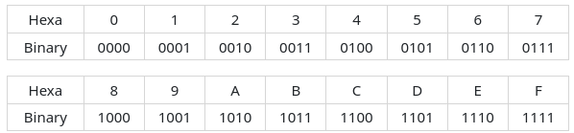

- Write the logical left shift and arithmetic right shift by one bit for the following:
  - 1000 1111
Logical Left Shift 0001 1110
Arithmetic Right Shift 1100 0111
  - 1111 0001
Logical Left Shift 1110 0010
Arithmetic Right Shift 1111 1000
- Write the truth table and draw the digital circuit using logic gates for the 1-bit full adder
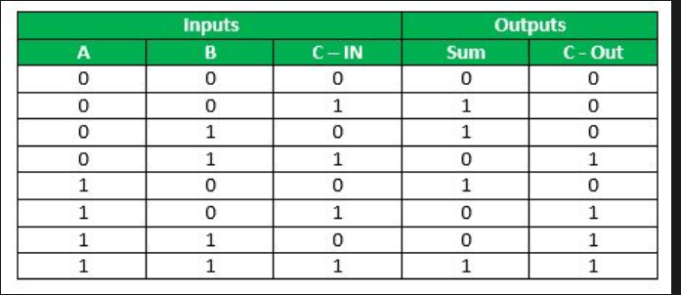

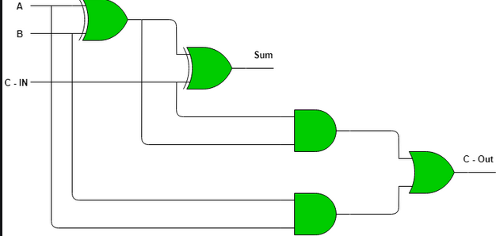
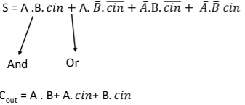

- Compute using booths algorithm 8x-6(use 5 bits to represent the numbers). Please show all the steps

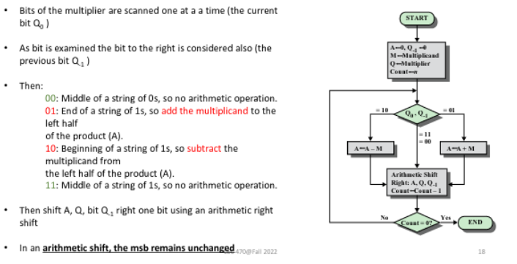

A | Q | Q-1 | M | Log
0000 | 1010 | 0 | 1000 | Populate Data
0000 | 0101 | 0 | 1000 | Shift
1000 | 0101 | 0 | 1000 | A = A - M
1100 | 0010 | 1 | 1000 | Shift
0100 | 0010 | 1 | 1000 | A = A + M
0010 | 0001 | 0 | 1000 | Shift
1010 | 0001 | 0 | 1000 | A = A - M
1101 | 0000 | 1 | 1000 | Shift

- Compute using booths algorithm 3x-3(use 4 bits to represent the numbers). Please show all the steps

A | Q | Q-1 | M | Log
000 | 101 | 0 | 011 | Populate Data
101 | 101 | 0 | 011 | A = A - M
110 | 110 | 1 | 011 | Shift
001 | 110 | 1 | 011 | A = A + M
000 | 111 | 0 | 011 | Shift
101 | 111 | 0 | 011 | A = A - M
110 | 111 | 1 | 011 | Shift
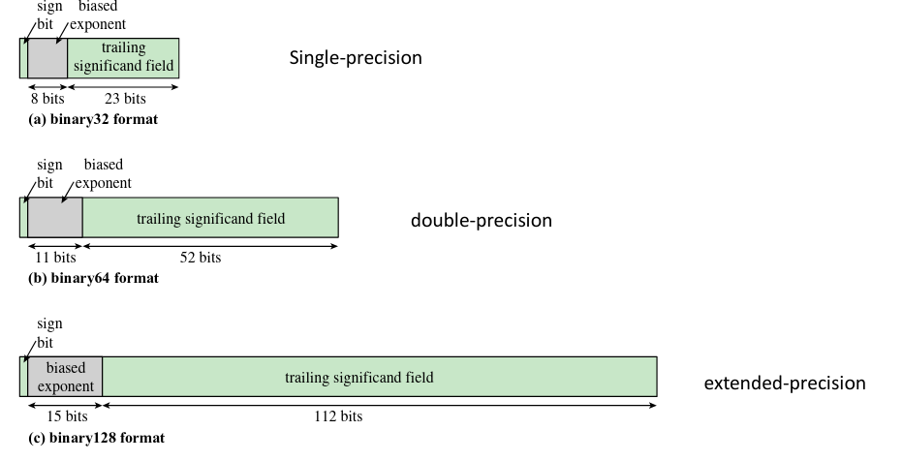
Sign bit: Exponent signficand
0 = + decimal value – 127 = exponent iimplied 1.0000
1 = -
- Write the normalized form for the following
  - 10000.111

1.0000111 * 2^4

  - 0.0000 1010 1111

1.0101111 * 2^-5

- Let AAAA0000 be a floating-point number in IEEE 32-bit floating expressed in hexadecimal. What is the decimal value of the number?
-1.3281250 * 10^-42

- Show the IEEE 754 binary representation of the number -0.75₁₀ in 32-bit format.
.75 * 2 = 1.5 → 1
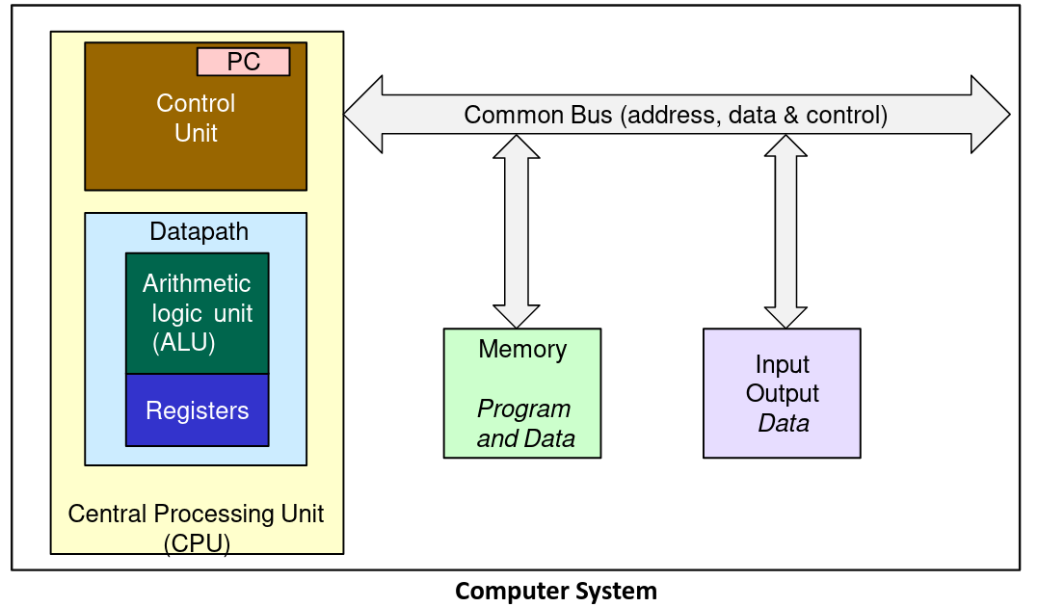
.5 * 2 = 1 → 1
.11 → 1.1 * 2^-1
E = 126 = 01111111
M = 1
1 01111110 10000000000000000000000
sign exponent mantissa

- What decimal number is represented by the following 32 bit IEEE format?
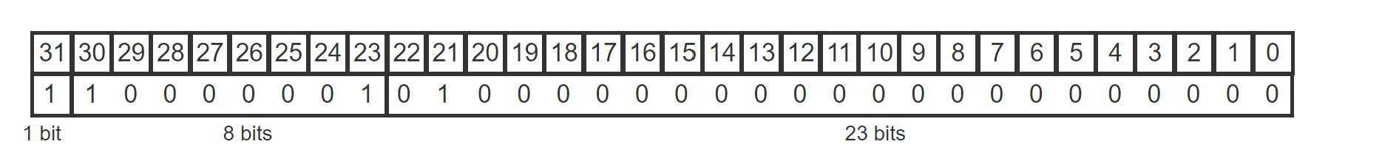

exponent = 129
exponent = 129 – 127 = 2

number will be negative due to sign bit.
Mantissa = .25

-1.25 *2^2
-1.25 * 4 = -5

Examples:
Clock time. If clock frequency is 900MHz, calculate the cycle time (1 point).
Cycle time = 1/f = 1/900 MHz = 1.11 GHz

Clock Speed. A program runs in 15 seconds on Computer A, which has a clock frequency of 600
MHz. We are trying to help a computer designer build a new machine B, that will run this
program in 6 seconds. One thing the designer can do is increase the clock frequency which will
affect the CPU design causing machine B to require 1.5 times as many clock cycles as machine A
for the same program. What clock rate should we tell the computer designer to target?
Given information:
Computer A: 15 sec and frequency = 600 MHz
Computer B: 6 sec and frequency =Y
If computer A takes X cycles, the computer B will take 1.5X cycles.
Program A runs for 15 sec= X/600 MHz ---------1)
Program B runs for 6 = 1.5X/Y -------------------2)
Dividing 1) by 2)
15/6= X/600 MHz /1.5X/Y
15/6 = Y/900 MHz
13500/6=Y
Y = 2250 MHz or2.25 GHz

