Student: Jeremiah Webb
Date: 11/15/2022

Code Snippet & Image:

#include <stdint.h>
#include <stdio.h>
#include <stdlib.h>
int main(int argc, char **argv) {
if (argc < 2) {
printf("Integer Argument expected!\n");
return 1;
}
char *addr_string = argv[1];
uint32_t address = strtol(addr_string, NULL, 10);
printf("The address %u contains:\n", address);
uint32_t page_size = 4096;
uint32_t page = address / page_size;
printf("page number = %u\n", page);
uint32_t offset = address % page_size;
printf("offset = %u\n", offset);
}

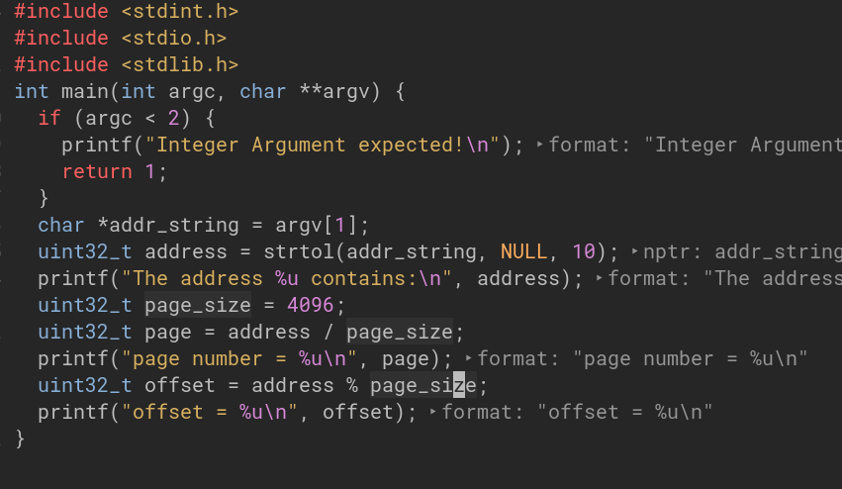

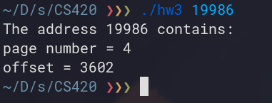
Code Output

