Name: Jeremiah Webb
Class: CS420
Date: 17th November 2022

3.2.1
(a)
For the 5 processes described below, draw a timing diagram showing when each process executes under FIFO, SJF, and SRT.
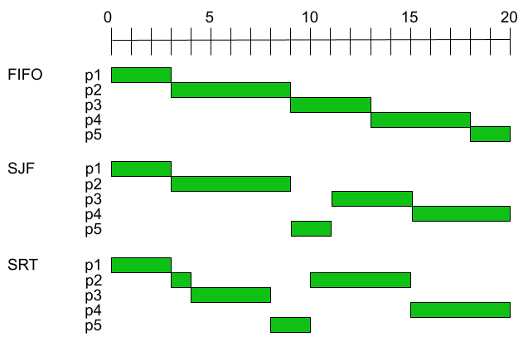

(b)
Determine the ATT for each scheduling algorithm for the 5 processes.
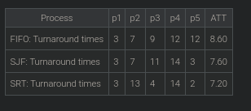

3.2.2 (a)
Starting at time 0, a new process p of length 3 arrives every 4 time units.
Starting at time 1, a new process q of length 1 arrives every 4 time units.
Determine the ATT under FIFO, SJF, and SRT.
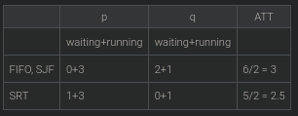

3.2.3
(a)
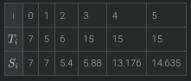

(b)

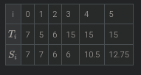

3.2.4
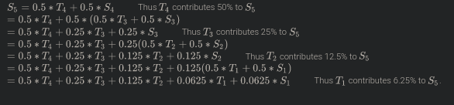
(a)

3.3.1
(a) Determine the average turnaround time, ATT, when the quantum is Q = 1 time unit.

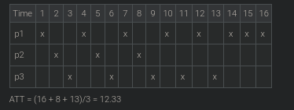

(b)Determine the average turnaround time, ATT, when the quantum is Q = 3 time units.
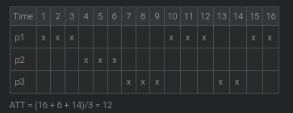

3.3.2 (a) How long will the execution take on a machine with n CPUs?
T ms
(b)How long will the execution take on a single CPU machine when the context switch overhead is zero?

n*t tms

(c) How long will the execution take on a single CPU machine when:
- the length of the time quantum is Q ms
- the time to perform each context switch is S ms

# of context switches: n*T/Q, total execution: n*T + (n*T/Q)*S ms

(d) Repeat the previous calculation using n=5, T=10,000, Q=100, S=10.

5*10,000 + (5*10,000/100)*10 = 55,000 ms.
3.3.3
(a) What should be the quantum size Q such that the gap between the end of one quantum and the start of the next quantum of any process does not exceed M ms?
Between the end of one quantum and the start of the next quantum, n - 1 processes will each execute one quantum: (n - 1)Q.
Additionally, n context switches will be needed for the interrupted process to restart: nS.
The sum of the two times must not exceed the limit M, i.e., (n - 1)Q + nS ≤ M. The largest Q that satisfies this condition is Q = (M - nS)/(n-1).

(b) For n = 5, S = 10, and M = 450, M = 90, M = 50, determine:
- The corresponding values of Q
- The percentage of CPU time wasted on context switching
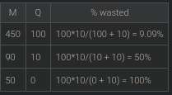

3.3.4
(a) T < Q

When T < Q, the quantum never expires. The execution repeats the timing sequence: T, S, T, S, ... . Thus for every T ms of execution, T + S ms of CPU time are needed. The fraction of wasted CPU time is S/(T + S).

(b) T >> Q
When T >> Q, each execution of T needs many quanta to complete. Each quantum is followed by a context switch. The fraction of wasted CPU time is S/(Q + S).

(c)Q approaches 0
When Q approaches 0, the value of S/(Q + S) approaches 1 (overhead approaches 100%).

(d)Under what condition will the wasted fraction of CPU time be 50%?
50% overhead means S/(Q + S) = 0.5, which is true when Q = S.

3.3.5 (a)Draw a timing diagram for the first 33 ms. On each of the 3 lines (one per process) show when the process is running and at which priority level.

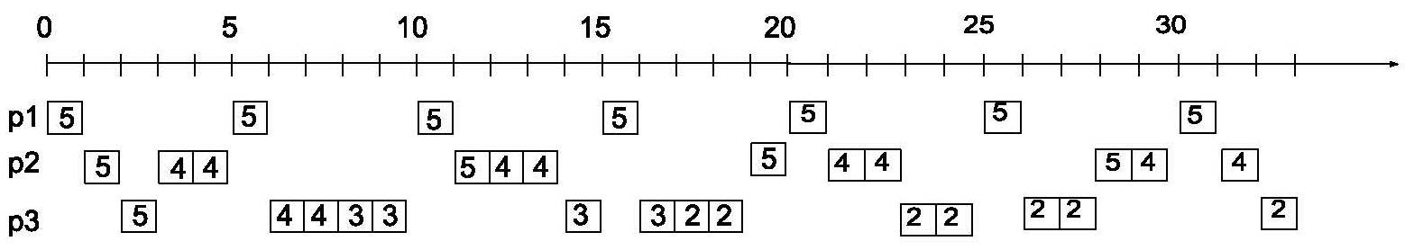

(b) Determine the ATT for each process.
P1 – ATT = 1
P2 – ATT = 4
P3 – ATT = 32

3.4.1 (a) Determine if a feasible schedule exists.
Determine if a feasible schedule exists.
5/20 + 10/100 + 42/120 = 0.25 + 0.1 + 0.35 = 0.7
0.7 < 1 and thus a feasible schedule exists.
(b)
5/20 + 10/100 + 42/120 = 0.25 + 0.1 + 0.35 = 0.7
0.7 < 1 and thus a feasible schedule exists.
(c)

The CPU fraction used by the 3 processes p1 through p3 is already 0.7.
Adding any more processes to the mix would likely result in an infeasible schedule.

3.4.2
(a)
For each case, determine if a feasible schedule is likely to be generated by:
- RM
- EDF
Case 1: Both RM & EDF. U = 3/50 + 70/1000 + 5/40 = 0.255
Case 2: Neither RM Nor EDF. U = 5/50 + 5/10 + 1/4 = 1.05
Case 3: EDF will produce feasible schedule. RM will most likely not produce a feasible schedule.
U = 5/20 + 7/10 + 4/100 = 0.99

(b)For each case, determine if a feasible schedule is likely to be generated by:
- RM
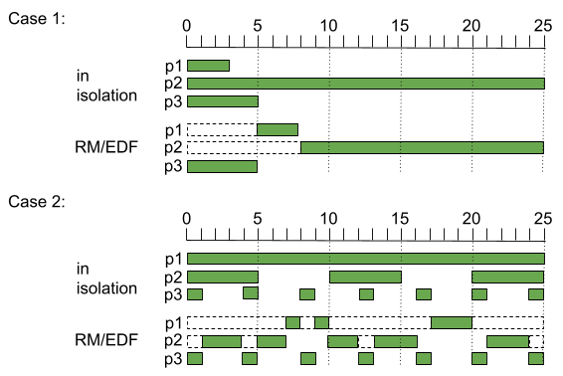
- EDF

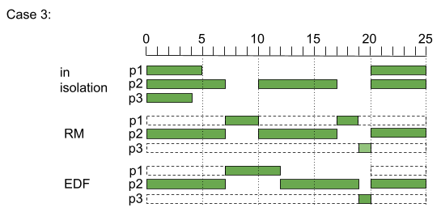

3.5.1
(a)
Show at which priority level the process p is executing during each of the 18Q time units.
