COMP9120 Group Project Report
Real-World Database Prototype

Project title | Campus Pantry: FoodHub Booking, Attendance and Inventory Database
Group name/number | Good Good Study, Day Day Up Group / 94
Team members | Nikhil Khatri 560743481; Ziyue Wu 560769023; Samouwel Aboud 570293396
Tutorial | 04&23
Submission date | 25 October 2026

Project Overview
Student food insecurity is now widespread in Australia, and campus pantries such as the University of Sydney FoodHub must ration limited food, volunteers and shelf space. Campus Pantry is a PostgreSQL database that replaces spreadsheets with one consistent record of who booked, who attended, who staffed each shift and what stock moved. Students book a 30-minute session and receive a QR token; staff check students in, roster supervisors and volunteers, and record purchases, batches and stock counts. A Python command-line prototype exercises every workflow, while triggers, constraints and row-level locks keep the data correct under concurrent use.

1. Problem and Requirements

1.1 Problem and Motivation
Studies at Australian universities found that 48% of surveyed students were food insecure (Whatnall et al., 2020), and one repeated survey found the rate rose from 42% in 2022 to 53% in 2024 (Kent et al., 2025). The University of Sydney FoodHub gives students free groceries, but they must register before collecting during limited weekday hours (Students' Representative Council [SRC], n.d.). With limited space, stock and volunteers, access must be booked and rationed. Doing this in spreadsheets causes double bookings, overfull sessions, lost stock history and understaffed shifts. These are consistency problems across related data, which is what a DBMS with constraints and transactions is built to prevent.

1.2 Users and Stakeholders
- Students – view free places, book one session per day, cancel, and present a QR token.
- Volunteers – request shifts and see whether staff approved them. A person can be a student and a volunteer at the same time.
- Staff (supervisors and assistants) – check students in, approve volunteers, record exceptions, purchases and stock counts.
- Pantry managers – need demand, attendance, waste and low-stock reports to plan purchasing.

1.3 Data Requirements
The system stores people identified by UniKey and their roles; shifts and their 30-minute sessions; bookings with status, QR token and any override details; staff duty assignments and volunteer requests; products, purchase records and lines; stock batches with unique StockNumbers and expiry dates; and an append-only history of physical stock counts, plus per-shift opening/closing quantities and receipt/waste adjustments.

1.4 Business Rules and Scope
ID | Rule
BR1 | A UniKey (4 lowercase letters + 4 digits) identifies each person; roles may overlap.
BR2 | A day has three 2-hour shifts, each containing four 30-minute sessions inside the shift's time range.
BR3 | A session holds at most 50 active (non-cancelled) bookings.
BR4 | A student has at most one active booking per date, unless a named staff member records an override with a reason.
BR5 | Each booking has a unique QR token; ATTENDED requires an attendance time; a token can be checked in once.
BR6 | Students may arrive late; unscanned bookings become ABSENT only after the 16:00 close.
BR7 | A shift can be OPEN or CLOSED only with exactly one MAIN_SUPERVISOR and one ASSISTANT; no person is rostered on overlapping shifts.
BR8 | Each received batch gets a StockNumber (STK-######) and must trace to a purchase line for the same product.
BR9 | Stock counts are never overwritten; quantities are non-negative.

Out of scope: real SSO login, email delivery of QR codes, food weights, and multi-site pantries.

1.5 Representative User Operations
- A student sees how many places remain in each session today and books one.
- Front-desk staff scan a QR token and mark the student attended.
- After closing (16:00), staff mark all remaining bookings as no-shows.
- A supervisor approves a volunteer's shift request and views the day's roster.
- Staff record a closing count and see each shift's opening, received, wasted, closing and dispensed quantities.
- Managers list products below their reorder threshold, batches near expiry, and sessions at 80%+ capacity.

2. Conceptual Design (ER Model)

2.1 Final ER Diagram
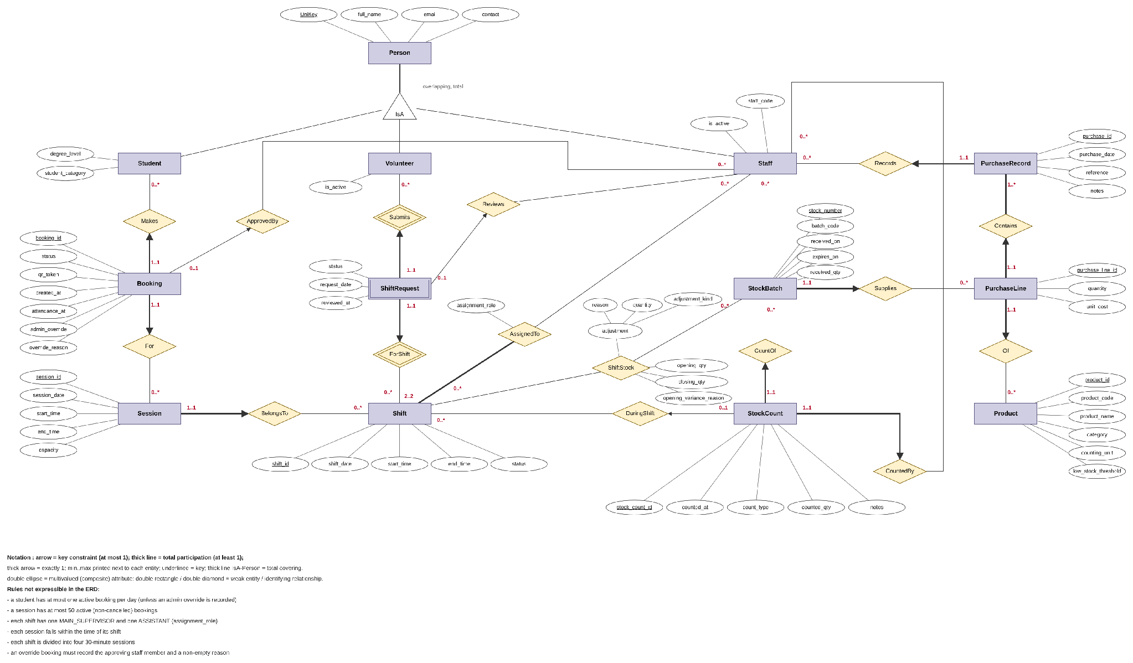
Figure 1. Final ER diagram of Campus Pantry in lecture notation (arrow = key constraint, thick line = total participation, triangle = IsA, double ellipse = multivalued attribute, double rectangle / double diamond = weak entity / identifying relationship).

2.2 Entities and Attributes
Entity | Identifier | Important attributes
Person (superclass) | UniKey | full_name, email, contact
Student / Volunteer / Staff (subclasses) | UniKey (inherited) | degree_level, student_category / is_active / staff_code, is_active
Shift | shift_id | shift_date, start_time, end_time, status (PLANNED/OPEN/CLOSED)
Session | session_id | session_date, start_time, end_time, capacity
Booking | booking_id | status, qr_token, created_at, attendance_at, admin_override, override_reason
Product | product_id | product_code, product_name, category, counting_unit, low_stock_threshold
PurchaseRecord | purchase_id | purchase_date, reference, notes
PurchaseLine | purchase_line_id | quantity, unit_cost
StockBatch | stock_number | batch_code, received_on, expires_on, received_qty
StockCount | stock_count_id | counted_at, count_type (OPENING/CLOSING/SPOT_CHECK), counted_qty, notes
ShiftRequest (weak entity) | UniKey of its Volunteer + shift_id of its Shift (no discriminator) | status (PENDING/APPROVED/REJECTED), request_date, reviewed_at

staff_code, qr_token and product_code are also unique, but ER notation shows only one key per entity, so they are declared as candidate keys in the logical schema (Section 3.1).
Booking is modelled as an entity rather than a relationship between Student and Session because it has its own lifecycle (CONFIRMED → ATTENDED / ABSENT / CANCELLED), its own identifier (the QR token) and its own optional relationship to the staff member who approved an exception. A student can also book the same session again after cancelling, which a relationship set, keyed only by its participants, could not record.

2.3 Relationships and Constraints
Relationship | Cardinality and participation | Reason
Person IsA Student / Volunteer / Staff | Overlapping, total (covering) | One person can hold several roles (e.g. kevi5326 is a student and a volunteer); every registered person has at least one role.
Booking – Makes – Student | Booking 1..1 (thick arrow); Student 0..* | Every booking belongs to one student; booking history is kept across days.
Booking – For – Session | Booking 1..1 (thick arrow); Session 0..* | The upper bound of 50 is a business rule ER cannot express, so it is enforced in SQL (Section 4.3).
Booking – ApprovedBy – Staff | Booking 0..1 (thin arrow); Staff 0..* | Only exception bookings name the staff member who approved them.
Session – BelongsTo – Shift | Session 1..1 (thick arrow); Shift 0..* | A session cannot exist outside a shift; policy creates four per shift.
Staff – AssignedTo – Shift (attribute assignment_role) | Shift 2..2 (thick line); Staff 0..* | Every shift needs exactly two staff; the duty role belongs to the assignment, not the person.
ShiftRequest – Submits – Volunteer; ShiftRequest – ForShift – Shift (identifying relationships) | ShiftRequest 1..1 in both (thick arrow); Volunteer 0..*, Shift 0..* | An application only exists for one volunteer and one shift, and is identified by them.
ShiftRequest – Reviews – Staff | ShiftRequest 0..1 (thin arrow); Staff 0..* | Staff approve or reject a specific application; pending ones have no reviewer yet.
PurchaseRecord – Records – Staff | PurchaseRecord 1..1 (thick arrow); Staff 0..* | Every purchase is recorded by one staff member.
PurchaseLine – Contains – PurchaseRecord | PurchaseLine 1..1; PurchaseRecord 1..* (thick line) | Invoice header/line structure; a record has at least one line.
PurchaseLine – Of – Product | PurchaseLine 1..1; Product 0..* | Each line buys one product.
StockBatch – Supplies – PurchaseLine | StockBatch 1..1; PurchaseLine 0..* | Every batch traces to the purchase that supplied it (BR8).
StockCount – CountOf – StockBatch; StockCount – CountedBy – Staff | StockCount 1..1 in both | Each count is of one batch and by one staff member.
StockCount – DuringShift – Shift | StockCount 0..1 (thin arrow); Shift 0..* | Spot checks may happen outside a shift.
Shift – ShiftStock – StockBatch (attributes opening_qty, closing_qty, opening_variance_reason; multivalued adjustment {adjustment_kind, quantity, reason}) | M:N, both 0..* | Shift handover balance for each batch, with receipts and waste recorded during the shift.

2.4 Design Rationale and Assumptions
- IsA instead of a role attribute. Role-specific attributes (degree level, staff code) and role-specific relationships (only staff can be assigned to shifts) belong on subclasses. Overlap is allowed because student volunteers are common at FoodHub.
- Separate Shift and Session. Staffing happens per 2-hour shift and booking per 30-minute session. Merging them would either repeat staffing four times or lose booking granularity.
- ShiftRequest as a weak entity. A volunteer's application for a shift has its own state and is reviewed by a staff member, so it needs to take part in a relationship of its own. A plain M:N relationship cannot, and a ternary Staff–Volunteer–Shift relationship would wrongly allow a review without an application. Making the application a weak entity owned by Volunteer and Shift lets Reviews attach to it directly, and the thin arrow says each application is reviewed at most once.
- Product is reached through PurchaseLine. A batch's product is not drawn as a separate relationship because it is already determined by the purchase line that supplied it. The logical design later copies product_id into stock_batch for performance; Section 3.4 treats this as a deliberate, controlled redundancy.
- Stock counts as events. Each count is a StockCount entity rather than a "current quantity" attribute on StockBatch, which keeps the audit trail required by BR9; stock on hand is derived from the latest count.
- Adjustments as a multivalued attribute. Within one shift a batch can have a receipt and a waste entry, each with its own quantity and reason, so adjustment is a multivalued composite attribute of ShiftStock rather than two fixed columns.
- Assumptions: shift times and capacities are fixed by policy (10:00–16:00 operating day); dispensed quantities are estimated from counts rather than recorded per student, which protects student privacy.
Traceability to Section 1: BR1 → Person/IsA; BR2 → BelongsTo; BR3–BR6 → Booking, For, Makes, ApprovedBy; BR7 → AssignedTo, ShiftRequest, Reviews; BR8 → Supplies; BR9 → StockCount and ShiftStock. The rules listed under the diagram cannot be drawn and are enforced in SQL (Section 4.3).

3. Logical Design and Normalisation

3.1 Relational Schema
Figure 2 is generated directly from the implemented PostgreSQL catalogue. Primary keys are underlined, (FK) marks foreign keys and arrows point to the referenced table, and (UQ) marks attributes that form a candidate (UNIQUE) key.
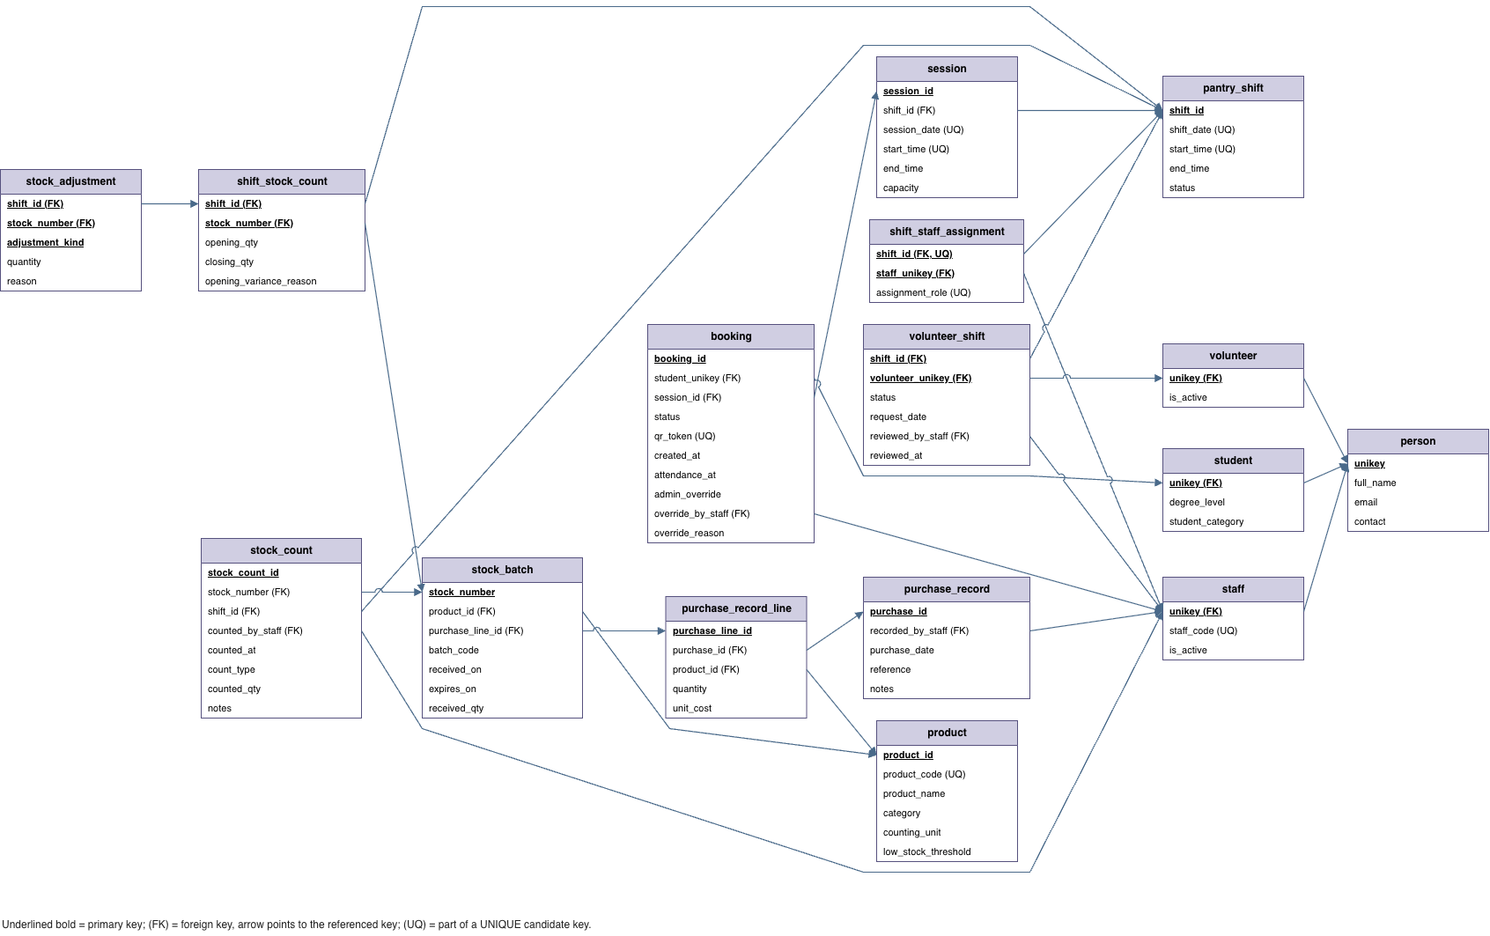
Figure 2. Relational (RM) diagram of the implemented schema (16 relations).
Relation | Primary key | Candidate keys | Foreign keys
person | unikey | – | –
student / volunteer / staff | unikey | staff: staff_code | unikey → person
pantry_shift | shift_id | (shift_date, start_time) | –
session | session_id | (session_date, start_time) | shift_id → pantry_shift (NOT NULL)
shift_staff_assignment | (shift_id, staff_unikey) | (shift_id, assignment_role) | shift_id → pantry_shift; staff_unikey → staff
volunteer_shift | (shift_id, volunteer_unikey) | – | → pantry_shift, volunteer; reviewed_by_staff → staff
booking | booking_id | qr_token | student_unikey → student; session_id → session; override_by_staff → staff
product | product_id | product_code | –
purchase_record | purchase_id | – | recorded_by_staff → staff
purchase_record_line | purchase_line_id | – | purchase_id → purchase_record; product_id → product
stock_batch | stock_number | – | product_id → product; purchase_line_id → purchase_record_line
stock_count | stock_count_id | – | stock_number → stock_batch; shift_id → pantry_shift; counted_by_staff → staff
shift_stock_count | (shift_id, stock_number) | – | → pantry_shift, stock_batch
stock_adjustment | (shift_id, stock_number, adjustment_kind) | – | (shift_id, stock_number) → shift_stock_count

3.2 Mapping from ER Model to Relations
- IsA hierarchy. Mapped with one relation per class (the "ER style" option). Each subclass table uses unikey as both primary key and foreign key to person. Because the hierarchy is overlapping, a single table with a type column would not work, and a table per subclass only (no person) would repeat name and email for people with several roles.
- 1:N with key constraint and total participation. BelongsTo, Makes, For, Records, Contains, Of, Supplies, CountOf and CountedBy are folded into the entity on the arrow side as NOT NULL foreign keys (e.g. session.shift_id NOT NULL), which enforces both the key constraint and total participation.
- 1:N without total participation. ApprovedBy becomes the nullable column booking.override_by_staff, and DuringShift becomes the nullable stock_count.shift_id.
- M:N with attributes. AssignedTo becomes shift_staff_assignment with PK (shift_id, staff_unikey) and the extra candidate key (shift_id, assignment_role), which gives "at most one supervisor and one assistant per shift" for free. ShiftStock becomes shift_stock_count.
- Weak entity. ShiftRequest becomes volunteer_shift, whose primary key is the owners' keys (shift_id, volunteer_unikey), each also a foreign key; the identifying relationships Submits and ForShift need no tables of their own. Because each request is reviewed at most once (key constraint), Reviews is folded in as the nullable foreign key reviewed_by_staff.
- Multivalued composite attribute. adjustment becomes its own relation stock_adjustment, keyed by the owner's key plus the distinguishing component: (shift_id, stock_number, adjustment_kind), with a composite foreign key to shift_stock_count.
- Added at the logical level. stock_batch.product_id is not in the ER model (it is implied by Supplies and Of); it was added on purpose and is analysed in 3.4.
- Derived values are not stored. Spaces remaining, attendance rates and estimated dispensed quantities are computed in views (v_booking_attendance, v_shift_stock_report), so they can never disagree with the base data.

3.3 Functional Dependencies
FDs were derived from the business rules, not from sample data. The non-trivial ones that matter for normalisation are:
Relation | Functional dependencies
staff | unikey → staff_code, is_active; staff_code → unikey
pantry_shift | shift_id → shift_date, start_time, end_time, status; {shift_date, start_time} → shift_id
session | session_id → all; {session_date, start_time} → session_id; shift_id → session_date (a session lies on its shift's date, BR2)
shift_staff_assignment | {shift_id, staff_unikey} → assignment_role; {shift_id, assignment_role} → staff_unikey
volunteer_shift | {shift_id, volunteer_unikey} → status, request_date, reviewed_by_staff, reviewed_at
booking | booking_id → all; qr_token → booking_id
product | product_id → all; product_code → product_id
purchase_record_line | purchase_line_id → purchase_id, product_id, quantity, unit_cost
stock_batch | stock_number → all; purchase_line_id → product_id (a batch is of the product that was purchased)
stock_count | stock_count_id → stock_number, shift_id, counted_by_staff, counted_at, count_type, counted_qty, notes
shift_stock_count | {shift_id, stock_number} → opening_qty, closing_qty, opening_variance_reason
stock_adjustment | {shift_id, stock_number, adjustment_kind} → quantity, reason

Dependencies that look plausible but were deliberately not assumed: email → unikey (shared or changed emails are possible), and start_time → end_time in pantry_shift (shift length is policy, not a law of the data).

3.4 Normalisation Analysis
All relations are in 1NF (atomic attributes; multi-valued roles were split into subclass tables). For a relation R to be in BCNF, every non-trivial FD X → Y over R must have a superkey X (Ramakrishnan & Gehrke, 2003).
Relations in BCNF (14 of 16). In person, the three subclass tables, pantry_shift, shift_staff_assignment, volunteer_shift, booking, product, purchase_record, purchase_record_line, stock_count, shift_stock_count and stock_adjustment, the left-hand side of every FD listed above is a candidate key, so they are in BCNF without decomposition. Two cases with more than one key are worth noting: in shift_staff_assignment both {shift_id, staff_unikey} and {shift_id, assignment_role} are candidate keys, so the FD between them does not break BCNF; in staff, staff_code → unikey has a key on its left side.
session: 3NF but not BCNF. The FD shift_id → session_date has a left-hand side that is not a superkey (a shift has four sessions). It does not break 3NF, because session_date is a prime attribute: it belongs to the candidate key {session_date, start_time}. The BCNF decomposition would be R1(shift_id, session_date) – which duplicates pantry_shift(shift_id, shift_date) – and R2(session_id, shift_id, start_time, end_time, capacity). That decomposition is lossless, but it is not dependency-preserving: the key {session_date, start_time} → session_id spans R1 and R2, so "no two sessions at the same date and time" could no longer be enforced by a UNIQUE constraint. Following the usual guidance to prefer 3NF when BCNF would lose a dependency (Silberschatz et al., 2020), we accept 3NF here, so the key stays declarative. The redundancy is controlled by trigger validate_session_shift(), which rejects any session whose date or times do not fit its shift (failure test 5).
stock_batch: deliberate 3NF violation. stock_number → purchase_line_id → product_id is a transitive dependency on a non-prime attribute, so storing product_id breaks 3NF. The normalised alternative is to drop product_id and join through purchase_record_line. We kept product_id because the most frequent operations (latest stock per product, low-stock and expiry reports) group batches by product, and the column lets the stock_batch_by_product index serve them directly. The resulting update anomaly (a batch pointing to rice while its purchase line says pasta) is blocked by trigger validate_stock_batch_product() on insert and update (failure test 8).

3.5 Final Design Decisions and Trade-offs
- Count history vs shift summary. stock_count is the authoritative, append-only event log; the ShiftStock quantities in shift_stock_count.closing_qty repeat the closing count so the handover report and Q6 variance query are simple. The duplication is controlled by writing both in a single transaction (Transaction E, Section 4.4), and validation check 8 verifies the stock arithmetic.
- One adjustment row per kind per shift. The key (shift_id, stock_number, adjustment_kind) keeps the report join one-to-one; the prototype adds repeated receipts to the existing quantity. The cost is that only the latest reason text is kept, which we accepted for a shift-level report.
- Surrogate keys. Identity columns are used for shifts, sessions and bookings so that foreign keys stay short and stable, but the natural keys ((date, start_time), qr_token, product_code, staff_code) are still declared UNIQUE so duplicates are impossible.
- Rules that cannot be keys. Capacity, one-booking-per-day, staffing completeness and overlap rules involve counts across rows, so they are triggers rather than CHECK constraints (Section 4.3).
- Known limitation. validate_session_shift() fires on changes to session, not to pantry_shift. Changing a shift's date after its sessions exist would leave them inconsistent, so shift times are treated as fixed once sessions are generated.

4. SQL, Integrity and Transactions

4.1 PostgreSQL Implementation
The database lives in schema campus_pantry on PostgreSQL 16 and is rebuilt from the submitted scripts in this order:
File | Purpose
01_schema.sql | 16 tables, CHECK/UNIQUE/FK constraints, 6 indexes, 6 trigger functions, 3 views
02_seed_data.sql | Synthetic data for one operating day (9 Oct 2026) and resets identity sequences
03_queries.sql | 12 management queries (Q1–Q12)
04_transactions.sql | Transaction scenarios A–F
05_validation.sql | 12 integrity checks that should return no violations
06_failure_tests.sql | 10 negative/boundary tests in PL/pgSQL (each cleans up after itself)
campus_pantry_app/test_all_rules.py | 17 end-to-end tests through the Python service layer, including a concurrency race

The seed data contains 29 people (17 students, 9 volunteers, 4 staff, with one student who is also a volunteer), 3 closed shifts with 12 sessions, 6 staff assignments, 10 volunteer registrations, 15 bookings, 1 purchase with 8 lines, 8 products and batches, 48 stock-count events, 24 shift stock rows and 5 adjustments. A one-shot script, campus_pantry_app/sql/rebuild_campus_pantry.sql, drops and recreates everything; we checked that it produces the same schema as running 01 and 02 separately.

4.2 Representative SQL Operations
The table summarises the 12 queries and the result each gives on the seed data. Two are shown in full below.
Query | Requirement served | Techniques | Result on seed data
Q1 | Shift stock movement report | View with two LEFT JOINs to the same table, CASE, COALESCE | 24 rows (8 batches × 3 shifts)
Q2 | Total dispensed per product | Aggregation over view, GROUP BY, ORDER BY | Rice 57, oat milk 35, bread 28 …
Q3 | Latest count per batch | DISTINCT ON with ORDER BY counted_at DESC | 8 rows, all CLOSING counts
Q4 | Products below reorder threshold | CTEs, DISTINCT ON, LEFT JOIN, SUM | 0 rows (all above threshold)
Q5 | Places left per session | View with COUNT … FILTER | 12 sessions; sessions 1–2 hold 7 and 8 bookings
Q6 | Handover variance between shifts | LATERAL subquery with LIMIT 1 | 1 row: rice +2 at shift 2 with reason
Q7 | Products never dispensed | Correlated NOT EXISTS | 0 rows
Q8 | Staff and volunteer roster | Multi-table joins, filter APPROVED | 6 staff duties, 10 volunteers
Q9 | Purchase cost by product | Three-table join, SUM(qty × cost) | 560 units, $1,050 total
Q10 | Attendance rate per session | FILTER, NULLIF to avoid ÷0, ROUND | Rate per session (NULL when no bookings)
Q11 | Batches expiring in 30 days | Date arithmetic with CURRENT_DATE | 0 rows on 24 Oct 2026; the bread and apple batches had already expired (15 and 20 Oct), and this range does not include expired stock
Q12 | Sessions ≥ 80% full | View + CEIL(capacity × 0.8) | 0 rows on seed; flagged in tests

Q6 – handover variance. For each shift's opening count, the LATERAL subquery finds the closing count of the most recent earlier closed shift for the same batch. The end_time <= start_time condition links back-to-back shifts on the same day.
SELECT cur.shift_id, cur.stock_number, cur.opening_qty,
prev.closing_qty AS previous_closing_qty,
cur.opening_qty - prev.closing_qty AS variance_qty,
cur.opening_variance_reason
FROM shift_stock_count cur
JOIN pantry_shift cur_shift ON cur_shift.shift_id = cur.shift_id
JOIN LATERAL (
SELECT s2.closing_qty
FROM shift_stock_count s2
JOIN pantry_shift sh2 ON sh2.shift_id = s2.shift_id
WHERE s2.stock_number = cur.stock_number AND sh2.status = 'CLOSED'
AND (sh2.shift_date < cur_shift.shift_date
OR (sh2.shift_date = cur_shift.shift_date
AND sh2.end_time <= cur_shift.start_time))
ORDER BY sh2.shift_date DESC, sh2.end_time DESC
LIMIT 1) prev ON true
WHERE cur.opening_qty - prev.closing_qty <> 0;
shift_id | stock_number | opening_qty | previous_closing_qty | variance_qty
2 | STK-000001 | 92 | 90 | 2
opening_variance_reason: Found 2 misplaced packs on shelf during handover
Q4 – low stock. Stock on hand is not stored. It is the sum of the latest count of each batch, found with DISTINCT ON, compared with the product's threshold. Products with no counts still appear (LEFT JOIN with COALESCE to 0).
WITH batch_latest AS (
SELECT DISTINCT ON (sc.stock_number) sc.stock_number, sb.product_id, sc.counted_qty
FROM stock_count sc JOIN stock_batch sb USING (stock_number)
ORDER BY sc.stock_number, sc.counted_at DESC, sc.stock_count_id DESC),
product_totals AS (
SELECT p.product_id, p.product_name, p.low_stock_threshold,
COALESCE(SUM(bl.counted_qty), 0) AS last_known_quantity
FROM product p LEFT JOIN batch_latest bl ON bl.product_id = p.product_id
GROUP BY p.product_id)
SELECT * FROM product_totals
WHERE last_known_quantity < low_stock_threshold;
Data modification statements are covered in Section 4.4 (INSERT booking, UPDATE check-in and cancellation, UPDATE … FROM for no-shows, INSERT + UPDATE for stock counts).

4.3 Integrity Constraints
Type | Mechanism (01_schema.sql) | Rule
Key | PRIMARY KEY on all 16 tables; UNIQUE on qr_token, staff_code, product_code, (shift_date, start_time), (session_date, start_time), (shift_id, assignment_role) | BR1, BR2, BR5, BR7
Domain | CHECK on UniKey regex ^[a-z]{4}[0-9]{4}$; status enumerations; capacity BETWEEN 1 AND 50; counted_qty ≥ 0; quantity > 0; end_time > start_time; expires_on ≥ received_on | BR1, BR3, BR9
Referential | 23 FOREIGN KEYs, NOT NULL where participation is total (e.g. session.shift_id) | BR2, BR8
Tuple-level | CHECK (status <> 'ATTENDED' OR attendance_at IS NOT NULL); CHECK admin_override ⇔ override_by_staff present | BR4, BR5
Cross-row (triggers) | validate_booking() – capacity and one booking per day, with row locks; validate_shift_status() – exactly 1 supervisor + 1 assistant before OPEN/CLOSED; validate_staff_shift_overlap(), validate_volunteer_shift_overlap(); validate_session_shift(); validate_stock_batch_product() | BR2–BR4, BR7, BR8

Examples of invalid operations being rejected (output of 06_failure_tests.sql):
[PASS] Test 1: Duplicate daily booking was rejected.
(Student already has an active booking on this date)
[PASS] Test 2: Admin override without staff was rejected.
(Admin override must identify the staff member)
[PASS] Test 3: Session capacity boundary (50 accepted, 51st rejected) strictly enforced.
[PASS] Test 4: Invalid UniKey format was rejected.
(new row for relation "person" violates check constraint "person_unikey_check")
[PASS] Test 6: Unstaffed shift transition to OPEN was rejected.
(Shift 4 must have exactly 1 MAIN_SUPERVISOR and 1 ASSISTANT before it can be OPEN)
[PASS] Test 8: Mismatched stock batch product was rejected.
(Stock batch product_id (2) does not match purchase line product_id (1))
Rules are enforced in the database, not only in Python, so they also hold for anyone using psql or pgAdmin directly. The Python layer repeats some checks only to give friendlier messages.

4.4 Transaction Scenario
Main scenario: booking a session (services.book_session, also scenario A in 04_transactions.sql). It is one transaction because a booking is only valid if all of these steps see the same state:
BEGIN; -- opened by psycopg2; `with conn:` commits, or rolls back on error
-- 1. lock the student row
SELECT unikey FROM student WHERE unikey = %s FOR UPDATE;
-- 2. session exists and has not finished
SELECT (session_date + end_time) < localtimestamp, session_date
FROM session WHERE session_id = %s;
-- 3. insert; BEFORE INSERT trigger validate_booking() then:
-- SELECT ... FROM session WHERE session_id = NEW.session_id FOR UPDATE;
-- count active bookings in the session -> RAISE if >= capacity
-- count student's active bookings that day -> RAISE unless override
INSERT INTO booking (student_unikey, session_id, qr_token, admin_override,
override_by_staff, override_reason)
VALUES (%s, %s, %s, %s, %s, %s) RETURNING booking_id;
COMMIT; -- QR token is shown to the student only after commit
The boundary is from the eligibility check to the insert. If the checks and the insert ran as separate transactions, another booking could commit in between and the check would be stale.
Other transactions in 04_transactions.sql: (B) QR check-in – a single conditional UPDATE … WHERE qr_token = ? AND status = 'CONFIRMED', so a second scan changes 0 rows; (C) cancellation, which frees the place at once because capacity counts only non-cancelled rows; (D) end-of-day no-shows using UPDATE … FROM session after 16:00; (E) closing stock count – INSERT into stock_count and UPDATE shift_stock_count.closing_qty, which must commit together or the audit log and the handover report would disagree; (F) an explicit ROLLBACK showing nothing persists.

4.5 Failure and Concurrency Reasoning
Failure and rollback (atomicity). Every write in the prototype runs inside with conn:. Any exception – a trigger's RAISE, a CHECK violation or a Python error – rolls back the whole transaction. In Transaction E, if the UPDATE of shift_stock_count fails (e.g. a negative quantity), the already-executed INSERT into stock_count is also undone, so no half-recorded count remains. Test 14 of test_all_rules.py shows this: the booking count is identical before and after an aborted transaction.
The concurrency problem. PostgreSQL's default isolation level is READ COMMITTED (PostgreSQL Global Development Group, n.d.). Without locks, two transactions can both count 49 bookings in a 50-place session, both pass the check and both insert, so the session ends up with 51. The same pattern lets one student get two bookings on the same day from two devices. This is a lost-update style anomaly: the interleaved schedule is not conflict-serializable, because each transaction's read is overwritten by the other's write.
Solution: row-level locks held to commit. validate_booking() takes an exclusive lock on the session row and on the student row (SELECT … FOR UPDATE) before counting. PostgreSQL holds these locks until COMMIT or ROLLBACK, as in strict two-phase locking (Ramakrishnan & Gehrke, 2003), so a second transaction for the same session or student waits. When it resumes, READ COMMITTED gives the trigger's next statement a fresh snapshot, so it sees the committed booking and correctly raises the capacity or duplicate error. Transactions for different sessions and students do not block each other, so concurrency is kept where it is safe. The locks are taken inside the trigger, so the rule holds even for SQL that bypasses the prototype.
Evidence. Test 11 starts two threads racing for the last place in a session. Exactly one wins and the other gets "Session capacity … has been reached"; the final count equals capacity. concurrency_demo.py has the same student book two sessions at once; the second request waits for the first to commit and is then rejected.
Deadlock. The service layer locks the student and then the session; the trigger locks the session and then the student (the student lock is already held, so it is a no-op). A transaction from the prototype and a hand-written INSERT for the same student and session could therefore wait on each other. PostgreSQL detects the cycle and aborts one transaction, which is rolled back and reported as an error, so data stays correct. Using a single lock order everywhere would remove this case.

4.6 Testing and Evidence of Correctness
Test set | What it covers | Result
06_failure_tests.sql (10 tests) | Duplicate booking, override without staff, 50/51 capacity boundary, bad UniKey, session outside shift, unstaffed shift opening, negative count, batch/product mismatch, repeated check-in, 16:00 boundary | 10/10 PASS
test_all_rules.py (17 tests) | Booking, duplicate rejection, dual-role user, volunteer request → approve/reject → roster, duplicate request, staff and volunteer overlap, staffing completeness, capacity + cancellation, concurrent race, QR check-in, no-show idempotence, override audit, inventory reconciliation and low stock, Q1–Q12, invariants | 17/17 PASS
05_validation.sql (12 checks) | Staffing completeness, over-capacity, attendance/timestamp consistency, StockNumber format, session-in-shift, stock arithmetic | 0 violations
concurrency_demo.py | Simultaneous bookings by one student | Second request rejected

All suites were run on 24 October 2026 against a fresh database built from the scripts on PostgreSQL 16, and test_all_rules.py was run twice in a row to confirm it cleans up after itself and can be repeated. Excerpt of the Python test output:
[PASS] Test 10: Capacity limit and cancellation place freeing
[PASS] Test 11: Concurrent race for final place
Winner: ['race0005'], Loser: ['race0006'], Final count: 5
[PASS] Test 13: No-show processing & idempotence
First run marked: 16, Second run marked: 0
[PASS] Test 14: Admin override safeguards & audit trail
Total Tests: 17 | Passed: 17 | Failed: 0

References
Kent, K., Visentin, D., Peterson, C., Elliott, C., Primo, C., & Murray, S. (2025). Food insecurity among Australian university students is higher and more severe across an extended period of high inflation: A repeated cross-sectional study 2022–2024. Health Promotion Journal of Australia, 36(2), Article e70037. https://doi.org/10.1002/hpja.70037
PostgreSQL Global Development Group. (n.d.). Chapter 13. Concurrency control (PostgreSQL 16 documentation). Retrieved October 24, 2026, from https://www.postgresql.org/docs/16/mvcc.html
Ramakrishnan, R., & Gehrke, J. (2003). Database management systems (3rd ed.). McGraw-Hill.
Silberschatz, A., Korth, H. F., & Sudarshan, S. (2020). Database system concepts (7th ed.). McGraw-Hill Education.
Students' Representative Council, University of Sydney. (n.d.). FoodHub. Retrieved October 24, 2026, from https://srcusyd.net.au/get-involved/foodhub/
Whatnall, M. C., Hutchesson, M. J., & Patterson, A. J. (2020). Predictors of food insecurity among Australian university students: A cross-sectional study. International Journal of Environmental Research and Public Health, 17(1), Article 60. https://doi.org/10.3390/ijerph17010060

Appendix (Optional)

A. How to reproduce
createdb campus_pantry
psql -d campus_pantry -f campus_pantry_sql/01_schema.sql
psql -d campus_pantry -f campus_pantry_sql/02_seed_data.sql
psql -d campus_pantry -f campus_pantry_sql/03_queries.sql # Q1-Q12
psql -d campus_pantry -f campus_pantry_sql/04_transactions.sql # scenarios A-F
psql -d campus_pantry -f campus_pantry_sql/05_validation.sql
psql -d campus_pantry -f campus_pantry_sql/06_failure_tests.sql
cd campus_pantry_app && pip install -r requirements.txt
python3 test_all_rules.py
python3 cli.py # e.g. student alex1001, staff must2203

B. Use of generative AI
Generative AI tools were used to help review code, generate test ideas and edit the wording of this report, as declared in the group's AI-use declaration. All SQL, test results and figures in this report were produced by running the submitted code, and the group checked and takes responsibility for the content.

