***Siniakou Aliaksandr***

**Node.js Back-end developer**, Full-stack developer (React)

Novolukoml, Belarus

**Contacts**:

Phone:+375292991308

Email: siniakoualiaksandr@gmail.com

[github.com/illusionoff](https://github.com/illusionoff)

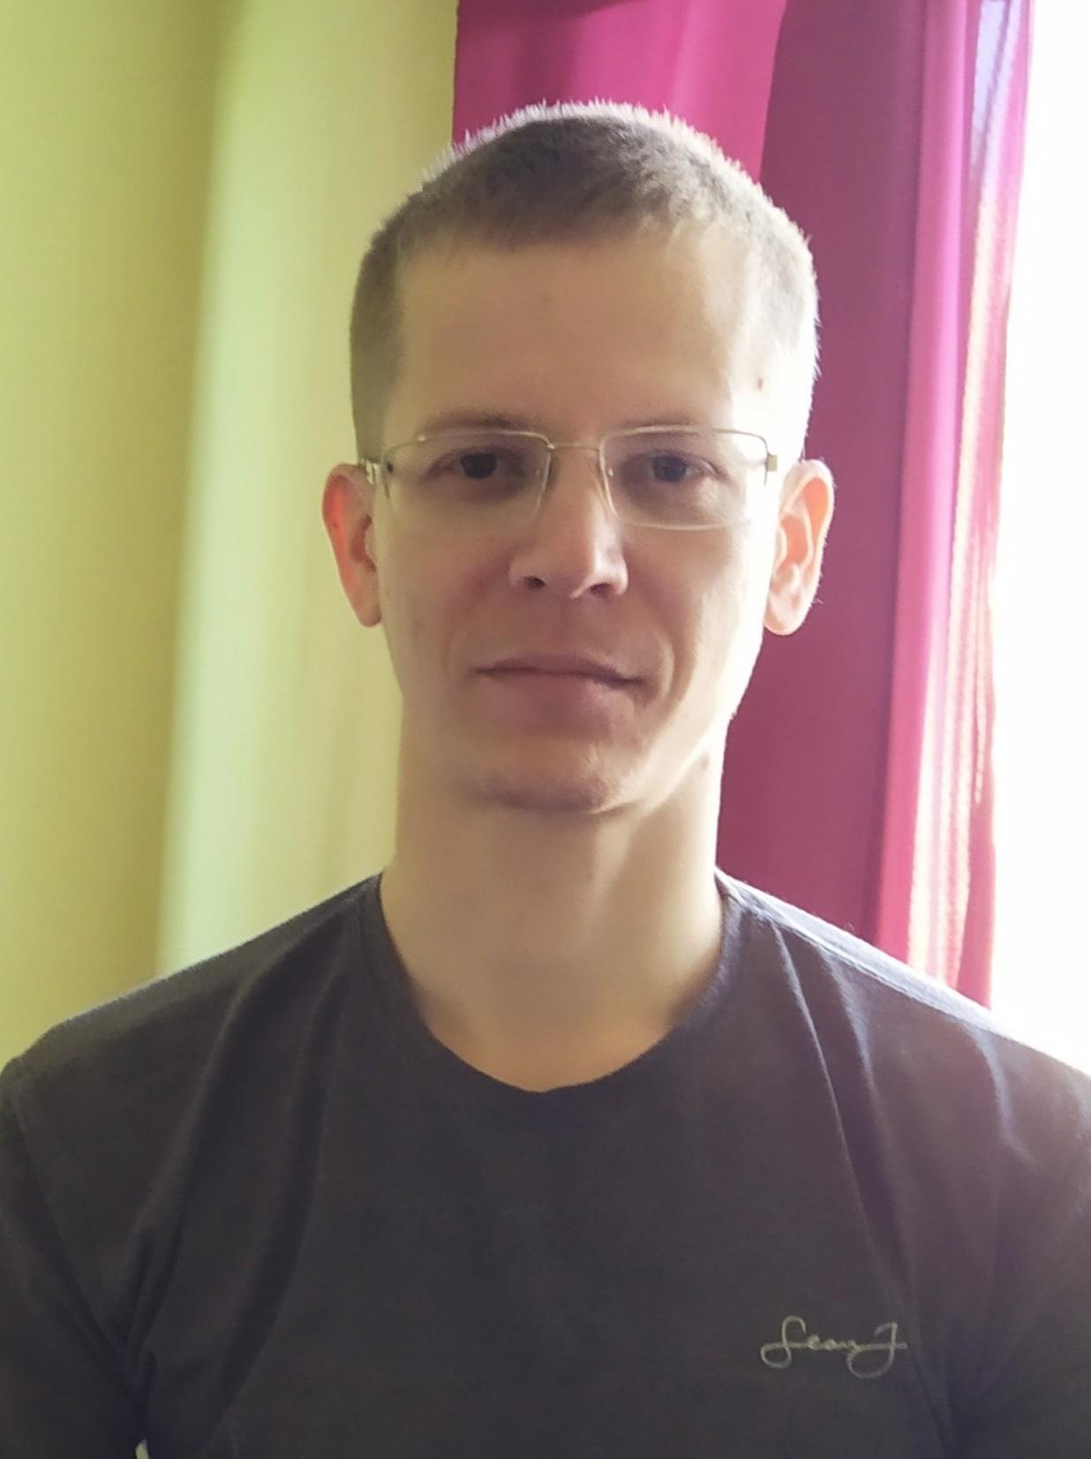

**Skills:**

* javascript
* Nodejs, Express, npm, REST API
* MongoDB, mongoose, PostgreSQL
* Linux, Nginx, pm2
* React, JSX, Handlebars
* HTML, CSS, materializecss
* passport.js, mocha
* eslint, prettier
* Git, GitHub
* VSCode, DevTools Chrome
* PHP
* JQuery
* MySQL

***English***: reading technical literature, *Russian*: native

**Projects:**

1. Portfolio website development [*Link Siniakoualex.com*](https://siniakoualex.com)

**Technologies**: Nodejs, Express, npm, React, materializecss, PostgreSQL, Nginx, pm2, eslint, prettier, GitHub

[*Link GitHub*](https://github.com/illusionoff/portfolio)

1. Pet project development[*Link “HomeMoneyCalc”*](https://178.20.42.150.sslip.io/) *. S*ervice that allows you to keep track of expenses and income.

**Technologies**: Nodejs, Express, npm, handlebars, MongoDB, mongoose, materializecss, Nginx, pm2, passport.js, mocha, eslint, prettier, GitHub

[*Link GitHub*](https://github.com/illusionoff/homemoneycalc)

***Education:***

1. Polotsk State University 2005-2010. “Faculty of Computer Science and Electronics. Modeling and computer design of radio electronic equipment”.
2. Vitebsk State Polytechnic College 2001-2005. “Design and production of radio electronic equipment”

***hobby:*** astronomy, psychology, physics, cryptocurrencies