***Siniakou Aliaksandr***

**Junior Node.js Back-end developer**, JuniorFull-stack Node.js React developer

Novolukoml, Belarus

***Contacts:***

Phone:+375292991308

Email: [siniakoualiaksandr@gmail.com](mailto:siniakoualiaksandr@gmail.com)

Site: [Siniakoualex*.*com](https://siniakoualex.com)

[github.com/illusionoff](https://github.com/illusionoff)

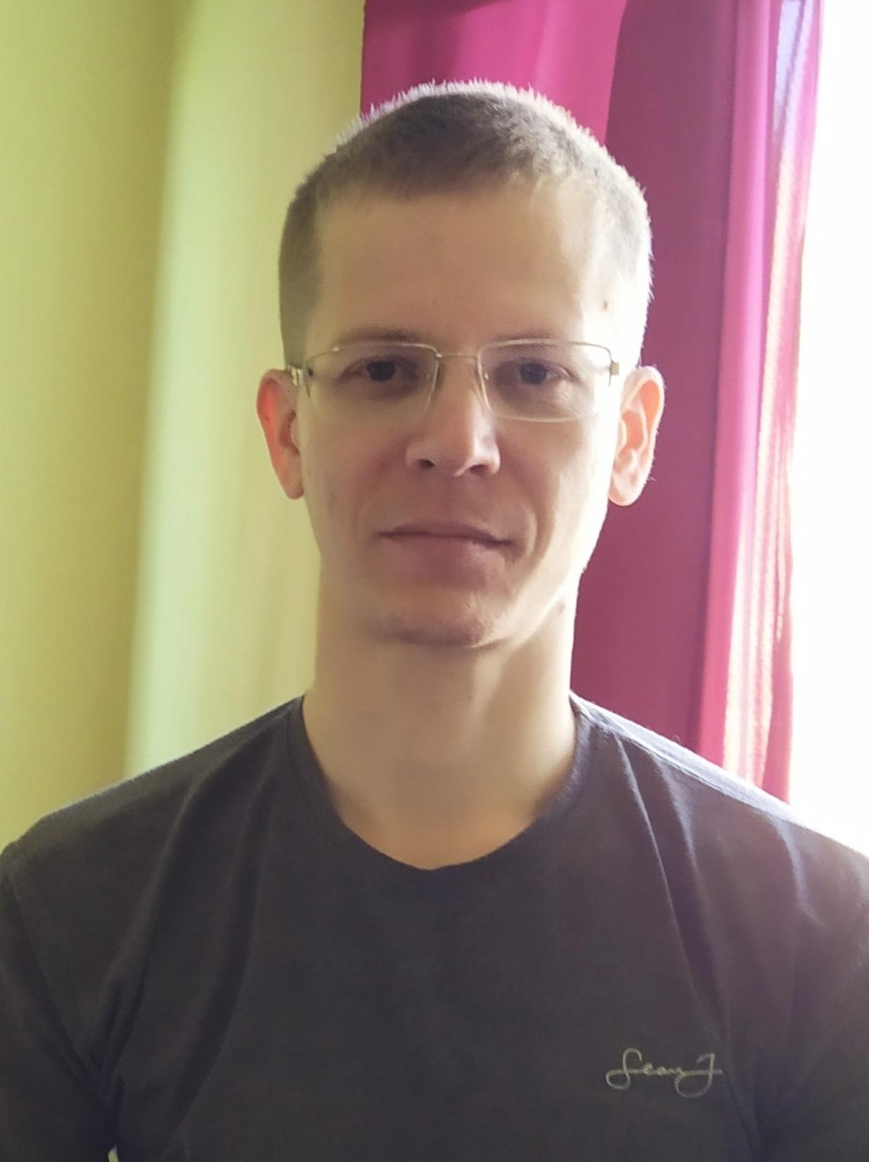

***Skills:***

* Javascript
* Node.js, Express, npm, REST API
* MongoDB, Mongoose, PostgreSQL
* Linux, Nginx, pm2
* React, JSX, Handlebars
* HTML, CSS, Materializecss
* Passport.js, Mocha
* Eslint, Prettier
* Git, GitHub
* VSCode, DevTools Chrome
* As a hobby, I have been developing in php, javascript, jQuery, MySQL, delphi for about 10 years intermittently.

***English***: A2/Pre-Intermediate (reading technical literature), *Russian*: native

***Projects:***

1. [*Siniakoualex.com*](https://siniakoualex.com) *,* [*GitHub*](https://github.com/illusionoff/portfolio) *.* Portfolio website.

Node.js, Express, npm, React, materializecss, PostgreSQL, Nginx, pm2, GitHub

1. [*“HomeMoneyCalc”*](https://178.20.42.150.sslip.io/)*,* [*GitHub*](https://github.com/illusionoff/homemoneycalcnew)*. S*ervice that allows you to keep track of expenses and income.

Node.js, Express, npm, handlebars, MongoDB, mongoose, materializecss, Nginx, pm2, passport.js, mocha, eslint, prettier, GitHub

***Education:***

1. Polotsk State University 2005-2010. “Modeling and computer design of radio electronic equipment”.
2. Vitebsk State Polytechnic College 2001-2005. “Design and production of radio electronic equipment”

***Hobby:*** astronomy, physics, cryptocurrencies, psychology.