## Activity 1: What Kind and How Many?

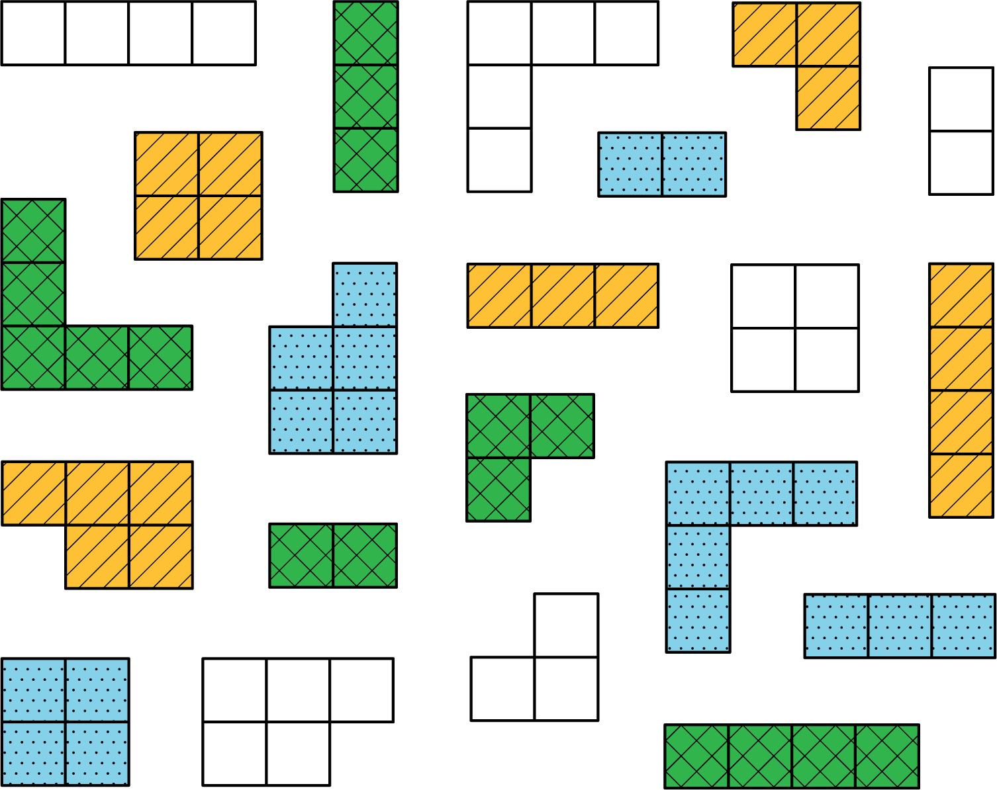

Think of different ways you could sort these figures. What categories could you use? How many groups would you have?



© CC BY Open Up Resources. Adaptations CC BY IM.