## Activity 2: A Huge Amount of Sparkling Orange Juice

Noah’s recipe for one batch of sparkling orange juice uses 4 liters of orange juice and 5 liters of soda water.

1. Use the double number line to show how many liters of each ingredient to use for different-sized batches of sparkling orange juice.

* 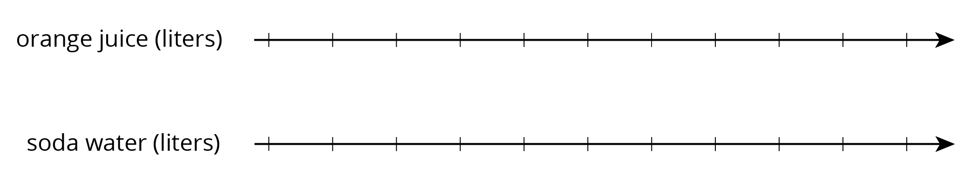

1. If someone mixes 36 liters of orange juice and 45 liters of soda water, how many batches would they make?
2. If someone uses 400 liters of orange juice, how much soda water would they need?
3. If someone uses 455 liters of soda water, how much orange juice would they need?
4. Explain the trouble with using a double number line diagram to answer the last two questions.



© CC BY Open Up Resources. Adaptations CC BY IM.