## Activity 3: Hourly Wages

Lin is paid $90 for 5 hours of work. She used the table to calculate how much she would be paid at this rate for 8 hours of work.

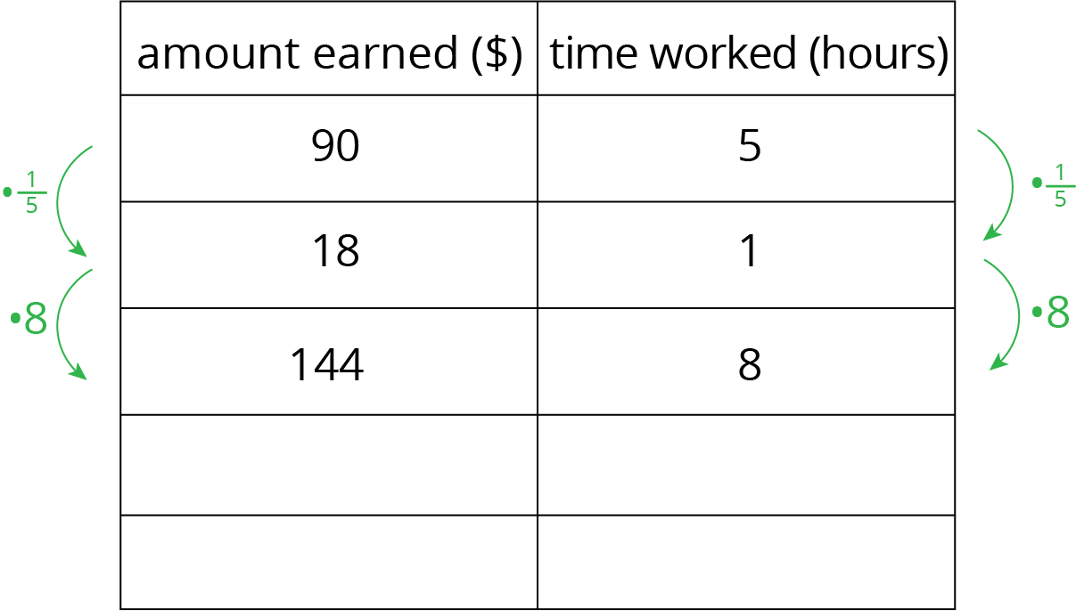

1. What is the meaning of the 18 that appears in the table?
2. Why was the number $\frac{1}{5}$ used as a multiplier?
3. Explain how Lin used this table to solve the problem.
4. At this rate, how much would Lin be paid for 3 hours of work? For 2.1 hours of work?



© CC BY Open Up Resources. Adaptations CC BY IM.