### Lesson 14 Practice Problems

1. A chef is making pickles. He needs 15 gallons of vinegar. The store sells 2 gallons of vinegar for $3.00 and allows customers to buy any amount of vinegar. Decide whether each of the following ratios correctly represents the price of vinegar.
   1. 4 gallons to $3.00
   2. 1 gallon to $1.50
   3. 30 gallons to $45.00
   4. $2.00 to 30 gallons
   5. $1.00 to $\frac{2}{3}$ gallon
2. A caterer needs to buy 21 pounds of pasta to cater a wedding. At a local store, 8 pounds of pasta cost $12. How much will the caterer pay for the pasta there?
   1. Write a ratio for the given information about the cost of pasta.
   2. Would it be more helpful to write an equivalent ratio with 1 pound of pasta as one of the numbers, or with $1 as one of the numbers? Explain your reasoning, and then write that equivalent ratio.
   3. Find the answer and explain or show your reasoning.
3. Lin is reading a 47-page book. She read the first 20 pages in 35 minutes.
   1. If she continues to read at the same rate, will she be able to complete this book in under 1 hour?
   2. If so, how much time will she have left? If not, how much more time is needed? Explain or show your reasoning.
4. Diego can type 140 words in 4 minutes.
   1. At this rate, how long will it take him to type 385 words?
   2. How many words can he type in 15 minutes?

* If you get stuck, consider creating a table.

1. A train that travels 30 miles in $\frac{1}{3}$ hour at a constant speed is going faster than a train that travels 20 miles in $\frac{1}{2}$ hour at a constant speed. Explain or show why.

* from Unit 2, Lesson 10

1. Find the surface area of the polyhedron that can be assembled from this net. Show your reasoning.

* 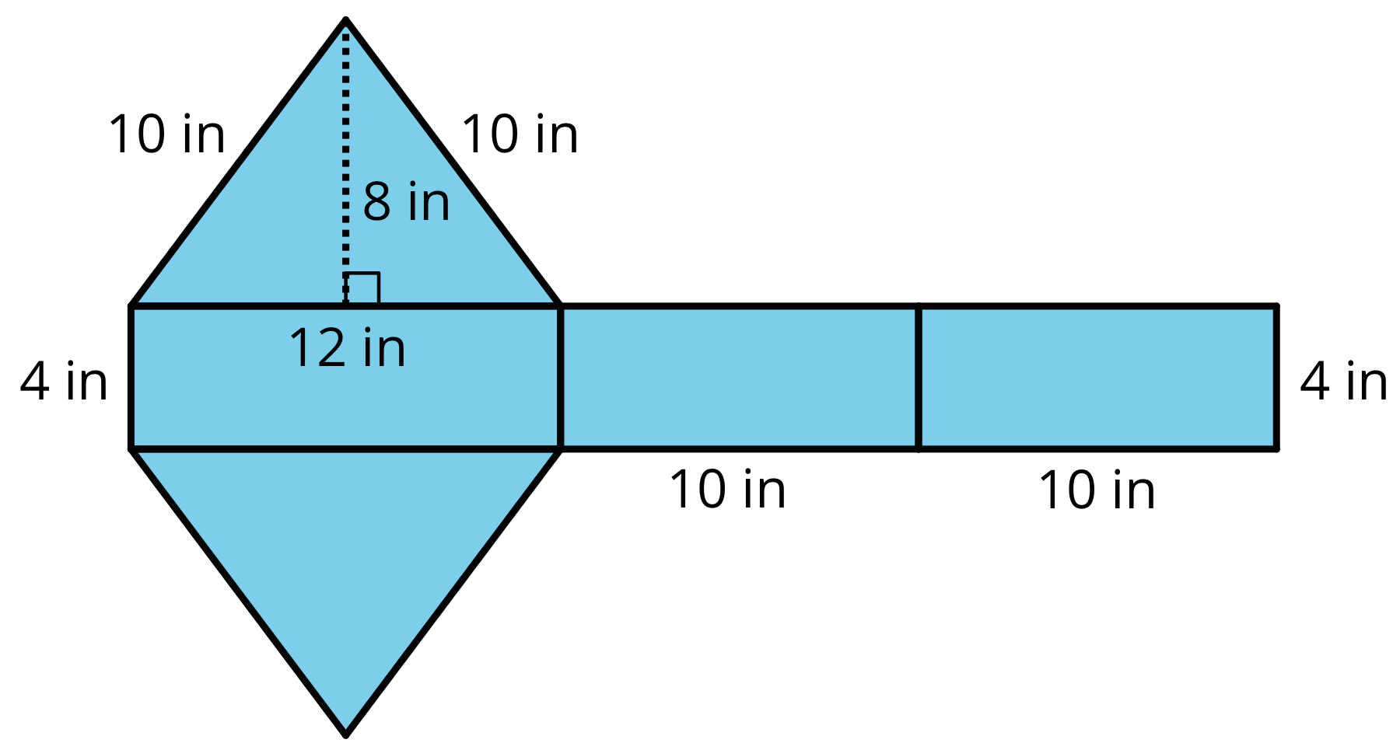
* from Unit 1, Lesson 14



© CC BY Open Up Resources. Adaptations CC BY IM.