## Activity 1: You Tell the Story

Describe a situation with two quantities that this tape diagram could represent.

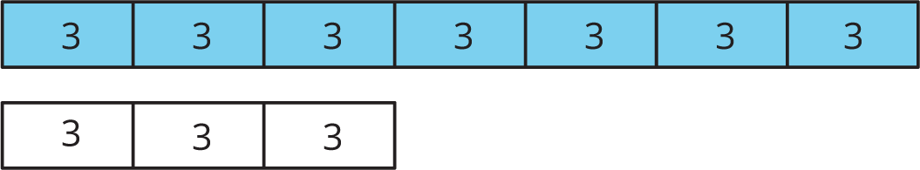



© CC BY Open Up Resources. Adaptations CC BY IM.