### Lesson 16 Practice Problems

1. Describe a situation that could be represented with this tape diagram.

* 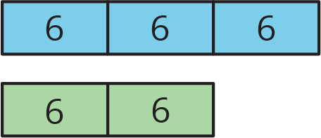

1. There are some nickels, dimes, and quarters in a large piggy bank. For every 2 nickels there are 3 dimes. For every 2 dimes there are 5 quarters. There are 500 coins total.
   1. How many nickels, dimes, and quarters are in the piggy bank? Explain your reasoning.
   2. How much are the coins in the piggy bank worth?
2. Two horses start a race at the same time. Horse A gallops at a steady rate of 32 feet per second and Horse B gallops at a steady rate of 28 feet per second. After 5 seconds, how much farther will Horse A have traveled? Explain or show your reasoning.
3. Andre paid $13 for 3 books. Diego bought 12 books priced at the same rate. How much did Diego pay for the 12 books? Explain your reasoning.

* from Unit 2, Lesson 10

1. Which polyhedron can be assembled from this net?

* 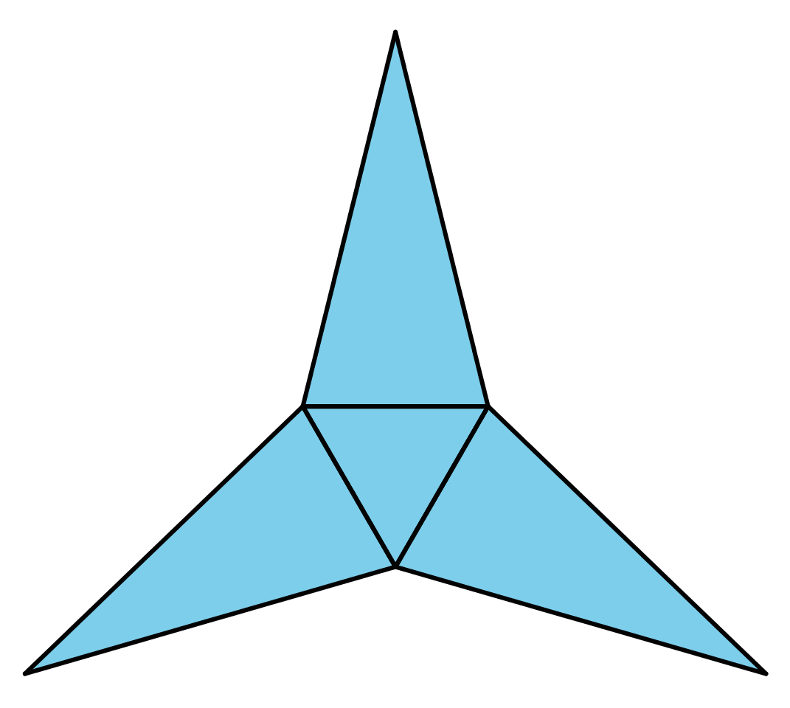
  1. A triangular pyramid
  2. A trapezoidal prism
  3. A rectangular pyramid
  4. A triangular prism
* from Unit 1, Lesson 15

1. Find the area of the triangle. Show your reasoning. If you get stuck, consider drawing a rectangle around the triangle.

* 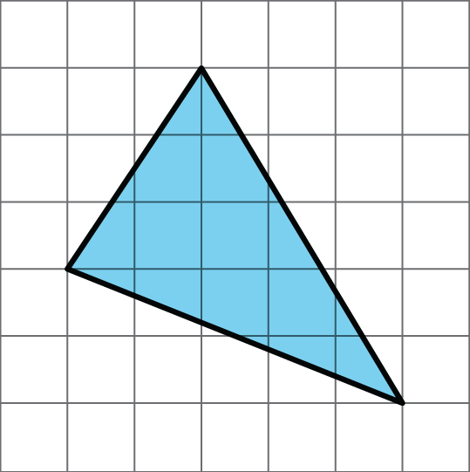
* from Unit 1, Lesson 10



© CC BY Open Up Resources. Adaptations CC BY IM.