## Activity 2: A Collection of Snap Cubes

Here is a collection of snap cubes.

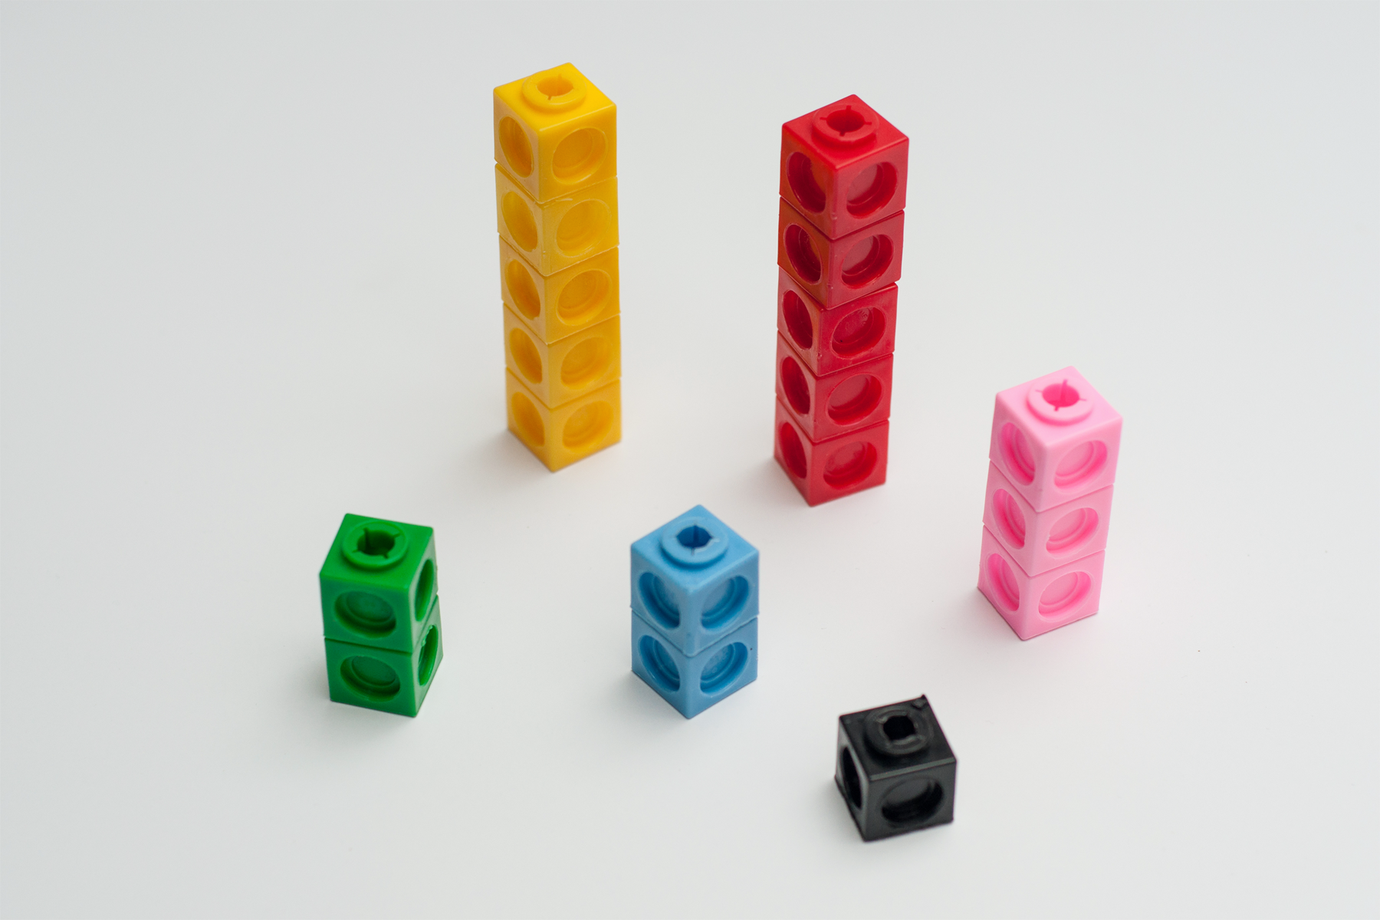

1. Choose two of the colors in the image, and draw a diagram showing the number of snap cubes for these two colors.
2. Trade papers with a partner. On their paper, write a sentence to describe a ratio shown in their diagram. Your partner will do the same for your diagram.
3. Return your partner’s paper. Read the sentence written on your paper. If you disagree, explain your thinking.



© CC BY Open Up Resources. Adaptations CC BY IM.