### Lesson 2 Practice Problems

1. Here is a diagram that describes the cups of green and white paint in a mixture.

* 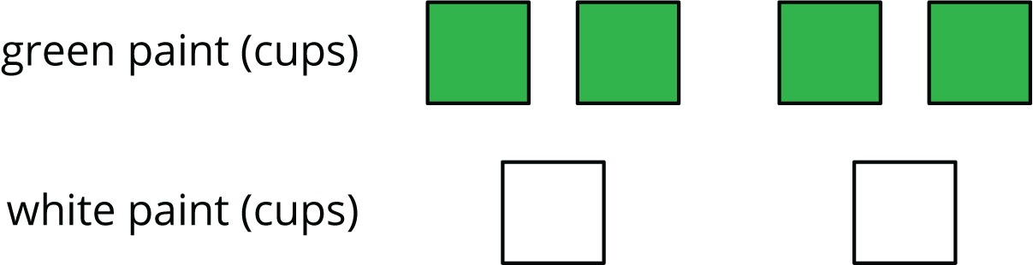
* Select **all** the statements that correctly describe this diagram
  1. The ratio of cups of white paint to cups of green paint is 2 to 4.
  2. For every cup of green paint, there are two cups of white paint.
  3. The ratio of cups of green paint to cups of white paint is $4:2$.
  4. For every cup of white paint, there are two cups of green paint.
  5. The ratio of cups of green paint to cups of white paint is $2:4$.

1. To make a snack mix, combine 2 cups of raisins with 4 cups of pretzels and 6 cups of almonds.
   1. Create a diagram to represent the quantities of each ingredient in this recipe.
   2. Use your diagram to complete each sentence.
      * The ratio of __________________ to __________________ to __________________ is ________ : ________ : ________.
      * There are ________ cups of pretzels for every cup of raisins.
      * There are ________ cups of almonds for every cup of raisins.
   3. A square is 3 inches by 3 inches. What is its area?
   4. A square has a side length of 5 feet. What is its area?
   5. The area of a square is 36 square centimeters. What is the length of each side of the square?

* from Unit 1, Lesson 17

1. Find the area of this quadrilateral. Explain or show your strategy.

* 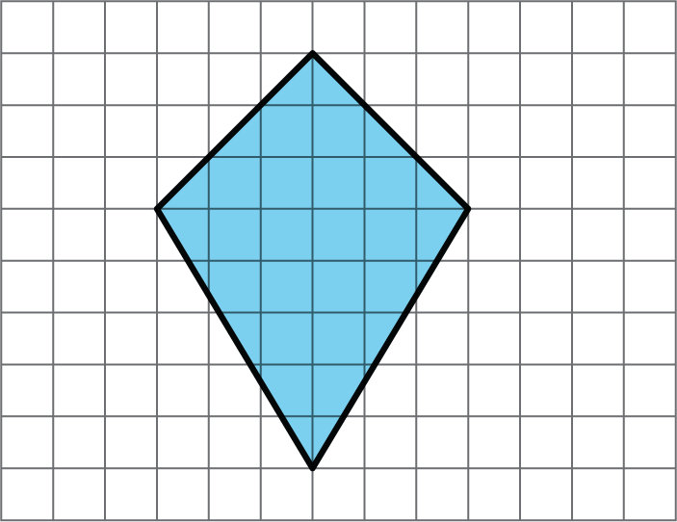
* from Unit 1, Lesson 11

1. Complete each equation with a number that makes it true.

$\frac{1}{8}⋅8=\text{_______}$

$\frac{3}{8}⋅8=\text{_______}$

$\frac{1}{8}⋅7=\text{_______}$

$\frac{3}{8}⋅7=\text{_______}$

* from Unit 2, Lesson 1



© CC BY Open Up Resources. Adaptations CC BY IM.