## Activity 1: Flower Pattern

This flower is made up of yellow hexagons, red trapezoids, and green triangles.

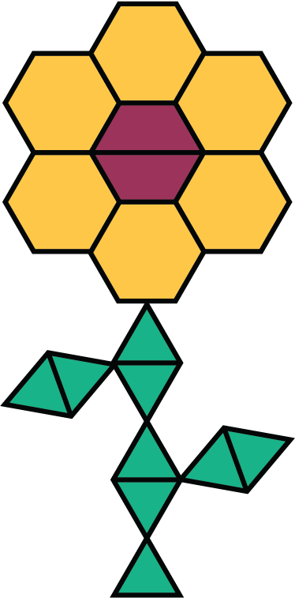

1. Write sentences to describe the ratios of the shapes that make up this pattern.
2. How many of each shape would be in two copies of this flower pattern?



© CC BY Open Up Resources. Adaptations CC BY IM.