## Activity 1: Dots and Half Dots

Dot Pattern 1:

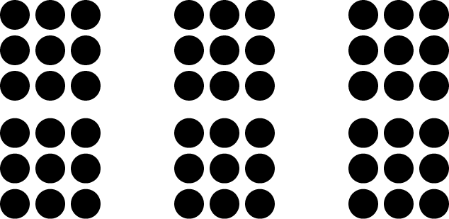

Dot Pattern 2:

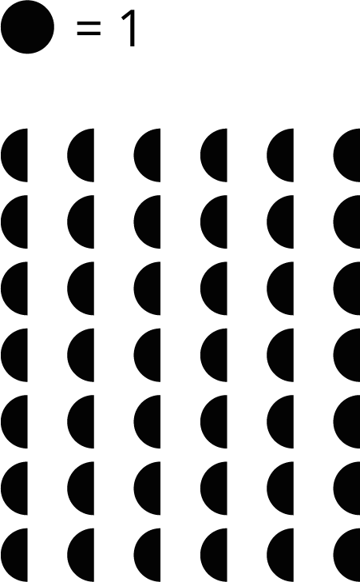



© CC BY Open Up Resources. Adaptations CC BY IM.