## Activity 2: Tuna Casserole

Here is a recipe for tuna casserole.

**Ingredients**

* 3 cups cooked elbow-shaped pasta
* 6 ounce can tuna, drained
* 10 ounce can cream of chicken soup
* 1 cup shredded cheddar cheese
* cups French fried onions

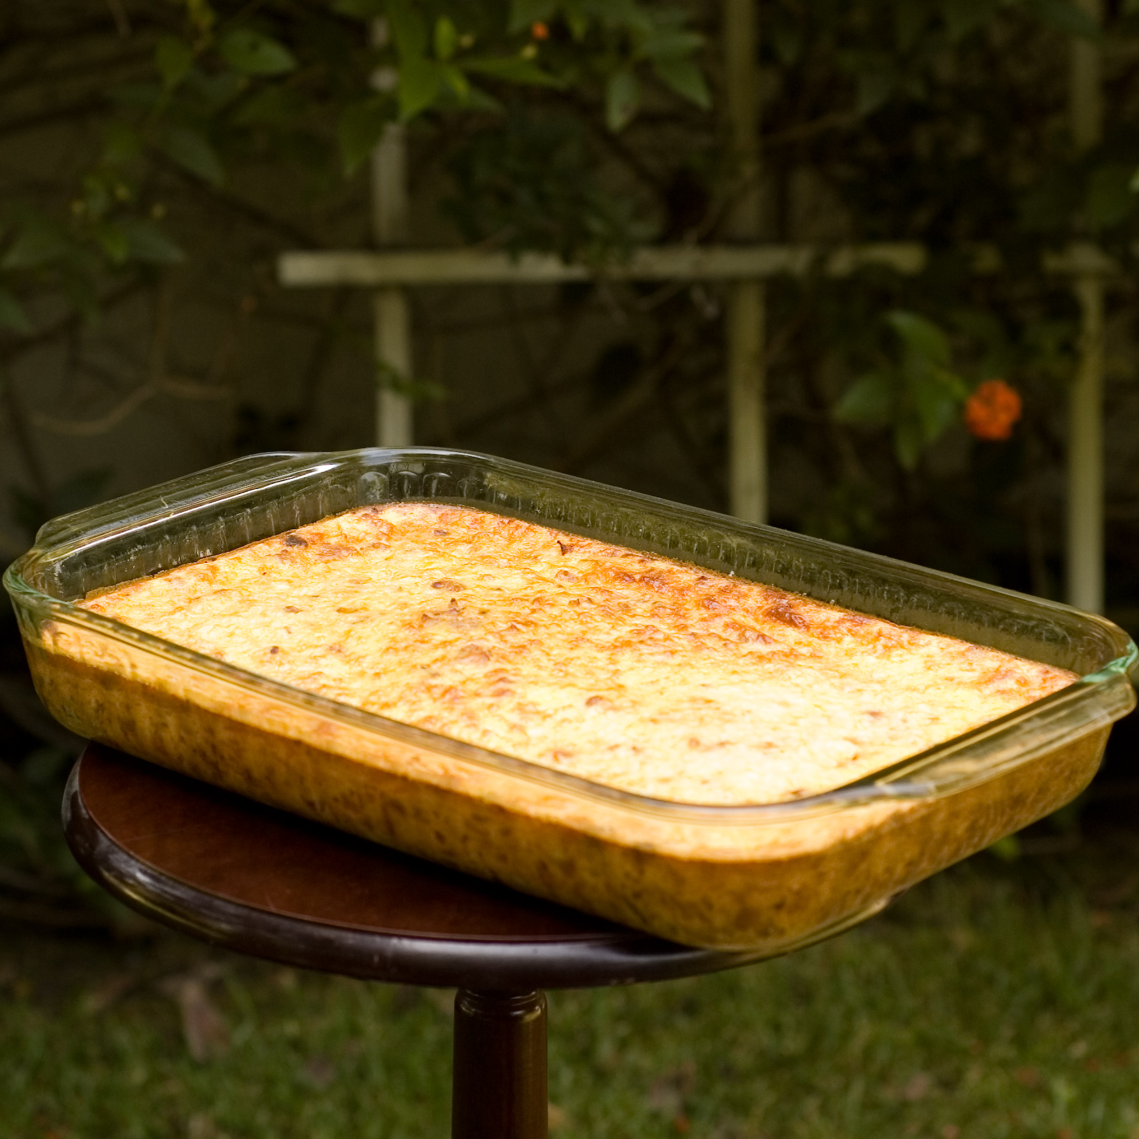

**Instructions**  
Combine the pasta, tuna, soup, and half of the cheese. Transfer into a 9 inch by 18 inch baking dish. Put the remaining cheese on top. Bake 30 minutes at 350 degrees. During the last 5 minutes, add the French fried onions. Let sit for 10 minutes before serving.

1. What is the ratio of the ounces of soup to the cups of shredded cheese to the cups of pasta in one batch of casserole?
2. How much of each of these 3 ingredients would be needed to make:
   1. twice the amount of casserole?
   2. half the amount of casserole?
   3. five times the amount of casserole?
   4. one-fifth the amount of casserole?
3. What is the ratio of cups of pasta to ounces of tuna in one batch of casserole?
4. How many batches of casserole would you make if you used the following amounts of ingredients?
   1. 9 cups of pasta and 18 ounces of tuna?
   2. 36 ounces of tuna and 18 cups of pasta?
   3. 1 cup of pasta and 2 ounces of tuna?

#### Are you ready for more?

The recipe says to use a 9 inch by 18 inch baking dish. Determine the length and width of a baking dish with the same height that could hold:

1. Twice the amount of casserole
2. Half the amount of casserole
3. Five times the amount of casserole
4. One-fifth the amount of casserole



© CC BY Open Up Resources. Adaptations CC BY IM.